It's great to get kids off Nauru, but detention centres in Australia are like prisons Nadine Chemali

The current focus on offshore processing is vital but onshore detention centres need attention
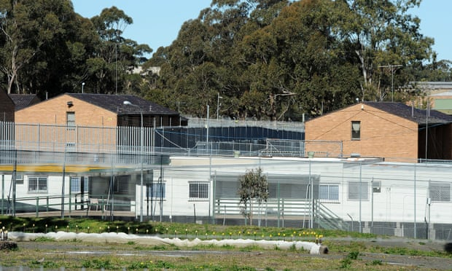

The activism and reporting on Australia’s offshore detention centre has been vital. But we must start looking beyond it and at the greater issue, or we are just plugging a hole in a continually leaky boat.
George Brandis has confirmed that all children will be removed from Nauru before the end of the year, social media is alight with the conversation. Twitter is bubbling with talk about offshore detention and how wonderful it is that these children are leaving Nauru. I don’t need to expand on the conditions on Nauru and Manus Island, it has been covered.
Unfortunately, these children will likely be placed in detention here, in Australia, where conditions are much the same.
If asylum seekers are allowed off Nauru and Manus Island, where will they go? Does Australia take these already traumatised people and put them in detention centres here indefinitely? And is that any better than where they are?
I have visited detention centres in Australia and I have worked with community groups that regularly visit migrant detention centres. Visiting an onshore detention centre is confronting, it is very much like visiting a prison. In most centres you pass multiple steel doors, fences or gates and walk through metal detectors or scanners manned by security guards, to the visitor’s area.
You cannot bring any fresh food, only sealed packaged items. Food such as fruit or vegetables are not allowed, no home cooked meals to share, to bring a cake for a birthday you need to obtain written permission. You may not bring any sporting equipment, you must obtain permission to bring a photograph of your friends or family. To even visit you must fill out pages and pages of forms and provide identification to await processing, just like you would with a prison.
Talking to detainees you hear stories of strip searches, assaults, being woken with a torch light to the face and asked to produce identity documents. Reports of people sewing their lips shut, self-harming, attempting suicide are not uncommon. Living in these conditions for adults would be difficult but for children, according to Dr Zachary Steele, co-author of The Mental Health and Well-Being of On-Shore Asylum Seekers in Australia Report, it is a direct route to lifelong trauma and mental health issues.
Some detainees, including children and unaccompanied minors (those here without a guardian), have been held for years with no release date. The average detainment time in other countries is considerably less, around 30 days in Canada and 10 days in France; according to the international Global Detention Project; which believes Australia “has the most restrictive immigration control regime in the world”.
It is time for Australia to look beyond this current situation, beyond our history of mandatory detention. It is time for a new cause, for the lives of all refugees and asylum seekers on its shores. The current focus on offshore processing, whilst vital is omitting the greater issue – we need fair and timely processing, we have a duty of care to provide people with their basic human rights.

