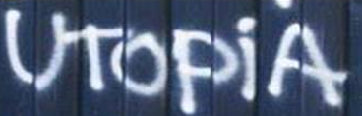
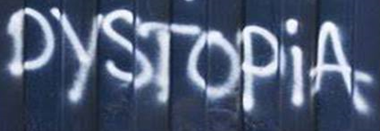
Year 9
Reading Skills
Development
Introduction:
What is dystopian fiction?

Utopia = an imagined place or society in which everything is perfect.
Dystopia = an imagined place or society in which there is great suffering or injustice.
Post-apocalyptic = the time following a catastrophic event where they majority of the human race is wiped out and the world is changed dramatically, e.g. nuclear war, zombie invasion, etc.
Dystopian fiction = made-up (not true) stories about societies where there are problems with things like government rules, poverty, or oppression; sometimes set in a post-apocalyptic world.

Dystopian Fiction / Films:
Can you think of any books or films that are set in a dystopian society?
Fiction (Books): | Films:
- The Hunger Games  - 1984 | - The Hunger Games  - I Am Legend
STATEMENT 1: ___________________________________________________________________
________________________________________________________________________________
I AGREE / DISAGREE BECAUSE: ________________________________________________________________________________
________________________________________________________________________________
________________________________________________________________________________
________________________________________________________________________________

________________________________________________________________________________

TASK:
Tick AGREE or DISAGREE next to each statement in the table below.
Pick TWO of the statements and explain why you agree or disagree with them.
STATEMENT 2: ___________________________________________________________________
________________________________________________________________________________
I AGREE / DISAGREE BECAUSE: ________________________________________________________________________________
________________________________________________________________________________
________________________________________________________________________________
________________________________________________________________________________

________________________________________________________________________________

Dystopian Elements and Characteristics:
Basic Building Blocks of Dystopian Fiction
TASKS:
1. Read the information in the box above and watch the video clip (if you have internet access).
What are the key features or characteristics of dystopian fiction?
Create a bullet point list with as many details as possible:

- Dystopia is subgenre of science fiction, because it depicts future fictional societies, and many of them use other elements of science fiction like time travel, space flight, amazing and advanced technologies, etc.
- Dystopian stories are often about survival; their primary theme is oppression and rebellion. The environment plays an important role in dystopian fiction. Dystopian stories take place in the future; usually in large cities devastated by pollution, war, revolutions, overpopulation and other disasters.
- Another characteristic of dystopian fiction is a strict division between the people or characters. This may be a separation by intellect, ability or class.
- In a typical dystopia, there is a strict government or leader who controls everything. There is also usually a protagonist (main character) who questions society, often feeling that something is terribly wrong and tries to change it.

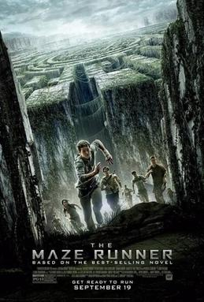
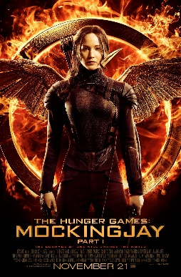
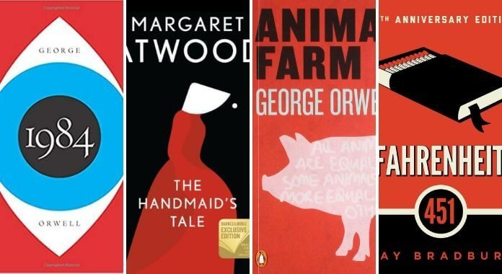
2. Think of a dystopian novel or film that you know of.
Which key features / characteristics do they show?
If you don’t know any dystopian novels or films, try researching them online or look
at the pictures below to give you inspiration.
Novel or film name: _______________________________________________________

Key features or characteristics of dystopian fiction: ____________________________________
________________________________________________________________________
________________________________________________________________________
________________________________________________________________________
________________________________________________________________________
________________________________________________________________________
________________________________________________________________________

3. Create a dystopian fact-file outlining how and why it is a good exemplar of this genre.
Include:
- plot summary
- main characters
- key features and characteristics of dystopian fiction
- reviews from readers and commentaries from experts
- your personal opinion

Extract 1 and activities:
Reading an example of dystopian fiction
Extract from Chapter One of 1984 by George Orwell
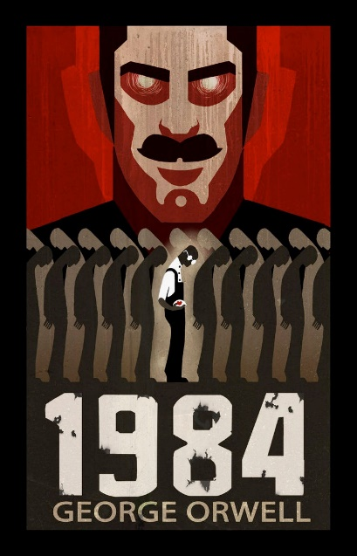
6It was a bright cold day in April, and the clocks were striking thirteen. Winston Smith, his chin nuzzled into his chest in an effort to escape the vile wind, slipped quickly through the glass doors of Victory Mansions, though not quickly enough to prevent a swirl of gritty dust from entering along with him.
The hallway smelt of boiled cabbage and old rag mats. At one end of it a coloured poster, too large for indoor display, had been tacked to the wall. It depicted simply an enormous face, more than a metre wide: the face of a man of about forty-five, with a heavy black moustache and ruggedly handsome features. Winston made for the stairs. It was no use trying the lift. Even at the best of times it was seldom working, and at present the electric current was cut off during daylight hours. This was part of the economy drive in preparation for Hate Week. The flat was seven flights up and Winston, who was thirty-nine and had a varicose ulcer above his right ankle, went slowly, resting several times on the way. On each landing, opposite the lift shaft, the poster with the enormous face gazed from the wall. It was one of those pictures which are so contrived that the eyes follow you about when you move. BIG BROTHER IS WATCHING YOU, the caption beneath it ran.
Inside the flat a fruity voice was reading out a list of figures which had something to do with the production of pig-iron. The voice came from an oblong metal plaque like a dulled mirror which formed part of the surface of the right-hand wall. Winston turned a switch and the voice sank somewhat, though the words were still distinguishable. The device (a telescreen, it was called) could be dimmed, but there was no way of switching it off completely. He moved over to the window: a smallish, frail figure, the thinness of his body merely emphasised by the blue overalls which were the uniform of the Party. His hair was very fair, his face naturally ruddy, his skin roughened by coarse soap and blunt razor blades and the cold of the winter that had just ended.
Outside, even through the shut window-pane, the world looked cold. Down in the street little eddies of wind were whirling dust and torn paper into spirals, and though the sun was shining and the sky a harsh blue, there seemed to be no colour in anything, except the posters that were plastered everywhere. The black-moustachio’d face gazed down from every commanding corner. There was one on the house-front immediately opposite. BIG BROTHER IS WATCHING YOU, the caption said, while the dark eyes looked deep into Winston’s own. Down at street level another poster, torn at one corner, flapped fitfully in the wind, alternately covering and uncovering the single word INGSOC. In the far distance a helicopter skimmed down between the roofs, hovered for an instant like a bluebottle, and darted away with a curving flight. It was a police patrol, snooping into people’s windows. The patrols did not matter, however. Only the Thought Police mattered.
Winston looked out of his window towards a huge building several kilometres away. The Ministry of Truth was startlingly different from any other object in sight. It was an enormous pyramidal structure of glittering white concrete, soaring up, terrace after terrace, three hundred metres into the air. From where Winston stood it was just possible to read, picked out on its white face in elegant lettering, the three slogans of the Party:
WAR IS PEACE. FREEDOM IS SLAVERY. IGNORANCE IS STRENGTH.
The Ministry of Truth contained, it was said, three thousand rooms above ground level and similar numbers below. Scattered about London there were just three other buildings of similar appearance and size. So completely did they dwarf the surrounding buildings that from the roof of Victory Mansions you could see all four of them simultaneously. They were the homes of the four Ministries between which the entire government was divided. The Ministry of Truth which concerned itself with news, entertainment, education and the fine arts. The Ministry of Peace which concerned itself with war. The Ministry of Love which maintained law and order. And the Ministry of Plenty which was responsible for economic affairs. Their names, in Newspeak: Minitrue, Minipax, Miniluv and Miniplenty.
The Ministry of Love was the really frightening one. There were no windows in it at all. Winston had never been inside the Ministry of Love, nor within half a kilometre of it. It was a place impossible to enter except on official business, and then only by penetrating through a maze of barbed-wire entanglements, steel doors and hidden machine-gun nests. Even the streets leading up to its outer barriers were roamed by gorilla-faced in black uniforms, armed with jointed truncheons.
TASKS:
- Read the extract from 1984 (above).
- Highlight / underline any parts that show you this novel is set in a dystopian society.

- Write one of the quotes you have highlighted / underlined here and explain what is suggests about the type of society Winston is living in:

QUOTE: _____________________________________________________________________
This suggests that _____________________________________________________________
____________________________________________________________________________
____________________________________________________________________________
____________________________________________________________________________
____________________________________________________________________________

- Identify five key features or conventions of dystopian fiction in this extract:

CHALLENGE: Include a quote from the extract for each.

- A student read the extract from 1984 and said: ‘The society in which Winston lives sounds pleasant and friendly.’ To what extent do you agree?
In your answer, you should:
- state whether you agree or disagree with the statement and explain why
- include evidence (quotes) from the extract to support your opinion
- explain what each quote tells the reader about the society Winston lives in
- pick out some individual words or techniques used by the writer and explain their effect
- include your personal opinion – would you like to live there? Why, or why not?
AIM TO WRITE AT LEAST ONE PEE PARAGRAPH (you may need to use extra paper).
____________________________________________________________________________________
____________________________________________________________________________________
____________________________________________________________________________________
____________________________________________________________________________________
____________________________________________________________________________________
____________________________________________________________________________________
____________________________________________________________________________________
____________________________________________________________________________________
____________________________________________________________________________________
____________________________________________________________________________________
____________________________________________________________________________________
____________________________________________________________________________________
____________________________________________________________________________________
____________________________________________________________________________________
Extract 2 and activities:
Setting in Dystopian Fiction
- The choice of setting is extremely important in a dystopian novel. Remember, a dystopia is a place where ‘normal life’ is different to how we know it: post-apocalyptic, perhaps after a nuclear war or a world-wide pandemic/disease; an extreme famine or starvation; an alien invasion; a society where the government or single leader has total control; etc.
- A writer’s choice of setting can almost act as another character in a dystopian novel; it helps create an expectation or impression for the reader of what might happen to the protagonist (main character), or helps them to sympathise with the characters’ suffering.
- This week, you are going to look at some examples of dystopian settings in fiction. This will help you prepare for creating your own dystopian setting next week. Look at the pictures below to give you an idea:

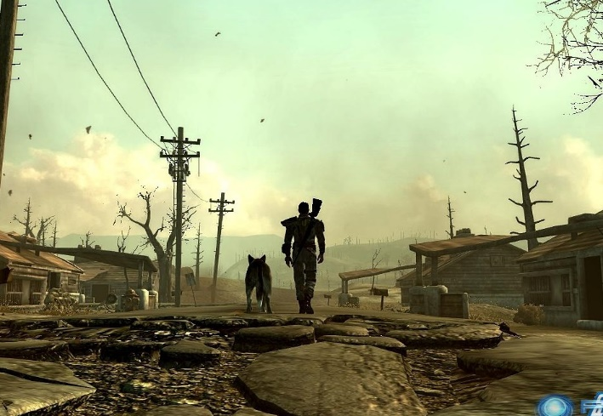
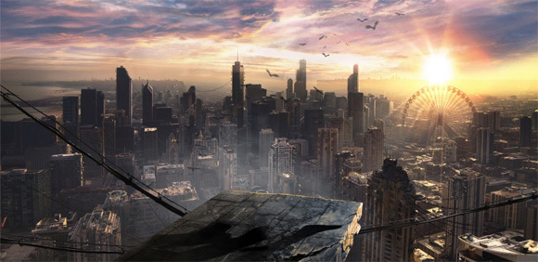
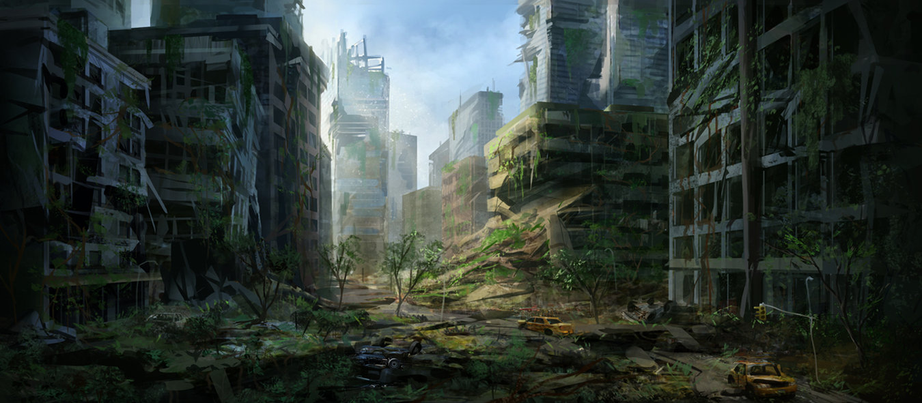

Setting: The Hunger Games – Suzanne Collins
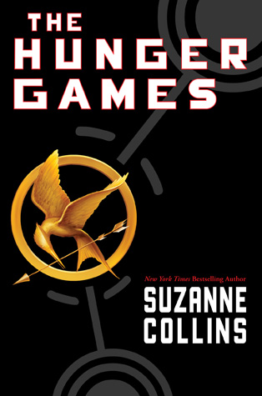
Our house is almost at the edge of the seam. I only have to pass a few gates to reach the scruffy field called the Meadow. Separating the meadow from the woods, in fact enclosing all of District 12, is a high chain-link fence topped with barbed wire loops. In theory, it’s supposed to be electrified twenty-four hours a day as a deterrent to the predators that live in the woods – packs of wild dogs, lone cougars, bears – that used to threaten our streets. But since we’re lucky to get two or three hours of electricity in the evenings, it’s usually safe to touch. Even so, I always take a moment to listen carefully for the hum that means the fence is live. Right now, it’s silent as a stone. Concealed by a clump of bushes, I flatten out on my belly and slide under a meter-long stretch that’s been loose for years. There are several other weak spots in the fence, but this one is so close to home I almost always enter the woods here.
As soon as I’m in the trees, I retrieve a bow and sheath of arrows from a hollow log. Electrified or not, the fence has been successful at keeping the flesh-eaters out of District 12. Inside the woods they roam freely, and there are added concerns like venomous snakes, rabid animals, and no real paths to follow. But there’s also food if you know how to find it. My father knew and he taught me some ways before he was blown to bits in a mine explosion. There was nothing left of him to bury. I was eleven then. Five years later, I still wake up screaming for him to run.
In the woods waits the only person with whom I can be myself. Gale. I can feel the muscles in my face relaxing, my pace quickening as I climb the hills to our place, a rock ledge overlooking a valley. A thicket of berry bushes protect it from unwanted eyes. The sight of him waiting there brings on a smile. Gale says I never smile except in the woods.
TASKS:
- Read The Hunger Games extract (above).
- Look for and highlight these language features used by the author to describe the setting:
  - Simile
  - 3-part lists (there are two to find!)
  - Alliteration
  - Onomatopoeia (a word that sounds like the noise it makes, e.g. Bang!)
  - Imagery
  - Personification (giving human characteristics to something non-human)

- CHALLENGE: How does the narrator (Katniss Everdeen) feel about the setting?
Explain your answer and include quotes in your response.

Extract 3 and Setting: Ready Player One – Ernest Cline

Our trailer was near the northern edge of the stacks, which ran up to a crumbling highway overpass. From my vantage point at the laundry room window, I could see a thin stream of electric vehicles crawling along the cracked asphalt, carrying goods and workers into the city. As I stared out at the grim skyline, a bright sliver of the sun peeked over the horizon. Watching it rise, I performed a mental ritual: Whenever I saw the sun, I reminded myself that I was looking at a star. One of over a hundred billion stars in our galaxy. A galaxy that was just one of billions of other galaxies in the observable universe. This helped me keep things in perspective. I’d started doing it after watching a science program from the early ‘80s called Cosmos.
I slipped out the window as quietly as possible and, clutching the bottom of the window frame, slid down the cold surface of the trailer’s metal siding. The steel platform on which the trailer rested was only slightly wider and longer than the trailer itself, leaving a ledge about a foot and a half wide all the way around. I carefully lowered myself until my feet rested on this ledge, then reached up to close the window behind me. I grabbed hold of a rope I’d strung there at waist level to serve as a hand hold and began to sidestep along the ledge to the corner of the platform. From there I was able to descend the ladder-like frame of the scaffolding. I almost always took this route when leaving or returning to my aunt’s trailer. A rickety metal staircase was bolted to the side of the stack, but it shook and knocked against the scaffolding, so I couldn’t use it without announcing my presence. Bad news. In the stacks, it was best to avoid being heard or seen, whenever possible. There were often dangerous and desperate people about…
…when I reached the bottom level, I jumped off the scaffold and dropped the few remaining feet to the ground. My rubber boots crunched into the slush and frozen mud. It was still pretty dark down here, so I took out my flashlight and headed east, weaving my way through the dark maze, doing my best to remain unseen while being careful to avoid tripping over a shopping cart, engine block, or one of the other pieces of junk littering the narrow alleys between the stacks. I rarely saw anyone out at this time of the morning. The commuter shuttles ran only a few times a day, so the residents lucky enough to have a job would already be waiting at the bus stop by the highway. Most of them worked as day labourers in the giant factory farms that surrounded the city.
After walking about half a mile, I reached a giant mound of old cars and trucks piled haphazardly along the stacks’ eastern perimeter. Decades ago, the cranes had cleared the park of as many abandoned vehicles as possible, to make room for even more stacks, and they’d dumped them in huge piles like this one all around the settlement’s perimeter. Many of them were nearly as tall as the stacks themselves.
I walked to the edge of the pile, and after a quick glance around to make sure I wasn’t being watched or followed, I turned sideways to squeeze through a gap between two crushed cars. From there, I ducked, clambered, and sidestepped my way farther and farther into the ramshackle mountain of twisted metal, until I reached a small open space at the rear of a buried cargo van. Only the rear third of the van was visible. The rest was concealed by the other vehicles stacked on and around it. Two overturned pickup trucks lay across the van’s roof at different angles, but most of their weight was supported by the cars stacked on either side, creating a kind of protective arch that prevented the van from being crushed by the mountain of vehicles piled above it.
I pulled out a chain I kept around my neck, on which there hung a single key. In a stroke of luck, this key had still been hanging from the van’s ignition when I’d first discovered it. Many of these vehicles had been in working condition when they were abandoned. Their owners had simply no longer been able to afford fuel for them, so they’d just parked them and walked away.
I pocketed my flashlight and unlocked the van’s rear right door. It opened about a foot and a half, giving me just enough room to squeeze inside. I pulled the door closed behind me and locked it again. The van’s rear doors had no windows, so I was hunched over in total darkness for a second, until my fingers found the old power strip I’d duct-taped to the ceiling. I flipped it on, and an old desk lamp flooded the tiny space with light.
The crumpled green roof of a compact car covered the crushed opening where the windshield had been, but the damage to the van’s front end didn’t extend beyond the cab. The rest of the interior remained intact. Someone had removed all of the van’s seats (probably to use as furniture), leaving a small “room” about four feet wide, four feet high, and nine feet long.
This was my hideout.
… This van was my refuge. My Batcave. My Fortress of Solitude. It was where I attended school, did my homework, read books, watched movies, and played videogames. It was also where I conducted my on-going quest to find Halliday’s Easter egg.
TASKS:
- Read the Ready Player One extract (above).
- Look for and highlight these language features used by the author to describe the setting:
  - Metaphor
  - 3-part lists
  - Alliteration
  - Onomatopoeia (a word that sounds like the noise it makes, e.g. Bang!)
  - Imagery
  - Personification (giving human characteristics to something non-human)

- CHALLENGE: How does the narrator (Wade Watts) feel about the setting?
Explain your answer and include quotes in your response.

Compare the two settings:
How do the authors present the setting in these extracts?
Ready Player One | Both | The Hunger Games
Idea 1:  Quote 1:  Idea 2:  Quote 2:  Idea 3:  Quote 3: | Idea 1: Both present the setting as dangerous.  Quote 1 (Hunger Games): ‘packs of wild dogs, lone cougars, bears’  Quote 1 (Ready Player One): ‘mound of old cars and trucks piled haphazardly‘ | Idea 1:  Quote 1:  Idea 2:  Quote 2:  Idea 3:  Quote 3:
EXTENSION HINT: Try to think of examples that support big ideas. i.e. the setting is dangerous, the setting is special to the speaker, the setting is isolated from the rest of the population
Plan for at least 3 areas of comparison.
e.g.
P 1: Both present the setting as dangerous
  - Ready Player One:
    - 3 part list (‘avoid tripping over a shopping cart, engine block, or one of the other pieces of junk’)
    - Imagery (‘mound of old cars and trucks piled haphazardly‘)
    - Metaphor (‘the ramshackle mountain of twisted metal’)
  - The Hunger Games:
    - 3 part list (x2!): (‘packs of wild dogs, lone cougars, bears’; ‘venomous snakes, rabid animals, and no real paths to follow’)
    - Onomatopoeia, Personification: (‘I always take a moment to listen carefully for the hum that means the fence is live’)
Compare the two settings:
How do the authors present the setting in these extracts?
Use your ideas from the table on the previous page to compare the settings used in The Hunger Games and Ready Player One. Aim to write three paragraphs – you may need extra paper.

______________________________________________________________________________________
______________________________________________________________________________________
______________________________________________________________________________________
______________________________________________________________________________________
______________________________________________________________________________________
______________________________________________________________________________________
______________________________________________________________________________________
______________________________________________________________________________________
______________________________________________________________________________________
______________________________________________________________________________________
______________________________________________________________________________________
______________________________________________________________________________________
______________________________________________________________________________________
______________________________________________________________________________________
______________________________________________________________________________________
______________________________________________________________________________________
______________________________________________________________________________________
______________________________________________________________________________________
______________________________________________________________________________________
Key words
dangerous simile
isolated metaphor
dystopian personification
threatening three-part list
effective imagery
perilous onomatopoeia
Sentence starters (if you need them!):
The writer presents the setting in _______ as…
This is seen in the quote…
This quote suggests that…
The use of the [language feature] creates the impression that…
The word ‘____’ implies…
This is similar / different to the setting in the other extract because…
Transferring reading skills into our writing
Creating Your Own Dystopian Setting
- By now, you should have an idea of what a dystopia is, some key characteristics of dystopian fiction, and what a dystopian setting could look like.

- This week, you are going to create your own dystopian setting.
Look back at Week Three if you need reminding.

- You will eventually write your own piece of dystopian fiction, so this setting could be the basis for your story when we come to plan it next week!

- Use the space below to plan some ideas before drawing your setting on the next page.

Where is it set?
(a town, city, different country or planet?)

What makes it dystopian?
(post-apocalyptic, alien invasion, deadly pandemic, controlling leader or government, or other?)

When is it set?
(the present day or in the future?)
Dystopian
Setting

Any other details or ideas?

Begin by drawing your dystopian setting below:

TASK:
Using your drawing to guide you (or the image above if you are still unsure), write a description of your dystopian setting. Remember to use punctuation and descriptive language techniques.
*NOTE – This is not your dystopian story (yet!). The purpose of the description is to create a clear image of your setting in your head before we start planning your story. You may need extra paper.
_____________________________________________________________________________________
_____________________________________________________________________________________
_____________________________________________________________________________________
_____________________________________________________________________________________
_____________________________________________________________________________________
_____________________________________________________________________________________
_____________________________________________________________________________________
_____________________________________________________________________________________
_____________________________________________________________________________________
_____________________________________________________________________________________
_____________________________________________________________________________________
_____________________________________________________________________________________
_____________________________________________________________________________________
_____________________________________________________________________________________
_____________________________________________________________________________________
_____________________________________________________________________________________
_____________________________________________________________________________________

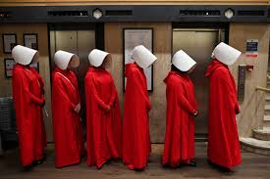
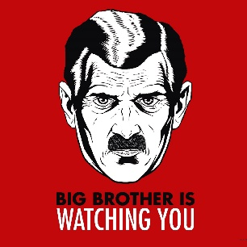
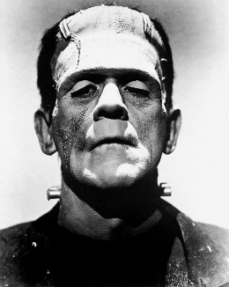
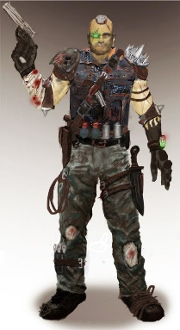
Extract 3:
Character
If you read dystopian fiction, or you have watched some dystopian films, you may already know what type of characters to expect.
Below is a list of ‘typical’ characters you might find in a dystopian novel:
- a protagonist who feels something is wrong with society, or feels trapped and wants to escape; they question the existing society and may aim to change something – usually brave and these characters allow the reader to experience the dystopian society through their eyes
- an oppressive leader or group - perhaps the government
- you may find a character based on technological / scientific advances – e.g. aliens, robots, monsters, etc.

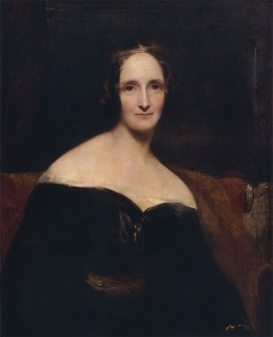
Extract from Frankenstein by Mary Shelley
It was on a dreary night of November that I beheld the accomplishment of my toils. With an anxiety that almost amounted to agony, I collected the instruments of life around me, that I might infuse a spark of being into the lifeless thing that lay at my feet. It was already one in the morning; the rain pattered dismally against the panes, and my candle was nearly burnt out, when, by the glimmer of the half-extinguished light, I saw the dull yellow eye of the creature open; it breathed hard, and a convulsive motion agitated its limbs.
How can I describe my emotions at this catastrophe, or how delineate the wretch whom with such infinite pains and care I had endeavoured to form? His limbs were in proportion, and I had selected his features as beautiful. Beautiful! Great God! His yellow skin scarcely covered the work of muscles and arteries beneath; his hair was of a lustrous black, and flowing; his teeth of a pearly whiteness; but these luxuriances only formed a more horrid contrast with his watery eyes, that seemed almost of the same colour as the dun-white sockets in which they were set, his shrivelled complexion and straight black lips.
Glossary
toils = work, effort delineate = define lustrous = shiny, glossy
convulsive = sudden, jerky wretch = unfortunate creature dun = off-white / grey
agitated = disturbed endeavoured = tried complexion = skin
TASKS:
- Read the extract from Frankenstein (previous page).
This extract from chapter five of Frankenstein depicts the creature being brought to life.
This novel introduced the idea of a ‘mad-scientist’ to popular culture.
- Highlight / underline any quotes that describe:
a. The setting
b. The monster
c. Frankenstein (he is the scientist, NOT the monster!):

- Write one of the quotes you have highlighted / underlined here and explain what is suggests about the thing it is describing.
QUOTE: _____________________________________________________________________
This suggests that _____________________________________________________________
____________________________________________________________________________
____________________________________________________________________________
____________________________________________________________________________
- CHALLENGE: Write a minimum of two PEE paragraphs in response to this question:
How does Shelley create and convey setting and character in the extract?
____________________________________________________________________________
____________________________________________________________________________
____________________________________________________________________________
____________________________________________________________________________
____________________________________________________________________________
____________________________________________________________________________
____________________________________________________________________________
____________________________________________________________________________
____________________________________________________________________________
____________________________________________________________________________
____________________________________________________________________________
____________________________________________________________________________
____________________________________________________________________________

Your own dystopian character
- By now, you should have an idea of what a dystopia is, some typical characters often found in dystopian fiction, and what a dystopian character could look like.

- Today, you are going to create your own dystopian character.

- You will be writing your own piece of dystopian fiction in the next couple of weeks, so this character could be the protagonist (main character; hero) or antagonist (rival / enemy of the protagonist) of your story.

- Use the space below to plan some ideas before drawing your character on the next page. You can plan / draw more than one character if you like, but no more than two.

Appearance +
Personality
What is their purpose in the story?

Who is your main character?
(Think about your choice of setting – make sure they make sense together!)

What makes them dystopian?
(How have they been affected by your choice of dystopia: post-apocalyptic, alien invasion, deadly pandemic, controlling leader or government, or other?)
Who is their main rival?
(Who or what is your protagonist fighting against? i.e.
an evil leader, an alien invasion, a zombie apocalypse, etc.)
Dystopian
Character

Any other details or ideas?

Begin by drawing your dystopian character/s below.
If you have planned more than one character, you may want to split this page up.

Label the key features / characteristics of each of your dystopian characters.
E.g.
Explain why you have designed them to look or act a certain way.
Do they have any weapons or special capabilities?
Does anything make them dystopian, or are they living in a dystopian society and fighting against it?

