LO1 Understand the importance of nutrition when planning menus

LEVEL 1 / 2 AWARD IN

HOSPITALITY AND CATERING unit 2

Name

Group

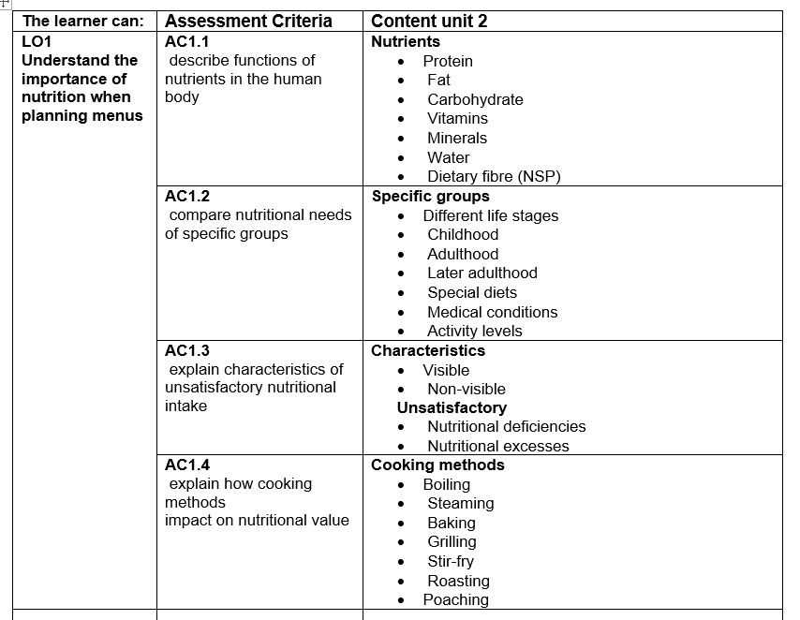

**LO1.1 Describe the functions of nutrients in the human body**

Macronutrients

moderate amounts

protein

carbohydrate

Fat

Micronutrients

tiny amounts

Vitamins

Minerals

Nutrients are divided into ……………………… and …………………………… nutrients.

…………………………………………………….are needed by the body in………………………….amounts, the GDA is in Grammes

……………………………………………………are needed by the body in ………………..amounts such as microgrammes

…………………. And ……………… are not actually nutrients but are essential to health.

**Functions of protein in the body** ……………………………………………………………………………………………………………………………………………………………………………………………………………………………………………………………………………………………………………………………..………………………………………………………………………………………………………………………………………………………………………………………………………………………………………………………………………………………………………………………………………………………………………………………………………………………………………………………………………………………………………………………………………………………………………………………………………………………………………………………………………………………………………………………………………………………………………………………………………………………………………………………………………………………………………………………………………………………………………………………

**HBV proteins**

……………………………………………………………………………………………………………………………………………………………………………………………………………………………………………………………………………………………………………………………..………………………………………………………………………………………………………………………………………………………………………….

**LBV proteins** ……………………………………………………………………………………………………………………………………………………………………………………………………………………………………………………………………………………………………………………………..……………………………………………………………………………………………………………………………………………………………………………………………………………………

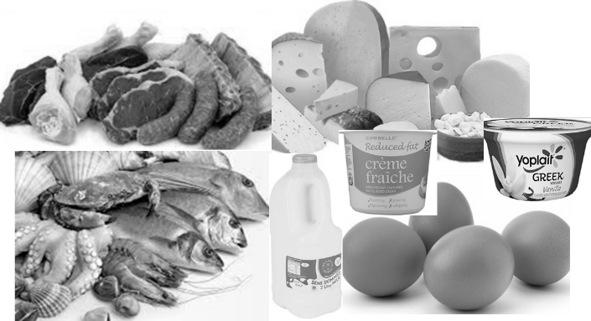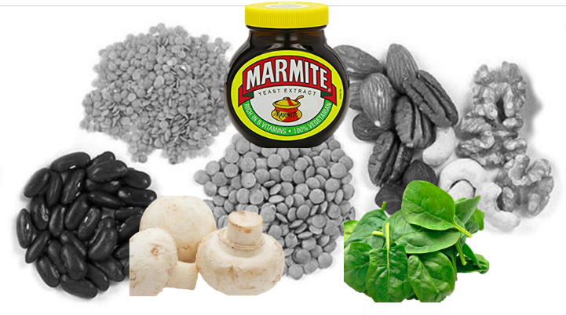

**Alternative proteins**

Soya products ………………………………………………………………………………………………………………………………………………………………………………………………………………………………………………………………………………………………………..…………………………………………………………………………………………………………………………………………………………………………………………………………………………………………………………………………

Quorn products ……………………………………………………………………………………………………………………………………………………………………………………………………………………………………………………………………………………………………………………………………………………………………………………………………………………………………………………………………………………………………………………….……………………………………………………………

**Functions of fat in the body** ……………………………………………………………………………………………………………………………………………………………………………………………………………………………………………………………………………………………………………………………..………………………………………………………………………………………………………………………………………………………………………………………………………………………………………………………………………………………………………………………………………………………………………………………………………………………………………………………………………………………………………………………………………………………………………………………………………………………………………………………………………………………………………………………………………………………………………………………………………………………………………………………………………………………………………………………………………………………………………………………

**Saturated fats**

……………………………………………………………………………………………………………………………………………………………………………………………………………………………………………………………………………………………………………………………..………………………………………………………………………………………………………………………………………………………………………….

**Unsaturated fats** ……………………………………………………………………………………………………………………………………………………………………………………………………………………………………………………………………………………………………………………………..……………………………………………………………………………………………………………………………………………………………………………………………………………………

**Fats and oils**

Fats ………………………………………………………………………………………………………………………………………………………………………………………………………………………………………………………………………………………………………..…………………………………………………………………………………………………………………………………………………………………………………………………………………………………………………………………………

Oils ……………………………………………………………………………………………………………………………………………………………………………………………………………………………………………………………………………………………………………………………………………………………………………………………………………………………………………………………………………………………………………………….……………………………………………………………

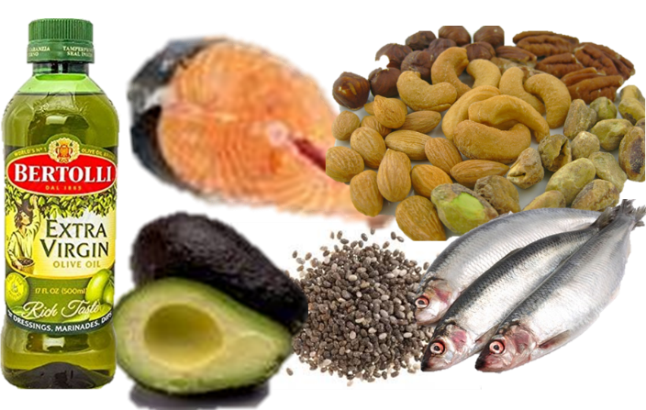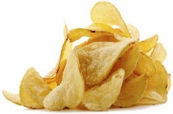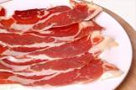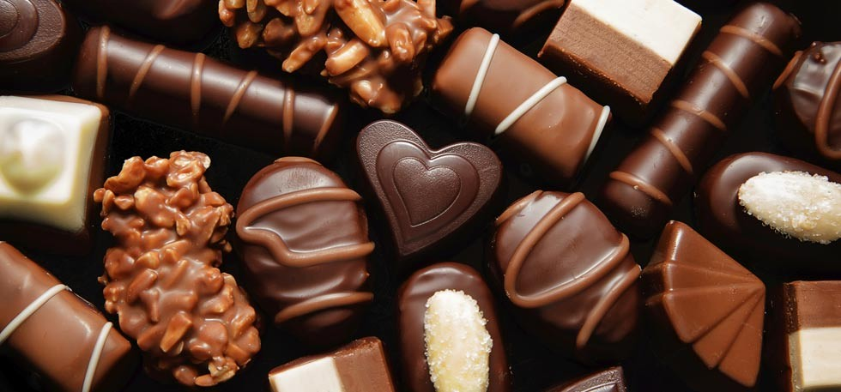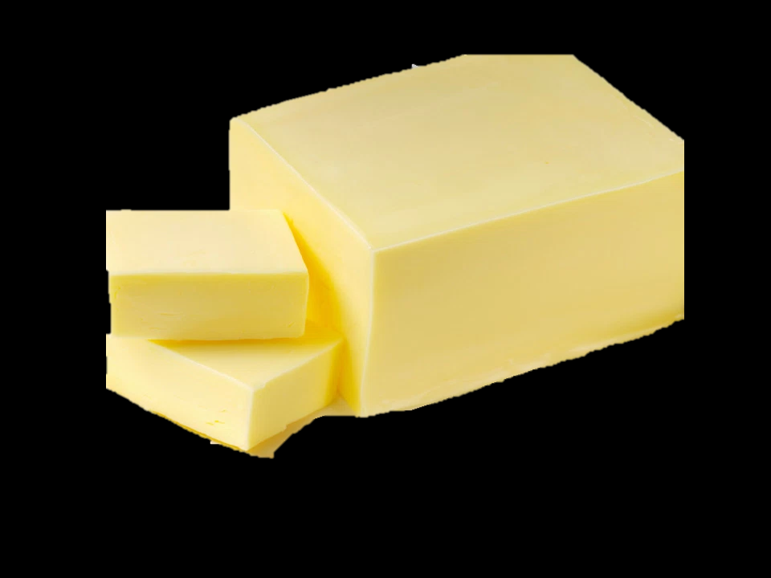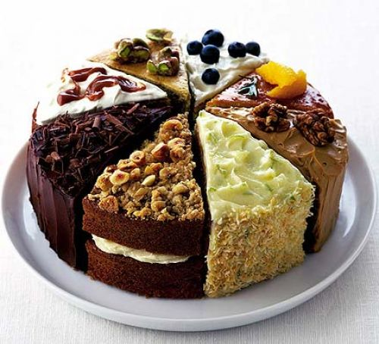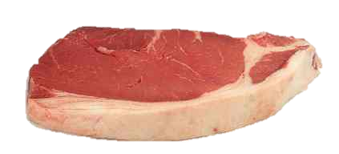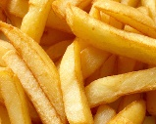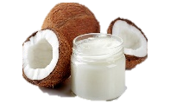

**Functions of Carbohydrate in the body** ……………………………………………………………………………………………………………………………………………………………………………………………………………………………………………………………………………………………………………………………..………………………………………………………………………………………………………………………………………………………………………………………………………………………………………………………………………………………………………………………………………………………………………………………………………………………………………………………………………………………………………………………………………………………………………………………………………………………………………………………………………………………………………………………………………………………………………………………………………………………………………………………………………………………………………………………………………………………………………………………

**Starches**

……………………………………………………………………………………………………………………………………………………………………………………………………………………………………………………………………………………………………………………………..……………………………………………………………………………………………………………………………………………………………………………………..………..

**Sugars** ……………………………………………………………………………………………………………………………………………………………………………………………………………………………………………………………………………………………………………………………..……………………………………………………………………………………………………………………………………………………………………………………………………………………

**Hidden sugars**

………………………………………………………………………………………………………………………………………………………………………………………………………………………………………………………………………………………………………..…………………………………………………………………………………………………………………………………………………………………………………………………………………………………………………………………………

……………………………………………………………………………………………………………………………………………………………………………………………………………………………………………………………………………………………………………………………………………………………………………………………………………………………………………………………………………………………………………………….……………………………………………………………………………………………………………………………………………………………………………………………………..……

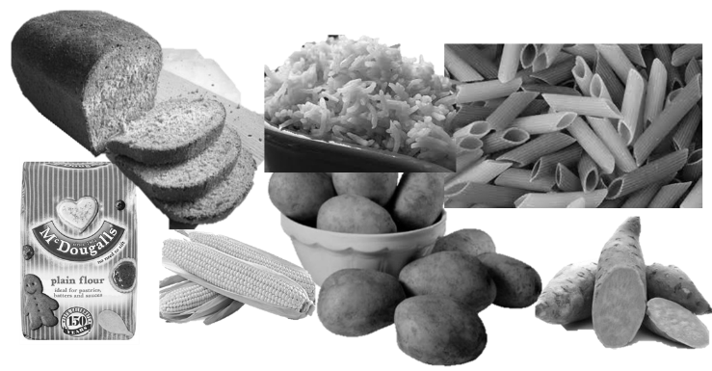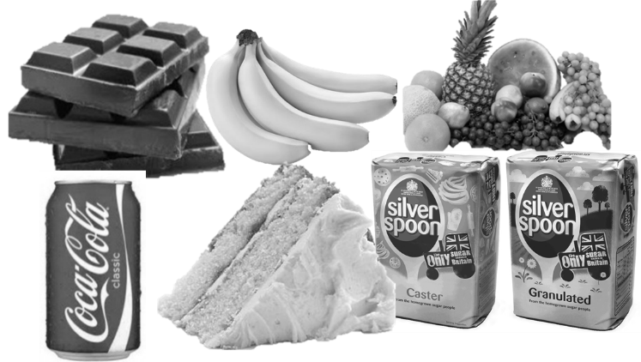

|  |  |  |
| --- | --- | --- |
| **Micro**  **Nutrient** | **Function in the body** | **Foods it is found in** |
| Vitamin  A |  |  |
| Vitamin  B  (group of vitamins) |  |  |
| Vitamin  C |  |  |
| Vitamin  D |  |  |
| Vitamin  E |  |  |
| Vitamin  K |  |  |
| Calcium |  |  |
| Iron |  |  |
| Sodium |  |  |
| Potassium |  |  |
| Fluoride |  |  |

**Functions of Carbohydrate in the body** ……………………………………………………………………………………………………………………………………………………………………………………………………………………………………………………………………………………………………………………………..………………………………………………………………………………………………………………………………………………………………………………………………………………………………………………………………………………………………………………………………………………………………………………………………………………………………………………………………………………………………………………………………………………………………………………………………………………………………………………………………………………………………………………………………………………………………………………………………………………………………………………………………………………………………………………………………………………………………………………………

**Starches**

……………………………………………………………………………………………………………………………………………………………………………………………………………………………………………………………………………………………………………………………..……………………………………………………………………………………………………………………………………………………………………………………..………..

**Sugars** ……………………………………………………………………………………………………………………………………………………………………………………………………………………………………………………………………………………………………………………………..……………………………………………………………………………………………………………………………………………………………………………………………………………………

**Hidden sugars**

………………………………………………………………………………………………………………………………………………………………………………………………………………………………………………………………………………………………………..…………………………………………………………………………………………………………………………………………………………………………………………………………………………………………………………………………

……………………………………………………………………………………………………………………………………………………………………………………………………………………………………………………………………………………………………………………………………………………………………………………………………………………………………………………………………………………………………………………….……………………………………………………………………………………………………………………………………………………………………………………………………..



**Functions of Fibre in the body** Although fibre is sometimes classified as a carbohydrate, it is not actually a nutrient as it is not absorbed by the body

…………………………………………………………………………………………………………………………………………………………………………………………………………………………………………………………………………………………………………………..……………………………………………………………………………………………………………………………………………………………………………………………………………………………………………………………………………………………………………………………………………………………………………………………………………………………………………………………………………………………………………………………………………………………………………………………………………………………………………………………………………………………………………………………………………………………………………………………………………………………………………………………………………………………………………………………………………………………………………………… **Functions of Fibre in the body**

**Sources of fibre**

………………………………………………………………………………………………………………………………………………………………………………………………………………………………………………………………………………………………………………………………………………………………………………………………………………………………………………………………..

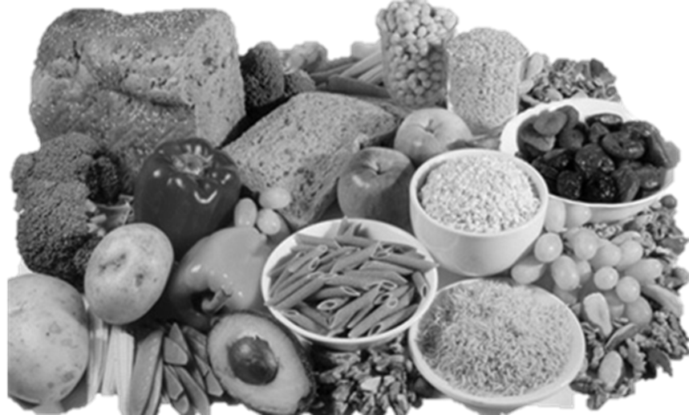

**Functions of Water in the body** …………………………………………………………………………………………………………………………………………………………………………………………………………………………………………………………………………………………………………………..…………………………………………………………………………………………………………………………………………………………………………………………………………………………………………………………………………………………………………………………………………………………………………………………………………………………………………………………………………………………………………………………………………………………………………………………………………………………………………………………………………………………………………………………………………………………………………………………………………………………………………………………………………………………………………………………………………………………………………………………..…… **Functions of Fibre in the body**

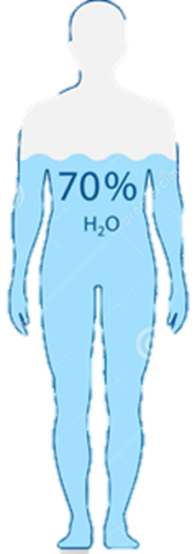

**Sources of Water in the diet**

………………………………………………………………………………………………………………………………………………………………………………………………………………………………………………………………………………………………………………………………………………………………………………………………………………………………………………………………..

**LO1.2 Compare the nutritional needs of specific groups**

How to present a good comparison

The ONLY distinction in this section is comparing the nutritional needs of 2 specific groups from your brief.

You must look at similarities and differences between the nutritional needs and requirements and produce a written comparison of the two.



**Mr Griffiths to the rescue!**

What does an English teacher know about LO1.2 ? Well, he knows how to use the language of comparison for a start.

* In some ways,………and…..are alike. For instance, they both ………………………..
* Another feature they have in common is that………………………
* Moreover, they are both………………………
* However, they also differ in some ways. For example,…………….., whilst…………….
* Another difference is that………………….., whereas…
* Finally………………………but………………….
* The similarities/differences seem more significant that the similarities/differences because…….

Age related needs

Young children ……………………………………………………………………………………………………………………………………………………………………………………………………………………

Dietary needs

Lactose intolerance ……………………………………………………………………………………………………………………………………………………………………………………………………………………

Dietary choices

Vegans ……………………………………………………………………………………………………………………………………………………………………………………………………………………

|  |  |
| --- | --- |
| Age group  Life stage | Nutritional needs |
| Children |  |
| Teenagers |  |
| Adults |  |
| Older adults |  |
| Diabetics |  |
| Coeliac  Gluten intolerance |  |
| Lactose intolerance |  |
| Food allergies |  |
| Vegans |  |
| Vegetarians |  |
| Religious diets |  |
|  |  |

Which groups may be at risk of dehydration?

* Older adults may have a weaker sense of thirst. If necessary they should be helped and encouraged to drink regularly.
* Childrenneed plenty of fluid and they should be encouraged to drink regularly, especially if they are very active.
* People who are very physically active should drink enough fluid to replace the water loss through sweating.

Useful data

|  |  |  |
| --- | --- | --- |
| Age | Sugar | salt |
| 4-6 | 19g | 3g |
| 7-10 | 24g | 5g |
| 11 + | 30g | 6g |

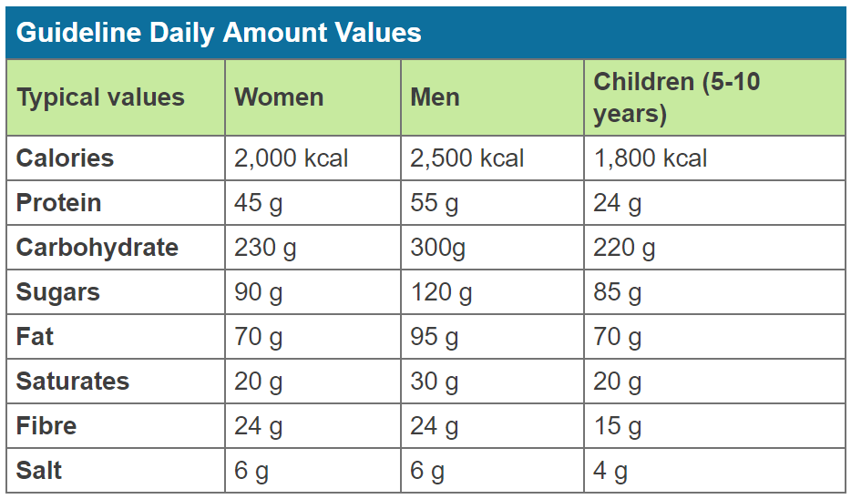

Choose 2 relevant groups and complete a comparison using specific information for each group- don’t forget the language of comparison.

……………………………………………………………………………………………………………………………………………………………………………………………………………………………………………………………………………………………………………………………………………………………………………………………………………………………………………………………………………………………………………………………………………………………………………………………………………………………………………………………………………………………………………………………………………………………………………………………………………………………………………………………………………………………………………………………………………………………………………………………………………………………………………………………………………………………………………………………………………………………………………………………………………………………………………………………………………………………………………………………………………………………………..

**LO1.3 Explain the characteristics of unsatisfactory nutritional intake**

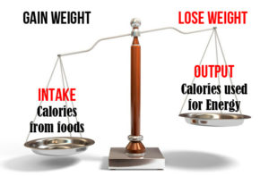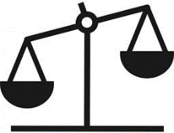

**Water**

Water is a special case, we get instant feedback if our bodies are lacking water ie we feel thirsty, as previously stated water is not a nutrient since it does not change in the body but nevertheless it is essential for good health.

Excess of water is very rare if you have too much water you can actually dilute your body tissues and fluids, your brain swells, presses on your skull and it can be deadly. Confusion, double vision and slurred speech will occur. Drinking over 6-10 litres at once could give you water intoxication

Lack of water can lead to **dehydration** . Dry mouth, tired or sleepy, sunken eyes, little urine, dark coloured urine, headache, saggy skin, no tears, dizziness.

Dehydration in children is an emergency and needs medical treatment as well as drinking water to relieve it, Adults are more likely to recognise the symptoms and act on it sooner.

Thirst is a sign you need to drink but dehydration is much more serious

* All food and drinks contain energy (except water)
* Energy balance is important in maintaining a healthy weight.
* Too little energy results in weight loss, this could be from a restricted diet or from eating disorders, or deliberate in weight loss diets.
* Too much energy leads to weight gain, overweight and obsess people have higher risk of developing type 2 diabetes, high blood pressure, heart disease and some cancers.
* **Over nutrition** is a problem usually associated with developed countries, such as the UK.
* The most common form of over nutrition is having an energy intake in excess of needs, resulting in overweightand obesity.
* Very high intakes of minerals and fat soluble vitamins (more can usually be obtained from food sources alone) can be toxic. This is because they are stored in the body, e.g. vitamin A is stored in the liver.
* **Under nutrition** occurs when is there is a deficiency of one or more nutrients. It may be mild or severe. Mild forms of under nutrition exists in the UK, e.g. micronutrient deficiency.
* Severe under nutrition is rare in countries like the UK, but can be common in some developing countries.
* The body may adapt to a short period of under nutrition. Some nutrients, such as fat-soluble vitamins, are stored in the body and can be used if the diet does not provide enough.

|  |  |  |
| --- | --- | --- |
| Nutrient | Excess – over nutrition | Deficiency- under nutrition |
| Protein |  |  |
| Fat |  |  |
| Carbohydrate |  |  |
| Dietary fibre |  |  |
| Vitamin A |  |  |
| Vitamin B |  |  |
| Vitamin C |  |  |
| Vitamin D |  |  |
| Vitamin E |  |  |
| Vitamin K |  |  |
| Calcium |  |  |
| Iron |  |  |
| Sodium |  |  |

**LO1.4 Explain how cooking methods impact on nutritional value.**

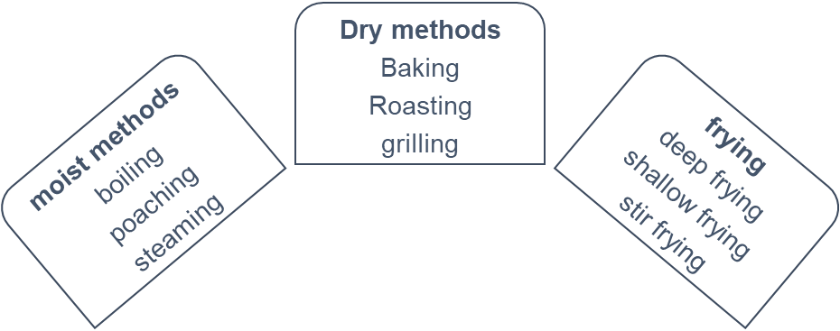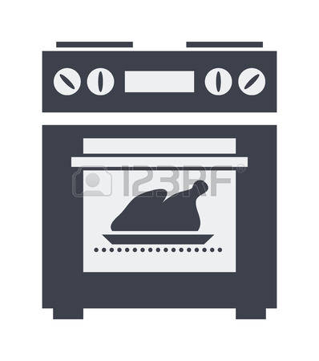

Methods of cooking

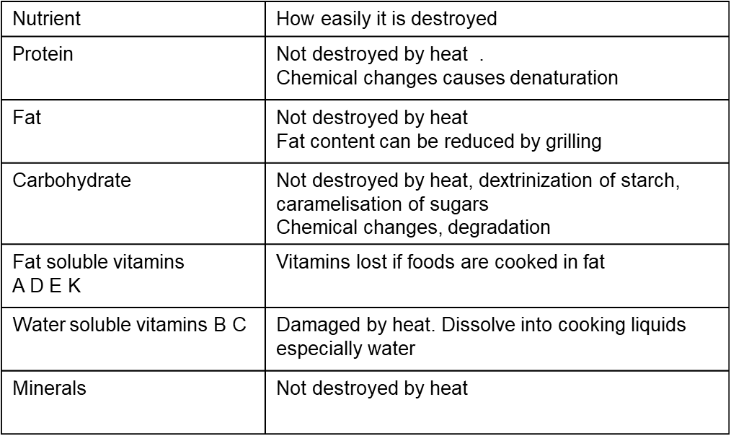

* The main nutrients affected are vitamins B and C which are damaged by heat and leech into cooking liquid
* Cooking at lower temperatures can reduce damage to nutrients
* Cooking in minimum water and using the water for sauces or gravy reduces overall vitamin loss

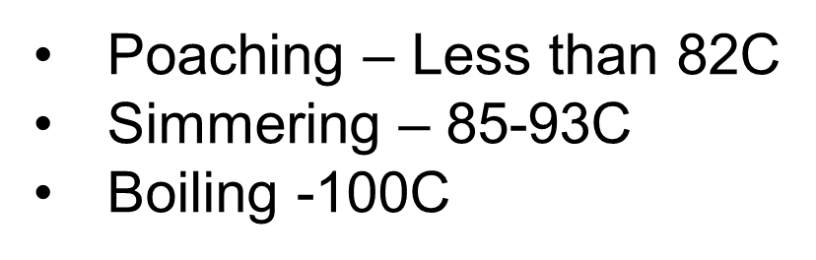

|  |  |
| --- | --- |
| Method of cooking | Effects on nutrients |
| Boiling, simmering and poaching |  |
| Steaming |  |
| microwave |  |
| Baking |  |
| Roasting |  |
| Grilling |  |
| Frying , stir fry |  |

**Vulnerable nutrients**

* Vitamin C Is destroyed by heat, exposure to light, air and dissolves into water
* Vitamin B6 and B12 are destroyed by exposure to light and dissolve in water
* Vitamin E is destroyed by exposure to air and light
* Calcium, iron small amounts can be lost by boiling
* Fats can be oxidised at very high temperatures

1. ………………………………………………………………………………………………………………………………………………………………………………………………………………
2. ……………………………………………………………………………………………………………………………………………………………………………………………………………..
3. ………………………………………………………………………………………………………………………………………………………………………………………………………………
4. ……………………………………………………………………………………………………………………………………………………………………………………………………………….
5. ……………………………………………………………………………………………………………………………………………………………………………………………………………….
6. ………………………………………………………………………………………………………………………………………………………………………………………………………………..
7. ……………………………………………………………………………………………………………………………………………………………………………………………………………….
8. ………………………………………………………………………………………………………………………………………………………………………………………………………………..
9. ……………………………………………………………………………………………………………………………………………………………………………………………………………….

LO2 Understand menu planning

LEVEL 1 / 2 AWARD IN

HOSPITALITY AND CATERING unit 2

Name

Group

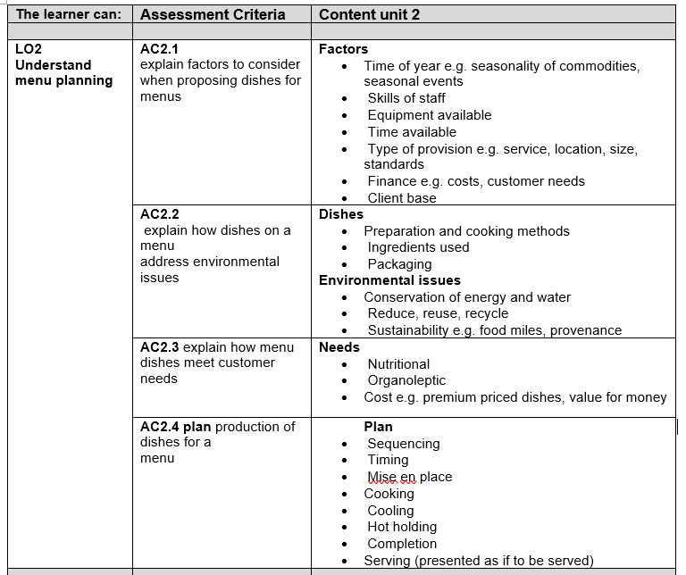

**LO2.1 Factors to consider when proposing dishes for menus**

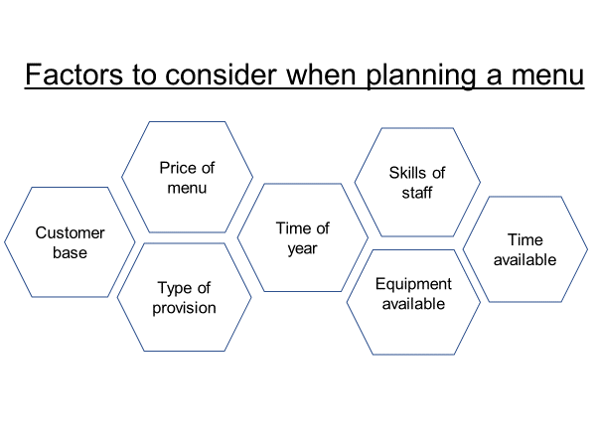

|  |  |
| --- | --- |
| **Factor** | **How it affects dishes proposed** |
| Customer base |  |
| Type of provision |  |
| Price of menu |  |
| Time of year and weather |  |
| Seasonal events |  |
| Skills of the kitchen and serving staff |  |
| Equipment available in the kitchen |  |

**THINK**

Not all of the factors will apply to every situation

You wont need to discuss the lack of a tandoor oven in your assessment if you are proposing dishes for an Italian bistro

You wont need to discuss the needs of businessmen in your assessment if you are proposing dishes for a holiday complex

Balancing a menu

Things to consider

* Consistency (thick or thin )
* Texture (crunchy, soft, crisp)
* Flavour (salty, sweet, sour, bitter)
* Colour
* Accompaniments (vegetables and sauces)
* Decoration (on sweet dishes)
* Garnish (on savoury dishes)

Variety of colours

…………………………………………………………………………………………………………………………………………………………………………………………………………………………………………………………………………………………………………………………………

Variety of shapes

………………………………………………………………………………………………………………………………………………………………………………………………………………………………………………………………………………………………………………………………..

Variety of textures

………………………………………………………………………………………………………………………………………………………………………………………………………………………………………………………………………………………………………………………………

Variety of ingredients

………………………………………………………………………………………………………………………………………………………………………………………………………………………………………………………………………………………………………………………………………………

Variety of flavours

…………………………………………………………………………………………………………………………………………………………………………………………………………………………………………………………………………………………………………………………..…

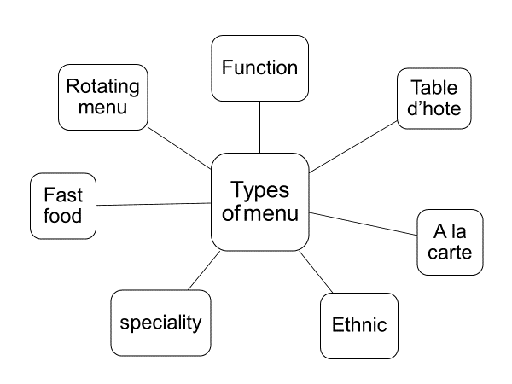

* Include enough dishes to offer an interesting choice to customers.
* It is better to offer a few dishes at a high standard rather than a wide range of lesser quality.

Conservation of energy and water

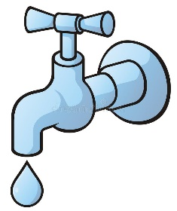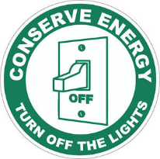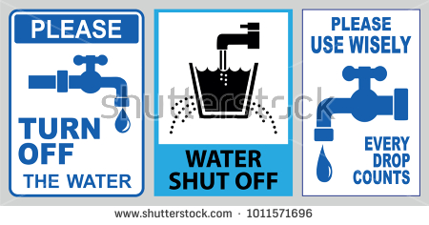

……………………………………………………………………………………………………………………………………………………………………………………………………………………………………………………………………………………………………………………………………………………………………………………………………………………………………………………………………………………………………………………………………………………………………………………………………………………………………………………………………….

……………………………………………………………………………………………………………………………………………………………………………………………………………………………………………………………………………………………………………………………………………………………………………………………………………………………………………………………………………………………………………………………………………………………………………………………………………………………………………………………………….

**LO2.2 Explain how dishes on a menu address environmental issues**

**Reduce** means to cut down on the amount of waste being thrown away

**Reuse** some thing that can be used again and again rather than thrown away , or another use found for

**Recycle** to process an item and create something else with it

**Conservation** to preserve or make them last for the future

**Energy**  provides the fuel to cook on or the power to make machines work. In the kitchen we use both electricity and gas

**Sustainable**  Conserving an ecological balance by avoiding depletion of natural resources

Hospitality and catering organisations need to be aware of environmental issues when running their businesses.

**Dishes**

* Preparation and cooking methods
* Ingredients used
* Packaging

**Environmental issues**

* Conserving energy and water when preparing food
* 3 Rs Reduce, Reuse, Recycle
* Food sustainability and provenance

**Ingredients used**

……………………………………………………………………………………………………………………………………………………………………………………………………………………………………………………………………………………………………………………………………………………………………………………………………………………………………………………………………………………………………………………………………………………………………………………………………………………………………………………………………………………………………………………………………………………………………………………………………………………………………………………………………………………………………………………………………………

**Packaging**

…………………………………………………………………………………………………………………………………………………………………………………………………………………………………………………………………………………………………………………………………………………………………………………………………………………………………………………………………………………………………………………………………………………………………………………………………………………………………………………………………………………………………………………………………………………………………………………………………………………………………………………………

**Preparation and cooking methods**

………………………………………………………………………………………………………………………………………………………………………………………………………………………………………………………………………………………………………………………………………………………………………………………………………………………………………………………………………………………………………………………………………………………………………………………………………………………………………………………………………………………………………………………………………………………………………………………………………………………………………………………………………………………………………………………………………………………………………………………………………………………………………………………………………………………………………………………………………………………………………………………………………………………………………………………………………………………..

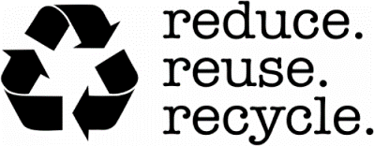

What does the provenance of food mean?

* Where our food comes from
* How it is grown
* Who grows or makes it
* What is in it

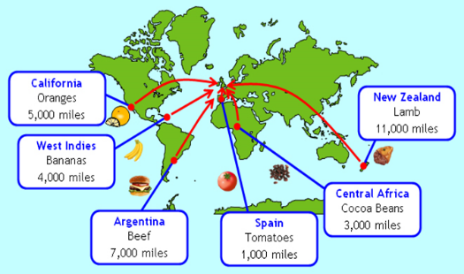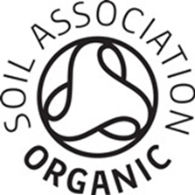

|  |  |
| --- | --- |
| Reduce |  |
| Reuse |  |
| Recycle |  |

|  |  |
| --- | --- |
| Scheme | details |
|  |  |
|  |  |
|  |  |
|  |  |
|  |  |

In your assessment you are going to write about how you personally will take account of environmental factors so don’t write about bananas in the assessment if you are not using them

You will need to mention things like you would like to use organic if the price was lower, some organic foods are shipped in form all over the world creating more food miles than locally bought produce so it is a balance of which is most important to you personally and requirements of the brief

**LO2.3 Explain how dishes on a menu meet customer needs**

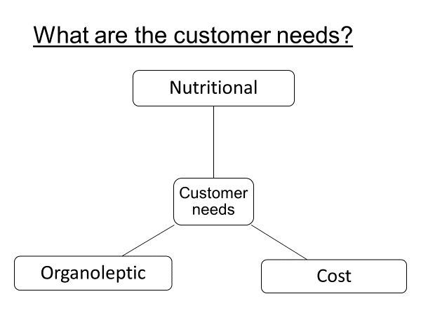

We already know what the customer needs are from LO1 and LO2 . what you need to do is say how YOUR dishes meet YOUR customer needs FROM THE BRIEF

Key points to explain

That you are making the dishes intended for your chosen group

Which of your dishes meet healthy eating guidelines or the eatwell guide

Mention the specific needs of adults that you looked at in AC1.2

* Meet the needs of different dietary needs?
* Meet the needs of the very young to the very old?
* Be adapted for allergy sufferers of different allergens?
* Be adapted to suit a customer preference or intolerance?
* Be portioned to suit the needs of children, adults and the elderly?

If you have dishes that aren’t healthy, explain that they would be ok as a special treat or as part of holiday meals and that if you are eating a balanced diet the rest of the time then you don’t need to worry too much about the occasional treat as long as you don’t eat them all the time

Mention the vitamins, minerals and macronutrients that the dishes provide but you don’t need to give much detail

Explain that local foods aren’t transported as far so don’t lose nutrients in transport, explain how the method of cooking will preserve nutrient content

**Nutritional needs**

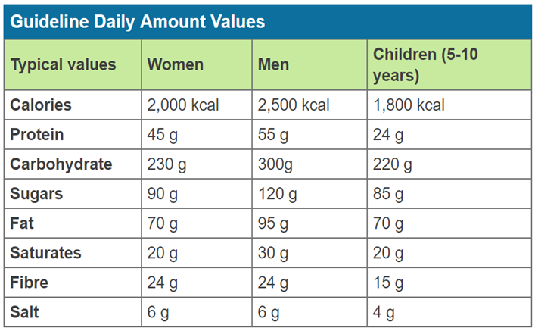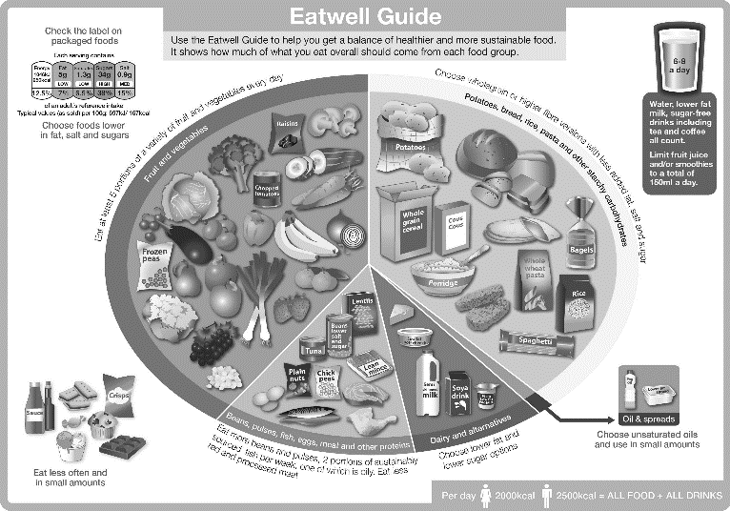

**Organoleptic needs**

This means how the dishes appeal to the customers senses .

* **Sight**- how will the dish be attractive , a variety of colours, shapes, textures and good quality of finish, plated up neatly using the space and height on the plate
* **Smell**- will the dishes have an appetising smell, will the customers want to eat it?
* **Taste**- what will be the main flavours customers will taste? Will the dish be spicy, fresh, meaty, savoury, cheesy, fruity, too spicy for children?
* **Touch**- How will the food feel in the mouth, will it be creamy, crunchy, smooth, chewy, crumbly,

**Costing needs**

* For this part you need to explain how you will keep the costs of the dishes reasonably low . Your reasons could be
* Buy food in season so it is not imported and expensive
* Buy food locally so that you don’t have to travel too far to buy it
* Minimise the waste produced
* Control the portion size so that you do not waste food that people are not going to eat and everyone gets the same size portion
* Not buying ready prepared ingredients because it is cheaper to prepare them from scratch
* Store the ingredients at the correct temperature so they don’t go off

|  |  |
| --- | --- |
| AC 2.3 Explain how dishes on a menu meet customer needs | |
| Give the sources of the nutrients in the dish and comapare to a balanced diet | My dishes xxx and xxx meet nutritional guidelines for both adults and children, they have protein, carbohydrate and not too much fat so meet the targets of the eatwell guide  My dish xxx is higher in fat and sugar but in the context of a balanced diet and eaten as a special treat it would be suitable . Buying foods locally would mean that they do not lose nutrients being transported long distances.  It would be suitable for vegetarians as it contains cheese and pasta for protein |
| Organoleptic  Describe the qualities of the dishes and how they will appeal | My dish xxx contains a variety of attractive colours, the taste and variety of textures of the Peppers and the chicken will be pleasing to the senses, the flavour is spicy but not too hot so it would be suitable for children. Locally produced foods in season are at the peak of their ripeness |
| Explain how you will keep costs reasonable  Portion control | I will use a whole chicken and cut portions to save on cost and buying local food which is in season means that the price of the ingredients would be lower since they are plentiful in season  I will control the portion size of the chicken by serving one breast, for the beans I will use one scoop of approximately 120g and the sauce by using a ladle |

**LO2.4 Plan production of dishes**

* The plan should be detailed enough that someone else could work from your plan and make the dishes as you intended
* Dovetailing – make sure that the sequence is logical and that it shows you are dovetailing ie while something is cooking, you are working on something else
* Contingencies- in the special points note any contingencies ie what you will do if it doesn’t go quite right eg “ if the cake is not cooked, leave it in the oven and check again in 5-10 mins”

|  |  |  |
| --- | --- | --- |
| **Mise en place** | | |
| Time | Step / process | Special points and contingencies |
|  |  |  |
|  |  |  |
| Put the time you start here | eg the temperature you pre heat the oven to , use antibacterial hand soap  Write in the steps for the mise en place here –not everything in one step |  |
|  |  |  |
|  |  |  |
|  |  |  |
| **Main production** | | |
| Time | Step / process | Special points and contingencies |
|  |  |  |
|  |  |  |
| Put the time you start here | Eg equipment you would use, food hygiene and safety points  Write in the steps for making the dishes here |  |
|  |  |  |
|  |  |  |
|  |  |  |
|  |  |  |
|  |  |  |
|  |  |  |
| **Finishing and serving** | | |
|  |  |  |
| Continue the time here | Give the plates, bowls etc that you will use and how you controlled portion size  Write in the steps for finishing off the dishes and how you will serve them, decorating, garnishing |  |
|  |  |  |
|  |  |  |



Colour code each dish on the timeplan so you know which you are working on

There is a **distinction** for this objective

You will only get the distinction if you stick to the marking criteria, ie **comprehensive** (thorough) and **detailed** with **well considered** (you thought about them) **contingencies** (what you will do if things don’t go to plan) for most situations.

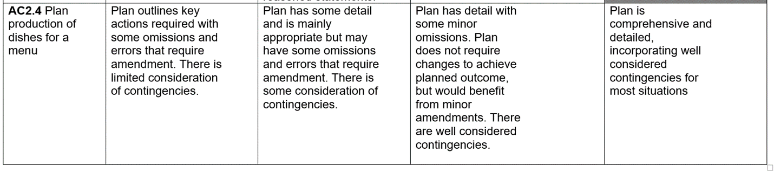

**What to do now**

* Type out the individual recipes in word format
* Colour code each recipe with a different colour
* Work out the order you need to prepare and cook the items
* Copy and paste onto the table in the correct order
* You can print out and cut the methods into strips and decide on the best order , when it is as good as you can make it, stick it down with Sellotape so it doesn’t get mixed up

|  |  |  |
| --- | --- | --- |
| Mise en place | | |
| Time | Step / process | Special points and contingencies |
|  |  |  |
|  |  |  |
|  |  |  |
|  |  |  |
|  |  |  |
|  |  |  |
|  |  |  |
|  |  |  |
| Main production of dishes | | |
| Time | Step / process | Special points and contingencies |
|  |  |  |
|  |  |  |
|  |  |  |
|  |  |  |
|  |  |  |
|  |  |  |
|  |  |  |
|  |  |  |
|  |  |  |
|  |  |  |
|  |  |  |
|  |  |  |
|  |  |  |
|  |  |  |
|  |  |  |
|  |  |  |
|  |  |  |
|  |  |  |
|  |  |  |
|  |  |  |
|  |  |  |
|  |  |  |
|  |  |  |
|  |  |  |
|  |  |  |
| Finishing and serving | | |
| Time | Step / process | Special points and contingencies |
|  |  |  |
|  |  |  |
|  |  |  |
|  |  |  |

|  |  |  |
| --- | --- | --- |
| Mise en place | | |
| Time | Step / process | Special points and contingencies |
|  |  |  |
|  |  |  |
|  |  |  |
|  |  |  |
|  |  |  |
|  |  |  |
|  |  |  |
|  |  |  |
| Main production of dishes | | |
| Time | Step / process | Special points and contingencies |
|  |  |  |
|  |  |  |
|  |  |  |
|  |  |  |
|  |  |  |
|  |  |  |
|  |  |  |
|  |  |  |
|  |  |  |
|  |  |  |
|  |  |  |
|  |  |  |
|  |  |  |
|  |  |  |
|  |  |  |
|  |  |  |
|  |  |  |
|  |  |  |
|  |  |  |
|  |  |  |
|  |  |  |
|  |  |  |
|  |  |  |
|  |  |  |
|  |  |  |
| Finishing and serving | | |
| Time | Step / process | Special points and contingencies |
|  |  |  |
|  |  |  |
|  |  |  |
|  |  |  |