Cross Country
Skills
Pacing, Appropriate gradient running technique, Race tactical awareness, Use of Target setting, Development of Pre and Post testing of Aerobic endurance.

Pacing – Pacing is the ability to control the speed at which you run, to allow you to run for a long period of time. In doing so you should be looking to run at the fastest speed you can maintain to defeat an opponent and win the race.
Appropriate gradient running technique – You should look to shorten your stride length when you are running uphill as this will enable you to generate more power from the hamstring to push your body forwards.
When running downhill you should lengthen your stride to ensure that you cover more distance with each stride and increase speed whilst maintaining effort.
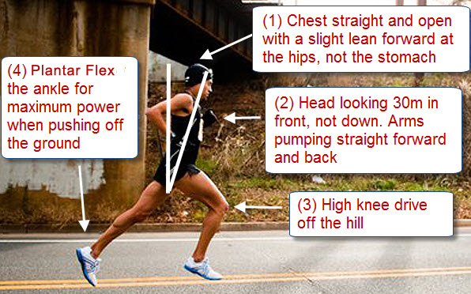
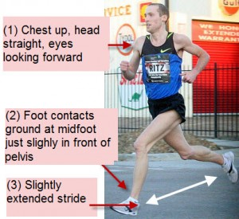

Race tactical awareness – When racing against an opponent there are a number of ways that you can race tactically to allow you to overcome and defeat them in competition. Dependent on your strengths, you may look to allow somebody else to pace you through the race with the aim of defeating them in a sprint finish. Alternatively you may look to run at the front of the race and run at a faster pace to attempt to discomfort your opponents.

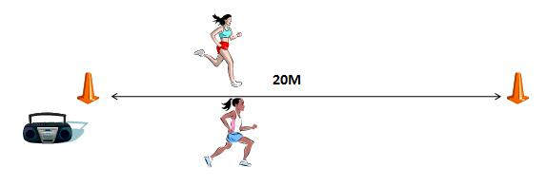
Use of Target Setting – Targets can be set for performers to attempt to motivate them to maximise and improve their performance. These targets can be set from previous performances or from the completion of fitness tests in key components of fitness such as Aerobic Endurance (Multi Stage Fitness Test)

Development of Pre and Post testing of Aerobic endurance. – The Multi Stage Fitness Test or Forestry Step Test can be used to test the VO2 Max and Aerobic Endurance of an athlete. This information can then be used to set targets. Tests can be completed at the finish of training programmes to highlight if somebody has improved their Aerobic Endurance levels.

Multi-Stage Fitness Test description
- The beep test is a multi-stage fitness test used to measure your aerobic endurance and VO2 max.
- You are required to run continuously between two lines which are 20m apart in time to recorded beeps.
- The first running speed is referred to as ‘level 1’, the second speed as ‘level 2’, and so on. Each level lasts approximately one minute.
- You need to ensure you get to the cones before the beep each time and must wait for the beep before continuing to run.
- Your aim is to achieve the highest possible level, only stopping when you can no longer physically continue.

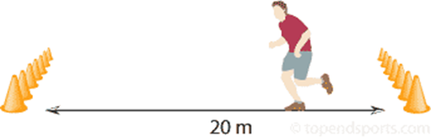
Advantages and Disadvantages of the test
Advantages (considering factors that might make the test practical to perform).
- Simple to set up with minimal equipment required
- More than one athlete can conduct the test at the same time.
- Can be conducted indoors or outdoors

Disadvantages (Consider factors that might make the results unreliable).
- Weather conditions can affect performance
- Motivation levels can positively or negatively affect performance
- Scoring can be subjective as to the completion of levels

Training Methods to improve performance
Continuous Training
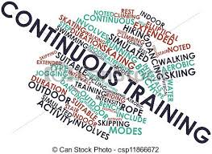
- Continuous training involves working for a sustained period of time without rest.
- This is training at a steady pace and moderate intensity for a minimum period of 30 minutes.
- It can involve any form of heart raising activity that takes place over an extended period of time.
- It improves Aerobic Endurance.

- Explain how a Cross Country athlete would use continuous training to improve performance in their sport? (3)

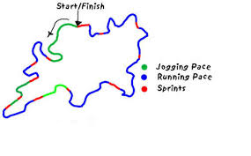
Fartlek Training
- Fartlek training or 'speed play' training is where the intensity of training is varied by running at different speeds or over different terrain.
- The training has no static rest period.
- It is important to know about other ways in which intensity of training can be increased, including the use of equipment (harness, running with weights or weighted backpack).
- It improves Aerobic and Anaerobic fitness depending on the duration of work periods.
- It is commonly used by games players.

- Explain how a Cross Country athlete would use fartlek training to improve performance in their sport? (3)

Interval Training
- Interval training involves alternating between periods of hard exercise and rest.
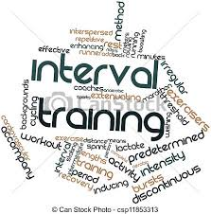
- This is where the individual performs a work period followed by a rest or recovery period.
- Typical work time when using it aerobically can vary from training for 30 seconds to five minutes.
- Recovery periods can be complete rest, walking or light jogging.
- Shuttle runs of varied distances are a common form of interval training.
- Typical work intervals for aerobic endurance will be around 60% maximum oxygen uptake (VO2 max).
- Decrease the number of rest periods and decrease work intensity to develop aerobic endurance.
- It can also improves speed and muscular endurance.

- Explain how a Cross Country athlete would use Interval training to improve performance in their sport? (3)

Psychological benefits of Cross-Country Running
Confidence Building
Running helps create confidence that is built when you set specific cross-country running goals and meet them which in turn branches out into other areas of your life. Overcoming difficulties and achieving goals that are both challenging and realistic will create confidence and help to build self-esteem.
Fight Depression and Mental Health Issues
The biochemical reactions in your body when you run releases hormones that reduce stress. In fact, many health professionals indicate that running and other aerobic exercise often has a similar effect on mildly depressed or anxious individuals as medication. Additionally, running does not have to be a solo sport. Engage the support of friends and family to further combat depression, which is often triggered by (or even causes) extreme loneliness. By building up a healthy support network around specific cross-country training goals, you will find that you can combat depression and poor mental health on a number of fronts.
Prevent Disease and Obesity
One of the biggest benefits to cross country running on a regular basis involves maintaining a healthy weight and exercising your cardiovascular system. How does this affect your psychological well-being? There have been definitive links between fatigue and poor health and depression.This can include conditions like chronic fatigue, obesity, and cardiovascular issues. Running combats all three of these by providing your body with natural energy, helping you maintain a healthy weight, and keeping your heart strong. Even mild exercise, like walking outside versus running, can have a benefit for those who are too ill to engage in a full running program.
It is without a doubt that these three psychological benefits alone are enough to get you to put on your running shoes. Enjoy long lasting, lifelong good psychological health with cross country running.

Pace Running- Coaches Clip Board

KS3 Middle distances – what level are you working at?
Distance | National Level | County Level | School Level
800m | Below 2:10mins | Below 2.30mins | Below 3.00mins
1500m | Below 5:30mins | Below 6.00mins | Below 6.30mins

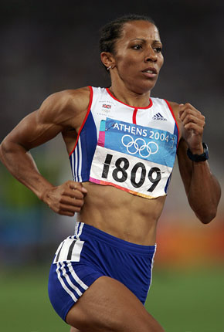
Good pacing is spreading our energy across the whole race, finishing strong and giving our full potential.
Arms should be bent at 90 degrees
1

2
Hands should be held in a relaxed fist

3
Back should be relaxed but straight

“Sometimes I like to hang back from the pace if it's too fast and gradually build myself up around the last 400m.”
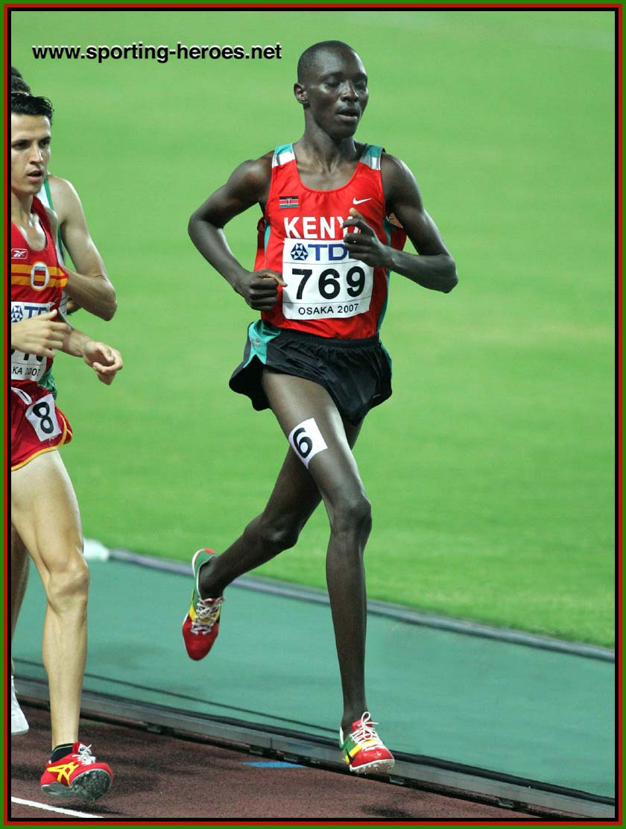
Moderate knee lift
Running style should be smooth and relaxed
Look forward with your chin off your chest
1
2
3

How far can you run in the specified times?
Key Question-

Why is pace judgement important when running middle distance races?
…………………………………………………………………………………………………………………………………………
…………………………………………………………………………………………………………………………………………
………………………………………………………………………………………………………
………………………………………………………………………………………………………
Key words-

Pace
Maximum
Stride length
Conserve
Judgement
 | Predicted Distance? | Successful?  Yes/ No
30secs
60 secs (1 min)
90 secs (1 min 30s)
120 secs (2 mins)
240 secs (4 mins)
Self Evaluation
What worked well?
1)
2)
3)
4)
Even better if?
1)
2)
3)
4)

Extension Questions
- Sam uses continuous training to prepare for a local 10k run.

Describe why ‘continuous training is a suitable method and using your knowledge of HR monitoring, explain how continuous training can be used to help Sam prepare for the 10Km run successfully

Use the structures below to help you answer the question

Describe main features of continuous training and link to activity.
HR monitoring should include 2+ of the following; Maximum HR, lower/upper threshold, Borg Scale

Possible responses to include:

30+ mins training time, no rest periods, low/med intensity, uses same movement (running)

Maximum HR ensures safe exercising
Calculating/monitoring at lower threshold ensures intensity is high enough.
Monitoring at upper threshold ensures that intensity is not too high and aerobic endurance is improving
Borg Scale to determine exercise intensity/Overload
Monitoring RHR as indicator of aerobic fitness improvements over the programme.

- Tarik is a long distance runner; he uses speed, muscular endurance and cardiovascular endurance when competing.

Explain and evaluate how he will use 3 types of aerobic endurance training to improve his performance.

Use the structures below to help you answer the question

Continuous training:

This is training at a steady pace and moderate intensity for a minimum period of 30 minutes.

Tariq will use continuous training to develop his cardiovascular endurance. This will assist him in running using aerobic respiration for an extended period of time at a moderate intensity. The continuous training will also develop his muscular endurance as his muscles will be working at a moderate intensity for an extended period of time which will offset the impacts of fatigue and enable him to maintain his consistent pacing throughout the performance.

Fartlek training:

This is where the intensity of training is varied by running at different speeds or over different terrain.
The training is continuous with no rest period.

It is important to know about other ways in which intensity of training can be increased, including the use of equipment (harness, running with weights or weighted backpack).

Fartlek training will benefit Tariq and improve his speed, muscular endurance and aerobic endurance. The continuous activity will develop his aerobic endurance and he must look to maintain an intensity of between 60-85% of his maximum heart rate to enhance his performance. The training will incorporate periods of increased intensity through increased speed or raised gradient.

This will develop his speed as his hamstring and quadriceps muscles will contract more powerfully and will generate more force. He will use this particularly at the finish of the race to outsprint an opponent.
His muscular endurance will be developed through his muscles contracting for an extended period of time for an increased duration of training which will ensure that they develop the ability to work harder for longer and maintain his stride length.

Interval training:

This is where the individual performs a work period followed by a rest or recovery period. Typical work time can vary from training for 30 seconds to five minutes; recovery periods can be complete rest, walking or light jogging.

Typical work intervals for aerobic endurance will be around 60% maximum oxygen uptake (VO2 max).

Decrease the number of rest periods and decrease work intensity to develop aerobic endurance.

For speed training, the work intervals will be shorter and more intense – performed at a high intensity, close to maximum.

Increase the number of rest periods and increase work to develop speed.

Tariq can use interval training to develop his speed and aerobic endurance. His speed will improve through short intense sprints of high intensity that will replicate the acceleration and speed required at the end of the race. By lengthening the periods of work and decreasing the intensity of the exercise Tariq will be able to develop his aerobic endurance which will allow him to run at a medium intensity for an extended period within the race.

