

Year 9

Food

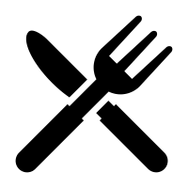

Name:……………………………………………………………………………

**Where does our Food come from?: Food and Organic Farming**

Consumers often do not think about the origin of the food they buy in the supermarket.

Have you ever thought about the origins of the food that you eat? Do you consider how it is grown or

produced? There are very many systems of farming in use today.

Consumers' concerns about the safety of the food we eat have raised a multitude of questions about food buying and growing. One of the major concerns has been the use of pesticides in farming and the hazardous presence of the pesticide residues in food. As a result, more and more consumers have resorted to organic food, which is an option believed to enhance our health.

Organic food is popular with many people but what does organic mean and what must the farmer do to allow him to label his food organic?

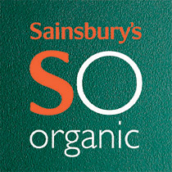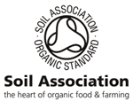

Organic crops are grown without toxic pesticides or growth hormones. The soil is usually enriched by natural mineral fertilisers only. Instead of pesticides, organic farming relies on beneficial insects that eat harmful insects. Plus, they also use a farming technique called "crop rotation" to rob insects of food and prevent weeds from developing.

**Downsides of Organic Food**

* **Cost** - Organic food usually costs 10% - 40% higher than non-organic products because of the following reasons: 1.) They are produced on a smaller scale and usually must be cultivated by hand, and that labour is expensive. 2.) Farmers need compensations for their lower yields, as some of their crops are lost to insects and animals. 3.) It is also more expensive to raise animals humanely than to keep them in small pens and cages. Pasture raised animals require a lot of space, and supplementing their grazing with organic feed costs a lot more than simply feeding them the least-expensive non-organic grain available.
* **Appearance** - Organic fruits and vegetables tend to have imperfections. But keep in mind; don't let looks fool you.

**Advantages of Organic Food**

* **Nutrition** - Organic food is rich in vitamins, minerals and enzymes which will help your body fight off infections more effectively.
* **Toxin-Free** - Since it is pesticide-free, it’s believed that it lowers the risk of cancer and certain birth defects.
* **Taste** – It is believed that organic products tend to taste better than non-organic ones.
* **Environment** - Organic farming is better for the environment since it does not use toxic chemicals that will run off to pollute soil and water. Also, it promotes a use of the land that will maintain richness in the soil for the next generations.

pollybell

**Case Study: Pollybell Farm - Lincolnshire**

**About Pollybell Organic Farm**

Pollybell Organic Farm is the organic farming business of the Brown family who have been involved with farming in Lincolnshire for over 120 years. The farm, part of Loveden Estates, is in the area known as the [Isle of Axholme](http://www.isleofaxholme.co.uk).

Pollybell Organic Farm is one of the UK's largest growers of organic vegetables producing approximately 26 million portions per year - enough for 14,000 people to have their 5-a-day every day of the year. They produce broccoli, cauliflower, four types of cabbage, curly kale, bunched carrots, beetroot, leeks and onions.

The Brown family started the conversion to organic from conventional farming in 1997. They have 3,500 acres that are fully organic or in conversion and which were certified organic in April 2011. All the land being farmed lies at or below sea level and is protected and drained by a network of dykes and drains that crisscross the farm.

In 2008 Pollybell Farm was named Organic Grower of the Year, in 2009 it was runner-up in the Progressive Farmer of the Year award, and in 2010 it won the North East region in the Beautiful Farm Awards.

An organic farm like Pollybell has to follow a system of growing crops that keeps soil fertile and, at the same time, controls bugs that attack the crops, weeds and plant diseases. In addition, taking out the harvest must be balanced with putting back fertility, while constantly ensuring that environmental protection and conservation are maintained.

In order to achieve this delicate and difficult balance crops need to be rotated around the fields as well as ‘resting’ the fields (i.e. leave them fallow) to ensure that fertility is maintained and pests and disease are controlled. The health of the crops is achieved using this programme of rotation and rest which reduces the need for artificial fertilisers and pesticides. A very small list of mostly natural chemical treatments are allowed to control pests, weeds and disease.

**Activities**

**Answer the following questions on A4 paper:**

1. What is organic farming?
2. Give 1 advantage and 1 disadvantage of Organic Farming.
3. Where is Pollybell farm?
4. How long have the Brown family been involved in farming?
5. How many portions of organic vegetables are produced by Pollybell farm per year?
6. What vegetables are grown at Pollybell farm?
7. How many acres of organic land does the farm have?
8. How is the fertility of the soil maintained and the pests controlled?
9. Imagine you work for a large food company. Write a speech to persuade the head of the company to use organic produce in your products. Use the following plan:
   1. Explain what organic farming is
   2. The advantages and disadvantages for your company
   3. Why you think your customers would like organic produce

**Where does our Food come from?: Food Miles**

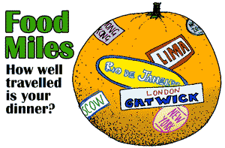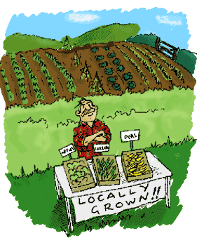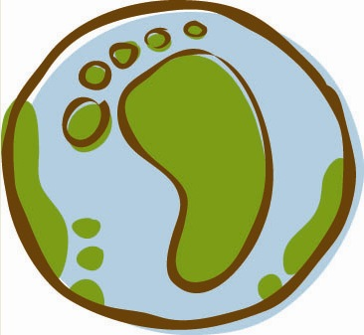

**What are food miles?**

Food miles are the measure of the distance a food travels from field to plate. Agriculture and food now account for nearly 30 per cent of goods transported on our roads. This travel adds a great deal to the carbon dioxide emissions that are contributing to climate change - which is why food miles matter. A new report by the Department for the Environment, Food and Rural Affairs (Defra) says that food miles rose by 15 per cent between 1992 and 2002.

**Why does our food travel so far?**

Food travels further these days partly because supermarkets have taken over from local and regional markets. A pint of milk or a crop of potatoes can be transported many miles to be packaged at a central depot and then sent many miles back to be sold near where they were produced in the first place. Also, because of the way the food processing industry works, ingredients travel around the country from factory to factory, before they make their way to the shops.

Imported produce makes up approximately 95% of the fruit and 50% of the vegetables in the UK. The amount of food being flown into the UK doubled in the 1990s and is predicted to rise further

each year. E.g. strawberries are flown in from warmer climates to satisfy the demand of British consumers and air travel has a far bigger impact on the environment than sea or road travel has.

Another reason for mounting food miles is labour costs. E.g. some British fish is now sent to China (lower labour costs) for processing, then sent back to the UK to be sold. Consumers are also directly responsible for increased food miles. We now travel further for our shopping and use the car more often to do it. Each year, the average UK adult travels about 135 miles by car to shop for food, more often than not making trips to large, out-of-town supermarkets. This is something the Government hopes the consumer will address.

**How far has my food travelled?**

It's very difficult to be sure. A food’s country of origin may be on the label but, beyond this, it’s generally impossible to tell how far the food has travelled and by what means. The means of transport - as well as the distance - is an important consideration. A long journey by boat, for example, has less environmental impact than a shorter one by road. This is part of the reason why good farmers’ markets have a policy of selling food from within a defined local area. Why else do food miles matter? The transport of live animals is an important animal welfare issue. The numbers of animals being moved around the country have grown with the trend for large, centralised abattoirs and meat processing plants. Animals are also exported and imported to and from other countries. For consumers, there is also the question of quality. Freshly picked fruit and vegetables are better nutritionally, as well as having more taste.

**What is being done?**

There are a number of initiatives aimed at improving local food in the UK, at both a regional and a local level. Sustain, the alliance for better food and farming, is piloting projects to get local food into local schools, hospitals and shops. Sustain is part of Food Links, an alliance of organisations around the UK involved in projects aimed at developing local food economies and decreasing the distance that food travels. Tully Wakeman of East Anglia Food Links believes it is crucial that local food is not a specialist product, but that it becomes a far bigger part of the mainstream. “We need to build the infrastructure to bring together farmers so they can supply a reliable stream of local produce,” he says. Supermarkets are increasingly aware of growing consumer concern about food miles and some are trying to increase locally produced food. How far this extends into their overall supplies remains to be seen.

The Government has decided to take action and is planning to reduce the environmental and social costs of food transport in the UK by 20 per cent by 2012. The recent Defra report estimates costs of food miles at £9billion each year, half of which is down to road congestion. To complicate matters further, the recent Defra report also shows that food miles are not the only way to measure the environmental impact the food we eat can have. For example, the report shows that it is less environmentally friendly to grow British tomatoes than it is to import tomatoes from Spain. It says the energy needed to heat the glass houses for growing tomatoes in Britain is significantly more than the energy used in transporting tomatoes from Spain, where no heating is used because of the warmer climate. However, British tomato growers have reduced the amount of energy they use in recent years and most now use natural gas for heating.

**What can I do?**

The individual consumer can make a difference right away, for example:

* Walk to local shops when possible and buy fresh ingredients to cook at home.
* Take fewer trips to the supermarkets.
* Buy food with as little packaging as possible to save miles on transporting rubbish to landfill sites.
* Buy British produce in its season.
* Buy locally grown food rather than imported.
* Buying organic food can also help as organic farming cuts down on the fossil fuels used to manufacture and transport the chemicals used in mainstream agriculture.

**Activities**

**Answer the following questions on A4 paper:**

1. Write a definition of the term FOOD MILES.
2. Why is it important that consumers consider food miles?
3. List three reasons why food travels so far.
4. What is being done to reduce food miles?
5. Think about the food you eat. Where does it come from? Write a list of specific things that your own family could do to reduce the food miles.
6. Explain how the food you choose can help to reduce carbon emissions and global warming.
7. Imagine you are a government adviser. Write a letter to local supermarkets telling them what they can do to reduce food miles. Use the following plan:
   1. Introduction
   2. Explain what you are trying to do
   3. Give basic advice on ways they can reduce food miles and encourage customers to reduce food miles.
8. Design a poster that could be displayed in your school, telling pupils about the effects of food miles and global warming. What can they do to reduce the effects?

**The Responsible Consumer: Fair Trade**

“Fair trade” is a system that is in place to improve conditions for those living in poverty and to ensure sustainable development. Its purpose is to create opportunities for producers and workers who have been economically disadvantaged by the normal trading methods.

It is when producers of items that we buy in local shops and supermarkets receive a fair price for the work they do in producing these items.

This price should always cover the cost of production, no matter how low the market price goes.

Goods that could be fairly traded included agricultural and farming produce (coffee, tea, bananas, cocoa, milk), household goods and clothing. In many parts of the world, the FAIRTRADE mark is used to designate food products as being fairly traded, with producers receiving the fair price for the production of these items.

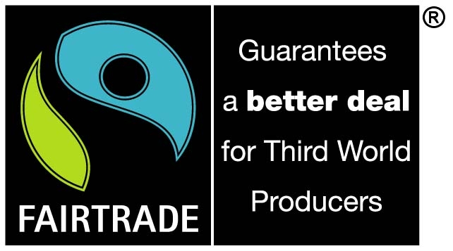

In the United Kingdom, nearly 900 products carry the FAIRTRADE mark. Awareness of these products is growing, with more consumers buying fair trade products than ever before. The amount of fair trade products bought in the UK has doubled in four years.

Comparing world prices to fair trade prices shows clearly how the growers can be protected by having in place a fair trade price. If the fair trade price for coffee is $1.25 per pound, this would provide a grower with enough money to invest in next year’s crop and make a living. This will remain at $1.25 even if the world price falls to less than one dollar. If the price was not held at the fair trade level, and the grower only received less than a dollar a pound, he or she would be forced to sell the crop for less than it cost to produce it and they would make a loss. This would leave them with insufficient money to invest in the next year’s crop and no money to live on.

Fair trade is not the same as free trade. The fair trade price is reached to ensure the growers have enough money for living and investing. In a free trade market, growers might be forced to accept a much lower price by the ‘middle men’ – those who import the product from the country to the rest of the world.

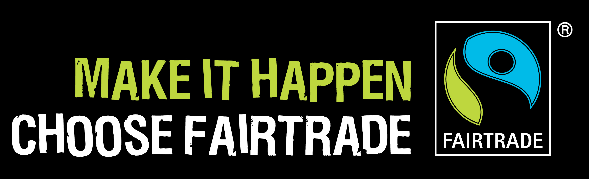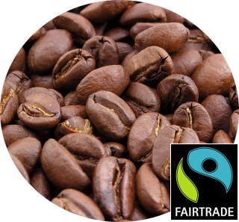

**Case Study: Cafedirect**

Cafedirect is an organisation that ensures fair trade for coffee growers. They agree to pay an agreed minimum to the growers regardless of the price of coffee on the world markets. This amount is calculated to give the growers sufficient money for production and to live on. If the world coffee price exceeds the Cafedirect price, the growers are paid the full world price plus a premium of 10 per cent. This extra premium is used on local community projects.

**A poem about Fair Trade**

For those unfair wages

Low payments, in stages

Have knock on effects, I should think.

Consider the child who can’t go to school

For he’s searching for water to drink.

His parents can’t pay his school fees.

Instead, he must pay his way.

By tending to crops, tilling the field.

Surely there’s some other way?

When you’re ready to part with your money

You can come to their aid

By backing the one with the logo

Commonly known as “Fairtrade”.

It could be chocolate

It could be bananas

It could be something you wear

It could be the s-t-i-t-c-h-e-r or farmer

Is trapped in a trade that’s not fair

Our lives are dictated by prices.

When we get a bargain we’re pleased

But there could well be a hidden cost

As the producer is pressured and squeezed.

**Activities**

**Answer the following questions on A4 paper:**

1. What is fair trade?
2. What goods can be fairly traded?
3. If the price of the product drops very low, will the farmer still get the money for the production of the product?
4. How many products carry the fair trade mark in the UK?
5. Is the amount of fair trade products being bought going up or going down?
6. What are ‘middle men’?
7. How does Café Direct work?
8. Re-read the poem above. Think about all the issues raised. Now write your own poem about fair trade.
9. Write a short assembly on fair trade which will tell your classmates about the initiative and how they can become involved.

**FOOD CHOICE: SPECIAL DIETS – VEGETARIANS**

**Why are people vegetarian?**

There are many reasons a person may choose to become a vegetarian. These include:

|  |
| --- |
| * They don’t like the thought of animals killed for food. |
| * Some religions do not eat meat. |
| * They are concerned about the environment and think meat production is expensive |
| * They consider a vegetarian diet more healthy. |
| * They enjoy the taste of the products. |
| * There is a wide variety of vegetarian products. |
|  |
|  |

**Vegetarians do not eat:**

|  |  |
| --- | --- |
| **PRODUCT** | **EXAMPLE** |
| Meat | Beef, pork, lamb |
| Fish | Cod, tuna, salmon, sardine |
| Poultry | Chicken, turkey, duck, goose |
| Game | Rabbit, deer, pheasant |
| Shellfish | Oyster, mussel, cockle |
| Crustacea | Lobster, shrimp, crab |
| Any products from dead animals | Gelatine, rennet, cochineal |

**Types of Vegetarian.**

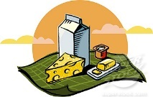

**Lacto vegetarians:**

eat dairy products but no eggs

**Lacto-ovo vegetarians:**

eat eggs and dairy products (e.g milk,

cheese, yoghurts)

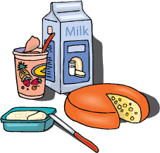 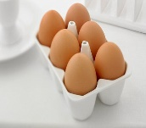

**Vegans:**

don’t eat eggs, dairy produce or any

animal product, including honey

**Ovo vegetarians:**

eat eggs but no dairy products

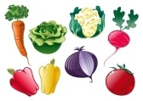

**So what do vegetarians eat?**

Lots of things! One of the great things about a vegetarian diet is that it is full of healthy, fresh, nutritious, delicious food! Vegetarians don’t just eat salad. They eat pasta, pizza, curry, rice, cheese, beans, jacket potatoes, eggs, and a wide variety of fruits and vegetables. Many even eat ice cream, chocolate, chips and crisps! The only things we don’t eat are those foods for which an animal (including fish) had to die.

**10 quick vegetarian facts...**

* Approximately one quarter of the world’s population enjoy a mostly vegetarian diet.
* It is estimated that a lifelong vegetarian will save the lives of approximately 760 chickens, 5 cows, 20 pigs, 29 sheep, 46 turkeys and half a tonne of fish.
* Many animals are vegetarians, including rhinos, elephants, giraffes, guinea pigs, rabbits, gorillas, hippos and goats.
* Vegetarians do not eat fish!
* Famous vegetarians include Albert Einstein, Pythagoras, Leonardo da Vinci, Gandhi, Leona Lewis, Paul McCartney, Natalie Portman, Pink, Brad Pitt, Morrissey, Russell Brand and Stella McCartney.
* A “westernised” diet containing meat requires up to 3 times as many resources as a vegetarian diet.
* Vegetarians enjoy the lowest rates of obesity, coronary heart disease and high blood pressure.
* The word “vegetarian” is derived from the Latin word “vegetus” meaning lively or vigorous.
* Veggies are no more prone to iron deficiency than meat eaters! Even those who do eat meat get a high percentage of their iron from vegetarian sources.
* Anyone eating dairy products and eggs will get plenty of vitamin B12 in their diet. Other good sources are fortified foods such as breakfast cereals, yeast extract and soya drinks.

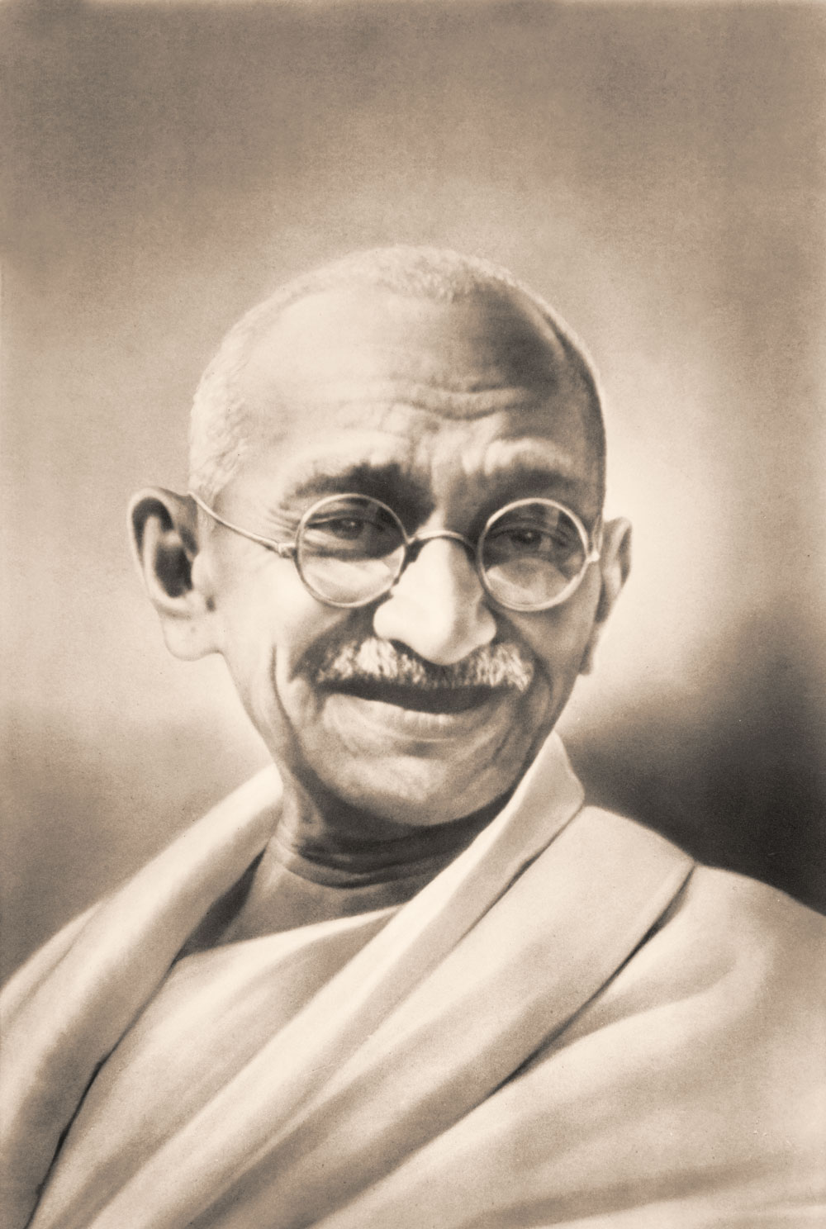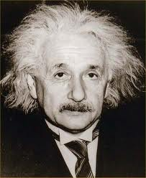

**Activities**

**Answer the following questions on A4 paper:**

1. List 3 reasons a person may choose to become a vegetarian and explain these in detail.
2. Choose 1 type of vegetarian and develop a 3 part meal. This should be a starter, main course and dessert. Explain why you have chosen each dish.
3. Approximately how many of the world’s population are vegetarian?
4. Name two animals that are vegetarian. List what you think they eat.
5. To get plenty of vitamin B12 what foods should a vegetarian eat?
6. Choose a vegetarian celebrity and write to them. Use the following plan:
   1. Introduce yourself and say how you are researching vegetarianism
   2. Ask why they decided to become a vegetarian (offer some reasons).
   3. Find out what type of vegetarian diet they have chosen to follow and why?
   4. Explain why you think it is good that they follow a vegetarian diet e.g. health benefits and environmental issues.
7. Produce a leaflet about being vegetarian. Use a plain piece of A4 and make it colourful.

**FOOD PREPARATION: COOKING TERMS**

In food preparation many chefs and cooks will follow a recipe. To be able to follow the recipe correctly it is important to be familiar with the cooking terms used to ensure the instructions can be followed with ease and so that the best results are achieved.

There are a wide variety of terms and phrases that are used and we will now explore a wide variety of these.

**Techniques of Preparation**

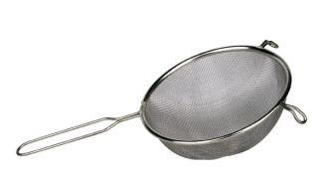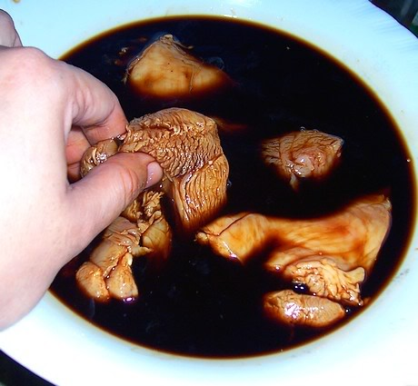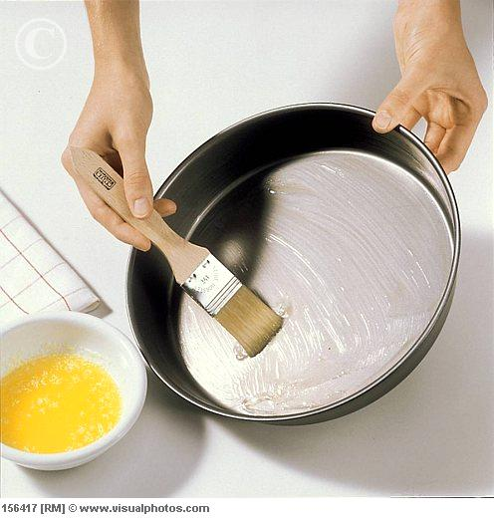

|  |  |
| --- | --- |
| **Method** | **Description** |
| Grease | Rub fat onto a piece of equipment or use lining-paper, to stop food sticking. |
| Brush | Spread a liquid coating on a food using a pastry brush or paper towel. |
| Marinate | To soak in a liquid to add flavour and/or tenderise (soften) a product. |
| Sift | To put dry ingredients through a sieve to add air or remove lumps. |

**Techniques of Mixing**

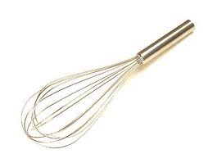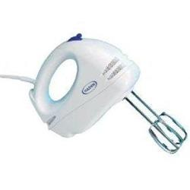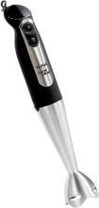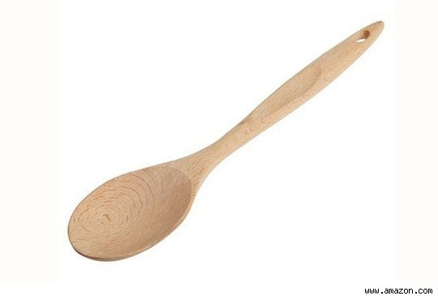

|  |  |
| --- | --- |
| **Method** | **Description** |
| Beat | To mix thoroughly in an over and over motion. May use a spoon or electric beater. |
| Cream | Soften and blend until smooth and light using a spoon or electric mixer. |
| Stir | To mix with a circular motion using a spoon or other utensil. |
| Whip | To beat rapidly with an electric mixer or wire whisk. Adds air and lightens a product. |

**Techniques of Cutting**

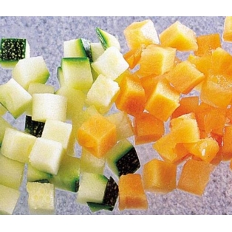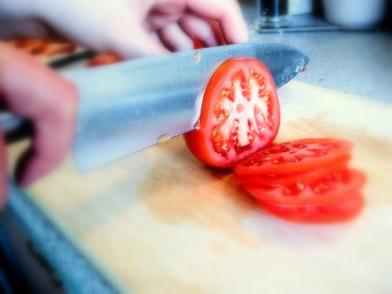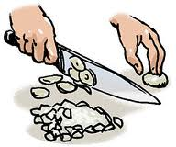

|  |  |
| --- | --- |
| **Method** | **Description** |
| Chop | To cut into small pieces. |
| Cube | To cut into small squares. |
| Dice | To cut into very small cubes. |
| Slice | To cut food into thin, flat pieces. |

**Techniques of Cooking**

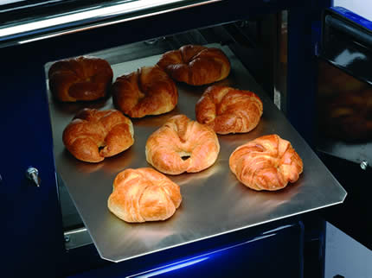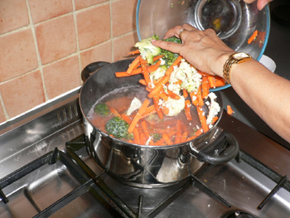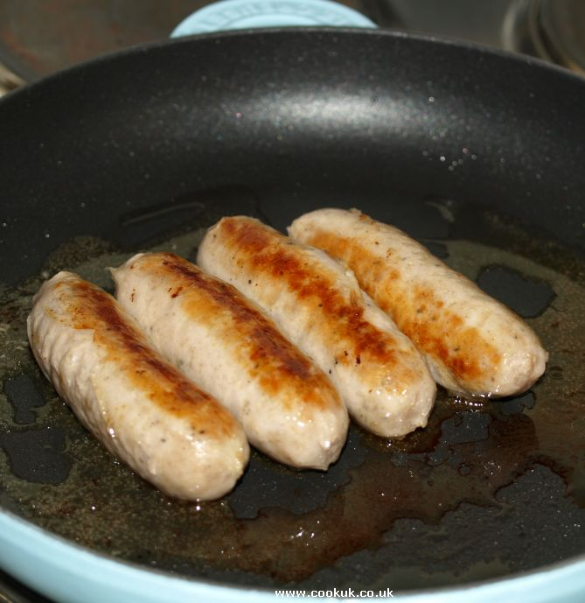

|  |  |
| --- | --- |
| **Method** | **Description** |
| Bake | To cook in an oven or oven type appliance, usually uncovered. |
| Boil | To cook in hot liquid, usually water, in which bubbles rise constantly. |
| Fry | To cook in hot fat. |
| Roast | To cook in fat, by dry heat, uncovered in an oven. |

**Activities**

**Answer the following questions on A4 paper:**

INSTRUCTIONS: Below is a list of cooking terms in scrambled form. Unscramble each word and then copy the sentences below onto A4 paper, inserting the correct word in the blank to the left of its definition.

**phiw grseae taeb tfis pcoh cueb**

**cmrea rits srtao ecid maratein bloi**

1. ___________ to beat rapidly to incorporate air and to increase volume. Tools:wire whisk, rotary beater.

2.____________ to mix ingredients thoroughly, usually in a bowl, using an over-and over motion. Tools: mixing spoon, wire whisk, rotary beater, electric mixer.

3. ____________ to cut food into small pieces. Tools: knife, food chopper.

4. ____________ to cut into small cubes. Tool: knife

5. ____________ to cut into small squares. Tool: knife.

6. ____________ to mix ingredients gently in a circular motion. Tool: mixing spoon.

7. ____________ to put a dry ingredient through a fine sieve. Tool: flour sifter, strainer.

8. ____________ to cook in hot liquid, usually water, in which bubbles rise constantly.

9. ____________ to soak in a liquid to add flavour and/or tenderise.

10. ___________ to soften and blend until smooth and light. Tools: mixing spoon, electric mixer.

11. ___________ to cook in fat, in a dry heat, uncovered in an oven.

12. ___________ to rub fat onto a piece of equipment or use lining-paper, to stop food sticking.

**Task Two**

Choose one of the areas: Preparation, mixing, cutting and cooking. Design a poster that could be displayed in your school to help pupils understand the different terms used within that area. The poster needs to be eye-catching, colourful and informative.

**How to Store Food Safely**

**Fridge storage**

Some foods need to be kept in the fridge to help stop bacteria growing. These include foods with a "use by" date, cooked foods and ready-to-eat foods such as desserts and cooked meats.

Here's how to prevent bacteria from growing:

* When preparing food, keep it out of the fridge for the shortest time possible.
* If you’re having a buffet, keep the food refrigerated until you’re ready to serve it.
* Cool leftovers as quickly as possible (within 90 minutes) and store them in the fridge. Eat them within two days.
* Store eggs in their box in the fridge.
* Never put open cans in the fridge as the metal of the can may transfer to the can's contents. Transfer the contents into a storage container or covered bowl.

Make sure food has cooled down before you put it in the fridge as if the food is still hot it will raise the temperature in the fridge, which isn’t safe as it can promote bacterial growth.

To ensure your fridge remains hygienic and in good working condition, clean it regularly.

Food debris accumulates over time and can increase the risk of cross-contamination.

**Storing meat**

It's especially important to store meat safely in the fridge to stop bacteria from spreading and avoid food poisoning.

* Store raw meat and poultry in clean, sealed containers on the bottom shelf of the fridge, so they can't touch or drip onto other food.
* Follow any storage instructions on the label and don't eat meat after its use-by date.
* Keep cooked meat separate from raw meat.

**Freezing and defrosting**

It’s safe to freeze meat and fish as long as you:

* Freeze it before the use-by date.
* Defrost meat and fish thoroughly before cooking. Lots of liquid will come out as meat thaws, so stand it in a bowl to stop bacteria in the juice spreading to other things.
* Defrost in a microwave if you intend to cook straightaway. Otherwise, put it in the fridge to thaw so that it doesn't get too warm.
* Cook food until it's piping hot all the way through.

Make sure the meat is properly wrapped in the freezer or it might get freezer burn, which will make it tough and inedible.

Date and label meat in the freezer and eat it within two days of defrosting. Don't keep food in a freezer indefinitely. Always have a good idea of what’s in your fridge and freezer.

**Activities**

**Answer the following on A4 paper:**

**Task One**

Copy the chart below and list 3 different ways to store foods. Draw a picture in the circle to show the foods that can be stored each way.

Storage instruction 1:

______________________

______________________

Storage instruction 2:

______________________

______________________

Storage instruction 3:

______________________

______________________

**Task Two**

For each of the products below write the storage instructions you would expect to see on the packaging.

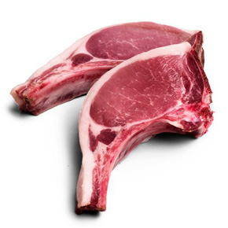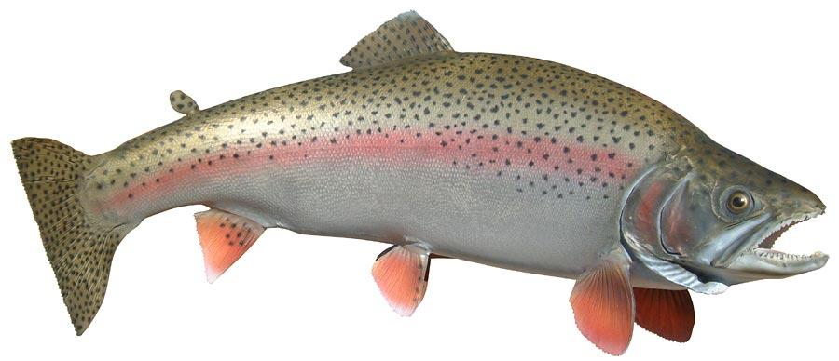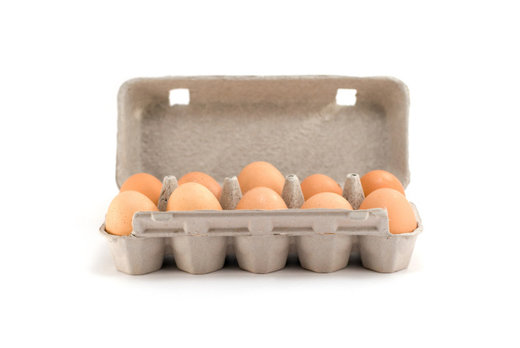

**Task Three**

Design a leaflet advising the public how to store food safely. It needs to be informative and detailed and should warn about what might happen if food is not stored correctly.