PSHE work booklet – Year 9

Contents:
- Target setting sheet
- 5 Ways to wellbeing diary
- Self-esteem activity
- Online stress and FOMO
- Careers

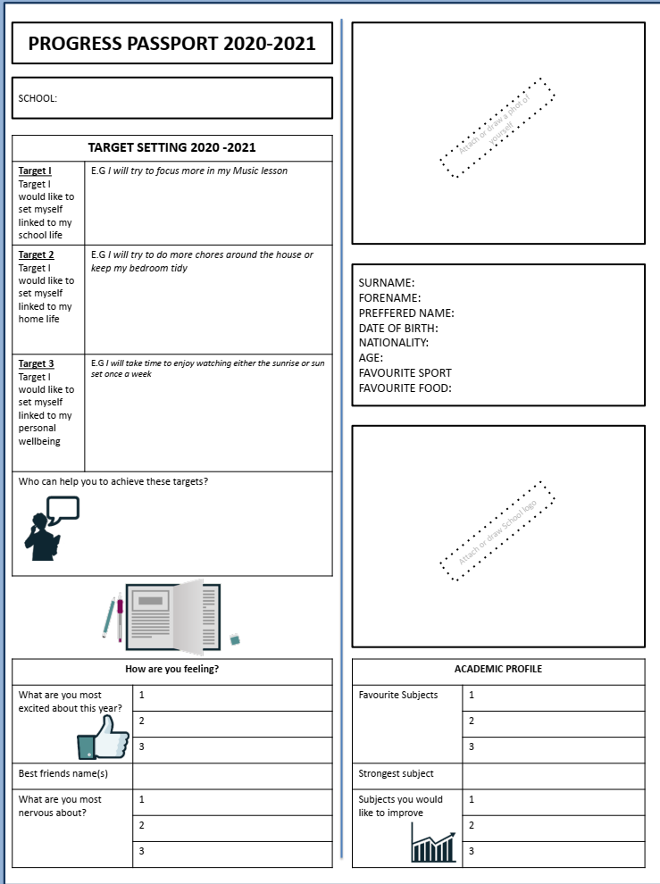
- Target setting- Fill in the following worksheet about you – think about your hopes and targets for the new school year.

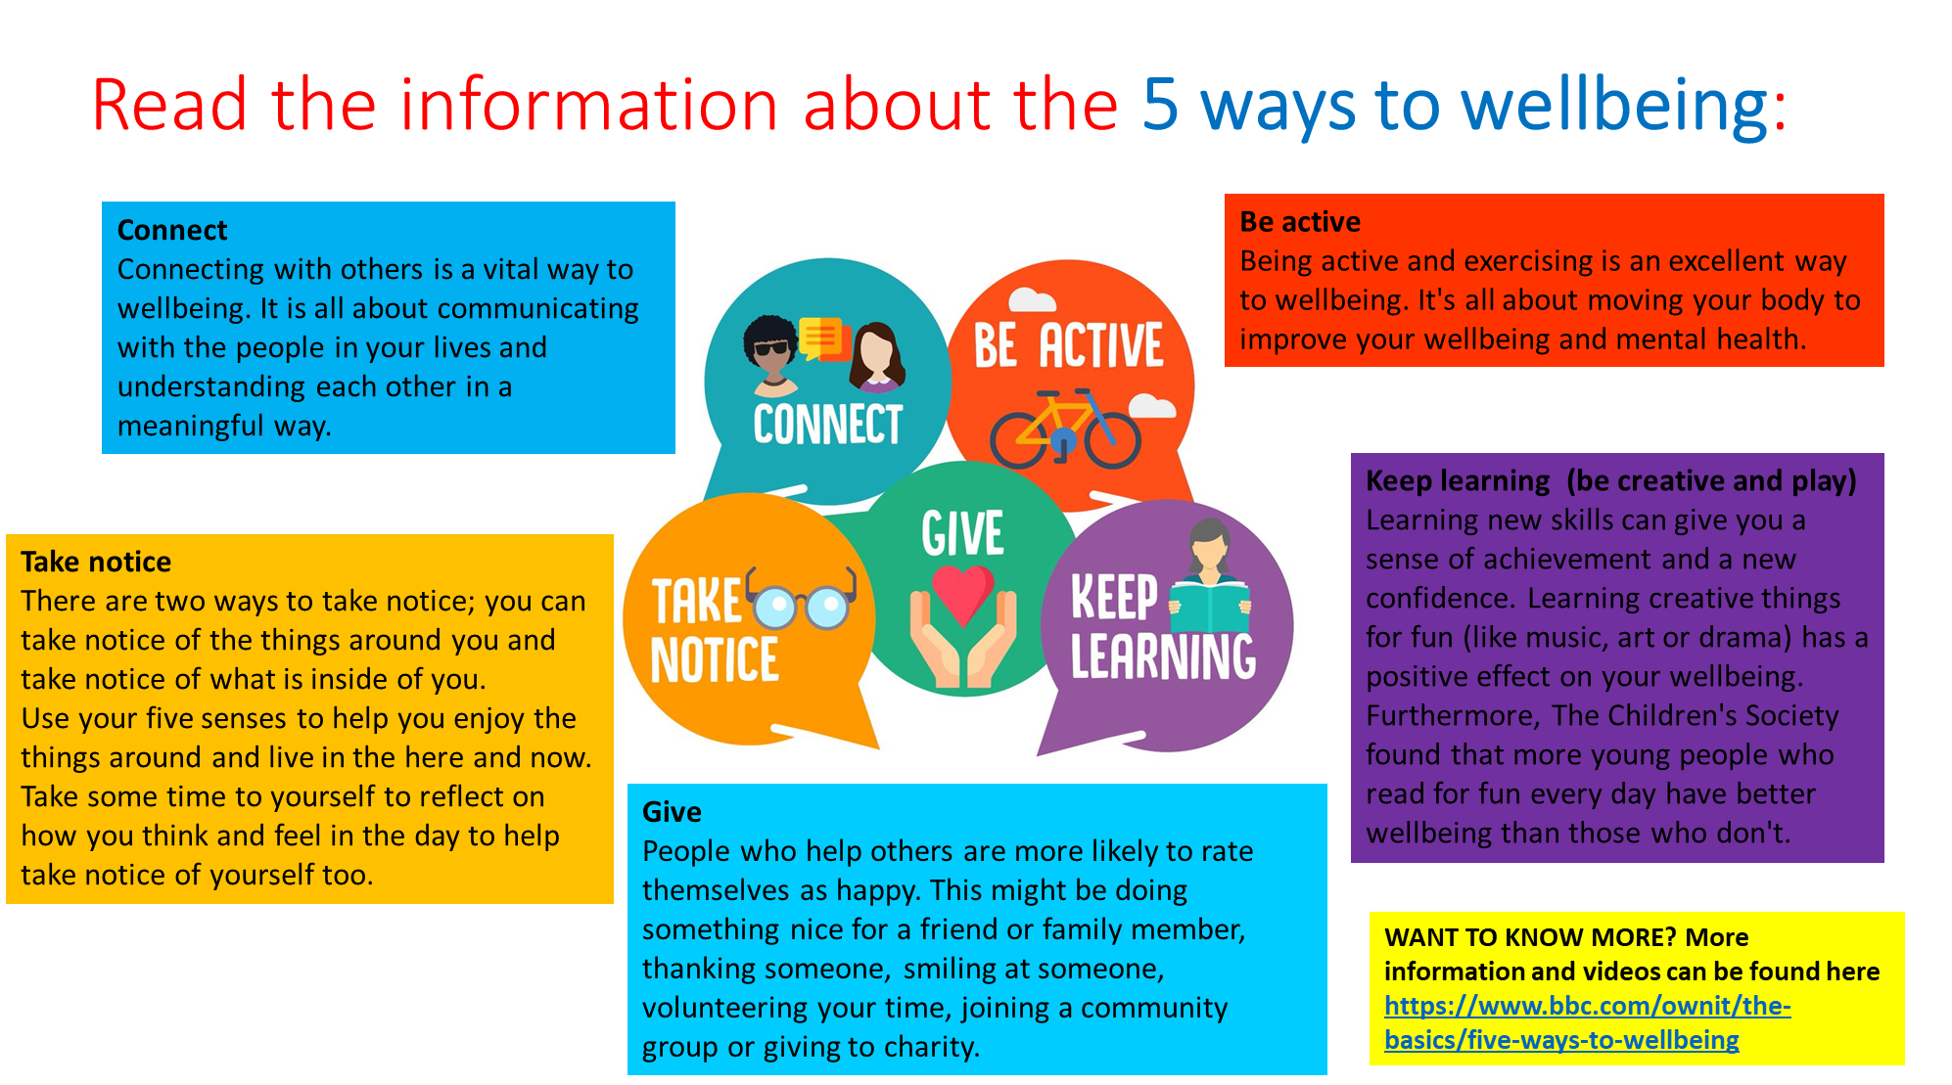
- 5 ways to wellbeing
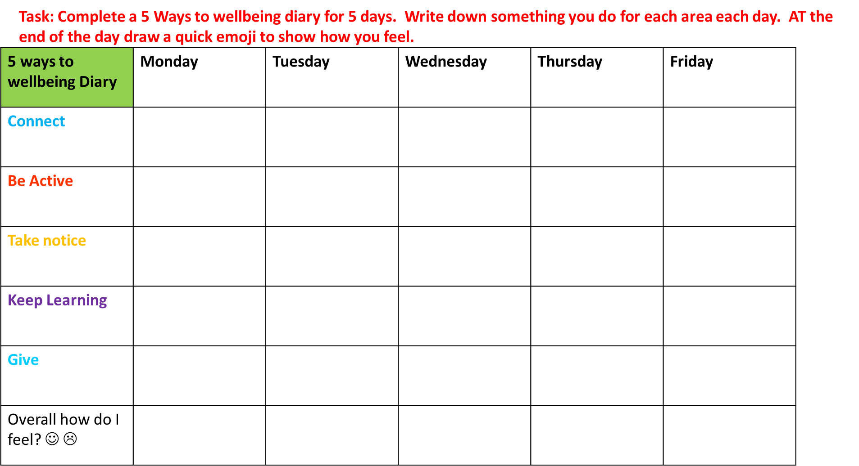
- Self esteem – Read through the information and complete the self esteem task sheet.
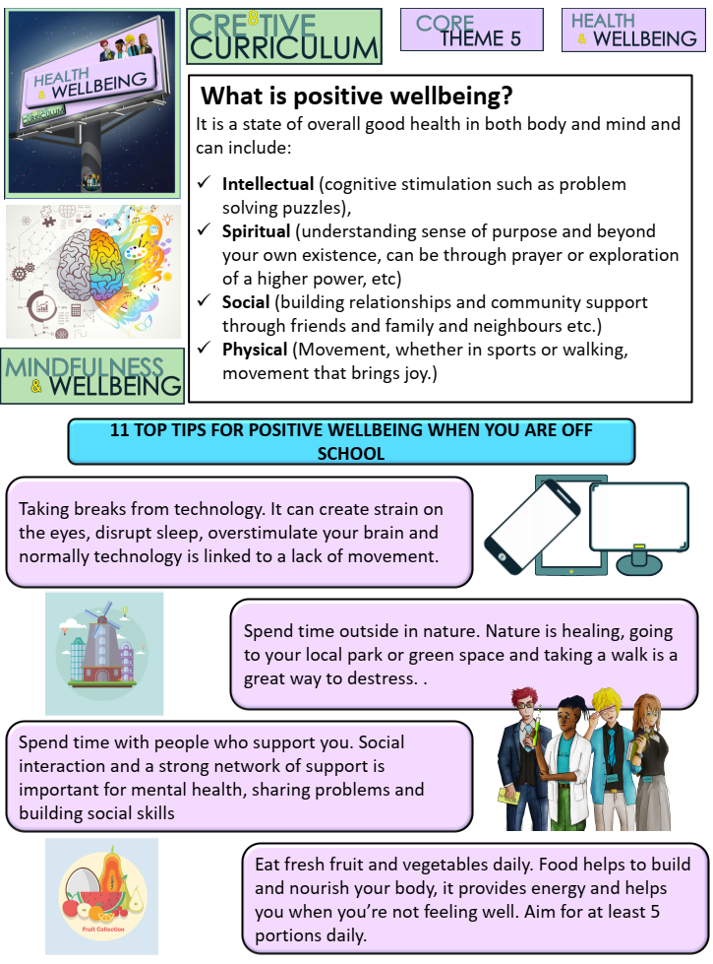
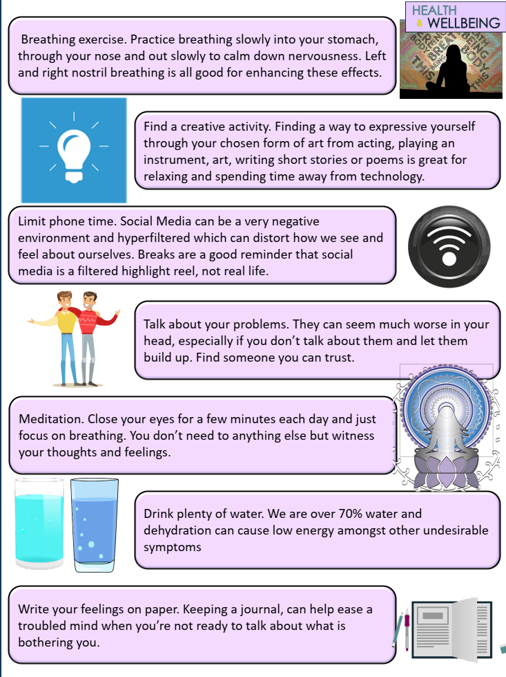

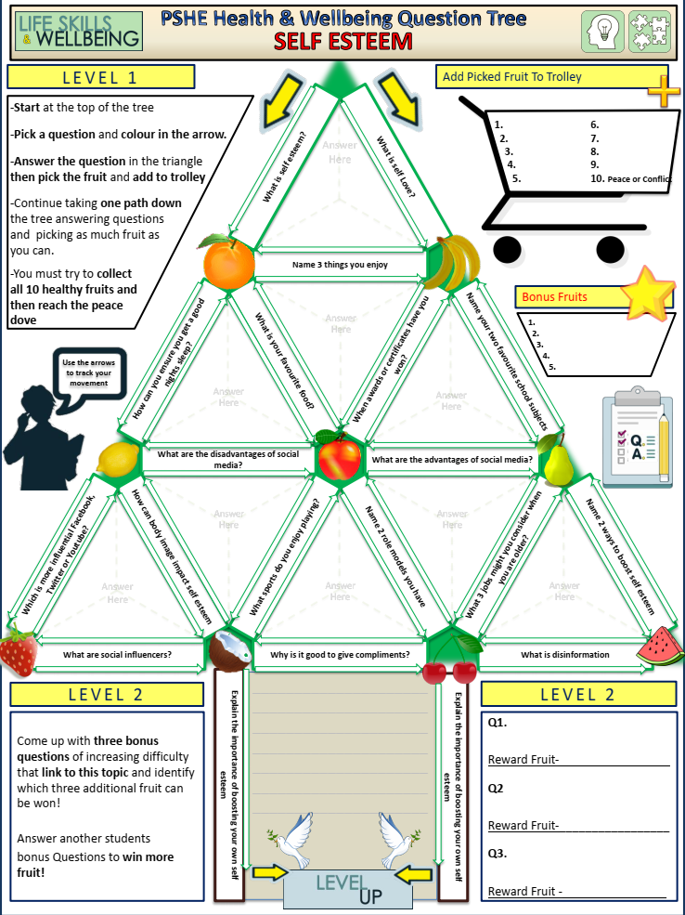

- Online stress and FOMO
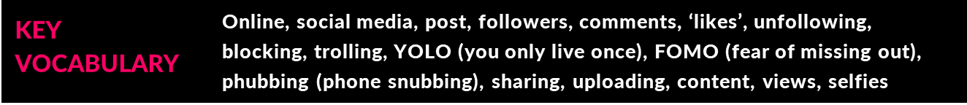
L.O: To learn how to manage the stress that may result from excessive use of social media or as a result of interacting with online content, including FOMO (the ‘fear of missing out’).

Task: Look at the Twitter-style questions on the slide below, and write very short answers to each question (no more than 140 characters).
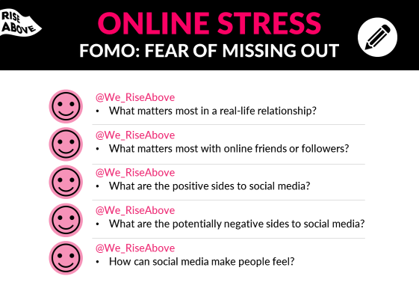

Task: Read the newspaper article below:

FOMO: How the Fear of Missing Out drives social media 'addiction'
Social media can help bring people closer together and share information.
But the endless stream of updates, invites and opportunities to gain the explicit approval and feedback of friends and family, can create a pressure of its own.
For some, FOMO - or the fear of missing out - leaves them in the grip of an "addiction" to their devices.
As part of a BBC News School Report story for the Six O'Clock News, a group of Year 11 students from Haggerston School in Hackney took on the the challenge of trying to turn their backs on Facebook status updates, Twitter posts and snapchat messages for a week.
School Reporter Sheveen were part of the group going cold turkey, and wrote about his experiences:

Sheveen's story
When I was chosen to take part in this project I was very enthusiastic and thought completing the entire week would be easy. But I was wrong…
After being briefed it fully hit me - not being able to access social media for a week is a really long time. Although this bothered me slightly, it didn't put me off attempting the project as I went on with it.
As we shut off our devices, I already felt as if I had lost a limb. I then had to think what I would do with the extra time I had which I would have spent 'wasting' on social media sites.
The first day was easy but that evening, just when I was going to make a vlog about how I felt, I received a message from a friend who needed help with his homework.
He messaged me about three times but I had to ignore him, leaving him with homework he couldn't complete.
The second day in and I was at school chatting with my friends and there was a video on Facebook that they all watched the evening before and were speaking and laughing about it. I felt as if I couldn't be as engaged in the conversation as I would otherwise be.
I definitely had more time on my hands, but I still don't feel I was more productive without social media to waste time on. I watched television, listened to music, did the same amount of homework - at more or less the same level of quality.
I feel social media isn't a need for me: it's just a way of passing time, even though I could be doing much more productive activities.
The thought of all the messages coming through at the weekend, and plans I that I wanted to know about, made me worry about what I was missing out on. It all weighed down on me. It was too much. I broke.
As I gave in on Saturday, I didn't have any difficulties communicating with friends about plans, even though I didn't converse with them during the school week.
I guess I am a social media addict but most people are, aren't they? If everyone is a social media addict then you could say that no-one is. Social media and electronic devices are the present and the future of society, and it's the main form of communication and has become essential to everyday life.
I doubt I will cut down on my usage of social media because I don't see the need to, unless it had a negative impact on my life.
It doesn't stop me from completing homework, or socialising with friends in person; if anything social media makes life easier as I have family in other countries which I converse with on social media sites, making it free and simple.

Task: Answer the following questions:
- How would you describe FOMO?
……………………………………………………………………………………………………………………………………………………………………………………………………………………………………………………………………………………………………………………………………………………………………………………………..
- How would you define stress?
……………………………………………………………………………………………………………………………………………………………………………………………………………………………………………………………………………………………………………………………………………………………………………………………..
- Do you think that FOMO is regularly experienced by young people? What might be the reasons they experience it?
……………………………………………………………………………………………………………………………………………………………………………………………………………………………………………………………………………………………………………………………………………………………………………………………..
- What advice would you give a friend who was experiencing stress all the time because of FOMO?
……………………………………………………………………………………………………………………………………………………………………………………………………………………………………………………………………………………………………………………………………………………………………………………………..

Task: Around each silhouette write down words that describe that person.
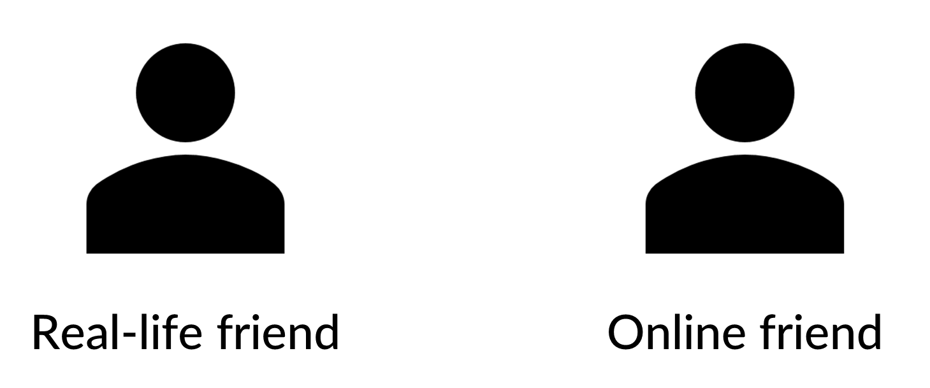

- What are the most significant differences between a person’s real-life friends and those they only interact with online?
……………………………………………………………………………………………………………………………………………………………………………………………………………………………………………………………………………………………………………………………………………………………………………………………..
……………………………………………………………………………………………………………………………………………………………………………………………………………………………………………………………………………………………………………………………………………………………………………………………..
- What are online friendships really about? What are the potential benefits, disadvantages and risks to communicating online?
……………………………………………………………………………………………………………………………………………………………………………………………………………………………………………………………………………………………………………………………………………………………………………………………..
……………………………………………………………………………………………………………………………………………………………………………………………………………………………………………………………………………………………………………………………………………………………………………………………..
- Does it matter if you talk to your friends mainly online rather than face to face?
……………………………………………………………………………………………………………………………………………………………………………………………………………………………………………………………………………………………………………………………………………………………………………………………..
……………………………………………………………………………………………………………………………………………………………………………………………………………………………………………………………………………………………………………………………………………………………………………………………..

- What effect can ‘phubbing’ (‘phone snubbing’, or paying more attention to your phone than to the real people you are with) have on relationships and friendships? Why do people do it?
……………………………………………………………………………………………………………………………………………………………………………………………………………………………………………………………………………………………………………………………………………………………………………………………..…………………………………………………………………………………………………………………………………………………………………………………………………………………………………………………………………………………………………………………………………………………………………………………………

