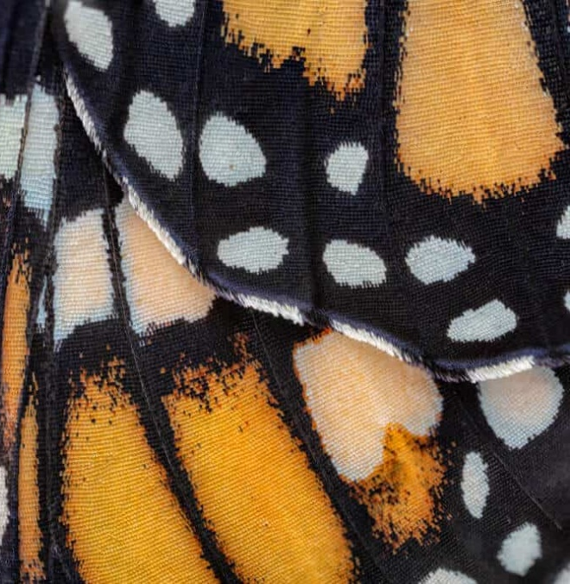
Year 9 Art Worksheet 1 Magnify - Butterfly
Complete an observational image of the magnified section of a butterfly wing.
Pay close attention to the shape and pattern.

Suggested materials:
Tonal pencil
Pencil crayon

Year 9 Art Worksheet 2 Magnify - Snowflake
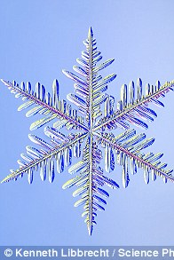
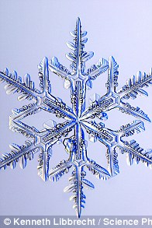
Complete the symmetrical image of the snowflake below.

Could you enhance it using biro pens or pencil crayons?

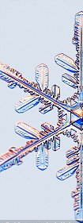

Year 9 Art Worksheet 3 Magnify - Rose
Complete an observational drawing of the magnified rose.
Consider the most effective materials needed to capture the blended colour.
Pencil crayon?
Watercolour?

Year 9 Art Worksheet 4 Magnify – Fish Scales
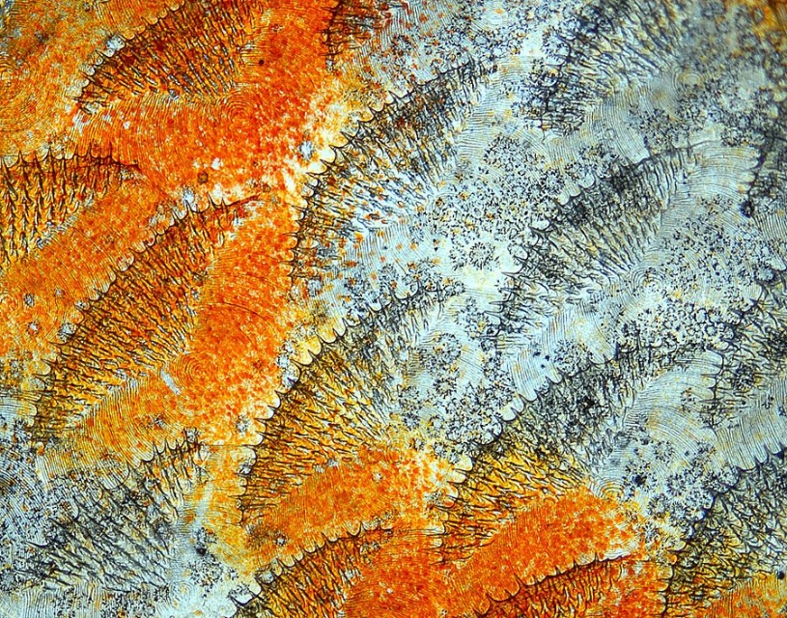
Develop a mixed media response to the magnified image of fish scales.

Suggested approach – develop a base of colour using pencil crayon or watercolour. Develop the pattern and mark making over the top using pencil crayon and biro.

Year 9 Art Worksheet 5 Magnify – Fabric
All of the images we have looked at in the Magnify project have been inspired by nature and natural forms. The image below is a magnified image of fabric.
Record the shapes and tones using one of the following materials or techniques: tonal pencil, biro, ink and bleed.

