

Year 8

Food



Name:……………………………………………………………………………

**FOOD CHOICE: SPECIAL DIETS – VEGETARIANS**

**Why are people vegetarian?**

There are many reasons a person may choose to become a vegetarian. These include:

|  |
| --- |
| * They don’t like the thought of animals killed for food. |
| * Some religions do not eat meat. |
| * They are concerned about the environment and think meat production is expensive |
| * They consider a vegetarian diet more healthy. |
| * They enjoy the taste of the products. |
| * There is a wide variety of vegetarian products. |
|  |
|  |

**Vegetarians do not eat:**

|  |  |
| --- | --- |
| **PRODUCT** | **EXAMPLE** |
| Meat | Beef, pork, lamb |
| Fish | Cod, tuna, salmon, sardine |
| Poultry | Chicken, turkey, duck, goose |
| Game | Rabbit, deer, pheasant |
| Shellfish | Oyster, mussel, cockle |
| Crustacea | Lobster, shrimp, crab |
| Any products from dead animals | Gelatine, rennet, cochineal |

**Types of Vegetarian.**

**Lacto vegetarians:**

eat dairy products but no eggs

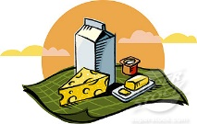

**Lacto-ovo vegetarians:**

eat eggs and dairy products (e.g milk,

cheese, yoghurts)

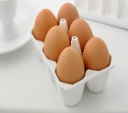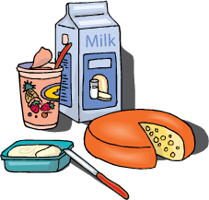

**Vegans:**

don’t eat eggs, dairy produce or any

animal product, including honey

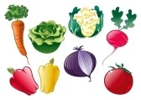

**Ovo vegetarians:**

eat eggs but no dairy products

**So what do vegetarians eat?**  
Lots of things! One of the great things about a vegetarian diet is that it is full of healthy, fresh, nutritious, delicious food! Vegetarians don’t just eat salad. They eat pasta, pizza, curry, rice, cheese, beans, jacket potatoes, eggs, and a wide variety of fruits and vegetables. Many even eat ice cream, chocolate, chips and crisps! The only things we don’t eat are those foods for which an animal (including fish) had to die.

**10 quick vegetarian facts...**

* Approximately one quarter of the world’s population enjoy a mostly vegetarian diet.
* It is estimated that a lifelong vegetarian will save the lives of approximately 760 chickens, 5 cows, 20 pigs, 29 sheep, 46 turkeys and half a tonne of fish.
* Many animals are vegetarians, including rhinos, elephants, giraffes, guinea pigs, rabbits, gorillas, hippos and goats.
* Vegetarians do not eat fish!
* Famous vegetarians include Albert Einstein, Pythagoras, Leonardo da Vinci, Gandhi, Leona Lewis, Paul McCartney, Natalie Portman, Pink, Brad Pitt, Morrissey, Russell Brand and Stella McCartney.
* A “westernised” diet containing meat requires up to 3 times as many resources as a vegetarian diet.
* Vegetarians enjoy the lowest rates of obesity, coronary heart disease and high blood pressure.
* The word “vegetarian” is derived from the Latin word “vegetus” meaning lively or vigorous.
* Veggies are no more prone to iron deficiency than meat eaters! Even those who do eat meat get a high percentage of their iron from vegetarian sources.
* Anyone eating dairy products and eggs will get plenty of vitamin B12 in their diet. Other good sources are fortified foods such as breakfast cereals, yeast extract and soya drinks.

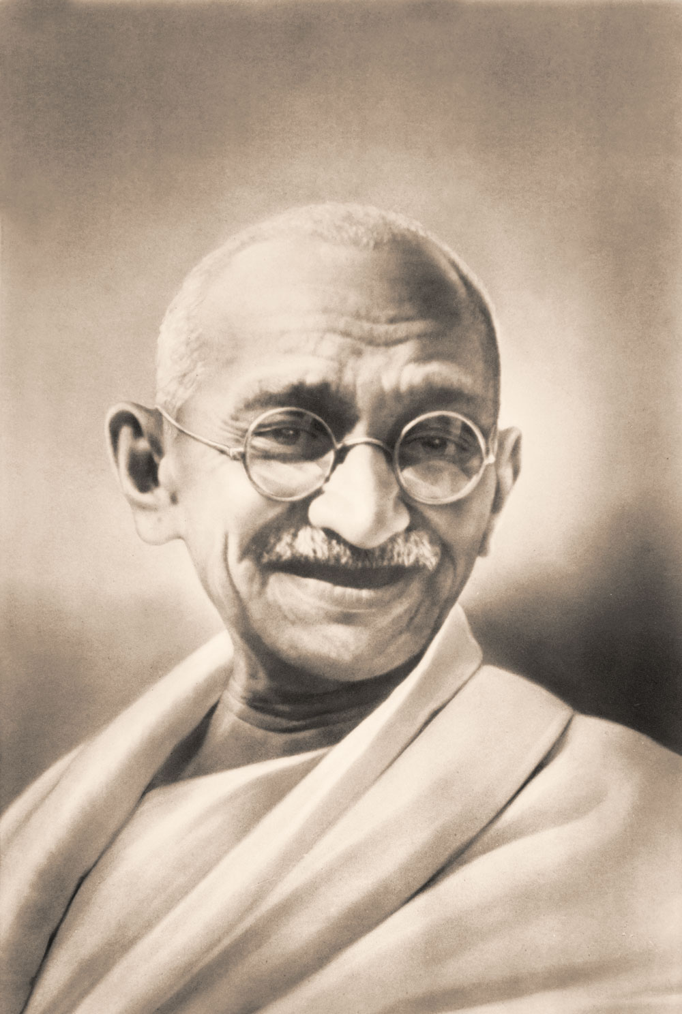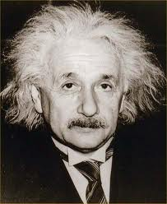

**Activities**

**Answer the following questions on A4 paper:**

1. List 3 reasons a person may choose to become a vegetarian and explain these in detail.
2. Choose 1 type of vegetarian and develop a 3 part meal. This should be a starter, main course and dessert. Explain why you have chosen each dish.
3. Approximately how many of the world’s population are vegetarian?
4. Name two animals that are vegetarian. List what you think they eat.
5. To get plenty of vitamin B12 what foods should a vegetarian eat?
6. Choose a vegetarian celebrity and write to them. Use the following plan:
   1. Introduce yourself and say how you are researching vegetarianism
   2. Ask why they decided to become a vegetarian (offer some reasons).
   3. Find out what type of vegetarian diet they have chosen to follow and why?
   4. Explain why you think it is good that they follow a vegetarian diet e.g. health benefits and environmental issues.
7. Produce a leaflet about being vegetarian. Use a plain piece of A4 and make it colourful.

**Food and Religion**

Different religious groups eat or don’t eat different foods for a variety of reasons – these sheets highlight a few of the reasons.

|  |  |
| --- | --- |
| Jew’s | * Do not eat shell fish or pork. * They do not eat dairy and meat in the same meal (this is because they do not eat mother and child together – so you cannot have chicken and egg together or milk and beef). * They only eat kosher meats (where the blood is drained from the body through a slit in the throat before the meat is soaked or salted). Kosher houses should have different sinks for dairy and meat along with different plates, cutlery and utensils: this is taken very seriously with in the Jewish religion. * Jews have fast days including Yom Kippur, Rosh Hashanah and Passover. |
| Hindus | * Do not eat Beef or any beef product – this is because the cow is a sacred animal and is treated as such. (This includes the use of leather for furniture). * Milk is permitted as no animal is killed during the collection. * Often vegetarian which comes from the principle of Ahimsa (not harming)? * Most Hindus don’t drink alcohol. |
| Sikhs | * Do not eat beef either for the same reasons as Hindus. * Many Sikhs are also vegetarians. * Many Sikhs will not eat Halal or Kosher meat as they believe they are not killed humanly. * Devout Sikhs do not drink alcohol. |
| Muslims | * Do not eat pork. * Only eat Halal meat (which is killed in the same way as Kosher). * Sea food without fins or scales (such as crabs, prawns and squids) considered undesirable by some Muslims. * Muslims should also avoid alcohol. * Muslims don’t eat whilst the sun is shining during the month long fast called Ramadan (Oct/Nov time) |
| Buddhists | * Buddhist try to avoid intentionally killing, Monks and Nuns are usually very strict and can be vegetarians. * Others will eat meat as long as it was not killed for the specific purpose of food. * Chinese Buddhists also avoid garlic and onions as they believe it makes meditation more difficult. |
| Some Catholics | * Some Catholics fast on Fridays and during the run up to lent. * Some Catholics eat fish on a Friday. |

**Activities**

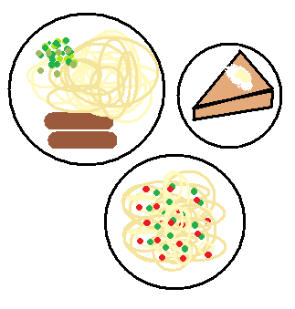Complete the following activities on A4 paper.

**Task one:**

Develop a 3 part meal suitable for one of the religious

groups you have looked at.

* Starter – soup or light bite.
* Main meal- Consider what type of meat, fish or vegetables that are suitable for your chosen religion
* Dessert- this can be sweet or savoury.

Write out your menu in detail as though it would be

used in a restaurant. You may use colour and add

images/drawings.

**Task two:**

State why the menu you have chosen is appropriate for the religious group you have chosen.

**Task three:**

Looking at your menu try to answer the following:

* Are there any special food stuffs you will need to find for your meal?
* Where could you get these specialist foods from?
* How can you prove the meal meets the dietary needs of your chosen religion? – show what nutrients you think your meal will provide. (For help with this read the healthy eating section of the booklet)

**Task four:**

Choose one of the religious groups above and design a leaflet that could be used to help someone, who doesn’t know about that religion, understand the dietary needs. Your leaflet should be colourful, eye-catching and informative.

**How to Store Food Safely**

**Fridge storage**

Some foods need to be kept in the fridge to help stop bacteria growing. These include foods with a "use by" date, cooked foods and ready-to-eat foods such as desserts and cooked meats.

Here's how to prevent bacteria from growing:

* When preparing food, keep it out of the fridge for the shortest time possible.
* If you’re having a buffet, keep the food refrigerated until you’re ready to serve it.
* Cool leftovers as quickly as possible (within 90 minutes) and store them in the fridge. Eat them within two days.
* Store eggs in their box in the fridge.
* Never put open cans in the fridge as the metal of the can may transfer to the can's contents. Transfer the contents into a storage container or covered bowl.

Make sure food has cooled down before you put it in the fridge as if the food is still hot it will raise the temperature in the fridge, which isn’t safe as it can promote bacterial growth.

To ensure your fridge remains hygienic and in good working condition, clean it regularly.

Food debris accumulates over time and can increase the risk of cross-contamination.

**Storing meat**

It's especially important to store meat safely in the fridge to stop bacteria from spreading and avoid food poisoning.

* Store raw meat and poultry in clean, sealed containers on the bottom shelf of the fridge, so they can't touch or drip onto other food.
* Follow any storage instructions on the label and don't eat meat after its use-by date.
* Keep cooked meat separate from raw meat.

**Freezing and defrosting**

It’s safe to freeze meat and fish as long as you:

* Freeze it before the use-by date.
* Defrost meat and fish thoroughly before cooking. Lots of liquid will come out as meat thaws, so stand it in a bowl to stop bacteria in the juice spreading to other things.
* Defrost in a microwave if you intend to cook straightaway. Otherwise, put it in the fridge to thaw so that it doesn't get too warm.
* Cook food until it's piping hot all the way through.

Make sure the meat is properly wrapped in the freezer or it might get freezer burn, which will make it tough and inedible.

Date and label meat in the freezer and eat it within two days of defrosting. Don't keep food in a freezer indefinitely. Always have a good idea of what’s in your fridge and freezer.

**Activities**

**Answer the following on A4 paper:**

**Task One**

Copy the chart below and list 3 different ways to store foods. Draw a picture in the circle to show the foods that can be stored each way.

Storage instruction 1:

______________________

______________________

Storage instruction 2:

______________________

______________________

Storage instruction 3:

______________________

______________________

**Task Two**

For each of the products below write the storage instructions you would expect to see on the packaging.

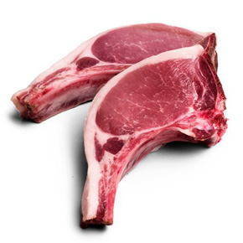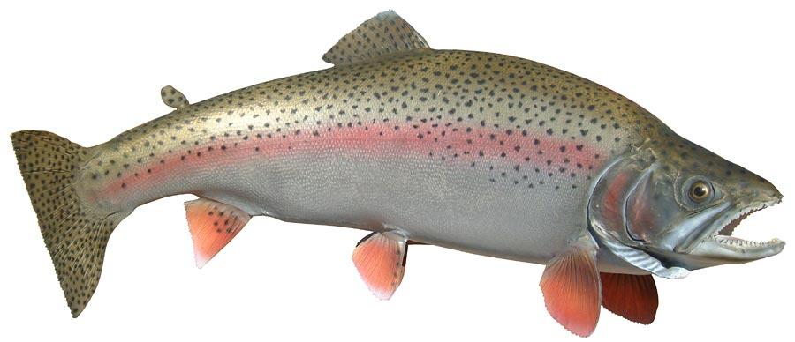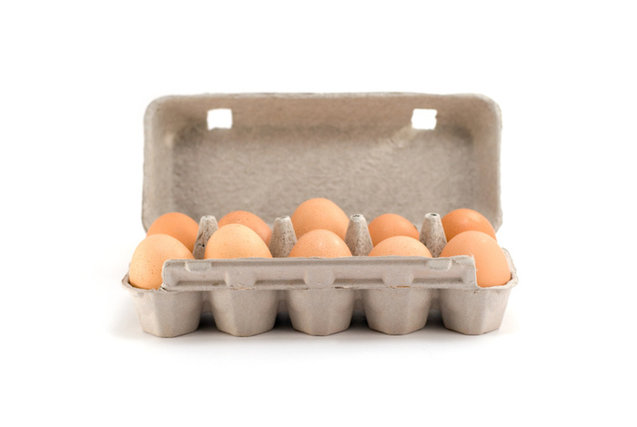

**Task Three**

Design a leaflet advising the public how to store food safely. It needs to be informative and detailed and should warn about what might happen if food is not stored correctly.

**FOOD POISONING**

**What is Food Poisoning?**

Food poisoning is an illness caused by eating contaminated food. Most people will get better without the need for treatment.

In most cases, the food that causes the illness has been contaminated by bacteria, such as salmonella.

**Symptoms of Food Poisoning**

The [symptoms of food poisoning](http://www.nhs.uk/Conditions/Food-poisoning/Pages/Symptoms.aspx) usually begin one to three days after eating contaminated food. They include:

* feeling sick
* vomiting
* diarrhoea
* stomach cramps

**How common is food poisoning?**

During 2010, there were almost 84,560 cases of food poisoning in England and Wales. However, the actual figure may be considerably higher than this because many people with mild symptoms do not report them

**Treating Food Poisoning**

Most people with food poisoning will get better without the need for treatment. In the meantime, you can relieve the symptoms of food poisoning by:

* drinking plenty of fluids
* eating easily digested food, such as toast, until you feel better
* resting

Occasionally, food poisoning can have more serious effects on a person’s health, particularly if they are vulnerable to the effects of an infection. For example, being older than 65 or having a condition that weakens the immune system, such as HIV or cancer, can increase a person’s chances of getting an illness and developing more serious symptoms.

Signs that you may have a more serious case of food poisoning that requires medical attention include:

* vomiting that lasts for more than two days
* not being able to keep liquids down for more than a day
* diarrhoea that lasts for more than three days or is bloody
* fever

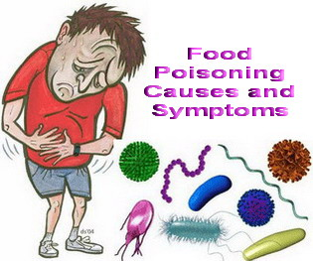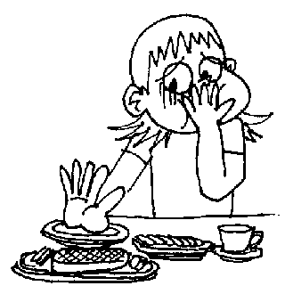

**Foods that may cause Food Poisoning**

Foods that are particularly vulnerable to contamination if they are not handled, stored or cooked properly include:

* raw meat and poultry
* 'ready to eat' foods such as cooked sliced meats, pate, soft cheeses and pre-packed sandwiches
* dairy products, such as eggs and milk

**How Bacteria Grow**

Bacteria need food, warmth, moisture and time to grow. They reproduce by dividing themselves, so one bacterium becomes two and then two become four and so on. In the right conditions one bacterium could become several million in 8 hours and thousands of millions in 12 hours.

This means that if a food is contaminated with a small number of bacteria and you leave it out of the fridge overnight it could be seriously contaminated by the next day. Then just one mouthful could make someone ill. If you put food in the fridge it will stop bacteria from multiplying.

Since you can't see, taste or smell bacteria, the only way that you can be sure that food is safe is to follow good food hygiene at all times.

**Activities**

**Task One**

**Answer the following questions on A4 paper:**

1. What is meant by the term Food Poisoning?
2. What are the four main symptoms of food poisoning?
3. How many cases of food poisoning were reported in England and Wales in 2010?
4. Is this number an accurate reflection of Food poisoning cases in England and Wales? If not, why not?
5. How is food poisoning treated?
6. What symptoms may be experienced with severe food poisoning?
7. What foods may cause food poisoning?
8. What conditions does bacteria need to multiply?
9. How can you stop bacteria from multiplying?

**Task Two**

Design a poster that could be displayed in a Health Centre informing the general public of what food poisoning is, the symptoms and how to prevent it.

