Year 8 Reading Skills

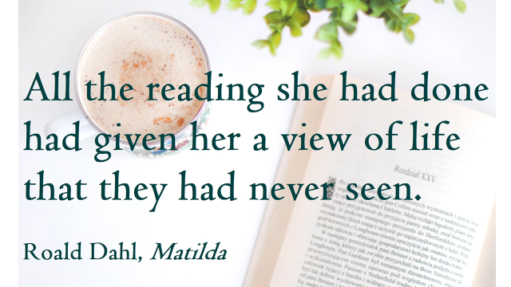

“Before you take me up to bed, will you tell me a story?”
A short story Click Clack The Rattlebag by Neil Gaiman

“Do you actually need me to take you up to bed?” I asked the boy.

He thought for a moment. Then, with intense seriousness, “Yes, actually I think you do. It’s because of, I’ve finished my homework, and so it’s my bedtime, and I am a bit scared. Not very scared. Just a bit.

“But it is a very big house, and lots of times the lights don’t work and it’s a sort of dark.”
I reached over and tousled his hair.
“I can understand that,” I said. “It is a very big old house.” He nodded. We were in the kitchen, where it was light and warm. I put down my magazine on the kitchen table. “What kind of story would you like me to tell you?”
“Well,” he said, thoughtfully. “I don’t think it should be too scary, because then when I go up to bed, I will just be thinking about monsters the whole time. But if it isn’t just a little bit scary then I won’t be interested. And you make up scary stories, don’t you? I know she says that’s what you do.”
“She exaggerates. I write stories, yes. Nothing that’s been published, yet, though. And I write lots of different kinds of stories.”
“But you do write scary stories?”
“Yes.”
The boy looked up at me from the shadows by the door, where he was waiting. “Do you know any stories about Click-clack the Rattlebag?”
“I don’t think so.”
“Those are the best sorts of stories.”
“Do they tell them at your school?”
He shrugged. “Sometimes.”
“What’s a Click-clack the Rattlebag story?”
He was a precocious child, and was unimpressed by his sister’s boyfriend’s ignorance. You could see it on his face. “Everybody knows them.”
“I don’t,” I said, trying not to smile.
He looked at me as if he was trying to decide whether or not I was pulling his leg. He said, “I think maybe you should take me up to my bedroom, and then you can tell me a story before I go to sleep, but a very not-scary story because I’ll be up in my bedroom then, and it’s actually a bit dark up there, too.”
I said, “Shall I leave a note for your sister, telling her where we are?”
“You can. But you’ll hear when they get back. The front door is very slammy.”
We walked out of the warm and cosy kitchen into the hallway of the big house, where it was chilly and draughty and dark. I flicked the light-switch, but nothing happened.
“The bulb’s gone,” the boy said. “That always happens.”
Our eyes adjusted to the shadows. The moon was almost full, and blue-white moonlight shone in through the high windows on the staircase, down into the hall. “We’ll be all right,” I said.
“Yes,” said the boy, soberly. “I am very glad you’re here.” He seemed less precocious now. His hand found mine, and he held on to my fingers comfortably, trustingly, as if he’d known me all his life. I felt responsible and adult. I did not know if the feeling I had for his sister, who was my girlfriend, was love, not yet, but I liked that the child treated me as one of the family. I felt like his big brother, and I stood taller, and if there was something unsettling about the empty house I would not have admitted it for worlds.

The stairs creaked beneath the threadbare stair-carpet.
“Click-clacks,” said the boy, “are the best monsters ever.”
“Are they from television?”
“I don’t think so. I don’t think any people know where they come from. Mostly they come from the dark.”
“Good place for a monster to come.”
“Yes.”
We walked along the upper corridor in the shadows, walking from patch of moonlight to patch of moonlight. It really was a big house. I wished I had a flashlight.
“They come from the dark,” said the boy, holding on to my hand. “I think probably they’re made of dark. And they come in when you don’t pay attention. That’s when they come in. And then they take you back to their… not nests. What’s a word that’s like nests, but not?”
“House?”
“No. It’s not a house.”
“Lair?”
He was silent. Then, “I think that’s the word, yes. Lair.” He squeezed my hand. He stopped talking.
“Right. So they take the people who don’t pay attention back to their lair. And what do they do then, your monsters? Do they suck all the blood out of you, like vampires?”
He snorted. “Vampires don’t suck all the blood out of you. They only drink a little bit. Just to keep them going, and, you know, flying around. Click-clacks are much scarier than vampires.”
“I’m not scared of vampires,” I told him.
“Me neither. I’m not scared of vampires either. Do you want to know what Click-clacks do? They drink you,” said the boy.
“Like a Coke?”
“Coke is very bad for you,” said the boy. “If you put a tooth in Coke, in the morning, it will be dissolved into nothing. That’s how bad coke is for you and why you must always clean your teeth, every night.”
I’d heard the Coke story as a boy, and had been told, as an adult, that it wasn’t true, but was certain that a lie which promoted dental hygiene was a good lie, and I let it pass.
“Click-clacks drink you,” said the boy. “First they bite you, and then you go all ishy inside, and all your meat and all your brains and everything except your bones and your skin turns into a wet, milk-shakey stuff and then the Click-clack sucks it out through the holes where your eyes used to be.”
“That’s disgusting,” I told him. “Did you make it up?”
We’d reached the last flight of stairs, all the way in to the big house.
“No.”
“I can’t believe you kids make up stuff like that.”
“You didn’t ask me about the rattlebag,” he said.
“Right. What’s the rattlebag?”
“Well,” he said, sagely, soberly, a small voice from the darkness beside me, “once you’re just bones and skin, they hang you up on a hook, and you rattle in the wind.”
“So what do these Click-clacks look like?” Even as I asked him, I wished I could take the question back, and leave it unasked. I thought: Huge spidery creatures. Like the one in the shower that morning. I’m afraid of spiders.
I was relieved when the boy said, “They look like what you aren’t expecting. What you aren’t paying attention to.”
We were climbing wooden steps now. I held on to the railing on my left, held his hand with my right, as he walked beside me. It smelled like dust and old wood, that high in the house. The boy’s tread was certain, though, even though the moonlight was scarce.
“Do you know what story you’re going to tell me, to put me to bed?” he asked. “It doesn’t actually have to be scary.”
“Not really.”
“Maybe you could tell me about this evening. Tell me what you did?”
“That won’t make much of a story for you. My girlfriend just moved in to a new place on the edge of town. She inherited it from an aunt or someone. It’s very big and very old. I’m going to spend my first night with her, tonight, so I’ve been waiting for an hour or so for her and her housemates to come back with the wine and an Indian takeaway.”
“See?” said the boy. There was that precocious amusement again. But all kids can be insufferable sometimes, when they think they know something you don’t. It’s probably good for them. “You know all that. But you don’t think. You just let your brain fill in the gaps.”
He pushed open the door to the attic room. It was perfectly dark, now, but the opening door disturbed the air, and I heard things rattle gently, like dry bones in thin bags, in the slight wind. Click. Clack. Click. Clack. Like that.
I would have pulled away, then, if I could, but small, firm fingers pulled me forward, unrelentingly, into the dark.

Answer the following questions in as much detail as possible .
- How does the writer introduce us to the boy? What are our first impressions?
________________________________________________________________________________________________________________________________________________________________________________________________________________________________________________________________________________________________________________________________________________________________________________________________________________________________________________________________________________________________________________________________________________________

- How does the writer develop the character of the boy? How does this build on our first impression?
________________________________________________________________________________________________________________________________________________________________________________________________________________________________________________________________________________________________________________________________________________________________________________________________________________________________________________________________________________________________________________________________________________________

- What is the twist in this story? What does the boy mean when he says: ‘You know all that. But you don’t think. You let your brain fill in the gaps.’
___________________________________________________________________________________________________________________________________________________________________________________________________________________________________________________________________________________________________________________________________________________________________________________________________________________________________________________________________________________________________________________________________________________________________________________________________________________________

- What is our final impression of the boy? How does this contrast to the rest of the story?
____________________________________________________________________________________________________________________________________________________________________________________________________________________________________________________________________________

A short story The Selfish Giant by Oscar Wilde
Every afternoon, as they were coming from school, the children used to go and play in the Giant's garden.
It was a large lovely garden, with soft green grass. Here and there over the grass stood beautiful flowers like stars, and there were twelve peach-trees that in the spring-time broke out into delicate blossoms of pink and pearl, and in the autumn bore rich fruit. The birds sat on the trees and sang so sweetly that the children used to stop their games in order to listen to them. 'How happy we are here!' they cried to each other.
One day the Giant came back. He had been to visit his friend the Cornish ogre, and had stayed with him for seven years. After the seven years were over he had said all that he had to say, for his conversation was limited, and he determined to return to his own castle. When he arrived he saw the children playing in the garden.
'What are you doing here?' he cried in a very gruff voice, and the children ran away.
'My own garden is my own garden,' said the Giant; 'any one can understand that, and I will allow nobody to play in it but myself.' So he built a high wall all round it, and put up a notice-board.

TRESPASSERS
WILL BE
PROSECUTED

He was a very selfish Giant.
The poor children had now nowhere to play. They tried to play on the road, but the road was very dusty and full of hard stones, and they did not like it. They used to wander round the high wall when their lessons were over, and talk about the beautiful garden inside.
'How happy we were there,' they said to each other.
Then the Spring came, and all over the country there were little blossoms and little birds. Only in the garden of the Selfish Giant it was still Winter. The birds did not care to sing in it as there were no children, and the trees forgot to blossom. Once a beautiful flower put its head out from the grass, but when it saw the notice-board it was so sorry for the children that it slipped back into the ground again, and went off to sleep. The only people who were pleased were the Snow and the Frost. 'Spring has forgotten this garden,' they cried, 'so we will live here all the year round.' The Snow covered up the grass with her great white cloak, and the Frost painted all the trees silver. Then they invited the North Wind to stay with them, and he came. He was wrapped in furs, and he roared all day about the garden, and blew the chimney-pots down. 'This is a delightful spot,' he said, 'we must ask the Hail on a visit.' So the Hail came. Every day for three hours he rattled on the roof of the castle till he broke most of the slates, and then he ran round and round the garden as fast as he could go. He was dressed in grey, and his breath was like ice.
'I cannot understand why the Spring is so late in coming,' said the Selfish Giant, as he sat at the window and looked out at his cold white garden; 'I hope there will be a change in the weather.'
But the Spring never came, nor the Summer. The Autumn gave golden fruit to every garden, but to the Giant's garden she gave none. 'He is too selfish,' she said. So it was always Winter there, and the North Wind, and the Hail, and the Frost, and the Snow danced about through the trees.
One morning the Giant was lying awake in bed when he heard some lovely music. It sounded so sweet to his ears that he thought it must be the King's musicians passing by. It was really only a little linnet singing outside his window, but it was so long since he had heard a bird sing in his garden that it seemed to him to be the most beautiful music in the world. Then the Hail stopped dancing over his head, and the North Wind ceased roaring, and a delicious perfume came to him through the open casement. 'I believe the Spring has come at last,' said the Giant; and he jumped out of bed and looked out.
What did he see?
He saw a most wonderful sight. Through a little hole in the wall the children had crept in, and they were sitting in the branches of the trees. In every tree that he could see there was a little child. And the trees were so glad to have the children back again that they had covered themselves with blossoms, and were waving their arms gently above the children's heads. The birds were flying about and twittering with delight, and the flowers were looking up through the green grass and laughing. It was a lovely scene, only in one corner it was still Winter. It was the farthest corner of the garden, and in it was standing a little boy. He was so small that he could not reach up to the branches of the tree, and he was wandering all round it, crying bitterly. The poor tree was still quite covered with frost and snow, and the North Wind was blowing and roaring above it. 'Climb up! little boy,' said the Tree, and it bent its branches down as low as it could; but the little boy was too tiny.
And the Giant's heart melted as he looked out. 'How selfish I have been!' he said; 'now I know why the Spring would not come here. I will put that poor little boy on the top of the tree, and then I will knock down the wall, and my garden shall be the children's playground for ever and ever.' He was really very sorry for what he had done.
So he crept downstairs and opened the front door quite softly, and went out into the garden. But when the children saw him they were so frightened that they all ran away, and the garden became Winter again. Only the little boy did not run, for his eyes were so full of tears that he died not see the Giant coming. And the Giant stole up behind him and took him gently in his hand, and put him up into the tree. And the tree broke at once into blossom, and the birds came and sang on it, and the little boy stretched out his two arms and flung them round the Giant's neck, and kissed him. And the other children, when they saw that the Giant was not wicked any longer, came running back, and with them came the Spring. 'It is your garden now, little children,' said the Giant, and he took a great axe and knocked down the wall. And when the people were gong to market at twelve o'clock they found the Giant playing with the children in the most beautiful garden they had ever seen.
All day long they played, and in the evening they came to the Giant to bid him good-bye.
'But where is your little companion?' he said: 'the boy I put into the tree.' The Giant loved him the best because he had kissed him.
'We don't know,' answered the children; 'he has gone away.'
'You must tell him to be sure and come here to-morrow,' said the Giant. But the children said that they did not know where he lived, and had never seen him before; and the Giant felt very sad.
Every afternoon, when school was over, the children came and played with the Giant. But the little boy whom the Giant loved was never seen again. The Giant was very kind to all the children, yet he longed for his first little friend, and often spoke of him. 'How I would like to see him!' he used to say.
Years went over, and the Giant grew very old and feeble. He could not play about any more, so he sat in a huge armchair, and watched the children at their games, and admired his garden. 'I have many beautiful flowers,' he said; 'but the children are the most beautiful flowers of all.'
One winter morning he looked out of his window as he was dressing. He did not hate the Winter now, for he knew that it was merely the Spring asleep, and that the flowers were resting.
Suddenly he rubbed his eyes in wonder, and looked and looked. It certainly was a marvellous sight. In the farthest corner of the garden was a tree quite covered with lovely white blossoms. Its branches were all golden, and silver fruit hung down from them, and underneath it stood the little boy he had loved.
Downstairs ran the Giant in great joy, and out into the garden. He hastened across the grass, and came near to the child. And when he came quite close his face grew red with anger, and he said, 'Who hath dared to wound thee?' For on the palms of the child's hands were the prints of two nails, and the prints of two nails were on the little feet.
'Who hath dared to wound thee?' cried the Giant; 'tell me, that I may take my big sword and slay him.'
'Nay!' answered the child; 'but these are the wounds of Love.'
'Who art thou?' said the Giant, and a strange awe fell on him, and he knelt before the little child.
And the child smiled on the Giant, and said to him, 'You let me play once in your garden, to-day you shall come with me to my garden, which is Paradise.'
And when the children ran in that afternoon, they found the Giant lying dead under the tree, all covered with white blossoms.

Answer the following questions in as much detail as possible.

- What is the moral of this story?
________________________________________________________________________________________________________________________________________________________________________________________________________________________________________________________________________________________________________________________________________________________________________________________________________________________________________________________________________________________________________________________________________________________

- What do the children symbolise in this story? What does the winter time symbolise?
________________________________________________________________________________________________________________________________________________________________________________________________________________________________________________________________________________________________________________________________________________________________________________________________________________________________________________________________________________________________________________________________________________________

- Who is the little boy that the giant grows to love best of all? ____________________________________________________________________________________________________________________________________________________________________________________________________________________________________________________________________________

- What is this a reference to: ‘For on the palms of the child’s hands were the prints of two nails and the prints of two nails were on the little feet.’?
________________________________________________________________________________________________________________________________________________________________________________________________________________________________________________________________________________________________________________________________________________________________________________________________________________________________________________________________________________________________________________________________________________________

A short story The Fly by Katherine Mansfield
Published in 1922, The Fly is often heralded as one of Katherine Mansfield's finest short stories. But it does not reward lazy readers! Your enjoyment of this story depends on how well you read the story. So please take your time and read it with careful attention. Readers will wish to contemplate the symbolism of the fly, and notice that the ending of the story plays on one of Woodfield's problems mentioned nearer to the beginning of the story.

" Y'ARE very snug in here," piped old Mr. Woodifield, and he peered out of the great, green leather armchair by his friend the boss's desk as a baby peers out of its pram. His talk was over; it was time for him to be off. But he did not want to go. Since he had retired, since his... stroke, the wife and the girls kept him boxed up in the house every day of the week except Tuesday. On Tuesday he was dressed and brushed and allowed to cut back to the City for the day. Though what he did there the wife and girls couldn't imagine. Made a nuisance of himself to his friends, they supposed ... Well, perhaps so. All the same, we cling to our last pleasures as the tree clings to its last leaves. So there sat old Woodifield, smoking a cigar and staring almost greedily at the boss, who rolled in his office chair, stout, rosy, five years older than he, and still going strong, still at the helm. It did one good to see him. Wistfully, admiringly, the old voice added, " It's snug in here, upon my word ! "
" Yes, it's comfortable enough," agreed the boss, and he flipped the Financial Times with a paper-knife. As a matter of fact he was proud of his room ; he liked to have it admired, especially by old Woodifield. It gave him a feeling of deep, solid satisfaction to be planted there in the midst of it in full view of that frail old figure in the muffler.
" I've had it done up lately," he explained, as he had explained for the past—how many ?— weeks. " New carpet," and he pointed to the bright red carpet with a pattern of large white rings. " New furniture," and he nodded towards the massive bookcase and the table with legs like twisted treacle. " Electric heating ! " He waved almost exultantly towards the five transparent, pearly sausages glowing so softly in the tilted copper pan.
But he did not draw old Woodifield's attention to the photograph over the table of a grave-looking boy in uniform standing in one of those spectral photographers' parks with photographers' storm-clouds behind him. It was not new. It had been there for over six years.
" There was something I wanted to tell you," said old Woodifield, and his eyes grew dim remembering. " Now what was it ? I had it in my mind when I started out this morning." His hands began to tremble, and patches of red showed above his beard.
Poor old chap, he's on his last pins, thought the boss. And, feeling kindly, he winked at the old man, and said jokingly, " I tell you what. I've got a little drop of something here that'll do you good before you go out into the cold again. It's beautiful stuff. It wouldn't hurt a child." He took a key off his watch-chain, unlocked a cupboard below his desk, and drew forth a dark, squat bottle. " That's the medicine," said he. " And the man from whom I got it told me on the strict Q.T. it came from the cellars at Windsor Cassel."
Old Woodifield's mouth fell open at the sight. He couldn't have looked more surprised if the boss had produced a rabbit.
" It's whisky, ain't it ? " he piped, feebly.
The boss turned the bottle and lovingly showed him the label. Whisky it was.
" D'you know," said he, peering up at the boss wonderingly, " they won't let me touch it at home." And he looked as though he was going to cry.
" Ah, that's where we know a bit more than the ladies," cried the boss, swooping across for two tumblers that stood on the table with the water-bottle, and pouring a generous finger into each. " Drink it down. It'll do you good. And don't put any water with it. It's sacrilege to tamper with stuff like this. Ah ! " He tossed off his, pulled out his handkerchief, hastily wiped his moustaches, and cocked an eye at old Woodifield, who was rolling his in his chaps.
The old man swallowed, was silent a moment, and then said faintly, " It's nutty ! "
But it warmed him ; it crept into his chill old brain—he remembered.
" That was it," he said, heaving himself out of his chair. " I thought you'd like to know. The girls were in Belgium last week having a look at poor Reggie's grave, and they happened to come across your boy's. They're quite near each other, it seems."
Old Woodifield paused, but the boss made no reply. Only a quiver in his eyelids showed that he heard.
" The girls were delighted with the way the place is kept," piped the old voice. " Beautifully looked after. Couldn't be better if they were at home. You've not been across, have yer ? "
" No, no ! " For various reasons the boss had not been across.
" There's miles of it," quavered old Woodifield, " and it's all as neat as a garden. Flowers growing on all the graves. Nice broad paths." It was plain from his voice how much he liked a nice broad path.
The pause came again. Then the old man brightened wonderfully.
" D'you know what the hotel made the girls pay for a pot of jam ? " he piped. " Ten - francs! Robbery, I call it. It was a little pot, so Gertrude says, no bigger than a half-crown. And she hadn't taken more than a spoonful when they charged her ten francs. Gertrude brought the pot away with her to teach 'em a lesson. Quite right, too ; it's trading on our feelings. They think because we're over there having a look round we're ready to pay anything. That's what it is." And he turned towards the door.
" Quite right, quite right! " cried the boss, though what was quite right he hadn't the least idea. He came round by his desk, followed the shuffling footsteps to the door, and saw the old fellow out. Woodifield was gone.
For a long moment the boss stayed, staring at nothing, while the grey-haired office messenger, watching him, dodged in and out of his cubby hole like a dog that expects to be taken for a run. Then : " I'll see nobody for half an hour, Macey," said the boss. " Understand ? Nobody at all."
" Very good, sir."
The door shut, the firm heavy steps recrossed the bright carpet, the fat body plumped down in the spring chair, and leaning forward, the boss covered his face with his hands. He wanted, he intended, he had arranged to weep...
It had been a terrible shock to him when old Woodifield sprang that remark upon him about the boy's grave. It was exactly as though the earth had opened and he had seen the boy lying there with Woodifield's girls staring down at him. For it was strange. Although over six years had passed away, the boss never thought of the boy except as lying unchanged, unblemished in his uniform, asleep for ever. " My son ! " groaned the boss. But no tears came yet. In the past, in the first months and even years after the boy's death, he had only to say those words to be overcome by such grief that nothing short of a violent fit of weeping could relieve him. Time, he had declared then, he had told everybody, could make no difference. Other men perhaps might recover, might live their loss down, but not he. How was it possible ? His boy was an only son. Ever since his birth the boss had worked at building up this business for him ; it had no other meaning if it was not for the boy. Life itself had come to have no other meaning. How on earth could he have slaved, denied himself, kept going all those years without the promise for ever before him of the boy's stepping into his shoes and carrying on where he left off ?
And that promise had been so near being fulfilled. The boy had been in the office learning the ropes for a year before the war. Every morning they had started off together ; they had come back by the same train. And what congratulations he had received as the boy's father ! No wonder ; he had taken to it marvellously. As to his popularity with the staff, every man jack of them down to old Macey couldn't make enough of the boy. And he wasn't in the least spoilt. No, he was just his bright, natural self, with the right word for everybody, with that boyish look and his habit of saying, " Simply splendid ! "
But all that was over and done with as though it never had been. The day had come when Macey had handed him the telegram that brought the whole place crashing about his head. " Deeply regret to inform you ..." And he had left the office a broken man, with his life in ruins.
Six years ago, six years ... How quickly time passed ! It might have happened yesterday. The boss took his hands from his face ; he was puzzled. Something seemed to be wrong with him. He wasn't feeling as he wanted to feel. He decided to get up and have a look at the boy's photograph. But it wasn't a favourite photograph of his; the expression was unnatural. It was cold, even stern-looking. The boy had never looked like that.
At that moment the boss noticed that a fly had fallen into his broad inkpot, and was trying feebly but desperately to clamber out again. Help ! help ! said those struggling legs. But the sides of the inkpot were wet and slippery ; it fell back again and began to swim. The boss took up a pen, picked the fly out of the ink, and shook it on to a piece of blotting-paper. For a fraction of a second it lay still on the dark patch that oozed round it. Then the front legs waved, took hold, and, pulling its small, sodden body up it began the immense task of cleaning the ink from its wings. Over and under, over and under, went a leg along a wing, as the stone goes over and under the scythe. Then there was a pause, while the fly, seeming to stand on the tips of its toes, tried to expand first one wing and then the other. It succeeded at last, and, sitting down, it began, like a minute cat, to clean its face. Now one could imagine that the little front legs rubbed against each other lightly, joyfully. The horrible danger was over ; it had escaped ; it was ready for life again.
But just then the boss had an idea. He plunged his pen back into the ink, leaned his thick wrist on the blotting paper, and as the fly tried its wings down came a great heavy blot. What would it make of that ? What indeed ! The little beggar seemed absolutely cowed, stunned, and afraid to move because of what would happen next. But then, as if painfully, it dragged itself forward. The front legs waved, caught hold, and, more slowly this time, the task began from the beginning.
He's a plucky little devil, thought the boss, and he felt a real admiration for the fly's courage. That was the way to tackle things ; that was the right spirit. Never say die ; it was only a question of ... But the fly had again finished its laborious task, and the boss had just time to refill his pen, to shake fair and square on the new-cleaned body yet another dark drop. What about it this time ? A painful moment of suspense followed. But behold, the front legs were again waving ; the boss felt a rush of relief. He leaned over the fly and said to it tenderly, " You artful little b . . ." And he actually had the brilliant notion of breathing on it to help the drying process. All the same, there was something timid and weak about its efforts now, and the boss decided that this time should be the last, as he dipped the pen deep into the inkpot.
It was. The last blot fell on the soaked blotting-paper, and the draggled fly lay in it and did not stir. The back legs were stuck to the body; the front legs were not to be seen.
" Come on," said the boss. " Look sharp ! " And he stirred it with his pen—in vain. Nothing happened or was likely to happen. The fly was dead.
The boss lifted the corpse on the end of the paper-knife and flung it into the waste-paper basket. But such a grinding feeling of wretchedness seized him that he felt positively frightened. He started forward and pressed the bell for Macey.
" Bring me some fresh blotting-paper," he said, sternly, " and look sharp about it." And while the old dog padded away he fell to wondering what it was he had been thinking about before. What was it ? It was... He took out his handkerchief and passed it inside his collar. For the life of him he could not remember.

Answer the following questions in as much detail as possible.
- In the first part of the story who has the higher status Mr Woodfield or the boss? Why?
________________________________________________________________________________________________________________________________________________________________________________________________________________________________________________________________________________________________________________________________________________________________________________________________________________________________________________________________________________________________________________________________________________________

- What happens in the story to destabilise the boss and make him seem vulnerable?
________________________________________________________________________________________________________________________________________________________________________________________________________________________________________________________________________________________________________________________________________________________________________________________________________________________________________________________________________________________________________________________________________________________

- What might the fly symbolise (Give two suggestions)? _______________________________________________________________________________________________________________________________________________________________________________________________________________________________________________________________________________________________________________________________________________
____________________________________________________________________________________________________________________________________________________________________________________________________________________________________________________________________________

- Why does the boss behave in the way that he does to the fly? ________________________________________________________________________________________________________________________________________________________________________________________________________________________________________________________________________________________________________________________________________________________________________________________________________________________________________________________________________________________________________________________________________________________

A short story Everyday Use by Alice Walker

I will wait for her in the yard that Maggie and I made so clean and wavy yesterday afternoon. A yard like this is more comfortable than most people know. It is not just a yard. It is like an extended living room. When the hard clay is swept clean as a floor and the fine sand around the edges lined with tiny, irregular grooves, anyone can come and sit and look up into the elm tree and wait for the breezes that never come inside the house.
Maggie will be nervous until after her sister goes: she will stand hopelessly in corners, homely and ashamed of the burn scars down her arms and legs, eyeing her sister with a mixture of envy and awe. She thinks her sister has held life always in the palm of one hand, that “no” is a word the world never learned to say to her.
You’ve no doubt seen those TV shows where the child who has “made it” is confronted, as a surprise, by her own mother and father, tottering in weakly from backstage. (A pleasant surprise, of course: What would they do if parent and child came on the show only to curse out and insult each other?) On TV mother and child embrace and smile into each other’s faces. Sometimes the mother and father weep, the child wraps them in her arms and leans across the table to tell how she would not have made it without their help. I have seen these programs.
Sometimes I dream a dream in which Dee and I are suddenly brought together on a TV program of this sort. Out of a dark and soft-seated limousine I am ushered into a bright room filled with many people. There I meet a smiling, gray, sporty man like Johnny Carson who shakes my hand and tells me what a fine girl I have. Then we are on the stage and Dee is embracing me with tears in her eyes. She pins on my dress a large orchid, even though she has told me once that she thinks orchids are tacky flowers.
In real life I am a large, big-boned woman with rough, man-working hands. In the winter I wear flannel nightgowns to bed and overalls during the day. I can kill and clean a hog as mercilessly as a man. My fat keeps me hot in zero weather. I can work outside all day, breaking ice to get water for washing; I can eat pork liver cooked over the open fire minutes after it comes steaming from the hog. One winter I knocked a bull calf straight in the brain between the eyes with a sledge hammer and had the meat hung up to chill before nightfall. But of course all this does not show on television. I am the way my daughter would want me to be: a hundred pounds lighter, my skin like an uncooked barley pancake. My hair glistens in the hot bright lights. Johnny Carson has much to do to keep up with my quick and witty tongue.
But that is a mistake. I know even before I wake up. Who ever knew a Johnson with a quick tongue? Who can even imagine me looking a strange white man in the eye? It seems to me I have talked to them always with one foot raised in flight, with my head turned in whichever way is farthest from them. Dee, though. She would always look anyone in the eye. Hesitation was no part of her nature.
* * *
“How do I look, Mama?” Maggie says, showing just enough of her thin body enveloped in pink skirt and red blouse for me to know she’s there, almost hidden by the door.
“Come out into the yard,” I say.
Have you ever seen a lame animal, perhaps a dog run over by some careless person rich enough to own a car, sidle up to someone who is ignorant enough to be kind to him? That is the way my Maggie walks. She has been like this, chin on chest, eyes on ground, feet in shuffle, ever since the fire that burned the other house to the ground.
Dee is lighter than Maggie, with nicer hair and a fuller figure. She’s a woman now, though sometimes I forget. How long ago was it that the other house burned? Ten, twelve years? Sometimes I can still hear the flames and feel Maggie’s arms sticking to me, her hair smoking and her dress falling off her in little black papery flakes. Her eyes seemed stretched open, blazed open by the flames reflected in them. And Dee. I see her standing off under the sweet gum tree she used to dig gum out of; a look of concentration on her face as she watched the last dingy gray board of the house fall in toward the red-hot brick chimney. Why don’t you do a dance around the ashes? I’d wanted to ask her. She had hated the house that much.
I used to think she hated Maggie, too. But that was before we raised money, the church and me, to send her to Augusta to school. She used to read to us without pity; forcing words, lies, other folks’ habits, whole lives upon us two, sitting trapped and ignorant underneath her voice. She washed us in a river of make-believe, burned us with a lot of knowledge we didn’t necessarily need to know. Pressed us to her with the serious way she read, to shove us away at just the moment, like dimwits, we seemed about to understand.
Dee wanted nice things. A yellow organdy dress to wear to her graduation from high school; black pumps to match a green suit she’d made from an old suit somebody gave me. She was determined to stare down any disaster in her efforts. Her eyelids would not flicker for minutes at a time. Often I fought off the temptation to shake her. At sixteen she had a style of her own: and knew what style was.
* * *
I never had an education myself. After second grade the school was closed down. Don’t ask me why: in 1927 colored asked fewer questions than they do now. Sometimes Maggie reads to me. She stumbles along good-naturedly but can’t see well. She knows she is not bright. Like good looks and money, quickness passes her by. She will marry John Thomas (who has mossy teeth in an earnest face) and then I’ll be free to sit here and I guess just sing church songs to myself. Although I never was a good singer. Never could carry a tune. I was always better at a man’s job. I used to love to milk till I was hooked in the side in ’49. Cows are soothing and slow and don’t bother you, unless you try to milk them the wrong way.
I have deliberately turned my back on the house. It is three rooms, just like the one that burned, except the roof is tin; they don’t make shingle roofs any more. There are no real windows, just some holes cut in the sides, like the portholes in a ship, but not round and not square, with rawhide holding the shutters up on the outside. This house is in a pasture, too, like the other one. No doubt when Dee sees it she will want to tear it down. She wrote me once that no matter where we “choose” to live, she will manage to come see us. But she will never bring her friends. Maggie and I thought about this and Maggie asked me, “Mama, when did Dee ever have any friends?”
She had a few. Furtive boys in pink shirts hanging about on wash-day after school. Nervous girls who never laughed. Impressed with her they worshiped the well-turned phrase, the cute shape, the scalding humor that erupted like bubbles in lye. She read to them.
When she was courting Jimmy T she didn’t have much time to pay to us, but turned all her faultfinding power on him. He flew to marry a cheap city girl from a family of ignorant flashy people. She hardly had time to recompose herself.
* * *
When she comes I will meet—but there they are!
Maggie attempts to make a dash for the house, in her shuffling way, but I stay her with my hand. “Come back here,” I say. And she stops and tries to dig a well in the sand with her toe.
It is hard to see them clearly through the strong sun. But even the first glimpse of leg out of the car tells me it is Dee. Her feet were always neat-looking, as if God himself had shaped them with a certain style. From the other side of the car comes a short, stocky man. Hair is all over his head a foot long and hanging from his chin like a kinky mule tail. I hear Maggie suck in her breath. “Uhnnnh,” is what it sounds like. Like when you see the wriggling end of a snake just in front of your foot on the road. “Uhnnnh.”
Dee next. A dress down to the ground, in this hot weather. A dress so loud it hurts my eyes. There are yellows and oranges enough to throw back the light of the sun. I feel my whole face warming from the heat waves it throws out. Earrings gold, too, and hanging down to her shoulders. Bracelets dangling and making noises when she moves her arm up to shake the folds of the dress out of her armpits. The dress is loose and flows, and as she walks closer, I like it. I hear Maggie go “Uhnnnh” again. It is her sister’s hair. It stands straight up like the wool on a sheep. It is black as night and around the edges are two long pigtails that rope about like small lizards disappearing behind her ears.
“Wa-su-zo-Tean-o!¹” she says, coming on in that gliding way the dress makes her move. The short stocky fellow with the hair to his navel is all grinning and he follows up with “Asalamalakim,² my mother and sister!” He moves to hug Maggie but she falls back, right up against the back of my chair. I feel her trembling there and when I look up I see the perspiration falling off her chin.
“Don’t get up,” says Dee. Since I am stout it takes something of a push. You can see me trying to move a second or two before I make it. She turns, showing white heels through her sandals, and goes back to the car. Out she peeks next with a Polaroid. She stoops down quickly and lines up picture after picture of me sitting there in front of the house with Maggie cowering behind me. She never takes a shot without making sure the house is included. When a cow comes nibbling around the edge of the yard she snaps it and me and Maggie and the house. Then she puts the Polaroid in the back seat of the car, and comes up and kisses me on the forehead.
Meanwhile Asalamalakim is going through motions with Maggie’s hand. Maggie’s hand is as limp as a fish, and probably as cold, despite the sweat, and she keeps trying to pull it back. It looks like Asalamalakim wants to shake hands but wants to do it fancy. Or maybe he don’t know how people shake hands. Anyhow, he soon gives up on Maggie.
“Well,” I say. “Dee.”
“No, Mama,” she says. “Not ‘Dee,’ Wangero Leewanika Kemanjo!”
“What happened to ‘Dee’?” I wanted to know.
“She’s dead,” Wangero said. “I couldn’t bear it any longer, being named after the people who oppress me.”
“You know as well as me you was named after your aunt Dicie,” I said. Dicie is my sister. She named Dee. We called her “Big Dee” after Dee was born.
“But who was she named after?” asked Wangero.
“I guess after Grandma Dee,” I said.
“And who was she named after?” asked Wangero.
“Her mother,” I said, and saw Wangero was getting tired. “That’s about as far back as I can trace it,” I said. Though, in fact, I probably could have carried it back beyond the Civil War through the branches.
“Well,” said Asalamalakim, “there you are.”
“Uhnnnh,” I heard Maggie say.
“There I was not,” I said, “before ‘Dicie’ cropped up in our family, so why should I try to trace it that far back?”
He just stood there grinning, looking down on me like somebody inspecting a Model A car. Every once in a while he and Wangero sent eye signals over my head.
“How do you pronounce this name?” I asked.
“You don’t have to call me by it if you don’t want to,” said Wangero.
“Why shouldn’t I?” I asked. “If that’s what you want us to call you, we’ll call you.”
“I know it might sound awkward at first,” said Wangero.
“I’ll get used to it,” I said. “Ream it out again.”
Well, soon we got the name out of the way. Asalamalakim had a name twice as long and three times as hard. After I tripped over it two or three times he told me to just call him Hakim-a-barber. I wanted to ask him was he a barber, but I didn’t really think he was, so I didn’t ask.
“You must belong to those beef-cattle peoples down the road,” I said. They said “Asalamalakim” when they met you, too, but they didn’t shake hands. Always too busy: feeding the cattle, fixing the fences, putting up salt-lick shelters, throwing down hay. When the white folks poisoned some of the herd the men stayed up all night with rifles in their hands. I walked a mile and a half just to see the sight.
Hakim-a-barber said, “I accept some of their doctrines, but farming and raising cattle is not my style.” (They didn’t tell me, and I didn’t ask, whether Wangero (Dee) had really gone and married him.)
We sat down to eat and right away he said he didn’t eat collards and pork was unclean. Wangero, though, went on through the chitlins and corn bread, the greens and everything else. She talked a blue streak over the sweet potatoes. Everything delighted her. Even the fact that we still used the benches her daddy made for the table when we couldn’t afford to buy chairs.
“Oh, Mama!” she cried. Then turned to Hakim-a-barber. “I never knew how lovely these benches are. You can feel the rump prints,” she said, running her hands underneath her and along the bench. Then she gave a sigh and her hand closed over Grandma Dee’s butter dish. “That’s it!” she said. “I knew there was something I wanted to ask you if I could have.” She jumped up from the table and went over in the corner where the churn stood, the milk in it clabber by now. She looked at the churn and looked at it.
“This churn top is what I need,” she said. “Didn’t Uncle Buddy whittle it out of a tree you all used to have?”
“Yes,” I said.
“Un huh,” she said happily. “And I want the dasher, too.”
“Uncle Buddy whittle that, too?” asked the barber.
Dee (Wangero) looked up at me.
“Aunt Dee’s first husband whittled the dash,” said Maggie so low you almost couldn’t hear her. “His name was Henry, but they called him Stash.”
“Maggie’s brain is like an elephant’s,” Wangero said, laughing. “I can use the chute top as a centerpiece for the alcove table,” she said, sliding a plate over the chute, “and I’ll think of something artistic to do with the dasher.”
When she finished wrapping the dasher the handle stuck out. I took it for a moment in my hands. You didn’t even have to look close to see where hands pushing the dasher up and down to make butter had left a kind of sink in the wood. In fact, there were a lot of small sinks; you could see where thumbs and fingers had sunk into the wood. It was beautiful light yellow wood, from a tree that grew in the yard where Big Dee and Stash had lived.
After dinner Dee (Wangero) went to the trunk at the foot of my bed and started rifling through it. Maggie hung back in the kitchen over the dishpan. Out came Wangero with two quilts. They had been pieced by Grandma Dee and then Big Dee and me had hung them on the quilt frames on the front porch and quilted them. One was in the Lone Star pattern. The other was Walk Around the Mountain. In both of them were scraps of dresses Grandma Dee had worn fifty and more years ago. Bits and pieces of Grandpa Jarrell’s paisley shirts. And one teeny faded blue piece, about the size of a penny matchbox, that was from Great Grandpa Ezra’s uniform that he wore in the Civil War.
“Mama,” Wangero said sweet as a bird. “Can I have these old quilts?”
I heard something fall in the kitchen, and a minute later the kitchen door slammed.
“Why don’t you take one or two of the others?” I asked. “These old things was just done by me and Big Dee from some tops your grandma pieced before she died.”
“No,” said Wangero. “I don’t want those. They are stitched around the borders by machine.”
“That’ll make them last better,” I said.
“That’s not the point,” said Wangero. “These are all pieces of dresses Grandma used to wear. She did all this stitching by hand. Imagine!” She held the quilts securely in her arms, stroking them.
“Some of the pieces, like those lavender ones, come from old clothes her mother handed down to her,” I said, moving up to touch the quilts. Dee (Wangero) moved back just enough so that I couldn’t reach the quilts. They already belonged to her.
“Imagine!” she breathed again, clutching them closely to her bosom.
“The truth is,” I said, “I promised to give them quilts to Maggie, for when she marries John Thomas.”
She gasped like a bee had stung her.
“Maggie can’t appreciate these quilts!” she said. “She’d probably be backward enough to put them to everyday use.”
“I reckon she would,” I said. “God knows I been saving ’em for long enough with nobody using ’em. I hope she will!” I didn’t want to bring up how I had offered Dee (Wangero) a quilt when she went away to college. Then she had told me they were old-fashioned, out of style.
“But they’re priceless!” she was saying now, furiously; for she has a temper. “Maggie would put them on the bed and in five years they’d be in rags. Less than that!”
“She can always make some more,” I said. “Maggie knows how to quilt.”
Dee (Wangero) looked at me with hatred. “You just will not understand. The point is these quilts, thesequilts!”
“Well,” I said, stumped. “What would you do with them?”
“Hang them,” she said. As if that was the only thing you could do with quilts.
Maggie by now was standing in the door. I could almost hear the sound her feet made as they scraped over each other.
“She can have them, Mama,” she said, like somebody used to never winning anything, or having anything reserved for her. “I can ’member Grandma Dee without the quilts.”
I looked at her hard. She had filled her bottom lip with checkerberry snuff and it gave her face a kind of dopey, hangdog look. It was Grandma Dee and Big Dee who taught her how to quilt herself. She stood there with her scarred hands hidden in the folds of her skirt. She looked at her sister with something like fear but she wasn’t mad at her. This was Maggie’s portion. This was the way she knew God to work.
When I looked at her like that something hit me in the top of my head and ran down to the soles of my feet. Just like when I’m in church and the spirit of God touches me and I get happy and shout. I did something I never done before: hugged Maggie to me, then dragged her on into the room, snatched the quilts out of Miss Wangero’s hands and dumped them into Maggie’s lap. Maggie just sat there on my bed with her mouth open.
“Take one or two of the others,” I said to Dee.
But she turned without a word and went out to Hakim-a-barber.
“You just don’t understand,” she said, as Maggie and I came out to the car.
“What don’t I understand?” I wanted to know.
“Your heritage,” she said. And then she turned to Maggie, kissed her, and said, “You ought to try to make something of yourself, too, Maggie. It’s really a new day for us. But from the way you and Mama still live you’d never know it.”
She put on some sunglasses that hid everything above the tip of her nose and chin.
Maggie smiled; maybe at the sunglasses. But a real smile, not scared. After we watched the car dust settle I asked Maggie to bring me a dip of snuff. And then the two of us sat there just enjoying, until it was time to go in the house and go to bed.

Answer the following questions in

- How are the narrator’s daughters different?
________________________________________________________________________________________________________________________________________________________________________________________________________________________________________________________________________________________________________________________________________________________________________________________________________________________________________________________________________________________________________________________________________________________

- What does Wangero (Dee) want her family’s quilts for? What would Maggie use the quilts for?
________________________________________________________________________________________________________________________________________________________________________________________________________________________________________________________________________________________________________________________________________________________________________________________________________________________________________________________________________________________________________________________________________________________

- What might the quilts symbolise? Consider their significance to both girls. _______________________________________________________________________________________________________________________________________________________________________________________________________________________________________________________________________________________________________________________________________________
____________________________________________________________________________________________________________________________________________________________________________________________________________________________________________________________________________

- What is the conflict in this story? ________________________________________________________________________________________________________________________________________________________________________________________________________________________________________________________________________________________________________________________________________________________________________________________________________________________________________________________________________________________________________________________________________________________

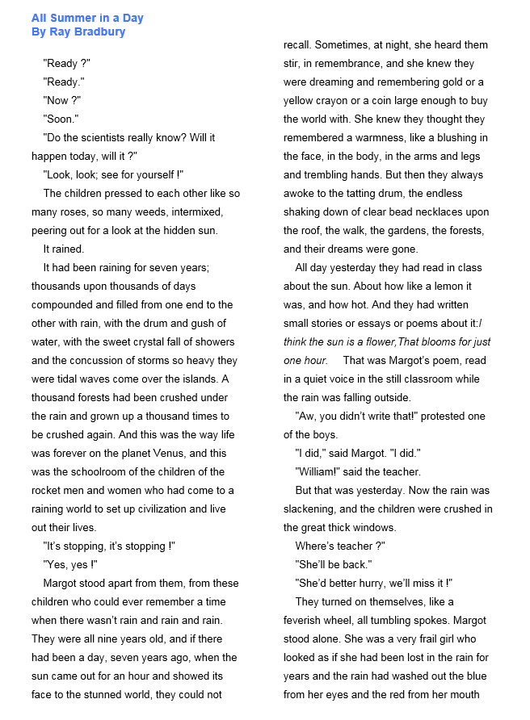

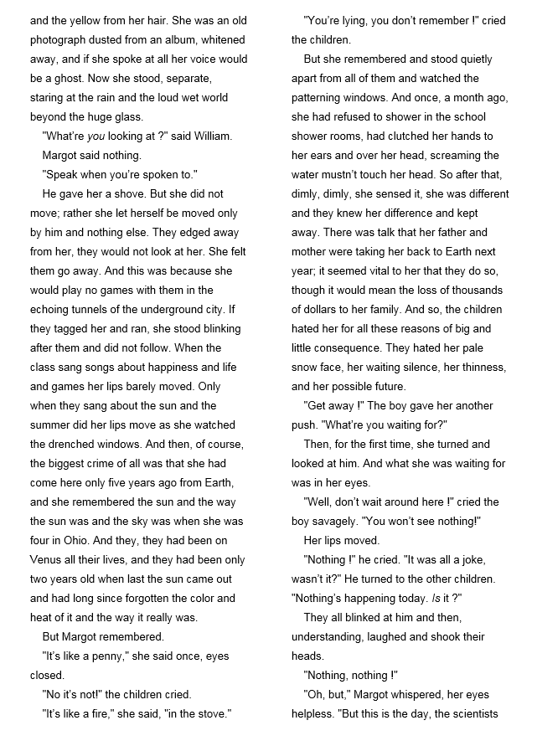

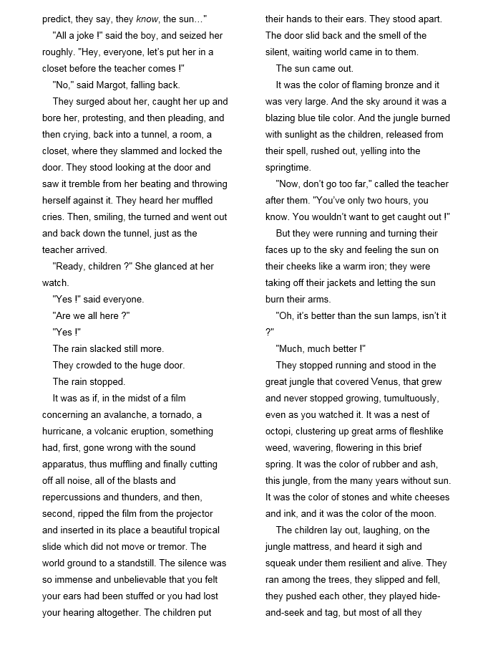

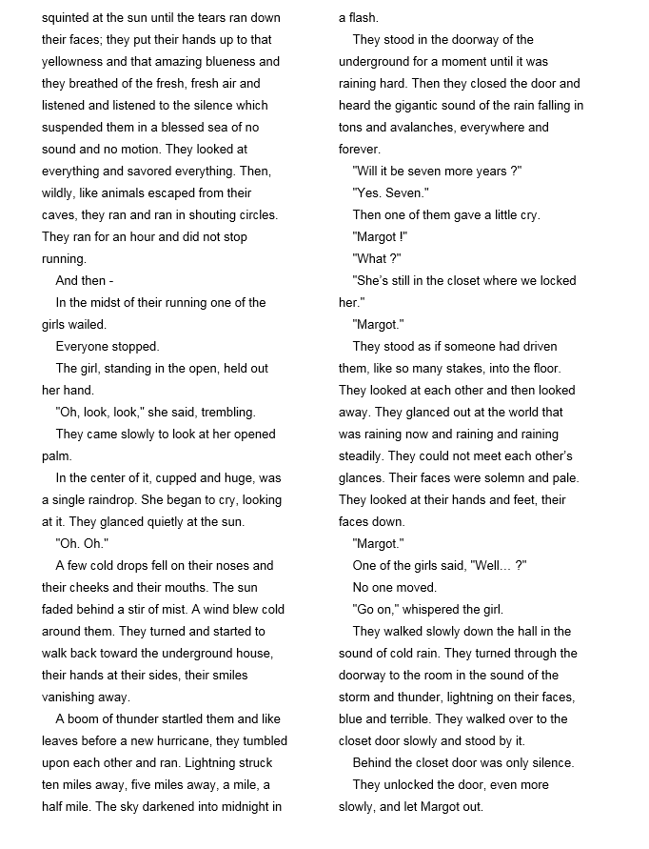

Answer the following questions in full sentences.

- Where is this story set? What are the children waiting for and why are they so excited?
__________________________________________________________________________________________________________________________________________________________________________________________________________________________________________________________________________________________________________________________________________________________________________________________________________________________________________________________________________________________

- Why do the other children resent Margot?
__________________________________________________________________________________________________________________________________________________________________________________________________________________________________________________________________________________________________________________________________________________________________________________________________________________________________________________________________

- What similes does Margot use to describe the sun to the other children?
_____________________________________________________________________________________________________________________________________________________________________________________________________________________________________________________________________________________________________________________________________________________________________________________________________________________________________________________________________________________________________________________________________________

- How do you think the children feel when they realise they have left Margot locked in the cupboard? Find a quote which reveals this. _____________________________________________________________________________________________________________________________________________________________________________________________________________________________________________________________________________________________________________________________________________________________________________________________________________________________________________________________________________________________________________________________________________

Transferring knowledge to our own writing.

Use some of the stylistic features you have seen in the short stories to help you create your own!
Look at the image and create a piece of creative writing on this. You need to at least write the opening.





