PSHE work booklet – Year 8

Contents:
- Target setting sheet
- 5 Ways to wellbeing diary
- Self-esteem activity
- UK parliament
- Budgeting

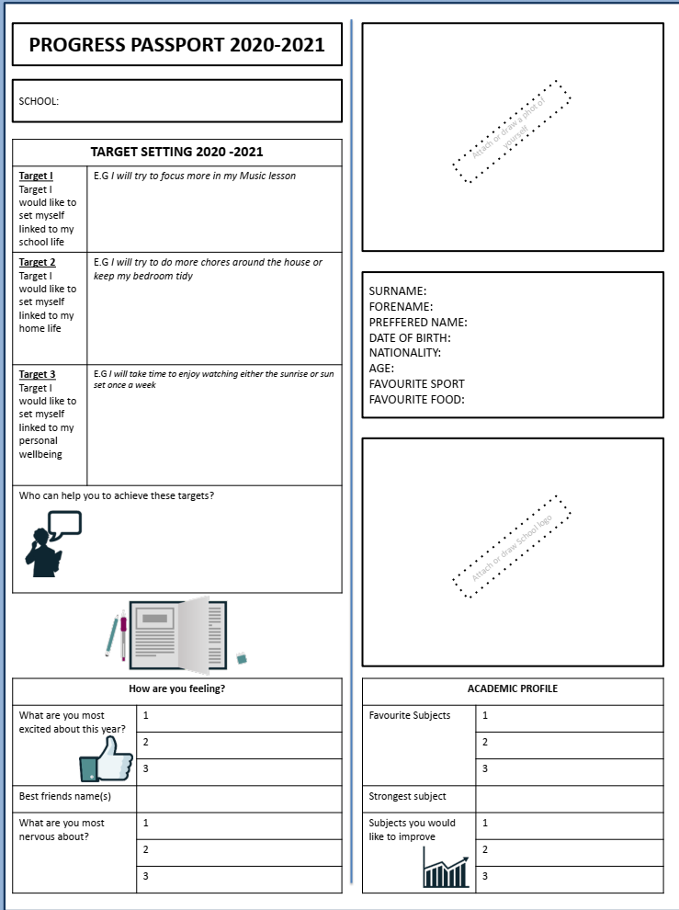
- Target setting- Fill in the following worksheet about you – think about your hopes and targets for the new school year.

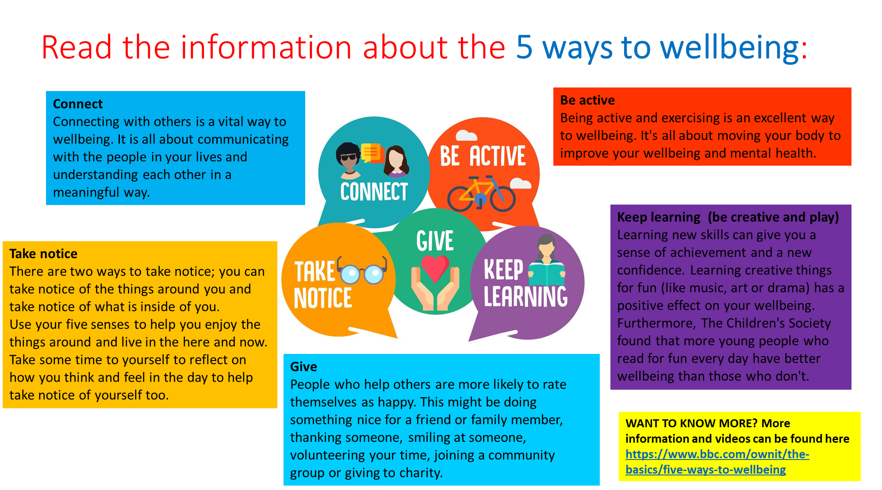
- 5 ways to wellbeing
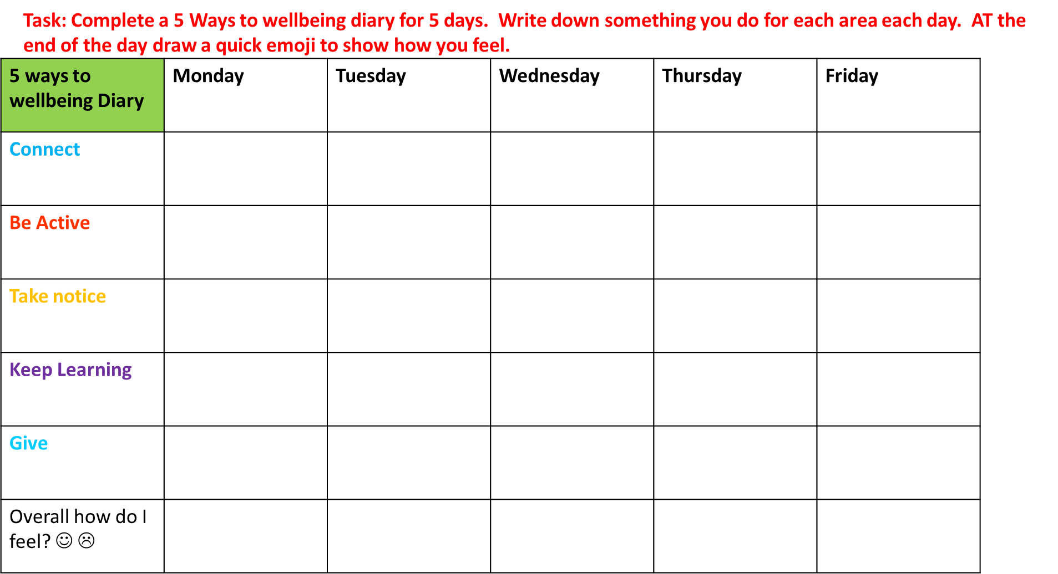
- Self esteem – Read through the information and complete the self esteem task sheet.
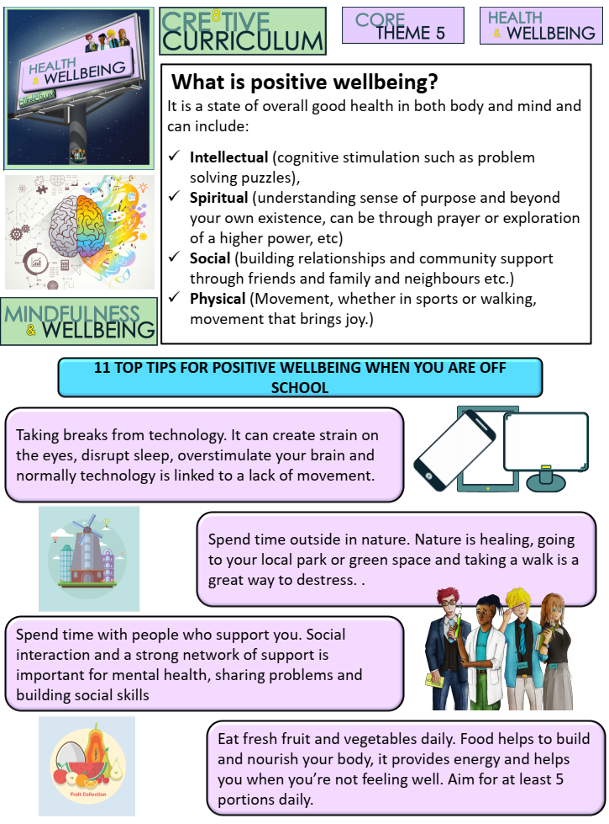
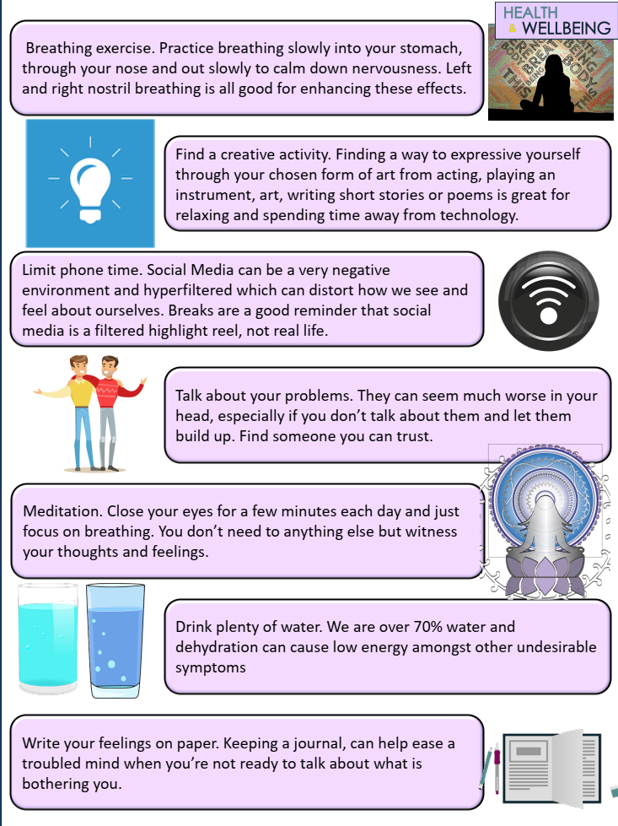

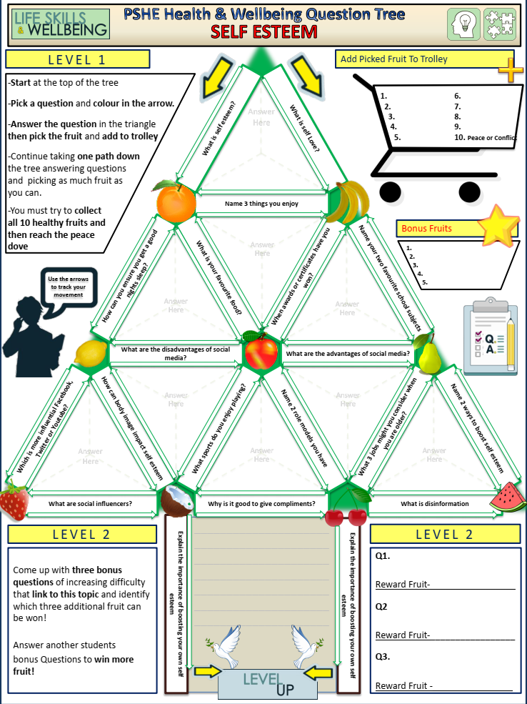

- UK Parliament

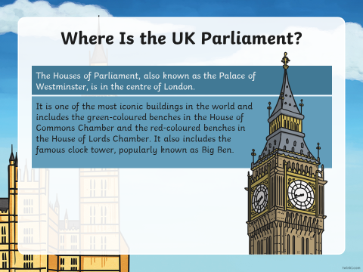
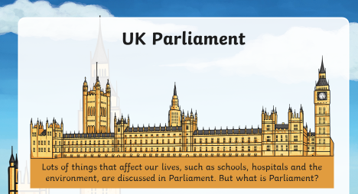
Task: Read through the following PowerPoint slides

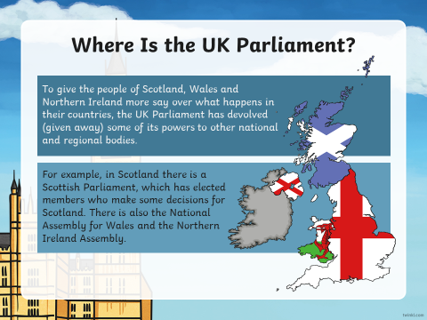

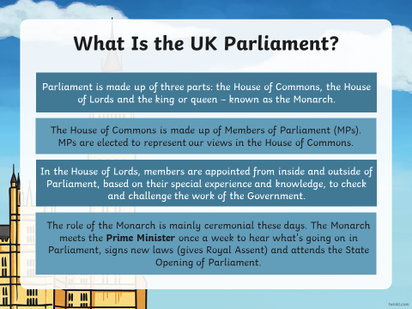

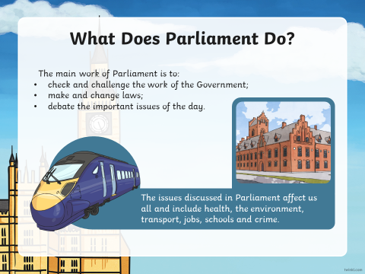

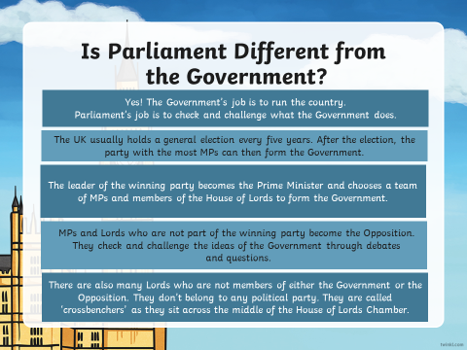

Task: Answer the following questions using the information you have read so far:

Task: What issues are important to you?
In Parliament, MPs and members of the House of Lords debate important issues that affects us all, such as schools, hospitals, crime and transport.
What issues are important to you? Look at the table below and circle/write down those you really care about.
Environment | Transport | Business | Fairness
The Arts | Animal welfare | Sports | World Poverty
Crime | Homelessness | Health | Education

Choose one to write about – why is it important to you and what would you like to see changed about it?
Write a short persuasive paragraph, use these prompts/question to help plan your answer:
- The issue:
- Why is it important to you?
- What do you think needs to change?
- What would you like parliament to do about this issue?

______________________________________________________________________________________________________________________________________________________________________________________________________________________________________________________________________________________________________________________________________________________________________________________________________________________________________________________________________________________________________________________________________________________________________________________________________________________________________________________________________________________________________________________________________________________________________________________________________________________________________________________________________________________________________________________________________________________________________________________________________________________________________________________________________________________________________________________________________________________________________________________________________________________________________________________________________________________________________________________________________________________________________________________________________

- Budgeting

