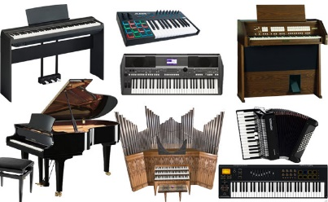
Keyboard Instruments

Name Form

- Look at the eight different images of different keyboard instruments shown below. Match the correct names of each instrument to their images choosing from the names given in the box below.

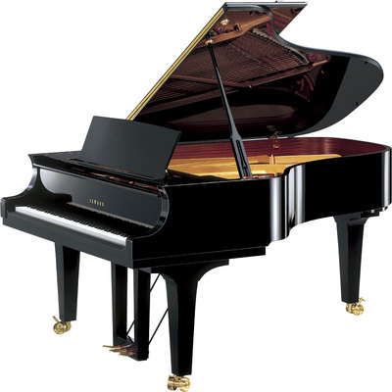 | 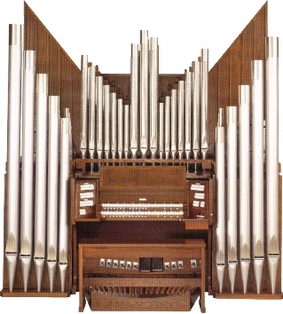 | 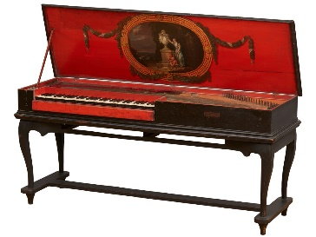 | 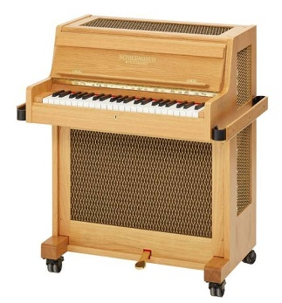
 | 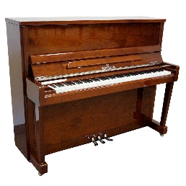 | 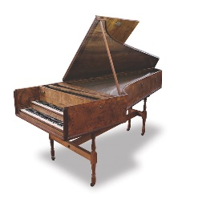

Harpsichord Celesta Upright Piano Accordion
Grand Piano Clavichord Synthesiser Organ

- Which do you think is the OLDEST type of keyboard instrument?

- Which do you think is the NEWEST type of keyboard instrument?

- Which TWO of the keyboard instruments make use of WIND or AIR to produce their sounds?

- Which FOUR of the keyboard instruments have strings inside that are either plucked, strummed or hit to produce their sound?

- Which keyboard instrument has metal bars inside that are hit to produce its sound?

- Which keyboard instrument produces its sound entirely electronically?

