Circles
Parts of a circle
Copy into your books
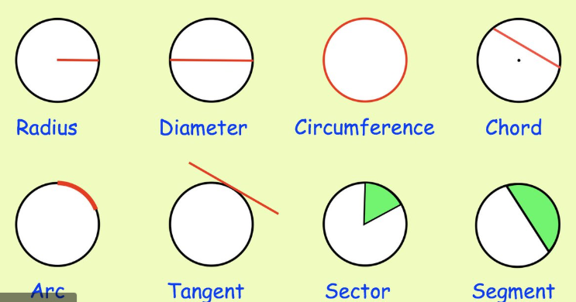
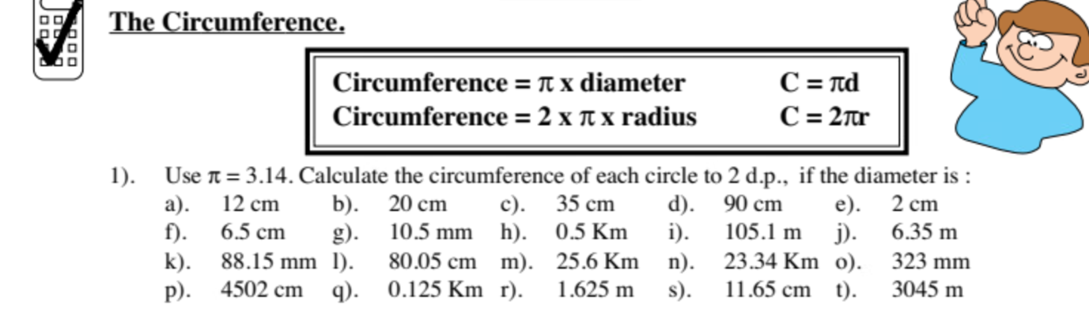
You can find the 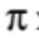button on your calculator or use the value 3.14
