Year 8 Art Worksheet 1 Milton Glaser
One of Milton Glaser’s most famous images shows a silhouetted face with bright, bold crazy hair.
Using the silhouette below, create your own image. You could use felt tips or pencil crayons.

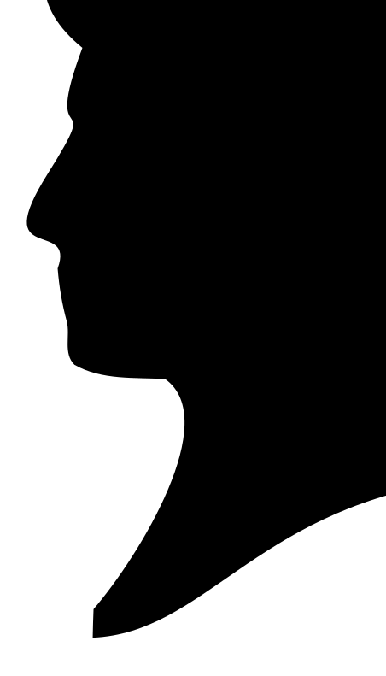

Year 8 Art Worksheet 2 Typography
Typography is about creating different styles of letters to express a brand, mood or theme. For example, a romance novel might have swirly letters, a horror novel would use a different style of lettering.
Below, create a name for a book. Consider the theme and design a title using a suitable typography. You do not need to design the whole book cover, just the title.

Year 8 Art Worksheet 3 Logos
Select two of the logos below and create accurate observational drawings.
This is more difficult than you think. The lines should be sharp, neat and accurate.

Year 8 Art Worksheet 4 Pop Art
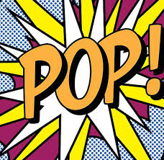
Recreate the famous Pop Art logo.
Make it bold, bright and colourful!

Year 8 Art Worksheet 5 Pop Art
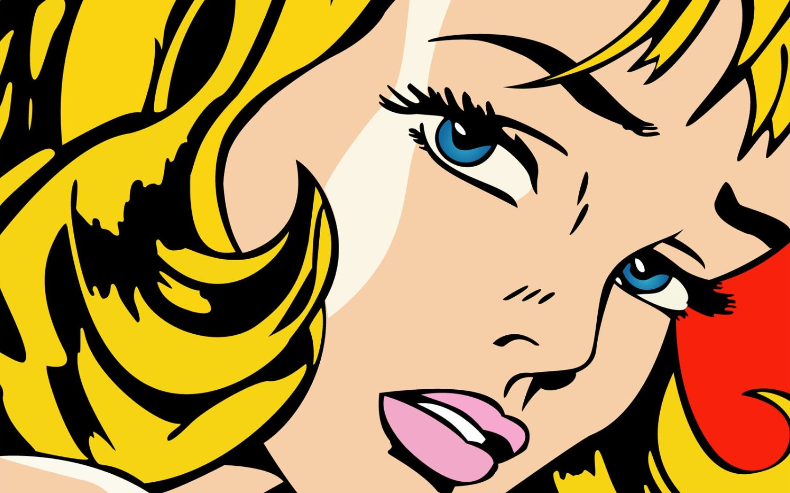
Create an observational drawing of Lichtenstein’s work.

