

Year 7

Food

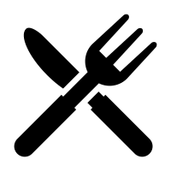

Name:……………………………………………………………………………

**Kitchen Safety and Hygiene**

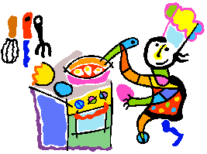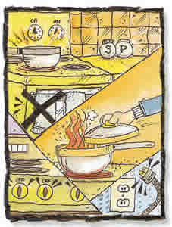

**What is Kitchen Safety?**

Cooking is fun but it is very important we know how to be safe. Do you know when you

should ask an adult for help, what to do before you start cooking and how to be safe in the kitchen? Here are 10 important rules to follow.

* Always ask permission before you start cooking.
* Never use knives with wet hands as it can make you drop them.
* Never try to catch a falling knife, you may cut yourself.
* Keep preparation areas tidy and neatly prepare all your ingredients before you start to cook so that there is nothing to cause accidents.
* Always use oven gloves when handling hot pots and pans or baking trays.
* Make sure that saucepan handles are turned in so they do not hang over the side of the cooker.
* Wear sensible footwear so that if anything drops you won’t hurt your feet.
* If something is spilled onto the floor clean it up straight away to prevent slips and falls.
* Don’t put electrical equipment near to water.
* Always ensure kitchen cleaning products are well labelled and locked away.

**What is Food Hygiene?**

The good practices which lead to clean workplaces and the safe production of food.

**What does it involve?**

1. Personal Hygiene
2. Cleaning and disinfecting
3. Preventing any bacteria multiplying
4. Destroying any harmful bacteria by cooking

Here are 5 basic rules to follow

* Never lick spoons and reuse them without cleaning them first because this will spread germs.
* Always tie long hair back so that it does not fall into food and spread germs.
* Always wash hands before preparing food.
* Never store cooked meat with raw meat as it may cause cross-contamination.
* Don’t allow pets into the kitchen while cooking.

**Activities**

**Answer the following questions on A4 paper:**

**Task One:**

**Directions:** Copy the following sentences onto a piece of paper.State whether each is “safe” or “unsafe”. For those that are unsafe, explain why.

1. Janet pulled her long hair out of her face and up into a pony tail before she started cooking.

2. Kimberly started preparing dinner while wearing flip flops.

3. Sonia finished washing her hands and went immediately back to chopping the vegetables. Since her hands were wet, she dropped the knife and tried her best to keep it from cutting her foot or hitting the floor.

4. Peter went to the bathroom and washed his hands immediately upon re-entering the kitchen before he began his food preparation.

5. Robert had only put the roast in the oven for about 5 minutes and decided to take it out quickly with his hands to finish seasoning it.

6. Steve always remembers to turn the pan handles toward the back of the stove while cooking.

7. Chloe immediately stopped what she was doing to clean up a spill on the floor.

8. Chris made sure to unplug all electrical appliances before starting to wash dishes.

**Task Two:**

Look at the following picture.

On a piece of A4 paper list any hazards or hygiene issues that can be seen in the picture. Explain why each is unsafe.

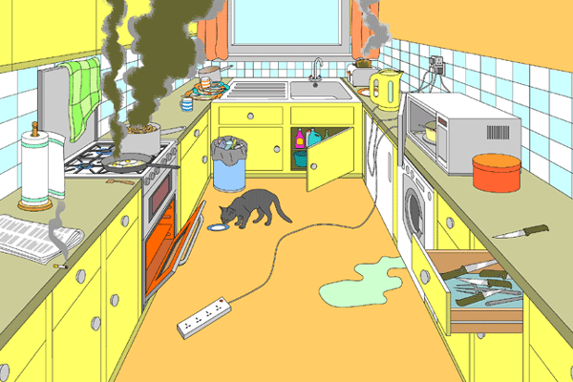

**Healthy Eating**

People choose and combine different foods to make meals and snacks. The total amount and range of foods eaten is called the diet.

Read the information about the diet and answer the questions in full detail.

Foods are split into categories:

Fruit and Vegetables

Potatoes, bread, rice, pasta and other starchy carbohydrates

Dairy and alternatives

Beans, pulses, fish, eggs, meat and other proteins

Oils and spreads

Foods high in fat, salt and sugars

The key to a healthy balanced diet is not to ban or omit any foods or food groups but to balance what you eat by consuming a variety of foods from each food group in the right proportions for good health.

It's a good idea to try to get this balance right every day, but you don't need to do it at every meal. And you might find it easier to get the balance right over a longer period, say a week.

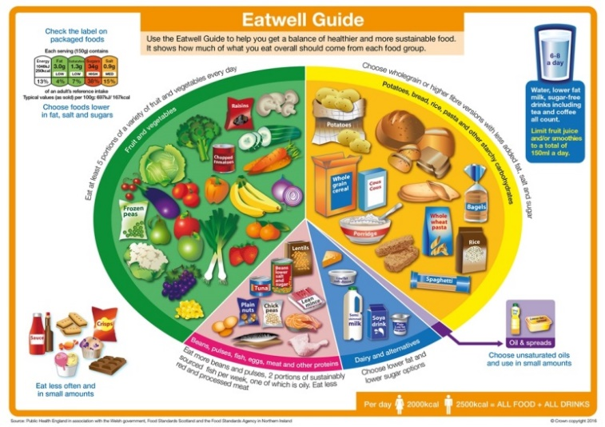

**The eatwell guide is a simple and clear way that shows the different types of food we need to eat – and in what proportions – to have a well balanced and healthy diet.**

**Fruit and vegetables**

These should make up just over a third of your daily diet and can be eaten as part of every meal, as well as being the first choice for a snack.

You should eat at least five portions of fruit and vegetables each day. Research suggests this can help to protect against obesity and various chronic diseases such as heart disease. This is because of the nutrients (vitamins and minerals) they contain.

**Potatoes, bread, rice, pasta and other starchy carbohydrates**

This food group should also make up just over a third of your diet and contains the starchy carbohydrates that are the body's main source of energy.

When selecting products from this food group, try to choose wholegrain foods as they are rich in fibre and other nutrients that have many health benefits, and people who consume whole grains seem to have a reduced risk of certain illnesses such as diabetes and coronary heart disease.

The final third of the eatwell plate is made up of three groups containing foods that need to be consumed in smaller proportions than the other two principal categories. These food groups also contain nutrients essential to our diet, so it's important not to leave them out altogether.

**Dairy and alternatives**

These should be eaten in moderation because of their high saturated fat content, but they're an important source of calcium, which is essential for healthy bones and teeth. Choose low-fat or reduced-fat versions.

**Beans, pulses, fish, eggs, meat and other proteins**

This food group includes both animal and plant sources of protein, which is a major functional and structural component of all cells. Protein provides the body with between 10 and 15 per cent of its dietary energy, and is needed for growth and repair.

**Oils and spreads**

Although some fat in the diet is essential, generally we are eating too much saturated fat and need to reduce our consumption.

Unsaturated fats are healthier fats that are usually from plant sources and in liquid form as oil, for example vegetable oil, rapeseed oil and olive oil.

**Foods high in fat, salt and sugars**

This includes products such as chocolate, cakes, biscuits, full-sugar soft drinks, butter and icecream. These foods are not needed in the diet. If they are included, have infrequently and in small amounts.

**How to eat a balanced diet**

* Eat a variety of foods to obtain all of the essential nutrients
* Too much as well as too little can be bad for you – balance is required
* Everyone's plate will look slightly different as we all have different requirements depending on our body’s shape and size, and our levels of activity.

**Is the eatwell guide for me?**

The eatwell plate applies to most people – whether they're a healthy weight or overweight, whether they eat meat or are vegetarian, and no matter what their ethnic origin.

However, it doesn't apply to children under the age of two because they have different nutritional needs. On average a student between 12 and 15 years will normally require between 2200 - 2500 Kcalories per day.

**Exercise and Diet**

It’s important to remember to keep your energy intake and energy usage in balance. Everyone is different in their energy needs because of the activities they do throughout the day. Those working in jobs which involve a lot of lifting will use more than those in office jobs. Also those who do a lot of sporting activities will use more energy than others who are less energetic. On some days when you have games or P.E. for example you may need to eat more food to balance the energy equation.

**Activities**

For each food, identify the food group from the eatwell plate to which it belongs. Copy the table below onto paper and list the main nutrients found in each food. An example has been done for you:

Choose the nutrients from the list below:

**Protein Carbohydrates Vitamins Minerals Fats/Sugars**

|  |  |  |
| --- | --- | --- |
| **Food** | **Food group from eatwell plate** | **Main nutrient(s)** |
| Cola Drink | Foods and drinks high in fat and/or sugar | Sugar |
| Rice |  |  |
| Chocolate |  |  |
| Apple |  |  |
| Wholemeal Bun |  |  |
| Beef Steak |  |  |
| Cottage Cheese |  |  |
| Canned Tuna |  |  |
| Crisps |  |  |
| Lettuce |  |  |
| Yoghurt |  |  |

**Answer the following questions:**

1. List the jobs below in order of energy requirements. Remember lifting and climbing take a lot of energy. **Postman, typist, scaffolder, driver, coal miner, hairdresser, teacher, builder, footballer, shop assistant.**
2. When you have made the list, write a detailed paragraph saying why you put the jobs in the order that you have.
3. Look at your school timetable and try to work out on which day you will use most energy. If you have a day on which you have to climb a lot of steps to get to your lessons this will use a lot of energy. If you have lessons like P.E. or where you move about a lot such as drama, you will use more energy than sitting at a desk. Check each day carefully and count 1 point for climbing to a first floor room, 2 points for a second floor room etc. Add 1 point for each active lesson such as P.E. The day with the most points is the day you will burn most food. Present the information in a chart.
4. Write a list of all the meals, snacks and drinks you had yesterday. Draw a diagram of the eatwell guide and write each item you ate in the correct category on the plate. When you have done this write a list of any activities you did. Finally write a paragraph saying whether or not you ate a balanced diet that day.
5. Design a poster that will help school children to understand what is meant by Healthy Eating, and which encourages them to make good food choices based on the Eatwell guide.

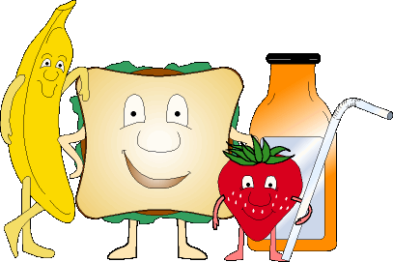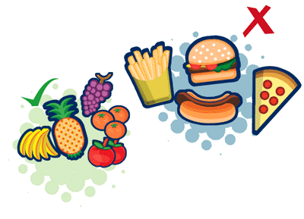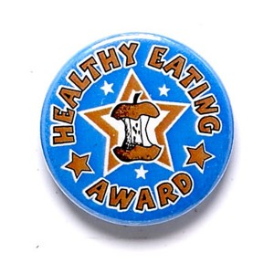

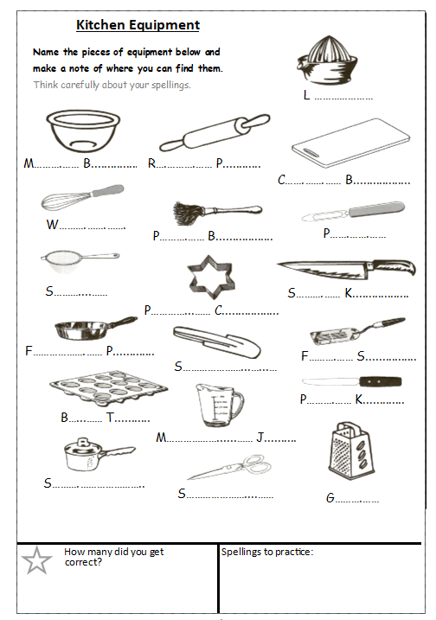

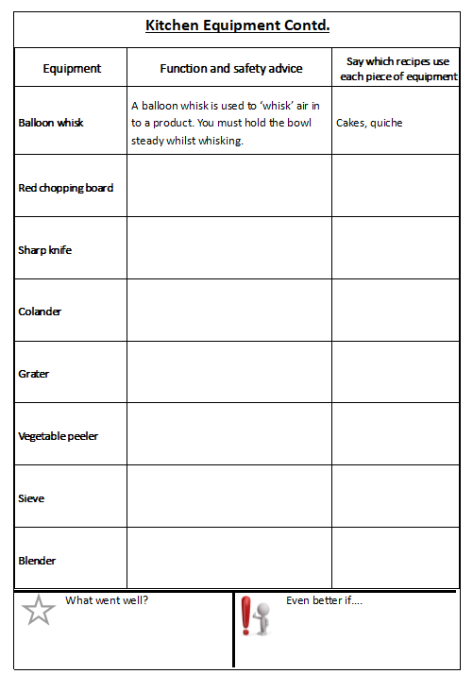

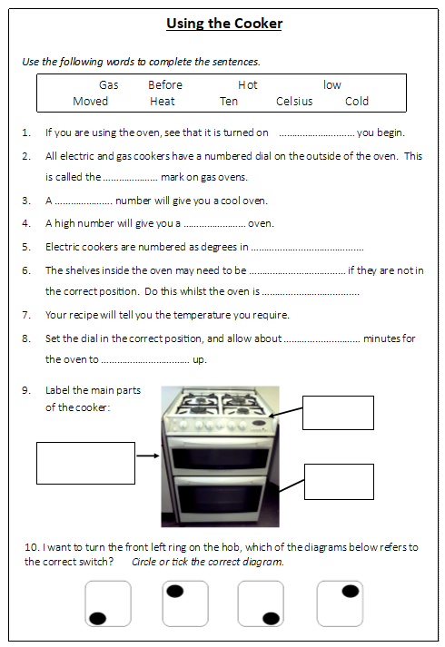

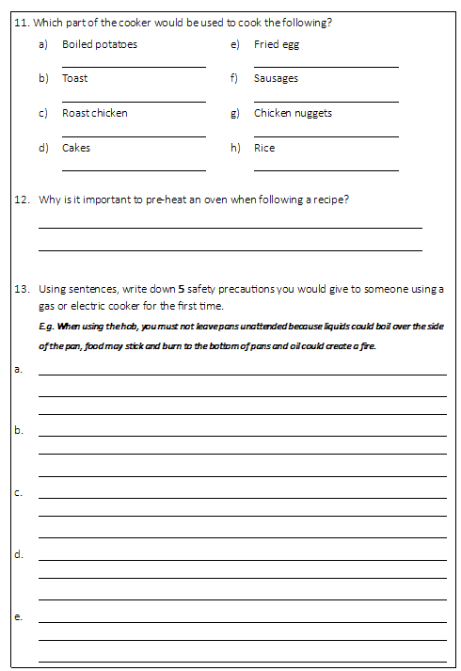

**Food and Religion**

Different religious groups eat or don’t eat different foods for a variety of reasons – these sheets highlight a few of the reasons.

|  |  |
| --- | --- |
| Jew’s | * Do not eat shell fish or pork. * They do not eat dairy and meat in the same meal (this is because they do not eat mother and child together – so you cannot have chicken and egg together or milk and beef). * They only eat kosher meats (where the blood is drained from the body through a slit in the throat before the meat is soaked or salted). Kosher houses should have different sinks for dairy and meat along with different plates, cutlery and utensils: this is taken very seriously with in the Jewish religion. * Jews have fast days including Yom Kippur, Rosh Hashanah and Passover. |
| Hindus | * Do not eat Beef or any beef product – this is because the cow is a sacred animal and is treated as such. (This includes the use of leather for furniture). * Milk is permitted as no animal is killed during the collection. * Often vegetarian which comes from the principle of Ahimsa (not harming)? * Most Hindus don’t drink alcohol. |
| Sikhs | * Do not eat beef either for the same reasons as Hindus. * Many Sikhs are also vegetarians. * Many Sikhs will not eat Halal or Kosher meat as they believe they are not killed humanly. * Devout Sikhs do not drink alcohol. |
| Muslims | * Do not eat pork. * Only eat Halal meat (which is killed in the same way as Kosher). * Sea food without fins or scales (such as crabs, prawns and squids) considered undesirable by some Muslims. * Muslims should also avoid alcohol. * Muslims don’t eat whilst the sun is shining during the month long fast called Ramadan (Oct/Nov time) |
| Buddhists | * Buddhist try to avoid intentionally killing, Monks and Nuns are usually very strict and can be vegetarians. * Others will eat meat as long as it was not killed for the specific purpose of food. * Chinese Buddhists also avoid garlic and onions as they believe it makes meditation more difficult. |
| Some Catholics | * Some Catholics fast on Fridays and during the run up to lent. * Some Catholics eat fish on a Friday. |

**Activities**

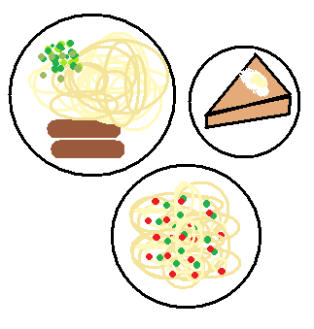Complete the following activities on A4 paper.

**Task one:**

Develop a 3 part meal suitable for one of the religious

groups you have looked at.

* Starter – soup or light bite.
* Main meal- Consider what type of meat, fish or vegetables that are suitable for your chosen religion
* Dessert- this can be sweet or savoury.

Write out your menu in detail as though it would be

used in a restaurant. You may use colour and add

images/drawings.

**Task two:**

State why the menu you have chosen is appropriate for the religious group you have chosen.

**Task three:**

Looking at your menu try to answer the following:

* Are there any special food stuffs you will need to find for your meal?
* Where could you get these specialist foods from?
* How can you prove the meal meets the dietary needs of your chosen religion? – show what nutrients you think your meal will provide. (For help with this read the healthy eating section of the booklet)

**Task four:**

Choose one of the religious groups above and design a leaflet that could be used to help someone, who doesn’t know about that religion, understand the dietary needs. Your leaflet should be colourful, eye-catching and informative.