Year 7
Developing Reading Skills

Introduction:
What is meant by ‘adventure’?

Adventure = An exciting experience that is typically bold, exciting, and sometimes dangerous. Adventures may be activities with some potential for physical danger such as travelling, exploring, skydiving, mountain climbing, scuba diving, etc.
Adventure fiction = Any writing (e.g. short stories or novels) based on imaginary events or people. Typically, characters will embark on a quest, journey or mission.
Adventure non-fiction = Any writing (e.g. autobiographies, travel writing) based on facts, real events, and real people’s adventures, e.g. expeditions or missions.

Examples:
Can you think of any books, films or TV shows that are
based on an adventure?
Books: | Films / TV Shows:
- Lord of the Flies  - Treasure Island | - Jumanji  - Avengers

Key Features of Adventure Writing:

- Adventure writing can take the form of fiction (stories about an imaginary place or people) or non-fiction (writing based on real-life events and people).

- Adventure writing often include:
  - Something exciting and extraordinary, often a quest or a mission.
  - Escaping danger, going on a quest, or experiencing something out of the ordinary.

- Watch this short video called ‘Adventure Novel Genre Introduction’ and make notes.
- what are the key features of adventure writing?
- what type of characters are typically included in an adventure story?
- can you think of any settings where adventure stories might be set?
- do you recognise any of the adventure stories in the video?
TASKS:
1. Think of an adventure novel or film that you know of.
Which key features / characteristics of adventure writing do they show?
If you don’t know any adventure novels or films, try researching them online or look
at the pictures below to give you inspiration.
Novel or film name: _______________________________________________________

Which key features of the adventure genre does it show? ______________________________
_______________________________________________________________________
_______________________________________________________________________
_______________________________________________________________________
_______________________________________________________________________
_______________________________________________________________________
_______________________________________________________________________
_______________________________________________________________________
_______________________________________________________________________

Characteristics of Adventure Fiction
Further Reading

Overview:
Adventure stories feature physical action and courageous heroes who save others from danger or impending doom. The adventure genre of fiction is fast-paced and usually centres on a protagonist (main character) in a dangerous or risky situation. Adventure fiction overlaps other genres, such as romance, thrillers, and science fiction.
Action and Excitement:
Adventure novels typically have fast-paced, action-packed plot lines. Stories about epic journeys or epic tales - often involving a mixture of adventure and fantasy - culminate with a thrilling climax or a series of climactic events. Examples include The Odyssey by Homer and Lord of the Rings by J.R.R. Tolkien. The setting of an adventure story often takes place in other worlds, places not yet discovered, or treacherous terrains (e.g. rainforests or Antarctica).

Courageous Protagonists:
Adventure-genre protagonists (main characters) are usually brave and logical. Examples include Katniss Everdeen in The Hunger Games series by Suzanne Collins and Beatrice Prior in the Divergent series by Veronica Roth. Heroes in adventure stories often face life or death scenarios that test their willingness to sacrifice their own lives for the sake of the greater good. Adventure stories contain a sense of urgency, so protagonists must accomplish their goals or missions in a short period of time.

Evil Adversaries:
Antagonists (the main character’s enemy or rival) in adventure novels tend to be extremely evil, so readers desperately want the hero or heroine to defeat them. Villains in superhero adventure stories show little regard for human life and have self-serving interests, such as the unquenchable desire for power, fame, or wealth. Even though heroes in adventure fiction have character flaws and often evolve during the story, the genre contains clearly defined ‘good’ and ‘bad’ characters.

Read the text above and add key information to your notes.
Use your notes to help you complete the task on the next page.

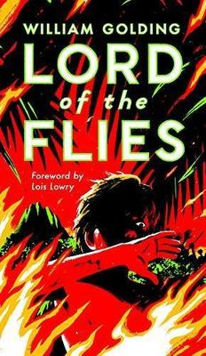
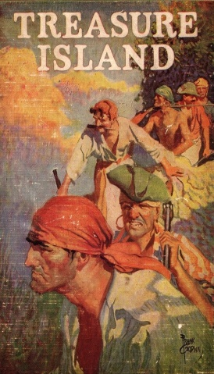
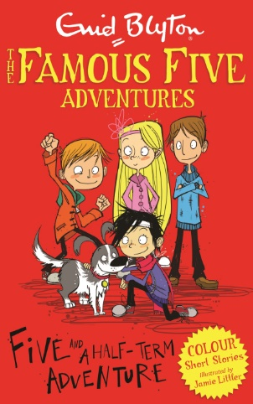
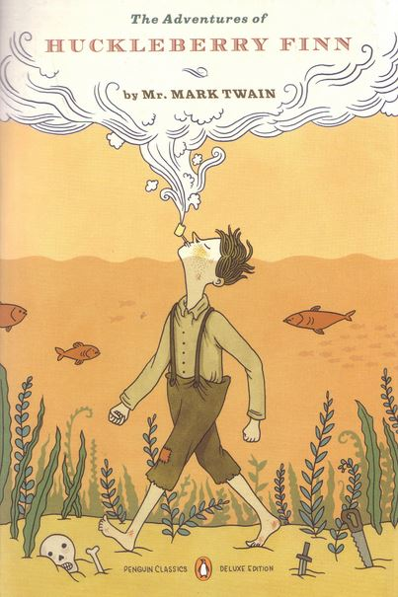
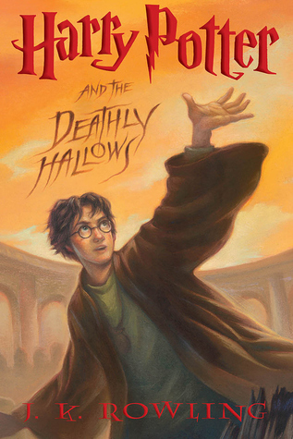
2. Create an adventure fact-file outlining how and why your chosen book / film is a good exemplar of this genre.
Include:
- plot summary
- main characters
- key features and characteristics of the adventure genre
- reviews from readers and commentaries from experts
- your personal opinion

Extract 1:
Reading an example of adventure fiction
Extract from Chapter One of Alice’s Adventures in Wonderland
by Lewis Carroll
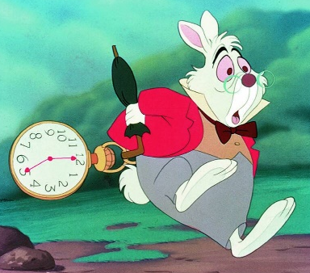
Extract summary:
In this extract Alice is sitting drowsily by a riverbank, bored by the book her older sister reads to her. Out of nowhere, a white rabbit runs past her, fretting as is it will be late. The Rabbit pulls a watch out of his waistcoat pocket and runs across the field and down a hole. Alice impulsively follows the rabbit and tumbles down the deep hole that resembles a well, falling slowly for a long time.
Extract 1: Alice was beginning to get very tired of sitting by her sister on the bank, and of having nothing to do: once or twice she had peeped into the book her sister was reading, but it had no pictures or conversations in it, “and what is the use of a book,” thought Alice, “without pictures or conversations?”
So she was considering, in her own mind, whether the pleasure of making a daisy-chain would be worth the trouble of getting up and picking the daisies, when suddenly a White Rabbit with pink eyes ran close by her.
There was nothing so very remarkable in that; nor did Alice think it so very much out of the way to hear the Rabbit say to itself “Oh dear! Oh dear! I shall be too late!” but, when the Rabbit actually took a watch out of its waistcoat-pocket, and looked at it, and then hurried on, Alice started to her feet, for it flashed across her mind that she had never before seen a rabbit with either a waistcoat-pocket, or a watch to take out of it, and, burning with curiosity, she ran across the field after it, and was just in time to see it pop down a large rabbit-hole under the hedge.

TASKS:
- Read the extract from Alice’s Adventures in Wonderland (above).
- Highlight / underline any parts that show you this novel could be considered an adventure story.

- Write one of the quotes you have highlighted here and explain how it shows the idea of ‘adventure’.
QUOTE: ______________________________________________________________________________________
This shows the idea of adventure because:__________________________________________________________
_____________________________________________________________________________________________
_____________________________________________________________________________________________
_____________________________________________________________________________________________
_____________________________________________________________________________________________

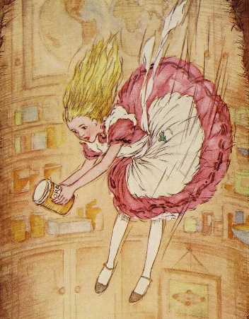
Extract 2: In another moment down went Alice after it, never once considering how in
the world she was to get out again. The rabbit-hole went straight on like a tunnel for
some way, and then dipped suddenly down, so suddenly that Alice had not a moment
to think about stopping herself before she found herself falling down a very deep well.
Either the well was very deep, or she fell very slowly, for she had plenty of time as she
went down to look about her and to wonder what was going to happen next. First, she
tried to look down and make out what she was coming to, but it was too dark to see
anything; then she looked at the sides of the well, and noticed that they were filled
with cupboards and book-shelves; here and there she saw maps and pictures hung
upon pegs. She took down a jar from one of the shelves as she passed; it was labelled ‘ORANGE MARMALADE’, but to her great disappointment it was empty: she did not like to drop the jar for fear of killing somebody, so managed to put it into one of the cupboards as she fell past it.
‘Well!’ thought Alice to herself, ‘after such a fall as this, I shall think nothing of tumbling downstairs! How brave they'll all think me at home! Why, I wouldn't say anything about it, even if I fell off the top of the house!’
Down, down, down...When suddenly, thump! thump! down she came upon a heap of sticks and dry leaves, and the fall was over.
Alice was not a bit hurt, and she jumped up on to her feet in a moment: she looked up, but it was all dark overhead; before her was another long passage, and the White Rabbit was still in sight, hurrying down it. There was not a moment to be lost: away went Alice like the wind, and was just in time to hear it say, as it turned a corner, ‘Oh my ears and whiskers, how late it's getting!’ She was close behind it when she turned the corner, but the Rabbit was no longer to be seen.

- A student read the extract from Alice’s Adventures in Wonderland and said: ‘The writer makes me think that Alice is about to have an amazing adventure.’ To what extent do you agree?
In your answer, you should:
- state whether you agree or disagree with the statement and explain why
- include evidence (quotes) from the extract to support your opinion
- explain what each quote tells the reader about Alice’s fantasy land / adventure
- pick out some individual words or techniques used by the writer and explain their effect
- include your personal opinion – are you interested in Alice’s fantasy land? Why, or why not?
AIM TO WRITE AT LEAST ONE PEE PARAGRAPH (you may need to use extra paper).
____________________________________________________________________________________________
____________________________________________________________________________________________
____________________________________________________________________________________________
____________________________________________________________________________________________
____________________________________________________________________________________________
____________________________________________________________________________________________
____________________________________________________________________________________________
Extract 4:
Setting in Adventure Writing
- The choice of setting is extremely important when writing a story.
The great thing about an adventure story is that you can let your imagination run wild!
- A writer’s choice of setting helps create an expectation or impression for the reader of what might happen to the protagonist (main character), or helps them to sympathise with the characters’ suffering.
- Your story could be set on Earth, maybe after an apocalypse, nuclear war, a world-wide pandemic/disease, or an alien invasion. Or it could be set in a remote part of the planet, such as a tropical island, in the middle of the ocean or the Antarctic. Or, it could be set somewhere completely ordinary and familiar!
- However, your story could be set ‘elsewhere’: another planet or somewhere not yet discovered by humans. This would allow you to really use your imagination!
- This week, you are going to look at some examples of adventure settings in fiction. This will help you prepare for creating your own adventure setting next week.
Look at the pictures below to give you an idea:

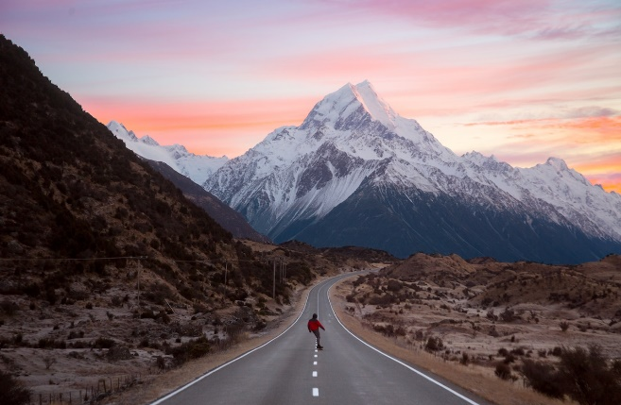
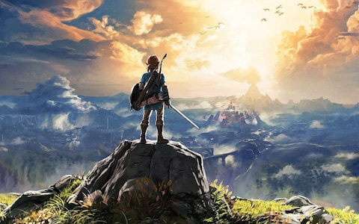
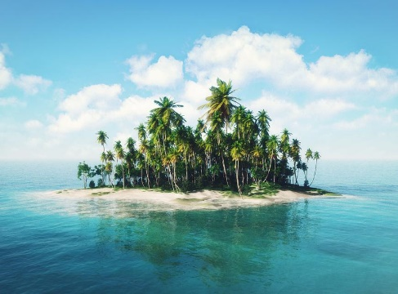
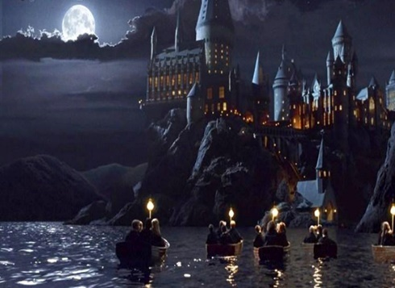

Setting: The Hunger Games – Suzanne Collins
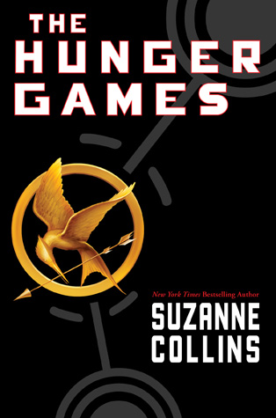
Our house is almost at the edge of the seam. I only have to pass a few gates to reach the scruffy field called the Meadow. Separating the meadow from the woods, in fact enclosing all of District 12, is a high chain-link fence topped with barbed wire loops. In theory, it’s supposed to be electrified twenty-four hours a day as a deterrent to the predators that live in the woods – packs of wild dogs, lone cougars, bears – that used to threaten our streets. But since we’re lucky to get two or three hours of electricity in the evenings, it’s usually safe to touch. Even so, I always take a moment to listen carefully for the hum that means the fence is live. Right now, it’s silent as a stone. Concealed by a clump of bushes, I flatten out on my belly and slide under a meter-long stretch that’s been loose for years. There are several other weak spots in the fence, but this one is so close to home I almost always enter the woods here.
As soon as I’m in the trees, I retrieve a bow and sheath of arrows from a hollow log. Electrified or not, the fence has been successful at keeping the flesh-eaters out of District 12. Inside the woods they roam freely, and there are added concerns like venomous snakes, rabid animals, and no real paths to follow. But there’s also food if you know how to find it. My father knew and he taught me some ways before he was blown to bits in a mine explosion. There was nothing left of him to bury. I was eleven then. Five years later, I still wake up screaming for him to run.
In the woods waits the only person with whom I can be myself. Gale. I can feel the muscles in my face relaxing, my pace quickening as I climb the hills to our place, a rock ledge overlooking a valley. A thicket of berry bushes protect it from unwanted eyes. The sight of him waiting there brings on a smile. Gale says I never smile except in the woods.
TASKS:
- Read The Hunger Games extract (above).
- Look for and highlight these language features used by the author to describe the setting:
  - Simile
  - 3-part lists (there are two to find!)
  - Alliteration
  - Onomatopoeia (a word that sounds like the noise it makes, e.g. Bang!)
  - Imagery
  - Personification (giving human characteristics to something non-human)

- CHALLENGE: How does the narrator (Katniss Everdeen) feel about the setting?
Explain your answer and include quotes in your response.
Extract 5 Setting: The Chronicles of Narnia – C.S. Lewis
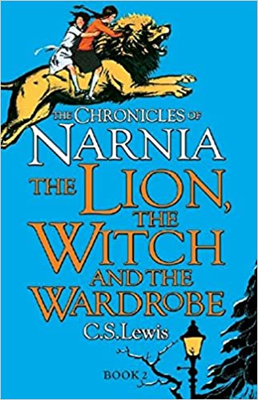
TASKS:
- Read the Chronicles of Narnia extract (above).
The film trailer is available here to help you visualise the setting.
- Look for and highlight these language features used by the author to describe the setting:
  - Imagery
  - Personification (giving human characteristics to something non-human)
  - Onomatopoeia (a word that sounds like the noise it makes, e.g. Bang!)
  - Alliteration

- CHALLENGE: How does the writer make you feel about this setting?
Explain your answer and include quotes in your response.
Every moment the patches of green grew bigger and the patches of snow grew smaller.
Every moment more and more of the trees shook off their robes of snow. Soon, wherever
you looked, instead of white shapes you saw the dark green of firs or the black prickly
branches of bare oaks and beeches and elms.
Then the mist turned from white to gold and presently cleared away altogether. Shafts of
delicious sunlight struck down on to the forest floor and overhead you could see a blue
sky between the treetops. Soon there were more wonderful things happening.
Coming suddenly round a corner into a glade of silver birch trees, Edmund saw the
ground covered in all directions with little yellow flowers. The noise of water grew louder.
Presently they crossed a stream. Beyond it they found snowdrops growing.
Only five minutes later, Edmund noticed a dozen crocuses growing round the foot of an
old tree - gold and purple and white.
Then came a sound even more delicious than the sound of the water. Close beside the path they were following, a bird suddenly chirped from the branch of a tree. It was answered by the chuckle of another bird a little further off. And then, as if that had been a signal, there was chattering and chirruping in every direction, and then a moment of full song, and within five minutes the whole wood was ringing with birds' music, and wherever Edmund's eyes turned he saw birds alighting on branches, or sailing overhead or chasing one another or having their little quarrels or tidying up their feathers with their beaks.
There was no trace of the fog now. The sky became bluer and bluer, and now there were white clouds hurrying across it from time to time. In the wide glades there were primroses. A light breeze sprang up which scattered drops of moisture from the swaying branches and carried cool, delicious scents against the faces of the travellers.
The trees began to come fully alive. The larches and birches were covered with green, the laburnums with gold. Soon the beech trees had put forth their delicate, transparent leaves. As the travellers walked under them the light also became green. A bee buzzed across their path. "This is no thaw," said the dwarf, suddenly stopping. "This is Spring.”
Compare the two settings:
How do the authors present the setting in these extracts?
The Hunger Games | Both | The Chronicles of Narnia
Idea 1: The setting in this extract is dangerous and threatening.  Quote 1: ‘packs of wild dogs, lone cougars, bears’  Idea 2:  Quote 2:  Idea 3:  Quote 3: | Idea 1: Both extracts are set in woodland with a focus on nature.  Quote 1 (Hunger Games):  ‘As soon as I’m in the trees, I retrieve a bow and sheath of arrows from a hollow log.’  Quote 1 (Narnia): ‘the dark green of firs or the black prickly  branches of bare oaks and beeches and elms.’ | Idea 1: The setting in this extract is calm, tranquil and peaceful.  Quote 1: ‘The sky became bluer and bluer’  Idea 2:  Quote 2:  Idea 3:  Quote 3:
EXTENSION HINT: Try to think of examples that support big ideas. i.e. the setting is dangerous, the setting is special to the speaker, the setting is isolated from the rest of the population
Plan for at least 3 areas of comparison.
e.g.
P 1: Both present the setting as dangerous
  - The Chronicles of Narnia:
    - Imagery (‘there was chattering and chirruping in every direction, and then a moment of full song, and within five minutes the whole wood was ringing with birds' music‘)
    - Personification (‘The trees began to come fully alive.’)
  - The Hunger Games:
    - 3 part list (x2!): (‘packs of wild dogs, lone cougars, bears’; ‘venomous snakes, rabid animals, and no real paths to follow’)
    - Onomatopoeia / Personification: (‘I always take a moment to listen carefully for the hum that means the fence is live’)

Compare the two settings:
How do the authors present the setting in these extracts?
Use your ideas from the table on the previous page to compare the settings used in The Hunger Games and The Chronicles of Narnia. Aim to write three paragraphs – you may need extra paper.

______________________________________________________________________________________
______________________________________________________________________________________
______________________________________________________________________________________
______________________________________________________________________________________
______________________________________________________________________________________
______________________________________________________________________________________
______________________________________________________________________________________
______________________________________________________________________________________
______________________________________________________________________________________
______________________________________________________________________________________
______________________________________________________________________________________
______________________________________________________________________________________
______________________________________________________________________________________
______________________________________________________________________________________
______________________________________________________________________________________
______________________________________________________________________________________
______________________________________________________________________________________
______________________________________________________________________________________
______________________________________________________________________________________
Key words
dangerous simile
isolated metaphor
relaxing personification
threatening three-part list
tranquil imagery
perilous onomatopoeia
Sentence starters (if you need them!):
The writer presents the setting in _______ as…
This is seen in the quote…
This quote suggests that…
The use of the [language feature] creates the impression that…
The word ‘____’ implies…
This is similar / different to the setting in the other extract because…
Transferring Reading to Writing:
Creating Your Own Setting
- By now, you should have an idea of what adventure writing is, some key characteristics of adventure writing, and what an adventure setting could look like.

- This week, you are going to create your own adventure setting.
Look back at Week Three if you need reminding.

- You will eventually write your own adventure story, so this setting could be the basis for your story when we come to plan it next week!

- Use the space below to plan some ideas before drawing your setting on the next page.

Where is it set?
(a town, city, different country or planet?)

What makes it an ‘adventure setting’?
(post-apocalyptic, alien invasion, deadly pandemic, new planet, isolated area or other?)

When is it set?
(the present day or in the future?)
Adventure
Setting

Any other details or ideas?

Begin by drawing your setting below:

TASK:
Using your drawing to guide you (or the image above if you are still unsure), write a description of your chosen setting. Remember to use punctuation and descriptive language techniques.
*NOTE – This is not your adventure story (yet!). The purpose of the description is to create a clear image of your setting in your head before we start planning your story. You may need extra paper.
_____________________________________________________________________________________
_____________________________________________________________________________________
_____________________________________________________________________________________
_____________________________________________________________________________________
_____________________________________________________________________________________
_____________________________________________________________________________________
_____________________________________________________________________________________
_____________________________________________________________________________________
_____________________________________________________________________________________
_____________________________________________________________________________________
_____________________________________________________________________________________
_____________________________________________________________________________________
_____________________________________________________________________________________
_____________________________________________________________________________________
_____________________________________________________________________________________
_____________________________________________________________________________________
_____________________________________________________________________________________

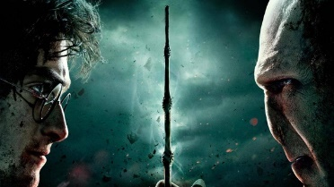
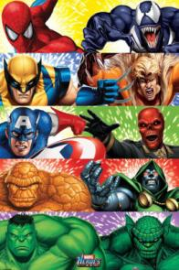
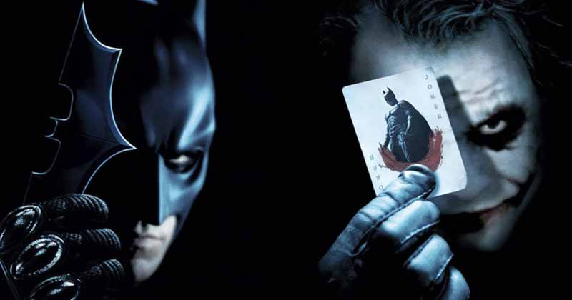
Extract 6:
Character
If you read adventure books, or you have watched some adventure films, you may already know what type of characters to expect.
Below is a list of ‘typical’ characters you might find in a dystopian novel:
- the protagonist (main character) may go on a dangerous journey in order to solve a problem or reach a goal.
- the antagonist (villain or enemy) may present obstacles that complicate the protagonist’s situation, making it harder for them to solve the problem or reach the goal.

Extracts from Harry Potter by J.K. Rowling
Description of Harry (protagonist):
‘Perhaps it had something to do with living in a dark cupboard, but Harry had always been small and skinny for his age. He looked even smaller and skinnier than he really was because all he had to wear were old clothes of Dudley's, and Dudley was about four times bigger than he was. Harry had a thin face, knobbly knees, black hair, and bright green eyes. He wore round glasses held together with a lot of Scotch tape because of all the times Dudley had punched him on the nose. The only thing Harry liked about his own appearance was a very thin scar on his forehead that was shaped like a bolt of lightning. He had had it as long as he could remember, and the first question he could ever remember asking his Aunt Petunia was how he had gotten it.’
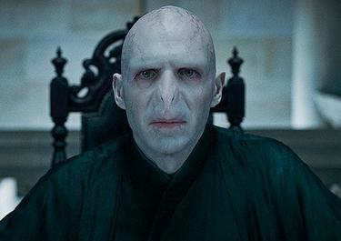
Description of Voldemort (antagonist):
‘His face shone through the gloom, hairless, snake-like, with slits for nostrils and gleaming red eyes whose pupils were vertical. He was so pale that he seemed to emit a pearly glow…His red eyes fastened upon Snape’s black ones with such intensity that some of the watchers looked away, apparently fearful that they themselves would be scorched by the ferocity of the gaze. After a moment or two, Voldemort’s lipless mouth curved into something like a smile.’
Key words
dangerous adjective
threatening verb
harmful simile
harmless pleasant
benign sympathy

Sentence starters (if you need them!):
The writer presents the character of _______ as…
This is seen in the quote…
This quote suggests that…
The use of the [language feature] creates the impression that…
The word ‘____’ implies…
This creates the impression that…
TASKS:
- Read the extract from Harry Potter (previous page).
- Highlight / underline any quotes that describe:
a. Harry
b. Voldemort

- Write one of the quotes you have highlighted / underlined here and explain what is suggests about the character.
QUOTE: _____________________________________________________________________________
This suggests that _____________________________________________________________________
____________________________________________________________________________________
____________________________________________________________________________________
____________________________________________________________________________________
- CHALLENGE: Write two paragraphs in response to this question:
What impression does Rowling create of each character in the extract?

____________________________________________________________________________________
____________________________________________________________________________________
____________________________________________________________________________________
____________________________________________________________________________________
____________________________________________________________________________________
____________________________________________________________________________________
____________________________________________________________________________________
____________________________________________________________________________________
____________________________________________________________________________________
____________________________________________________________________________________
____________________________________________________________________________________
____________________________________________________________________________________
____________________________________________________________________________________
____________________________________________________________________________________
____________________________________________________________________________________

