FABRIC PROPERTIES

LEARNING OUTCOME: YOU WILL BE ABLE TO IDENTIFY THE EXPECTED PROPERTIES OF A PROPOSED TEXTILE ITEM AND
CHOOSE A SUITABLE FABRIC

PROPERTIES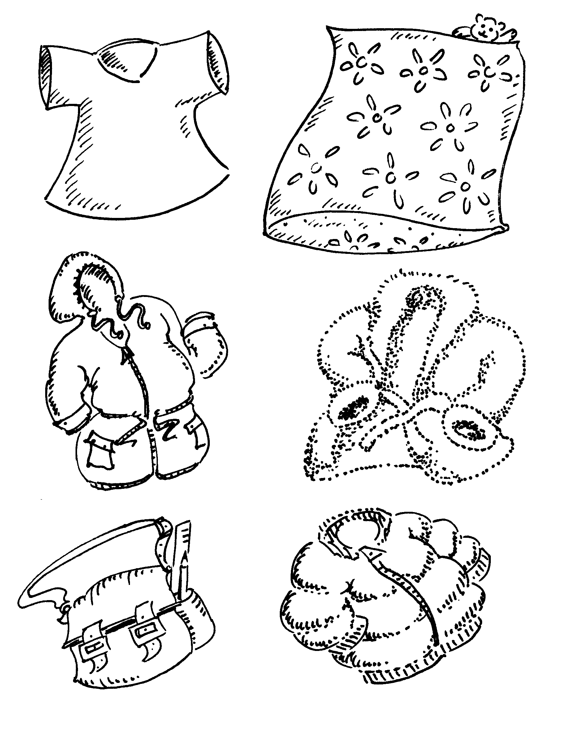

1 In ‘Fabric Construction’ you identified the
properties of different materials. Choose appropriate words from the chart and write them around
the six textile items shown in the illustration.
2 Identify which fabrics would be
suitable for the six items illustrated. Write the name of your chosen fabric next to the item.
3 Create a reference chart to show fabrics and their properties. List these under the headings:
• properties
• textures
• appearance.
PROPERTIES
Checked
Shiny
stretchy
warm
light
waterproof
absorbent
strong
heavy
washable
easy to iron
crease resistant
stain resistant
hard wearing
easily dyed
wind proof
dull
dark
insulating
non-iron
soft
smooth
comfortable
warm
hard
rough
stiff
crisp
coloured
plain
patterned
stripy

…………………………………………………………………………………………………………………………………………………………………………………………………………………………………………………………………………………………………………………………………………………………………………………………………………………………………………………………………………………………………………………………………………………………………………………………………………………………………………………………………………………
…………………………………………………
…………………………………………………
………………………………………………………………………………………………………………………………………………………

