FABRIC CONSTRUCTION

LEARNING OUTCOME: YOU WILL BE ABLE TO IDENTIFY HOW A FABRIC IS CONSTRUCTED

1 What are the different construction methods
used for fabrics? The illustration will give you
some ideas.
Why do we need fabrics made in different ways?
2 Draw a diagram of each of the construction
methods and record the different ways in which
each type of fabric is used. Can you think of anymore?
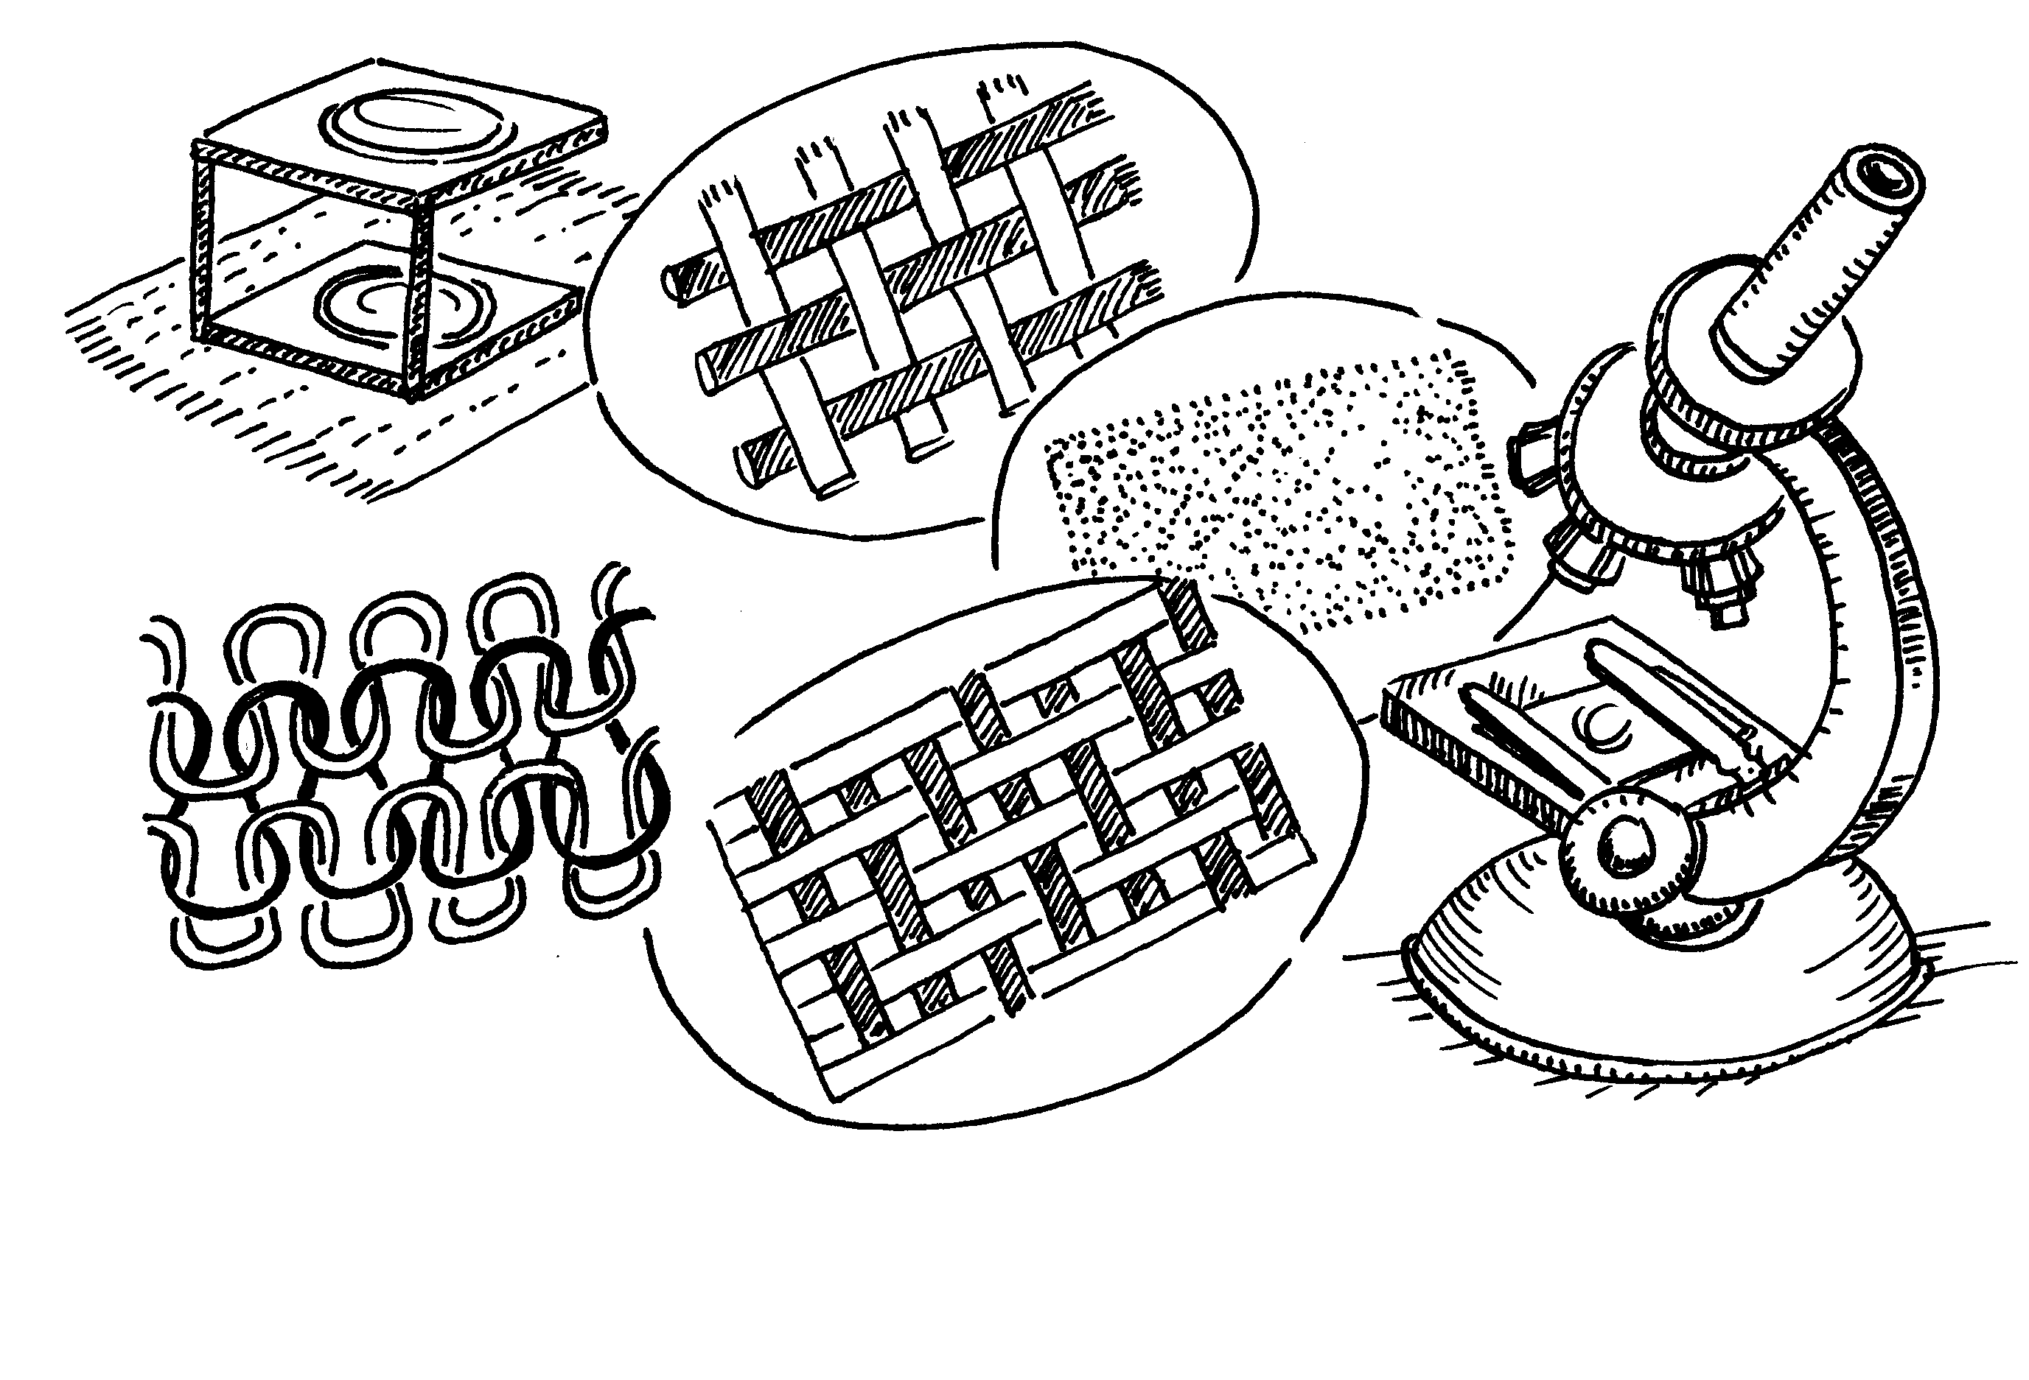

Construction Method | Examples of Uses

