INTRODUCTION TO TEXTILES
LEARNING OUTCOME: YOU WILL LEARN TO RECOGNISE WHERE TEXTILES ARE USED AROUND US, IDENTIFY SOME PROPERTIES
OF TEXTILES AND IDENTIFY SOME TEXTILES BY NAME

1. Look at the spider diagram sheet. Now brainstorm textile words associated with each of the headings given – for example, under ‘equipment’ you could say ‘sewing
machine’. Write down your ideas on the sheet.

2. Think about all the different types of textile you
use in the course of a day. Then imagine all the
things you would like to do on your ‘dream day’
and list the textile items you would use during
those activities. The illustration below may give
you some ideas.
Now draw and label your ideas around the 24-
hour clock sheet.

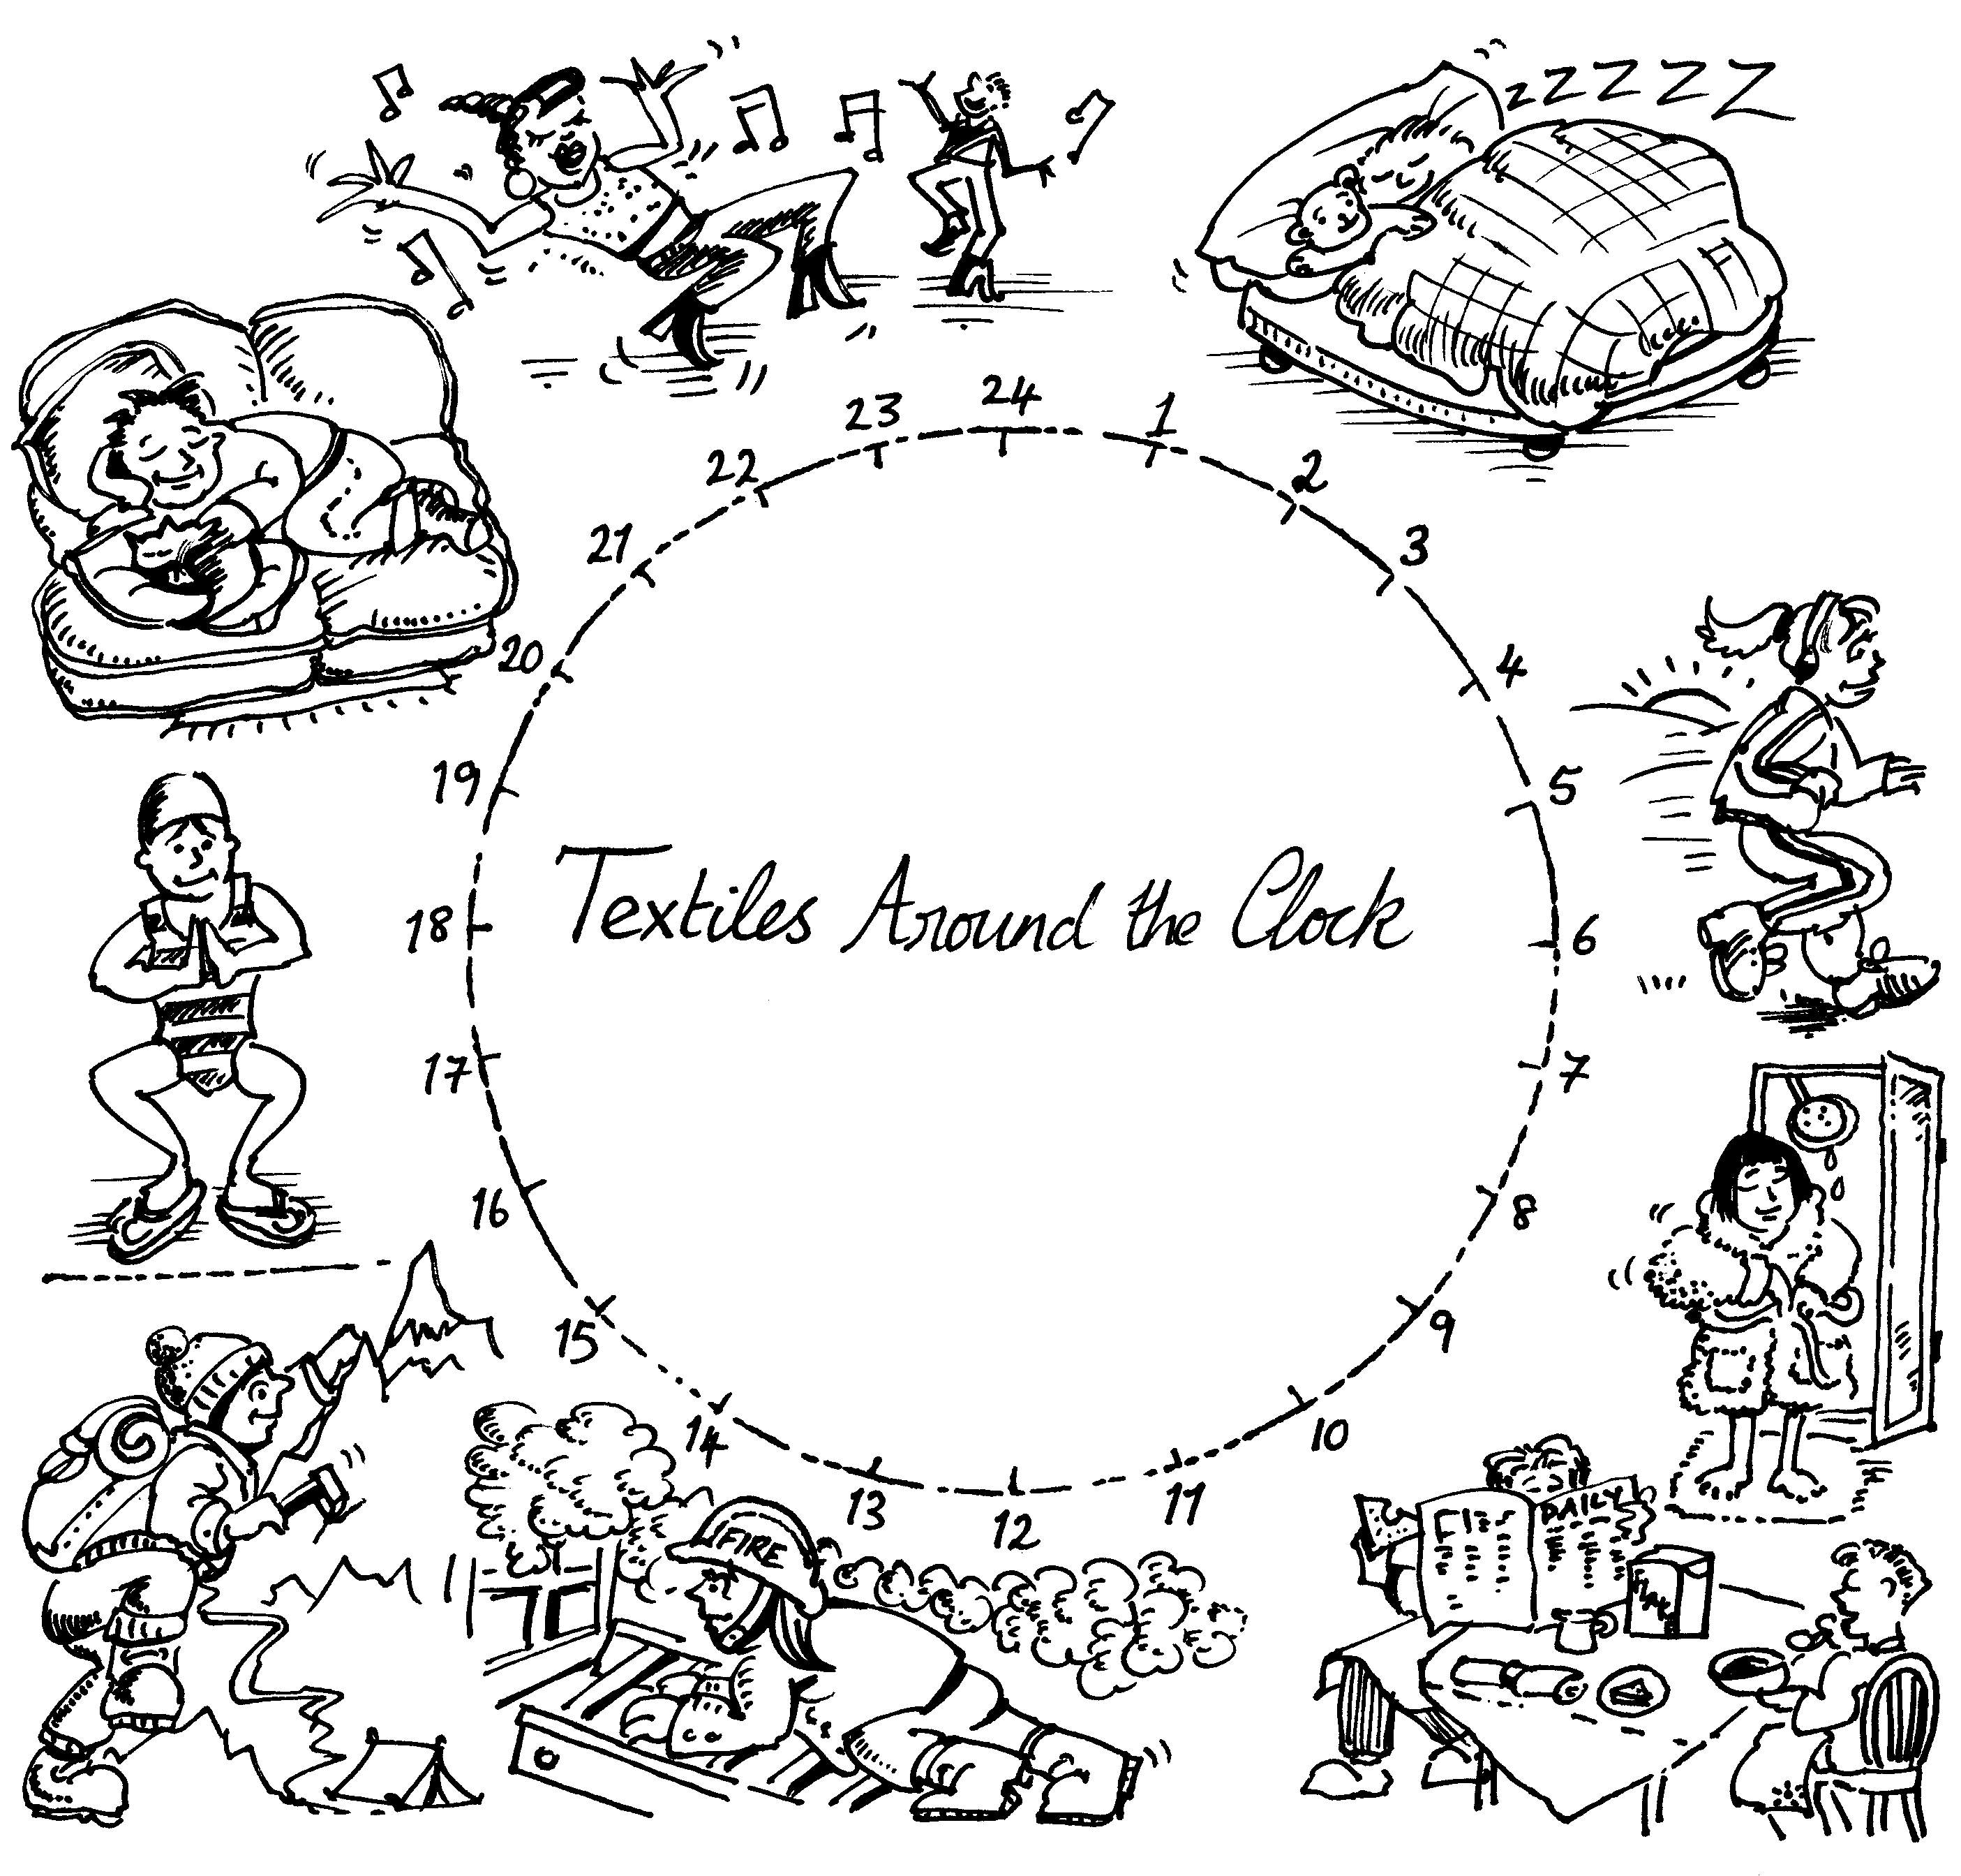

Properties
In the Home
Garment construction
Decoration
Fibres
Fabric Construction
Clothing
Equipment
Textiles around us

6am
Midnight
Midday
6pm
Textiles around the Clock

