PSHE work booklet – Year 7

Contents:
- Target setting sheet
- 5 Ways to wellbeing diary
- Self-esteem activity
- Dangers of smoking
- Budgeting

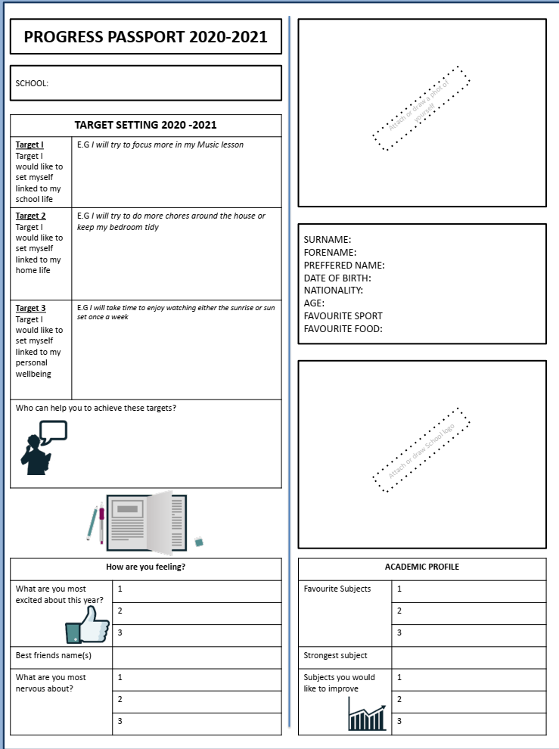
- Target setting- Fill in the following worksheet about you – think about your hopes and targets for the new school year.

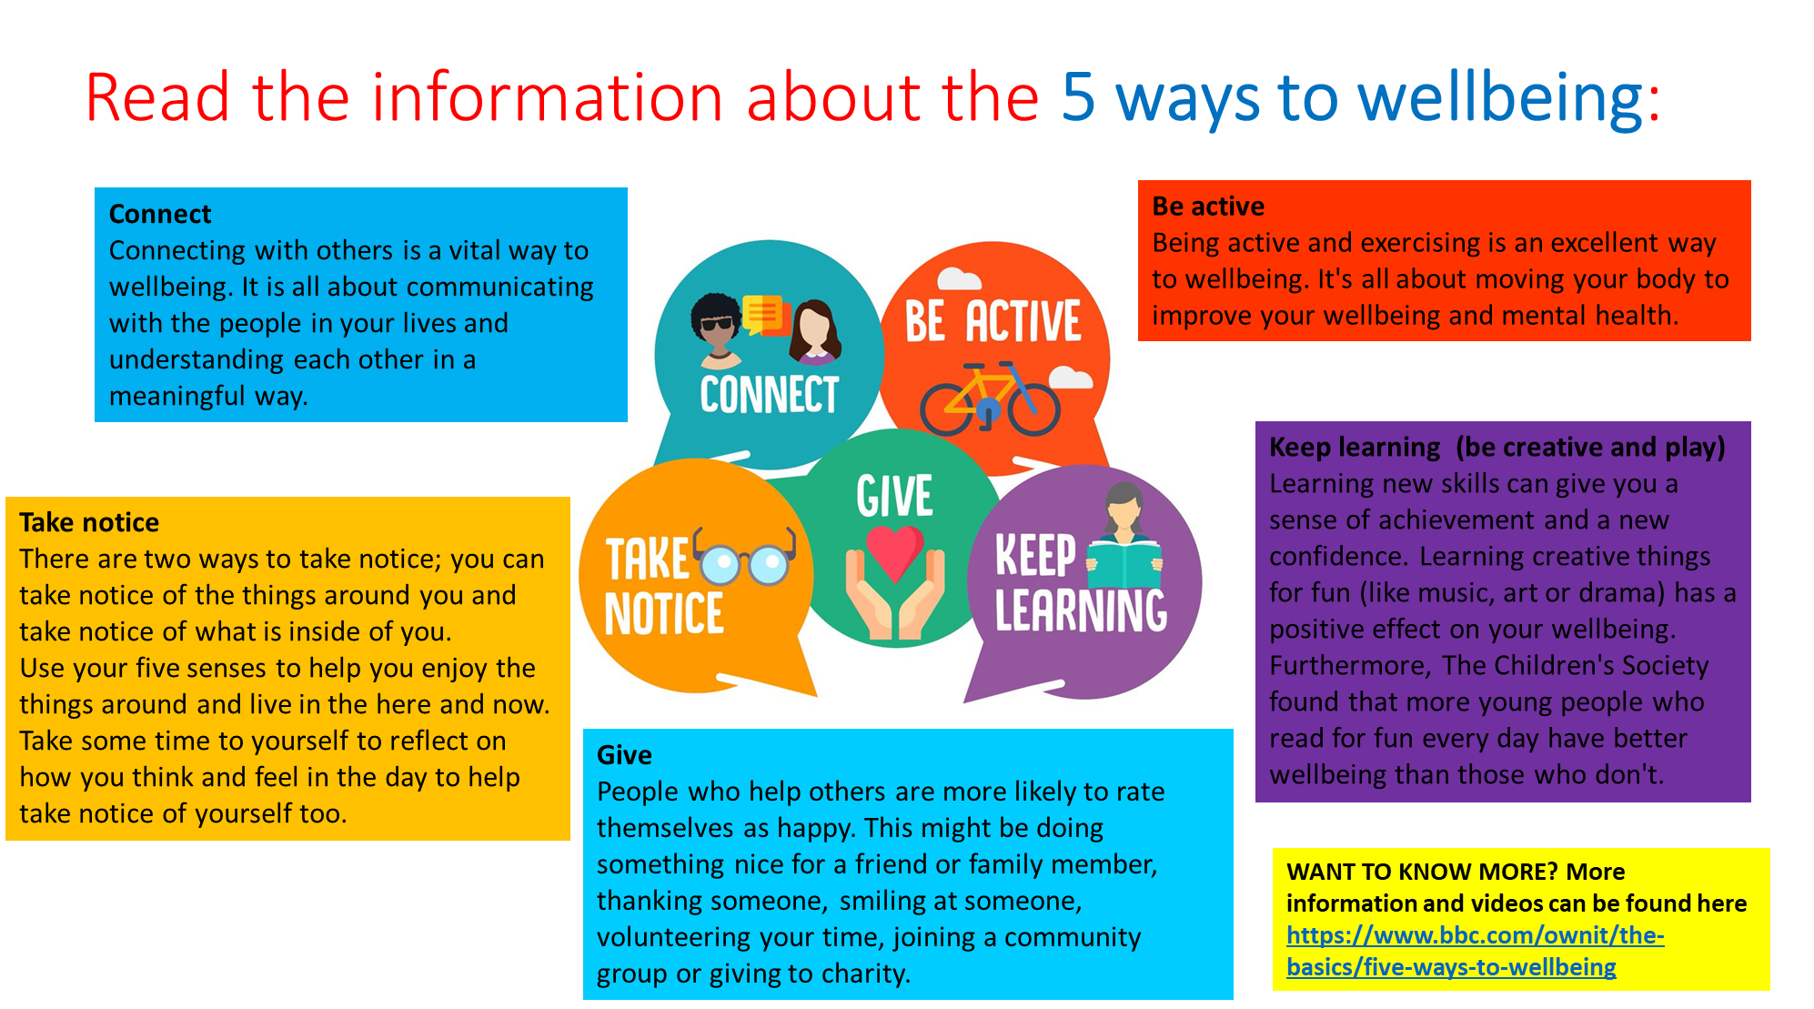
- 5 ways to wellbeing
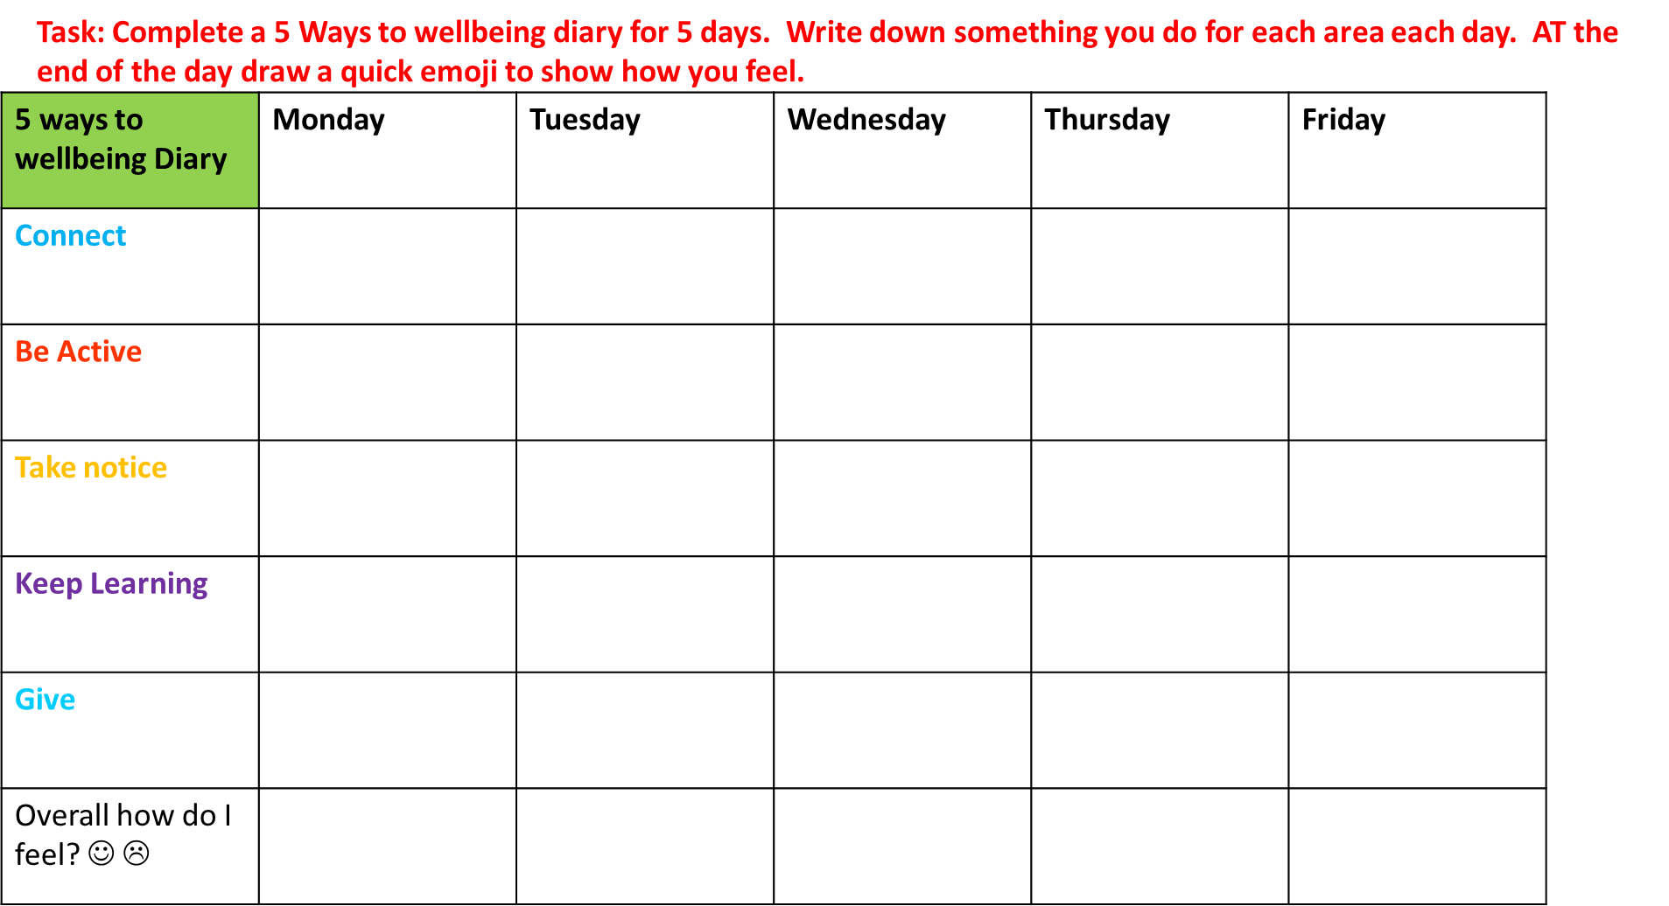
- Self esteem – Read through the information and complete the self esteem task sheet.
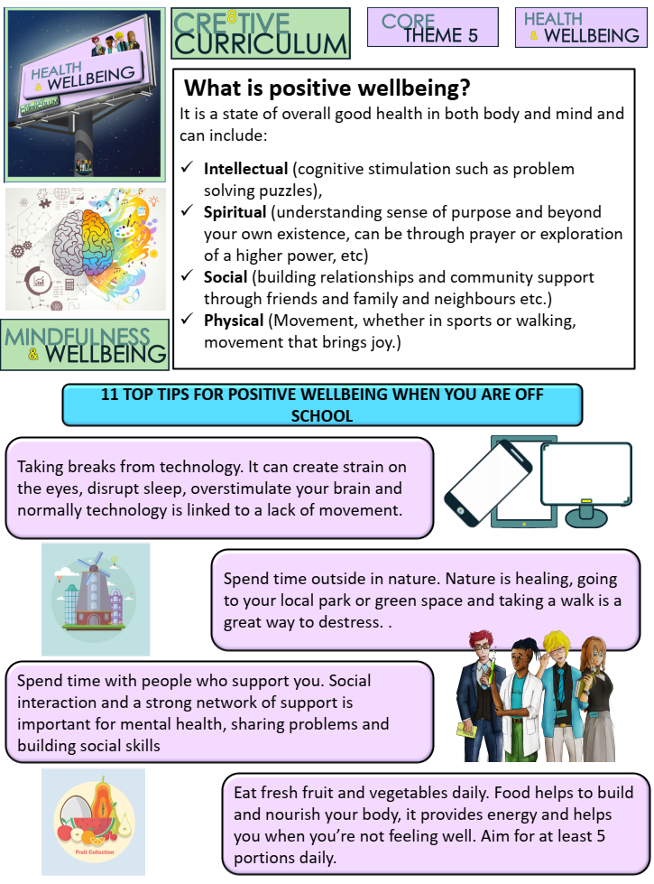
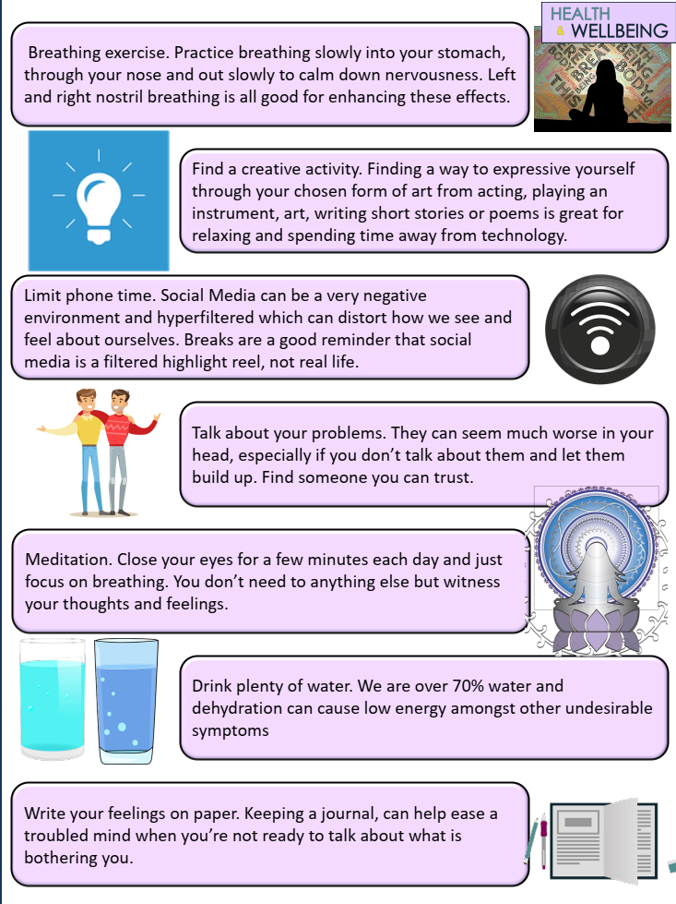

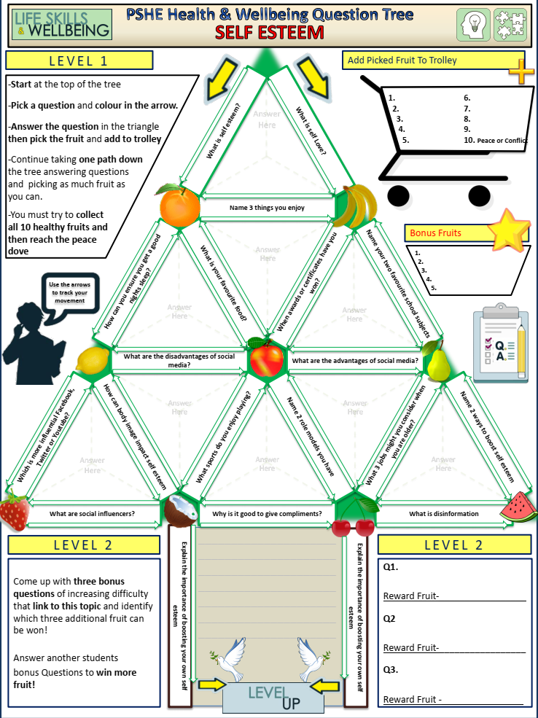

- Dangers of smoking
Year 7 PSHE :Dangers of smoking
L.O: To know the dangers of smoking

Task – Match up the key words with their meanings.

Task: Read this information about the dangers of smoking.

Task: Using the information above, answer the following questions in full sentences:
- Why is smoking expensive for the UK government?
………………………………………………………………………………………………………………………………………………………………………………………………………………………………………………………………………………………………………………………………………………………………………………………………………………………………………………………………………………………………
- How much does smoking cost an individual?
………………………………………………………………………………………………………………………………………………………………………………………………………………………………………………………………………………………………………………………………………………………………………………………………………………………………………………………………………………………………
- What percentage of adults in the UK are smokers?
………………………………………………………………………………………………………………………………………………………………………………………………………………………………………………………………………………………………………………………………………………………………………………………………………………………………………………………………………………………………
- Why do people find it difficult to give up smoking?
………………………………………………………………………………………………………………………………………………………………………………………………………………………………………………………………………………………………………………………………………………………………………………………………………………………………………………………………………………………………
- How is the brain affected by cigarette smoke?
………………………………………………………………………………………………………………………………………………………………………………………………………………………………………………………………………………………………………………………………………………………………………………………………………………………………………………………………………………………………
- What is a craving? Explain why smokers experience craving?
………………………………………………………………………………………………………………………………………………………………………………………………………………………………………………………………………………………………………………………………………………………………………………………………………………………………………………………………………………………………
- Why do you think smoking in the UK has halved since 1974?
………………………………………………………………………………………………………………………………………………………………………………………………………………………………………………………………………………………………………………………………………………………………………………………………………………………………………………………………………………………………
- What do some people use to help them stop smoking?
………………………………………………………………………………………………………………………………………………………………………………………………………………………………………………………………………………………………………………………………………………………………………………………………………………………………………………………………………………………………
- Why does the heart have to work harder when someone is smoking?
………………………………………………………………………………………………………………………………………………………………………………………………………………………………………………………………………………………………………………………………………………………………………………………………………………………………………………………………………………………………

- Budgeting

A budget is a plan which helps you to manage your money by keeping track of how much you have (your income) and how much you spend (expenditure).
Task: Answer the following questions:
- Where do you get your money from now?
………………………………………………………………………………………………………………………………………………………….

- Where will you get your money from in the future (in 10-15 years time)?
…………………………………………………………………………………………………………………………………………………………….

- List five things you will NEED to spend your money on in the future?
…………………………………………………………………………………………………………………………………………………………………………………………………………………………………………………………………………………………………………………………………………………..
Budgets are important because:
- Budgets allow you to keep easy control over your money.
- It ensures that money is not wasted or spent on frivolous things.
- It helps people save.
- It helps you monitor your spending habits.
- It helps you stay out of debt.
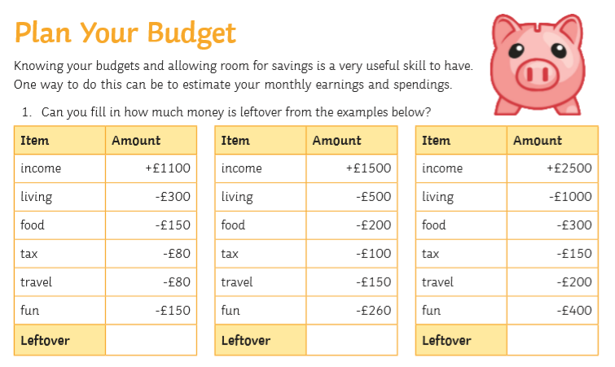

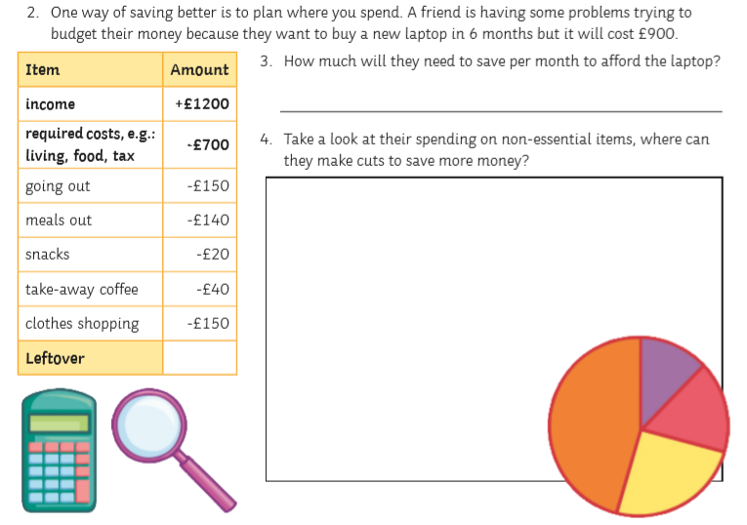

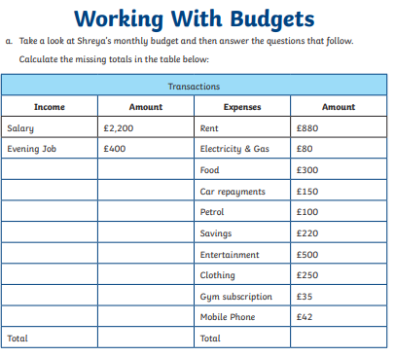
TASKS:
- How much money does Shreya have left at the end of the month?
- How much does Shreya save each month?
- What is Shreya’s biggest monthly expenditure?
- What is Shreya’s smallest monthly expenditure?
- If Shreya would like to save money, what changes could she make to her monthly budget?

