Year 7 Art Worksheet 1 Mark Making Portrait
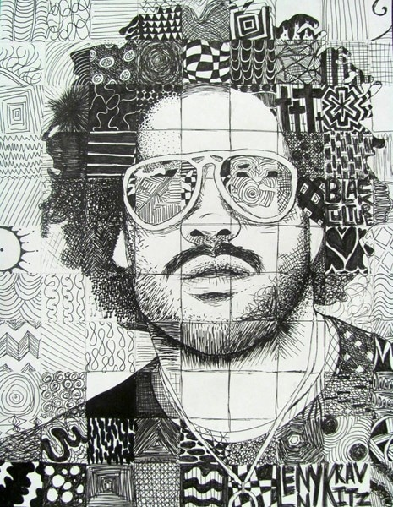
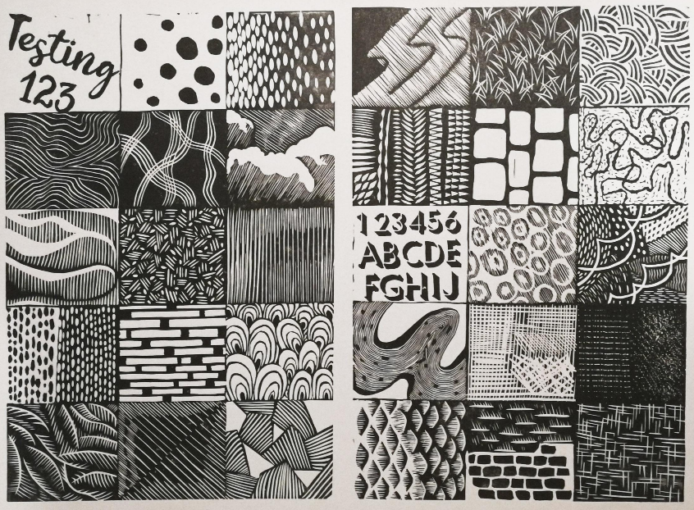
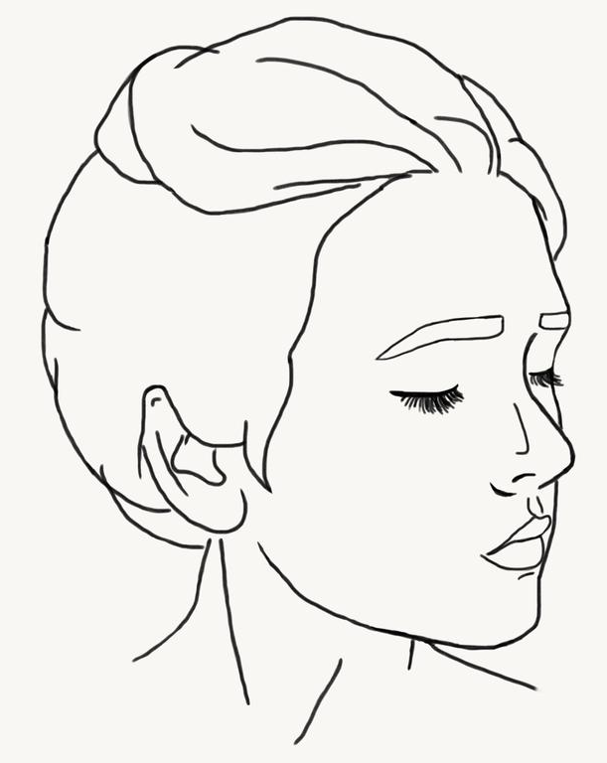
Divide the portrait outline into sections. This could be done as squares like in the example above, or however you wish.
Add an example of mark making to each of your sections.

Remember to use less dense mark making to lighter areas of the portrait and heavier, denser patterns to darker areas.

Year 7 Art Worksheet 2 Pencil Crayon Eye

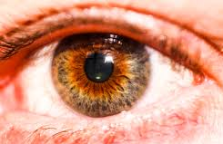
Using pencil crayon, observe and record the eye image in as much detail as possible. Remember to overlap and layer your pencil crayons to create the right tones.

Year 7 Art Worksheet 3 Maori Portrait
The Maori tribe, who originated in New Zealand, applied permanent tattoos to their faces known as Ta Moko.
Complete the Maori portrait below as a symmetrical image.

Year 7 Art Worksheet 4 Manga Self Portrait
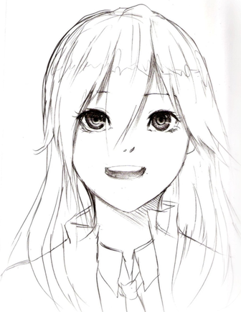
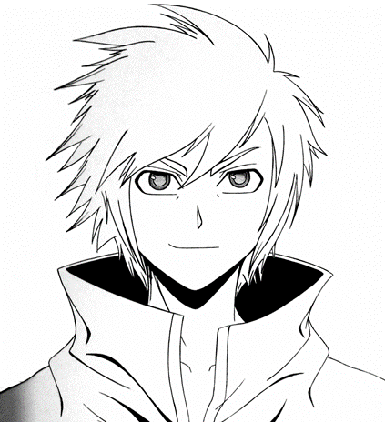
Manga is a style of graphic novels originating from Japan.
Look carefully at the style – large eyes, small nose, pointy hair.
In the space below, draw a self portrait in the Manga style.

Year 7 Art Worksheet 5 Profile Portrait
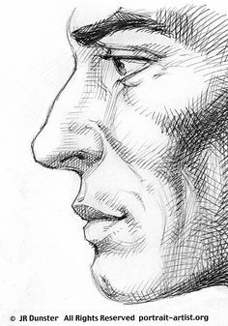
All of the portraits we have done so far have been drawn face on.
Create an observational drawing of the profile picture shown.
Record the mark making and cross hatching using black pen.

