Home Learning: Year 11

Macbeth

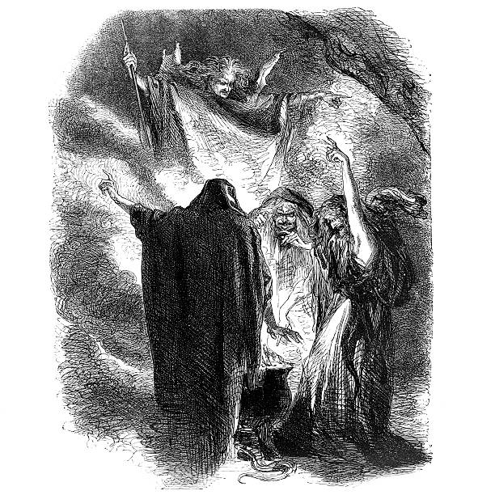
Complete the activities and then answer the following essay question.
Big Question

How does Shakespeare create a foreboding atmosphere in A1-S1?

Vocabulary

Foreboding | Darkness | Mystery
Menacing | Light | Tension
Threatening | Thunder | Suspense
Mysterious | Lightning | Foresight

Retrieval Task

- The Witches enter to thunder and lighting

- The First Witch asks when they will meet again

- The First Witch asks where they will meet

- The First Witch calls for her familiar

- The Second Witch calls for her familiar

- All the Witches chant about the weather

Extract Act 1 Scene 1

FIRST WITCH When shall we three meet again
In thunder, lightning, or in rain?
SECOND WITCH When the hurlyburly’s done,
When the battle’s lost and won.
THIRD WITCH That will be ere the set of sun. 5
FIRST WITCH Where the place?
SECOND WITCH Upon the heath.
THIRD WITCH There to meet with Macbeth.
FIRST WITCH I come, Graymalkin!
SECOND WITCH Paddock calls. 10
THIRD WITCH Anon!
ALL Fair is foul, and foul is fair,
Hover through the fog and filthy air.

Multiple-Choice Question

Which statement most accurately describes the effect of the weather conditions at the start of the play?

- Dramatic and terrifying

- Menacing and sinister

- Reassuring and pleasant

- Chaotic and frightening

Complete the tasks and then answer the following essay style response:

How does Shakespeare present Macbeth as a formidable warrior in A1-S2?

Vocabulary

Brutal | Courageous | Warrior
Ruthless | Valiant | Hero
Formidable | Merciless | Thane
Violent | Loyal | Traitor

Retrieval

- Malcolm asks the wounded Captain for his report

- The Captain says that Macbeth defeated Macdonald

- Duncan requests that surgeons attend the Captain

- Ross says that the Thane of Cawdor is a traitor

- Ross declares the battle was been won

- Duncan decides to reward Macbeth

Extract

CAPTAIN Doubtful it stood,
As two spent swimmers, that do cling together
And choke their art. The merciless Macdonwald –
Worthy to be a rebel, for to that 10
The multiplying villanies of nature
Do swarm upon him – from the Western Isles
Of kerns and gallowglasses is supplied;
And Fortune, on his damned quarrel smiling,
Show’d like a rebel's whore: but all’s too weak, 15
For brave Macbeth – well he deserves that name –
Disdaining Fortune, with his brandish’d steel,
Which smoked with bloody execution,
Like valour’s minion carved out his passage

Multiple-Choice Question

Which adjectives most accurately describes the presentation of Macbeth?

- Bold, brave and ruthless

- Murderous and evil

- Cowardly and treacherous

- Loyal, kind, trustworthy
Big Question – Essay style responses and activities to help.

What prophecies do the Witches make about Macbeth and Banquo in A1-S3?

Vocabulary

Prophecy | Thane | Supernatural
Future | King | Mystery
Power | Descendants | Trust
Ambition | Fate | Suspicion

Retrieval

- Banquo sees the Witches for the first time

- Macbeth encourages them to speak

- The Witches greet Macbeth and Banquo

- The Third Witch says that Macbeth will be king

- Banquo asks the Witches about his own future

- Macbeth asks the Witches to stay and speak further

Extract

BANQUO How far is’t called to Forres? What are these,
So wither’d and so wild in their attire,
That look not like th’inhabitants o’ th’ earth,
And yet are on’t? – Live you, or are you aught 40
That man may question? You seem to understand me,
By each at once her choppy finger laying
Upon her skinny lips; you should be women,
And yet your beards forbid me to interpret
That you are so. 45
MACBETH Speak, if you can: what are you?
FIRST WITCH All hail, Macbeth, hail to thee, thane of Glamis!
SECOND WITCH All hail, Macbeth, hail to thee, thane of Cawdor!

Multiple-Choice Question

Which one of statements below about the prophecies is inaccurate?

- Macbeth will become Thane of Cawdor

- Banquo will become King of Scotland after Macbeth

- Macbeth will become King of Scotland

- Banquo’s sons will become kings

Big Question – Essay style response and activities to help.

How do Macbeth and Banquo react to the prophecies and how do their reactions differ in A1-S3?

Vocabulary

Prophecy | Power | Supernatural
Fate | Ambition | Trust
Future | Glory | Intelligence
Hope | Happiness | Reality

Retrieval

- Banquo questions the reality of what he has witnessed

- Ross announces to Macbeth that he will be rewarded

- Banquo realises that one of the prophecies is true

- Macbeth questions Banquo about how he feels

- Banquo warns the prophecies might harm them both

- Banquo notices Macbeth is intrigued by the prophecies

Extract

MACBETH [Aside] Two truths are told,
As happy prologues to the swelling act
Of the imperial theme – I thank you, gentlemen –
This supernatural soliciting
Cannot be ill, cannot be good. If ill,
Why hath it given me earnest of success,
Commencing in a truth? I am Thane of Cawdor.
If good, why do I yield to that suggestion,
Whose horrid image doth unfix my hair
And make my seated heart knock at my ribs
Against the use of nature? Present fears
Are less than horrible imaginings.

Multiple-Choice Question

Which statement most accurately describes the Macbeth’s reaction to the prophecies?

- Eager to become king

- Uncertain, but also intrigued

- Mortified at the thought of Duncan’s death

- Happy at what he has heard, but also sceptical

Big Question

To what extent is Lady Macbeth presented as an ambitious and assertive character in A1-S5?

Vocabulary

Prophecy | Thane | Supernatural
Future | King | Mystery
Power | Descendants | Trust
Ambition | Fate | Suspicion

Retrieval

- Macbeth’s letter reveals that he met the Witches

- Lady Macbeth believes Macbeth lacks ruthlessness

- The Attendant announces that Duncan will arrive

- Macbeth arrives and Lady Macbeth greets him

- Lady Macbeth tells Macbeth to hide his true feelings

- Lady Macbeth reassures Macbeth that he has a plan

Extract

LADY MACBETH yet do I fear thy nature, 15
It is too full o' the milk of human kindness
To catch the nearest way: thou wouldst be great,
Art not without ambition, but without
The illness should attend it: what thou wouldst highly,
That wouldst thou holily; wouldst not play false, 20
And yet wouldst wrongly win: thou’ldst have, great Glamis,
That which cries, ‘Thus thou must do’, if thou have it;
And that which rather thou dost fear to do
Than wishest should be undone. Hie thee hither,
That I may pour my spirits in thine ear 25
And chastise with the valour of my tongue
All that impedes thee from the golden round

Multiple-Choice Question

Which statement most accurately describes Lady Macbeth’s initial reaction to Macbeth’s letter?

- Doubtful about the credibility of the prophecies

- Excited to hear the news and keen to know more

- Excited to hear to the news and eager act swiftly

- Concerned at the trouble the prophecies might cause
Assessment

How does Shakespeare present Lady Macbeth as a powerful woman in A1-S5?

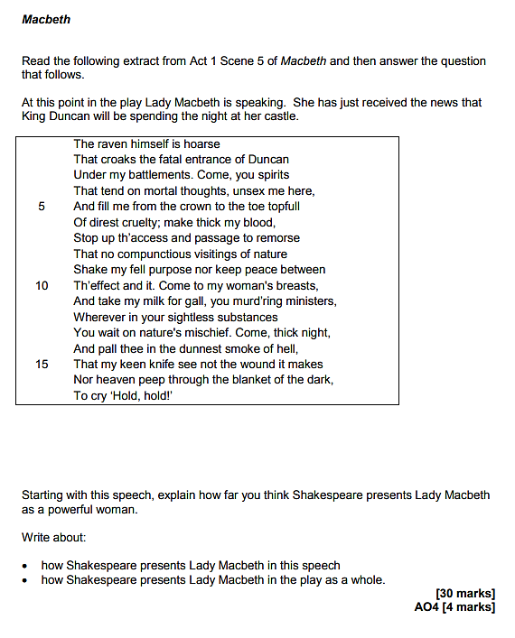

Source: https://filestore.aqa.org.uk/resources/english/AQA-87021-SQP-V1.PDF

Key Points on the Extract to consider ( you may be able to think of others)

- This is the first time the audience sees Lady Macbeth
- The raven is symbolic of death and Lady Macbeth’s murderous intentions
- Lady Macbeth’s direct appeal to the spirit world emphasises her cruel, evil nature
- This is further emphasised by her references to the ‘thick night’ and ‘smoke of hell’
- Lady Macbeth’s rejection of her femininity helps to establish her as a ruthless character
- Techniques to explore: tone, alliteration, sibilance, symbolism, metaphor.

Wider Links you could think about…

- A1S5: Lady Macbeth concedes that her husband lacks ruthlessness; she initially flatters him; she reassures about her plan
- A1S7: Lady Macbeth calls her husband a coward; she accuses him of breaking his promise; she attempts to reassure him
- A2S2: More accusations of cowardice; Lady Macbeth’s confidence and strength contrasts to Macbeth’s mental fragility
- A3S4: Lady Macbeth attempts to reassure the Scottish nobles; she despairs at Macbeth’s erratic behaviour
- A5S1: Lady Macbeth is plagued by guilt; she sleepwalks whilst darkly remembering Duncan and Macduff’s family

