Lesson 4 Introduction to magnets
Permanent and induced magnets
All magnets produce a magnetic field. A magnetic field is a region around the magnet where other magnets experience a non-contact force acting on them.
There are two types of magnets – permanent magnets and induced (or temporary) magnet. Permanent magnets (e.g. bar magnets) produce their own magnetic field all the time. Induced magnets only produce a magnetic field when they’re in another, external magnetic field. When the external field is removed, induced magnets quickly lose their magnetism (or most of it).
This video shows an iron nail becoming an induced magnet. https://www.youtube.com/watch?v=Tudgy7J5GlI
Magnets are made from magnetic materials. There are three common magnetic materials – iron, nickel and cobalt. Some alloys (metals made by mixing two or more elements) and compounds (something which is composed of two or more elements) of these elements are also magnetic. For example, steel is magnetic because it contains iron.
Drawing magnetic fields
A magnetic field can be represented by a field diagram. A field diagram is just a series of lines that show where a magnetic field exists and its direction.
This video shows how iron fillings (small shavings of iron) can be used to show the magnetic field of a bar magnet. https://www.youtube.com/watch?v=j8XNHlV6Qxg&t=12s
All magnets have two poles – a north pole and a south pole. Magnetic field lines have arrows on them that always point from north to south. The direction of the field lines show the direction of the force a north pole would feel if it was placed in that location. The stronger the magnetic field at any point, the closer together the field lines are.
Which part of a field diagram shows the stronger magnetic field? How do you know?

You need to know the field diagrams for bar magnets and uniform fields.

Bar magnets
The magnetic field is strongest at the poles of a magnet. So field lines for magnets are closest together at the poles, as shown in the figure below. The further away from a magnet you get, the weaker the field is.
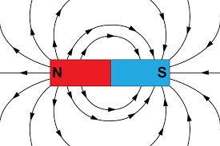
Uniform magnetic fields
Uniform magnetic fields are created between two opposite magnetic poles. Uniform fields have the same strength everywhere – so the field lines are evenly spaced, parallel, straight lines.
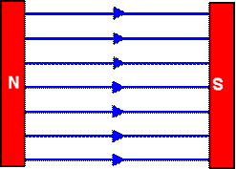
Forces between magnets
The forces between two permanent magnets can be attractive or repulsive. Two poles that are the same (these are called ‘like’ poles) will repel each other. Two different poles (‘unlike poles’) will attract each other.
If you try and put two north poles of a bar magnet together, you will feel a push as the two poles repel one other. If you try and put a north and a south pole of a bar magnet together, they will stick together as they attract one another. The first 55 seconds of this video show this https://www.youtube.com/watch?v=Mp0Bu75MSj8

Compasses

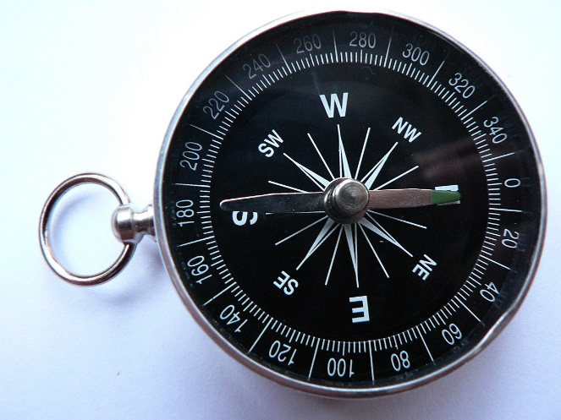
Inside a compass is a tiny bar magnet called a needle. The north pole of this magnet is attracted to the south pole of any other magnet it is near. So the compass points in the direction of the magnetic field it is in.
You can find the shape and direction of a magnetic field by using a compass. First, you put the magnet on a piece of paper and draw around it. Then, place the compass on the paper near the magnet. Mark the direction of the compass needle by drawing two dots – one at each end of the needle. Move the compass so that the tail (south) end of the needle is where the tip (north)of the needle was. Put another dot by the tip of the needle. Repeat this around the magnet and then join up the marks you’ve made – you’ll end up with a drawing of one field line around the magnet. Repeat this method at different points around the magnet to get several field lines.
When they’re not near a magnet, compasses always point north. This is because the Earth generates its own magnetic field (where the North pole is actually a magnetic south pole). This shows that the inside (core) of the Earth must be magnetic.
This video shows how a plotting compass (a tiny compass) can be used to show the magnetic field of a bar magnet. https://www.youtube.com/watch?v=NWUgK8W-4JM

Questions
- Draw the magnetic field of a bar magnet. Where is the field the strongest?
- Draw a uniform magnetic field.
- What is a magnetic field?
- Describe what is meant by an ‘induced magnet’.
- Do like poles attract or repel each other. What is the force that causes this?
- How do we know that the Earth’s core is magnetic?
- Draw the magnetic field of the Earth.

Answers
- Draw the magnetic field of a bar magnet. Where is the field the strongest?
The field is the strongest at the poles of the bar magnet.
- Draw a uniform magnetic field.
- What is a magnetic field?
A magnetic field is a region where magnets experience a non-contact force acting on them.
- Describe what is meant by an ‘induced magnet’.
An induced magnet is a magnetic material which only becomes a magnet (with its own magnetic field) when it is placed inside another magnetic field.
- Do like poles attract or repel each other. What is the force that causes this?
Like poles repel because the two magnetic fields interact with one another.
- How do we know that the Earth’s core is magnetic?
When not in the field of another magnet, the magnet in a compass points north. It is experiencing a magnetic force, so the Earth must have a magnetic field. For the Earth to have a magnetic field, its core must be magnetic.
- Draw the magnetic field of the Earth.
