PSHE work booklet – Year 11

Contents:
- Target setting sheet
- 5 Ways to wellbeing diary
- Self-esteem activity
- Sharing information safely online
- Employability skills

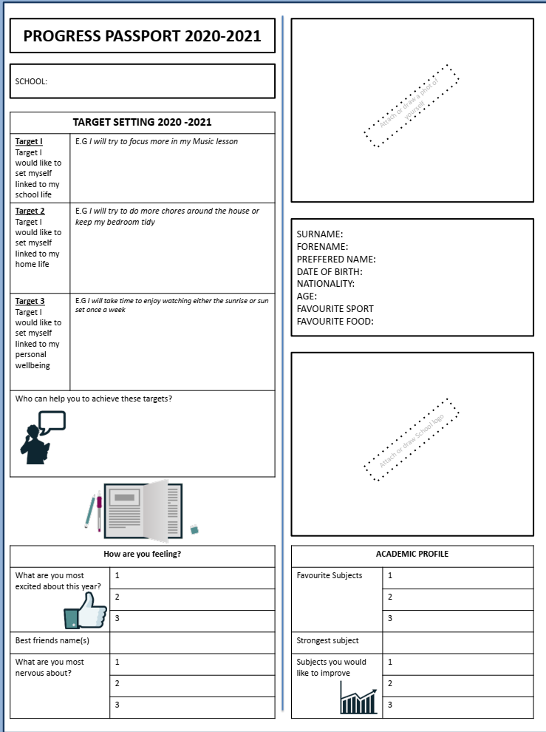
- Target setting- Fill in the following worksheet about you – think about your hopes and targets for the new school year.

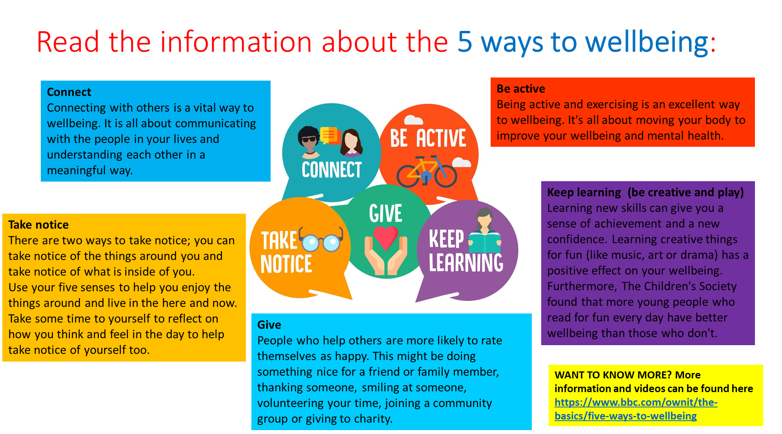
- 5 ways to wellbeing
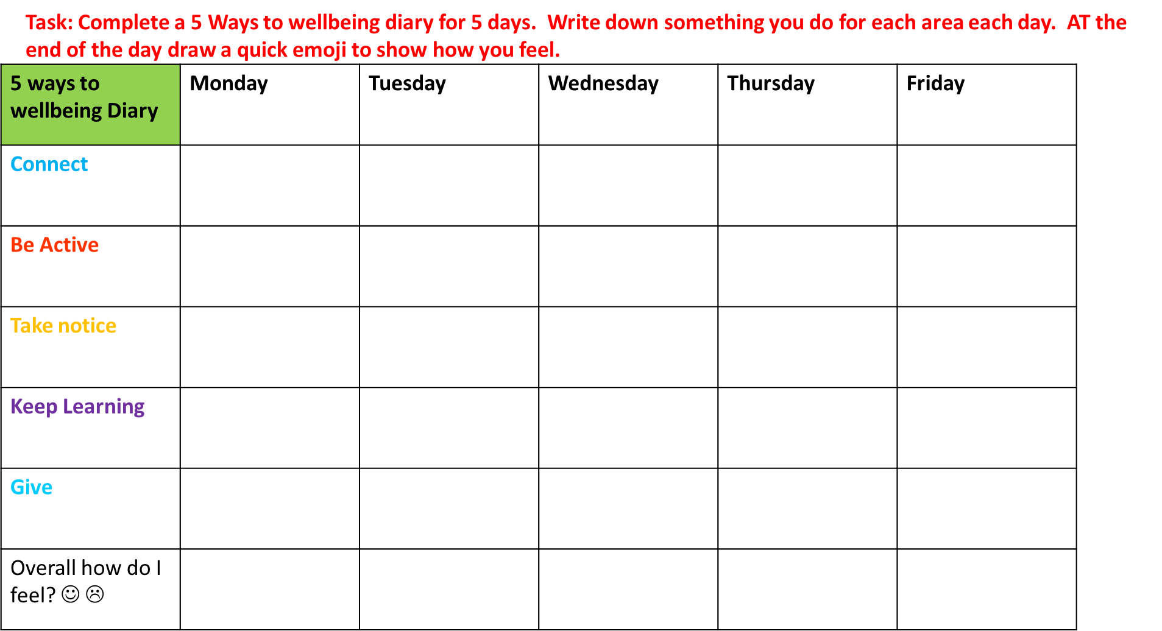
- Self esteem – Read through the information and complete the self esteem task sheet.
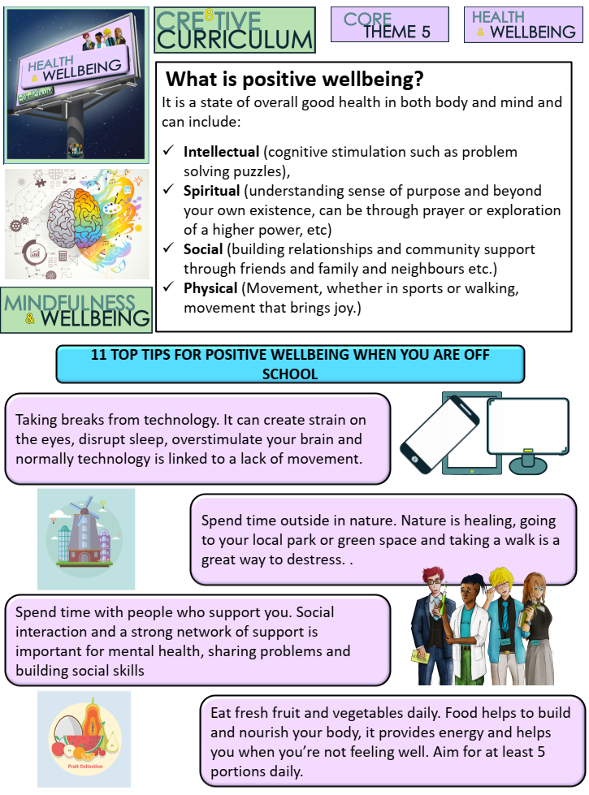
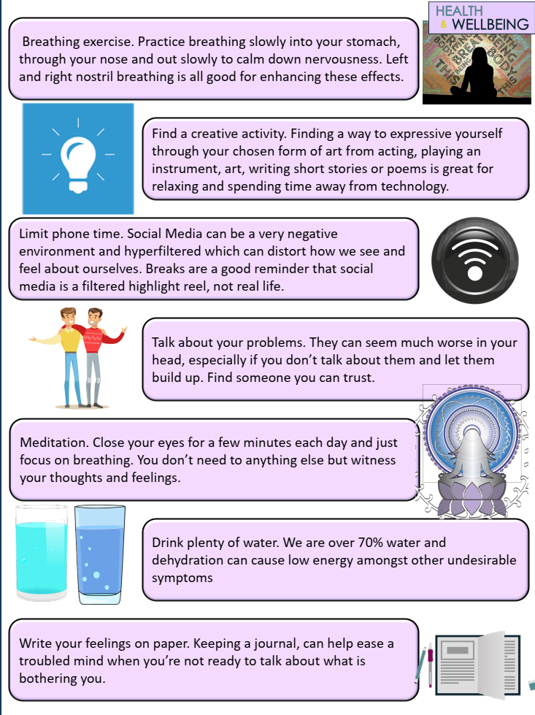

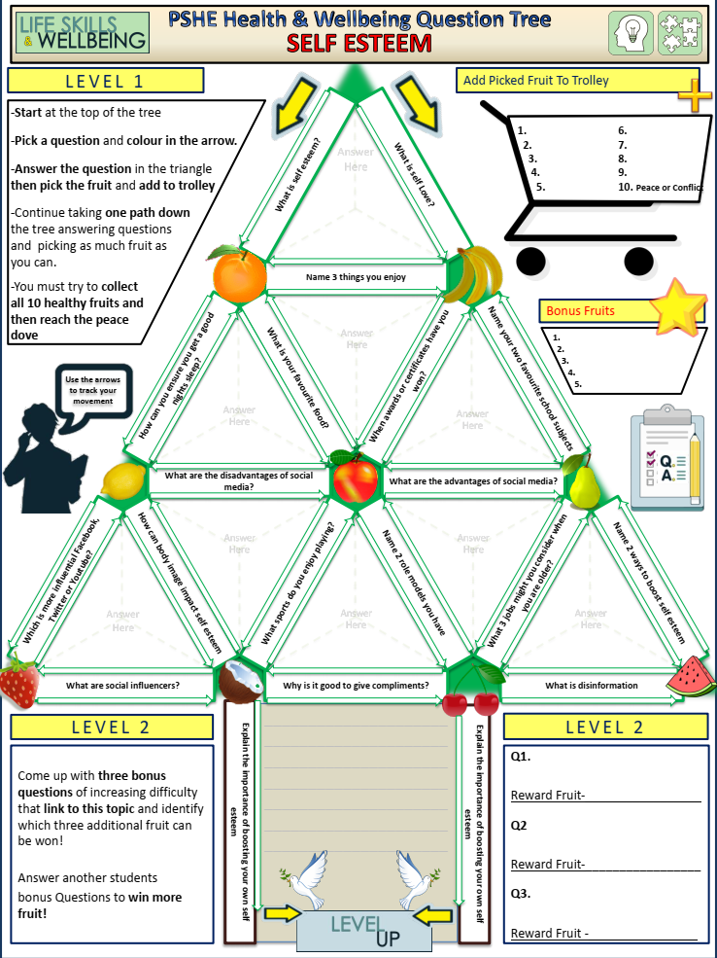

- Sharing information safely online
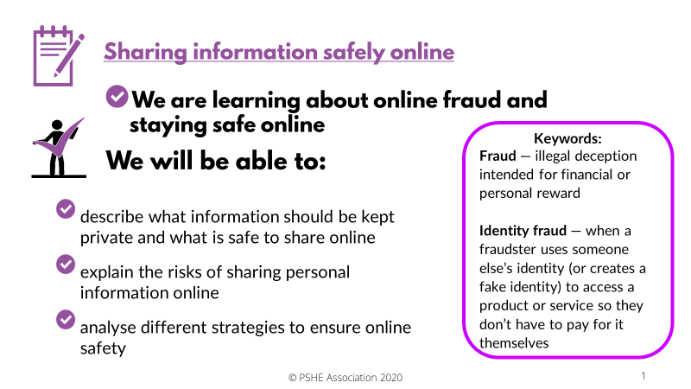

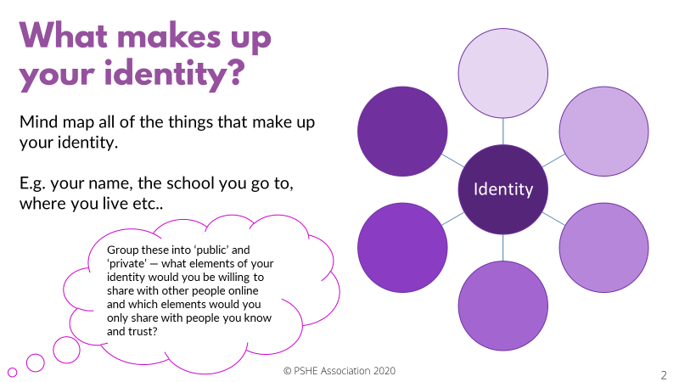

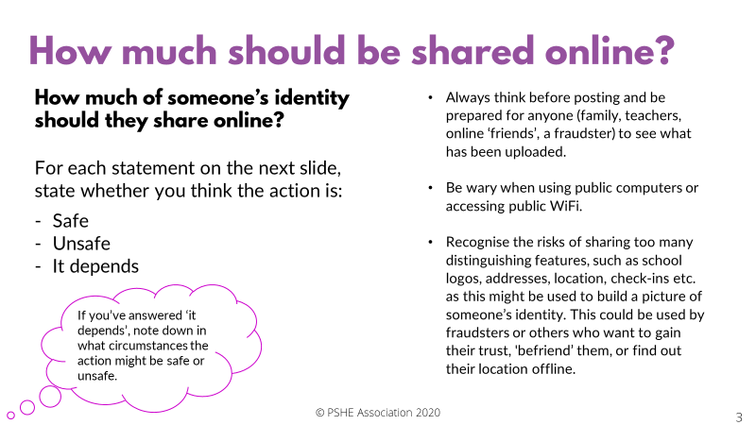
For each statement decide whether it is safe, unsafe, or it depends?
Action | Safe, unsafe, or it depends?
Posting a photo wearing school uniform
Checking privacy settings on social media after accepting a new update
Doing online banking on public Wi-Fi at a café
Always checking in at favourite locations
Having passwords of 10 or more characters that include numbers, letters and capitals
Using date of birth as a pin number for a bank card
Saving bank card details on a public computer in a library
Having address, email and phone number on a profile
page
Renewing antivirus software when it runs out
Entering bank card details to buy something from Amazon
Having open settings so anyone can send a friend request or view your profile
Setting a profile so only friends, or friends of friends can follow or like posts
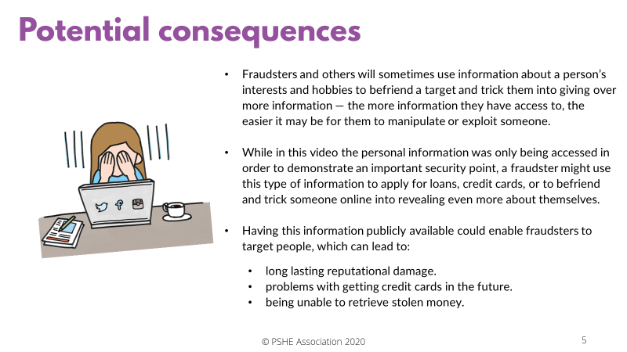

Put the bullet points in order by putting the online safety tip you think is most important at number 1, down to the least important safety tip.
- Have secure passwords (e.g. three random words with letters, numbers, capitals)
- Make sure photos don’t include sensitive or private information
- Don’t overshare information on social media
- Password and pin protect all devices
- Update firewalls and antivirus software
- Don’t access personal information if using public Wi-Fi (e.g. in a café or on a train)
- Always check before passing on anyone else’s information, even to a friend
- Regularly check privacy settings, especially after updates
- If unsure about online safety, visit an online source of support (e.g. thinkuknow.co.uk)

Using what you now know about the consequences of sharing personal information online, and the different strategies that could be used to stay safe, write a short piece of advice to the three characters below: Afterwards read the next slide to reveal the answers: Does your advice include some of these key points?

AALIYAH
Aaliyah has been contacted on social media by someone she doesn’t know. They have sent her a message telling her a little bit about themselves and have asked her questions about herself in return. They seem to just want to be friends.
What would your advice to Aaliyah be?

AUSTIN
Austin has been sent an email, congratulating him on winning a competition. He can’t remember entering this particular one, but all he has to do to claim his prize is enter a few simple details. He’s excited to have won something!
What would your advice to Austin be?

Personal reflection
Using what you have learnt today, write down three things that you will aim to do in future to increase your safety online.

- Employability skills
Self-management |  | Analysing facts and situations and applying creative thinking to develop appropriate solutions.
Team working |  | Manipulation of numbers, general mathematical awareness and its application in practical contexts (e.g. measuring, weighing, estimating and applying formulae).
Business & customer  awareness |  | Basic understanding of key drivers for business success – including importance of innovation, taking calculated risks and profit – and the need to provide customer satisfaction and build customer loyalty.
Problem solving |  | Application of literacy, ability to produce clear, structured written work and oral literacy, including listening and questioning.
Communication & literacy |  | Basic IT skills, including familiarity with word processing, spread sheets, file management and use of internet search engines.
Application of numeracy |  | Respecting others, co-operating, negotiating/persuading, contributing to discussions, and awareness of interdependence with others.
Application of IT |  | Accept responsibility, flexibility, resilience, self-starting, appropriate assertiveness, time management, readiness to improve own performance based on feedback/reflective learning.
TASK: Match up the employability skills on the left with the meaning on the right.

Task: Audit the skills you have by putting a tick in the column you most agree with.
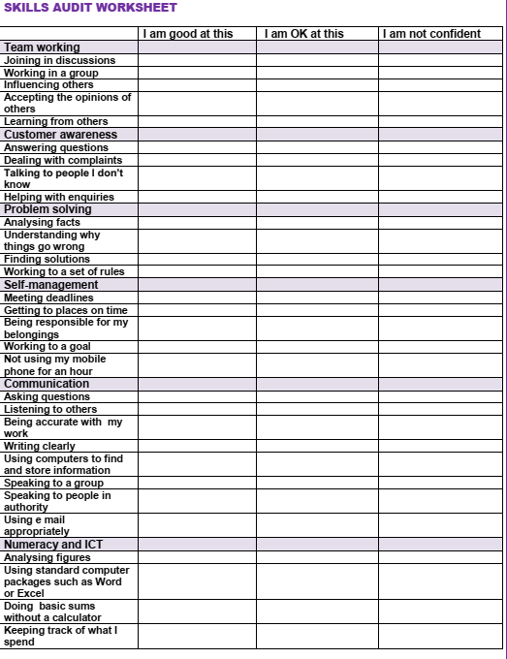

TASK: Now you have audited your skills consider how you will work on those skills. Write an example of something you could do in each of the boxes below:

