Chemical Changes Mastery Booklet
This booklet covers:
- Reactivity of metals
- Extraction of metals
- Electrolysis

Part 1: Reactivity of Metals
Recap questions:
- Describe the structure and bonding in metals. You may use a diagram to help.
- Magnesium is a metal. Give three likely properties of magnesium.
- Explain why magnesium conducts electricity.
- Francium is a metal. It reacts with bromine (Br₂) to form francium bromide (FrBr). Write a word and symbol equation for this reaction.
Potassium
Sodium
Lithium
Calcium
Magnesium
(Carbon)
Zinc
Iron
(Hydrogen)
Copper
Gold
- 100g of Fr is used with 50g of bromine. Which is excess and which is limiting?
- 75g of Fr is reacted with an excess of bromine. How much FrBr is formed?
- FrBr is an ionic substance. Explain why it only conducts electricity when molten or dissolved in water.
- Fr is more reactive than Li. Explain why by making reference to its electrons.
- There are two isotopes of Francium, Fr-223 and Fr-221. Making reference to their numbers of protons, neutrons and electrons, discuss the similarities and differences between these two isotopes
- A sample of Francium is found to have an abundance of 81% Fr-223 and 19% Fr-221. Calculate the average mass of the atoms in this sample.
- Challenge: A similar sample is found to have a mass of 222.32. It contains 70% Fr-223, 22% Fr-221 and one other isotope. Calculate the mass of the other isotope.
A student heats up a piece of magnesium in air. It reacts with oxygen to make magnesium oxide. The student then heats up a piece of copper, but no reaction takes place. This is because different metals can have different reactivities: how easy it is for them to react.
- Which is more reactive, magnesium or copper? Explain your answer
- Write a word equation for the reaction of magnesium with oxygen.
- The formula for magnesium oxide is MgO. Write and balance a symbol equation for the reaction in Q2
- Label all reactants and products in the equations above.
A reaction where oxygen is added is called an oxidation reaction. If oxygen is removed, it is called a reduction reaction.
- Draw an atom of magnesium and an atom of oxygen.
- Use arrows to show what occurs when they react with each other.
- Draw the ions that are formed as a result of this reaction.
- Explain why this reaction is called an oxidation reaction
- In this reaction, the student started with 5g of magnesium. At the end of the reaction, they had 6.2g of magnesium oxide. Why did the mass increase?
- Magnesium oxide can also be turned into magnesium and oxygen. Write an equation for this reaction.
- What name is given to this type of reaction?
- Explain why oxygen has a low melting point.
- Explain why magnesium has a high melting point.
- Under what conditions will magnesium oxide conduct electricity?
- Challenge: which is more reactive: magnesium or calcium? Explain your answer.
The student takes the magnesium and puts it in a test tube with some acid in. The student notices that the acid starts to fizz quiet vigorously. The student takes the copper in and notices that it does not fizz at all. The student decides to try it again but with iron, and sees that it fizzes, but only a little bit.
- Put the three metals tested in order of their reactivity
- When iron atoms react, they form iron ions with a 3+ charge. What has happened to the iron atoms in terms of electrons?
- Why is it important that the student uses the same acid for each reaction?
- What else should the student try to keep the same?
- In the iron reaction, iron sulphate is formed. Iron sulphate has a formula of Fe₂(SO₄)₃. How many atoms are present in iron sulphate and what atoms are they?
- Challenge: what is it about some metals that make them more reactive than other metals?
Scientists use experiments like the one above to put metals into order by their reactivity. We call this the reactivity series. Most elements in the series are metals, but carbon and hydrogen are often included as well. In the series to the right, potassium is the most reactive and copper the least.
More reactive metals can displace less reactive ones, taking their place in a compound. For example, potassium reacts with sodium chloride to make potassium chloride and sodium. It has taken the place of the sodium in the chlorine.
Potassium + sodium chloride sodium + potassium chloride
However, this would not occur in reverse:
Potassium chloride + sodium no reaction
This is because sodium is less reactive than potassium so cannot displace it.
- For the element pairs below, state which is more reactive and which is less reactive
  - Calcium and lithium
  - Gold and copper
  - Sodium and iron
  - Zinc and copper
  - Copper and zinc
  - Iron and zinc
  - Iron and calcium
  - Sodium and lithium
- For each reaction below, state whether or not it would occur.
  - Magnesium oxide + calcium
  - Iron chloride + zinc
  - Copper bromide + gold
  - Zinc chloride + potassium
  - Iron sulphate + copper
  - Iron + lithium sulphate
  - Magnesium + iron oxide
- Write a word equation for the reaction of potassium with sodium chloride
- Explain why this is a displacement reaction
- When zinc reacts with iron bromide it forms zinc bromide and iron. Write a word equation for this reaction
- Identify any elements and compounds in the reaction
- How does this prove that zinc is more reactive than iron?
- When copper is added to lithium chloride no reaction takes place. Explain why this is the case.
- The reaction between calcium chloride and lithium is shown below. Copy the equation into your book and balance it.
CaCl₂ + Li LiCl + Ca
- In the reaction above, calcium chloride contains calcium ions. What charge do calcium ions have?
- Use your periodic tables to calculate the number of protons, neutrons and electrons in calcium, chlorine and lithium.
- Give the charges and relative masses of protons, neutrons and electrons.
- A student wishes to know how much gas will be produced when metal X, metal Y and metal Z react with water. The student collects and measures the amount of gas produced in one minute. Why is it important to always use one minute?
- The student notices that Y produces the most gas and X the least amount of gas. Write a reactivity series for the three metals.
- Which metal would react easiest with oxygen?
Metal | Extraction method
Potassium | Electrolysis: using electricity to split up the compound
Sodium
Lithium
Calcium
Magnesium
(carbon)
Zinc | Reduction with carbon: where carbon can remove the oxygen from a metal oxide
Iron
Copper
Gold | Mined from the Earth’s crust
- Metal X has three electrons in its outer shell. What charge will it form when it becomes an alloy?

Part 2: Extracting metals
We need metals for all sorts of uses, from electrical wiring to construction. Most metals are found as ores. An ore is a rock that contains enough of a metal compound in it to be worth extracting. Some metals are so unreactive that they can be found as elements in the Earth’s crust.
The way we extract the metal depends on its reactivity
Metals more reactive than carbon need electrolysis. Metals less reactive than carbon can be reduced by it.

An example of a reduction with carbon is:
Iron oxide + carbon iron + carbon dioxide
- Why is the reaction above an example of a reduction? Go back to the second paragraph on page 1 if you cannot remember.
- A scientist finds a rock with a very small amount of aluminium oxide in it. Explain why this rock cannot be called an Ore
- Francium is more reactive than lithium. How can francium be extracted from francium oxide?
- Aluminium is more reactive than zinc, but less reactive than magnesium. What more information would you need before you could say how aluminium should be extracted from aluminium oxide?
- Lithium. Iron and zinc are all placed in acid. Which one would react the most? Explain your answer.
- Zinc can be produced from zinc oxide by reduction with carbon. Write a word equation for this reaction
- Explain why gold is found naturally in the Earth’s crust.
- Silver is also found naturally in the Earth’s crust, but is more reactive than gold. Where would it go in the reactivity series.
- Lithium reacts with copper oxide to form lithium oxide and copper. Write a word equation for this reaction.
- The symbol equation is:
Li + CuO Li₂O + Cu
Copy the equation into your book and balance it.
- Explain why lithium has been oxidised and copper oxide has been reduced.
- Iron oxide reacts with sodium to form sodium oxide and iron.
- Write a word equation for this reaction.
- The symbol equation for this reaction is:
Fe₂O₃ + Na Na₂O + Fe
Copy the equation into your book and balance it.
- Identify what has been oxidised and what has been reduced.
- Potassium and zinc oxide are reacted together. Suggest the products of this reaction.
- What has been oxidised and what has been reduced? Explain your answer.

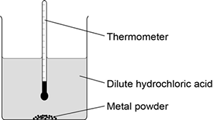
GCSE Practice Questions
Question 1: A student investigated the reactivity of different metals. The student used the apparatus shown in the figure to the right.
The student used four different metals. The student measured the temperature rise for each metal three times. The student’s results are shown in the table below.
Metal | Temperature rise in °C |  |  | Mean  temperature  rise in °C
 | Test 1 | Test 2 | Test 3
Calcium | 17.8 | 16.9 | 17.5
Iron | 6.2 | 6.0 | 6.1 | 6.1
Magnesium | 12.5 | 4.2 | 12.3 | 12.4
Zinc | 7.8 | 8.0 | 7.6 | 7.8

(a) Give two variables the student should control so that the investigation is a fair test.
(b) One of the results for magnesium is anomalous. Which result is anomalous? Suggest one reason why this anomalous result was obtained.
(c) Calculate the mean temperature rise for calcium.
(e) Aluminium is more reactive than iron and zinc but less reactive than calcium and magnesium. Predict the temperature rise when aluminium is reacted with dilute hydrochloric acid.

Question 2: A student investigated the reactivity of three different metals. This is the method used.
1. Place 1 g of metal powder in a test tube.
2. Add 10 cm³ of metal sulfate.
3. Wait 1 minute and observe.
4. Repeat using the other metals and metal sulfates.
The student placed a tick in the table below if there was a reaction and a cross if there was no reaction.

 | Zinc | Copper | Magnesium
Copper sulfate
Magnesium sulfate
Zinc sulfate

(a) What is the dependent variable in the investigation?
(c) The student used measuring instruments to measure some of the variables. Draw one line from each variable to the measuring instrument used to measure the variable.

Variable |  | Measuring instrument
 |  | Balance
 |  | Measuring cylinder
Mass of metal powder
 |  | Ruler
 |  | Burette
Volume of metal sulfate
 |  | Thermometer
 |  | Test tube

(d) Use the results shown in table above to place zinc, copper and magnesium in order of reactivity.
(e) Suggest one reason why the student should not use sodium in this investigation.
(f) Out of calcium, gold, lithium and potassium, which metal is found in the Earth as the metal itself?
(g) Iron is found in the Earth as iron oxide (Fe₂O₃). Iron oxide is reduced to produce iron. Balance the equation for the reaction.
___Fe₂O₃ + ___C → ___Fe + ___CO₂
(h) Name the element used to reduce iron oxide.
(i) What is meant by reduction?
Question 3: Metals are used in the manufacture of pylons and overhead power cables.
Suggest one reason why iron (steel) is used to make pylons.
(b) The table shows some of the properties of two metals.

Metal | Density in g per cm³ | Melting point in°C | Percentage(%) relative electrical conductivity | Percentage(%) abundance in Earth’s crust
copper | 8.92 | 1083 | 100 | 0.007
aluminium | 2.70 | 660 | 60 | 8.1

Use the information in the table to suggest why aluminium and not copper is used to conduct electricity in overhead power cables.

Part 3: Electrolysis
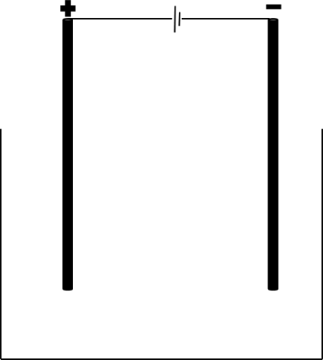
Electrolysis is the process of using electricity to split apart ionic compounds. The compounds can either be molten (liquid) or in a solution. The basic apparatus for electrolysis is always very similar:
Power source
Negative electrode: cathode
Positive electrode: anode
Container
The compound to be split up goes in the container. It is called the electrolyte.

A useful mnemonic to remember the names of the electrodes is PANIC: positive anode, negative is cathode.
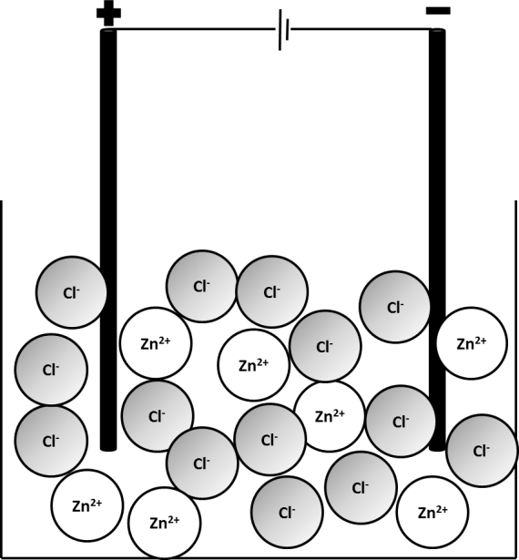
- A student is to electrolyse sodium chloride. If the sodium chloride is a solid, what must be done to it before it can be electrolysed?
- What is the electrolyte in this case?
- List the apparatus required to electrolyse sodium chloride

Electrolysis of liquids
Ionic compounds need to be molten or in solution for electrolysis to work. This is because the charged particles that make them up (ions) need to be free to move to the electrodes.
The positive ion (always a metal) will travel to the cathode, where it will gain electrons to become an element,
The negative ion (the non-metal) will travel to the anode, where it will lose electrons to become an element.
The example below involves electrolysis of molten zinc chloride, ZnCl₂(l). When zinc chloride is melted, the ions which make it up become free to move. The Zn²⁺(l) will travel to the cathode and the Cl⁻(l) will travel to the anode.
Pure zinc metal will be produced at the cathode and chlorine will be produced at the anode.
- In the electrolysis of zinc chloride, what is the electrolyte?
- In the electrolysis of each of the molten compounds below, state which elements will be produced:

  - Zinc iodide
  - Lithium bromide
  - Iron fluoride
  - Sodium oxide
  - Potassium chloride

- For each of the compounds in question 5, state at which electrode each element will be produced.
- Deduce the formulae of each of the compounds in question 5
- Why can electrolysis not be performed on covalent substances?
- Why can electrolysis not be performed on metals?

Redox and half equations recap
In previous units, we have learnt that:
- Oxidation is Loss of Electrons
- Reduction is Gain of Electrons
In the electrolysis of zinc chloride, Zn²⁺(l) gains two electrons to form Zn(s). This can be represented by a half equation:
Zn²⁺(l) + 2e⁻ Zn(s)
This occurs at the cathode. At the anode, Cl⁻(l) turns into Cl₂(g). This can also be represented by a half equation:
Cl⁻(l) Cl₂(g) + e⁻
This is not balanced as we need two Cl⁻ ions in order to form Cl₂. Each of those ions will lose one electron so two electrons are lost overall:
2Cl⁻(l) Cl₂(g) + 2e⁻
Example 2: electrolysis of NaCl(l)
NaCl(l) will split up into Na⁺(l) and Cl⁻(l). Na⁺(l) will travel to the cathode where it will be reduced to form Na(s). Cl⁻(l) will travel to the anode where it will be oxidised to form Cl₂(g).
Na⁺(l) + e⁻ Na(s)
2Cl⁻(l) Cl₂(g) + 2e⁻
Ideally, there should be the same number of electrons in each half equation so we multiply the first equation by 2:
2Na⁺(l) + 2e⁻ 2Na(s)
2Cl⁻(l) Cl₂(g) + 2e⁻
- Copy the table below into your exercise book. Add 7 empty rows.
Formula | Positive ion | Negative ion | Element formed at cathode | Element formed at anode | Half equation at cathode | Half equation at anode
ZnCl₂ | Zn²⁺(l) | Cl⁻(l) | Zn(s) | Cl₂(g) | Zn²⁺(l) + 2e⁻ Zn(s) | 2Cl⁻(l) Cl₂(g) + 2e⁻

- Complete the table for the electrolysis of the compounds:

  - NaCl
  - NaBr
  - KI
  - CaCl₂
  - AlBr₃
  - Na₂O (to form oxygen gas)
  - Al₂O₃

- Define an ore
- Why is gold found naturally in the Earth’s crust?
- Why is electrolysis not necessary to extract iron from iron oxide?
- What properties would you expect iron oxide to have?
- When iron (III) oxide is reacted with carbon, iron and carbon dioxide are produced. Write a word equation for this reaction
- A student has a sample of calcium chloride from which they want to extract pure calcium. Why is electrolysis of calcium oxide required to extract pure metal calcium?
- Challenge: write a balanced symbol equation for the reaction in 16. Remember that you will have to deduce the formula of iron oxide (it isn’t FeO!)
- Challenge: deduce the formula of vanadium (V) oxide and give half equations for its electrolysis

Electrolysis of aluminium oxide
Because aluminium is more reactive than carbon, it must be extracted using electrolysis. Electrolysis requires a lot of energy so scientists have to find ways to minimise the energy use
Aluminium oxide’s melting point is very high so we mix it with a substance called cryolite which brings down the melting point.

At the cathode, Al³⁺(l) is reduced to Al(s):
Al³⁺(l) + 3e⁻ Al(l)
Al is formed as a liquid as the temperatures used are so hot.
At the anode, O²⁻(l) is oxidised to O₂(g):
2O²⁻(l) O₂(g) + 4e⁻
The electrodes are made of carbon. When the oxygen gas is produced, it reacts with the carbon to make carbon dioxide:
C(s) + O₂(g) CO₂(g)
This means that gradually the anode wears away over time and needs to be replaced. This is another cost to consider in the production of aluminium.
- Explain why the formula of aluminium oxide is Al₂O₃ and not AlO₃
- Balance the equation:
Al + O₂ Al₂O₃
- In terms of electrons, explain how aluminium reacts with oxygen to form aluminium oxide.
- In terms of its bonding and structure, explain why aluminium oxide has a high melting point.
- Explain why aluminium oxide needs to be molten before it can be electrolysed.
- In the electrolysis of aluminium oxide, the electrodes are made of graphite. Explain how graphite can conduct electricity.
- Why must the anodes be regularly replaced?
- Sometimes, the anodes react with oxygen to form carbon monoxide (CO). Write a balanced symbol equation for this reaction.
- Is electrolysis an exothermic or endothermic change?
- Explain your answer.

Electrolysis of solutions
If an ionic compound is soluble, then we can electrolyse its solution as the ions become free to travel through the water. If we take NaCl as an example, when it is dissolved in water we obtain Na⁺(aq) and Cl⁻(aq).
We would expect to therefore obtain pure Na at the cathode. However, the element produced actually depends on the reactivity of the elements involved.
- If the metal is more reactive than hydrogen, hydrogen gas will be produced at the cathode
- Unless the non-metal is a halogen, oxygen gas will be produced
This is because water can also be electrolysed, breaking down to form hydrogen and oxygen. The process by which water is electrolysed works as follows:
First, water breaks apart into ions: H₂O(l) H⁺(aq) + OH⁻(aq)
The hydrogen ions are attracted to the cathode where they gain electrons and form hydrogen gas:
2H⁺(aq) + 2e⁻ H₂(g)
The OH⁻ ions are attracted to the anode where they lose electrons and form oxygen:
4OH⁻(aq) O₂(g) + 2H₂O(l) + 4e⁻
- For each of the below, state which elements are formed at the anode and at the cathode

  - Copper sulphate
  - Silver nitrate
  - Tin chloride
  - Zinc fluoride
  - Zinc sulphate
  - Calcium nitrate
  - Potassium chloride

- Explain why potassium can only be extracted from potassium nitrate if it is molten, not if it is dissolved.
- Sodium chloride is dissolved in water.
  - Which ions are present when the compound is dissolved? (hint – there are 2)
  - As soon as the electrolysis starts, which ions are present? (hint – there are 4)
  - Which element will be formed at the anode?
  - Which element will be formed at the cathode?
  - Give a half equation for the reaction at the anode and at the cathode
  - The process is repeated but with copper (II) sulphate. Give half equations for the reactions at the anode and the cathode
GCSE Questions
Q1.This question is about halogens and their compounds.
The table below shows the boiling points and properties of some of the elements in Group 7 of the periodic table.
 | Element | Boiling point in °C | Colour in aqueous solution
 | Fluorine | −188 | colourless
 | Chlorine | −35 | pale green
 | Bromine | X | orange
 | Iodine | 184 | brown

(a) Why does iodine have a higher boiling point than chlorine?
(b) Predict the boiling point of bromine.
(d) A redox reaction takes place when aqueous chlorine is added to potassium iodide solution. What is the ionic equation for the reaction of chlorine with potassium iodide?
(e) Why does potassium iodide solution conduct electricity?
(f) What are the products of electrolysing potassium iodide solution?
Q2.This question is about zinc.
Figure 1 shows the electrolysis of molten zinc chloride.
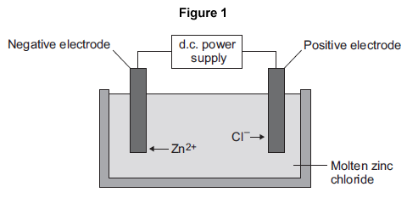
(a) Zinc chloride is an ionic substance.
Complete the sentence.
When zinc chloride is molten, it will conduct .................................................. .(1)
(b) Zinc ions move towards the negative electrode where they gain electrons to produce zinc.
(i) Name the product formed at the positive electrode. ....................................................................... (1)
(ii) Explain why zinc ions move towards the negative electrode. (2)
(iii) What type of reaction occurs when the zinc ions gain electrons? (1)
(c) Zinc is mixed with copper to make an alloy.
(i) Figure 2 shows the particles in the alloy and in pure zinc.
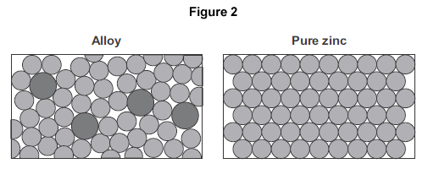
Use Figure 2 to explain why the alloy is harder than pure zinc. (2)
Q3.This question is about magnesium and magnesium chloride.
(a) Magnesium chloride contains magnesium ions (Mg²⁺) and chloride ions (Cl⁻). Describe, in terms of electrons, what happens when a magnesium atom reacts with chlorine atoms to produce magnesium chloride. (4)
(b) Magnesium chloride can be electrolysed.
The diagram below shows two experiments for electrolysing magnesium chloride.
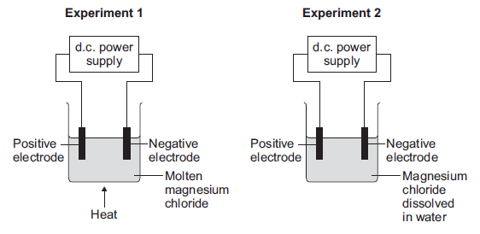
(i) Explain why magnesium chloride must be molten or dissolved in water to be electrolysed. (2)
(ii) Explain how magnesium is produced at the negative electrode in Experiment 1. (3)
(iii) In Experiment 2 a gas is produced at the negative electrode. Name the gas produced at the negative electrode. (1)
(iv) Suggest why magnesium is not produced at the negative electrode in Experiment 2. (1)
(v) Complete and balance the half equation for the reaction at the positive electrode.
.......... Cl⁻ → Cl₂ + .......... (1)
(c) Magnesium is a metal. Explain why metals can be bent and shaped. (2)

