PSHE work booklet – Year 10

Contents:
- Target setting sheet
- 5 Ways to wellbeing diary
- Self-esteem activity
- Importance of sleep
- Sharing information safely online

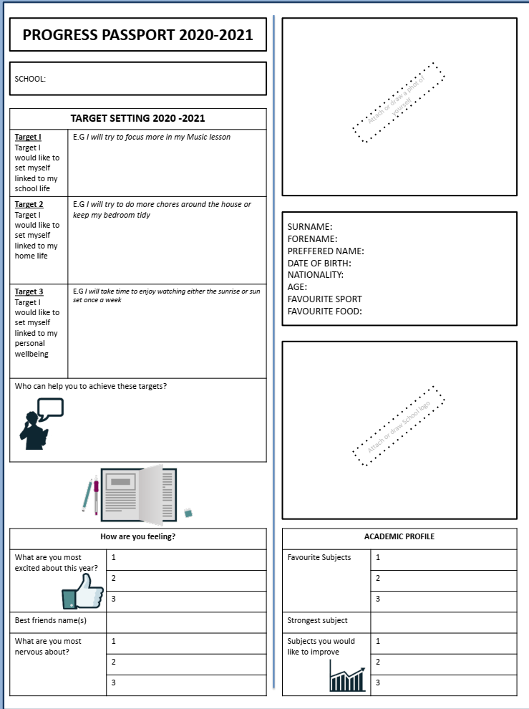
- Target setting- Fill in the following worksheet about you – think about your hopes and targets for the new school year.

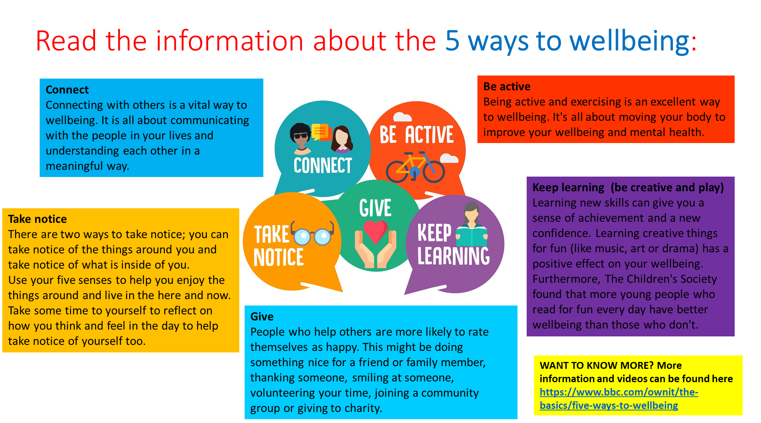
- 5 ways to wellbeing
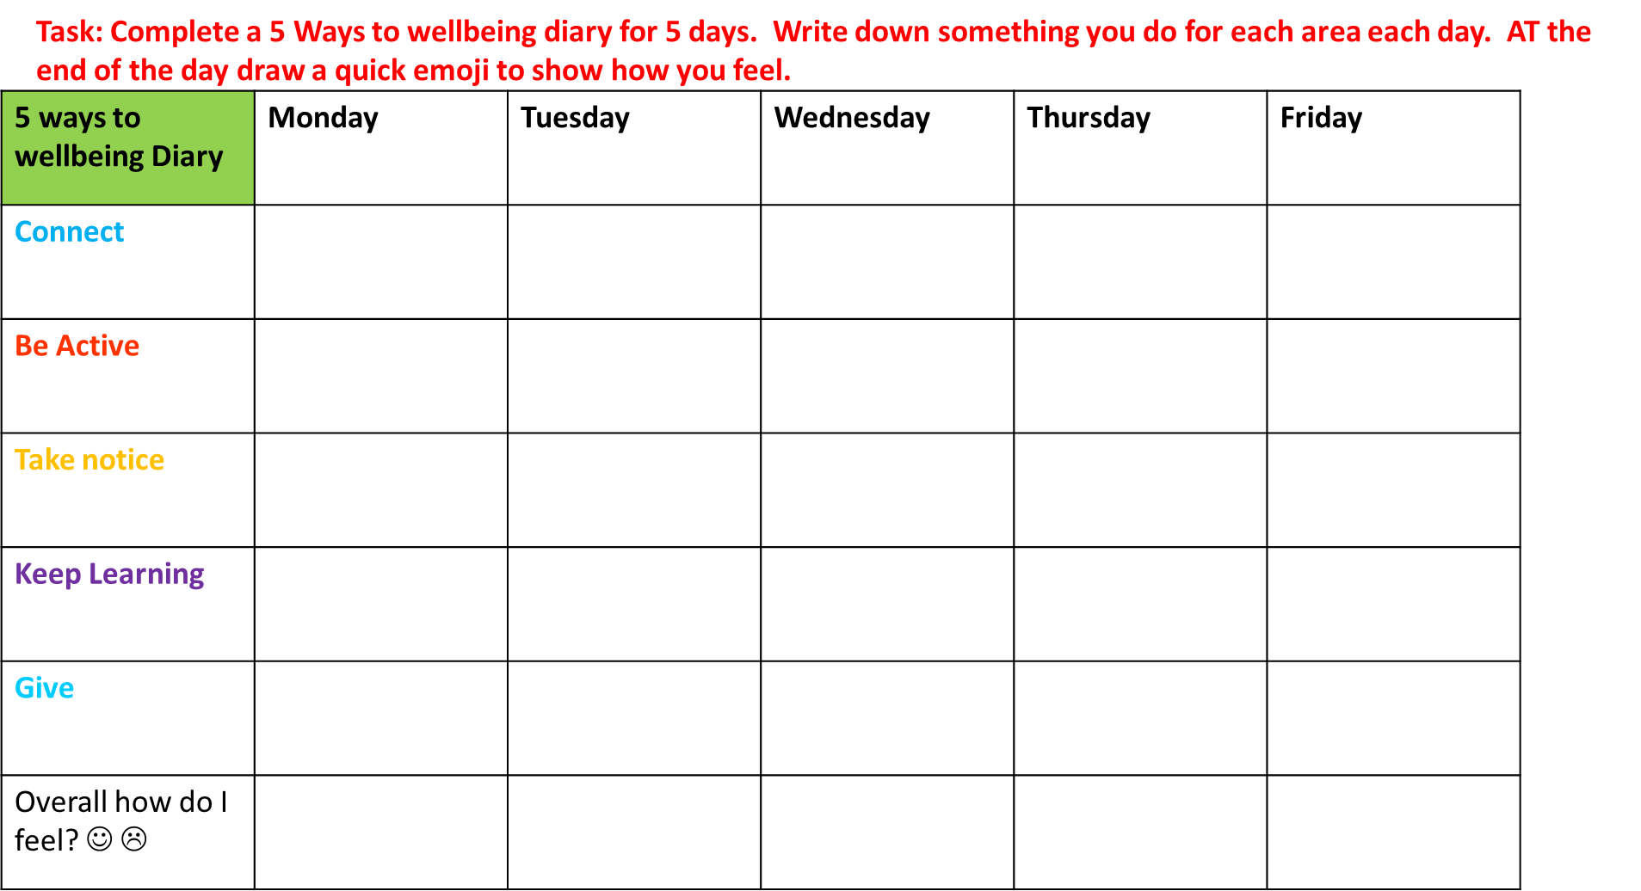
- Self esteem – Read through the information and complete the self esteem task sheet.
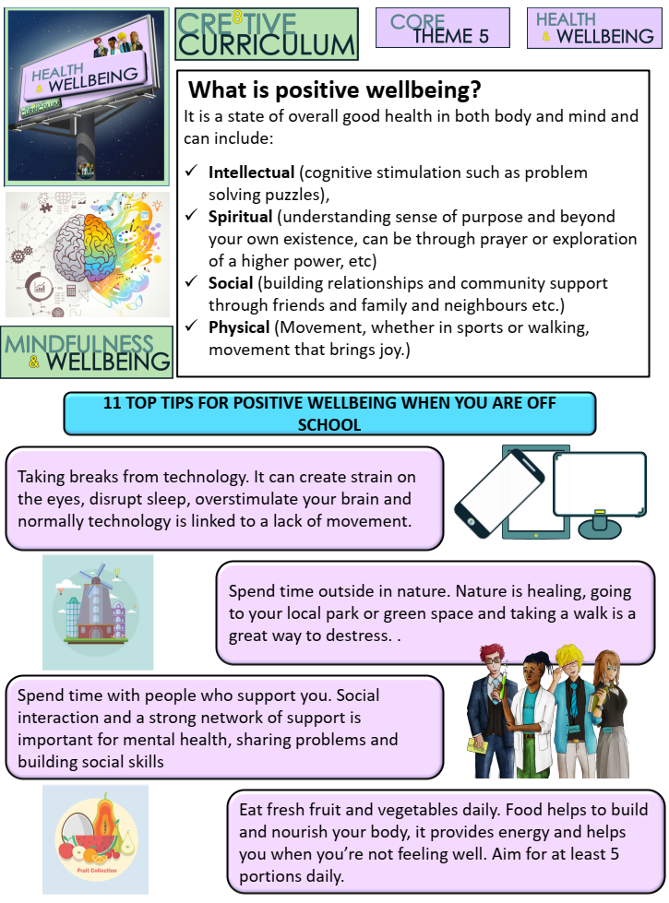
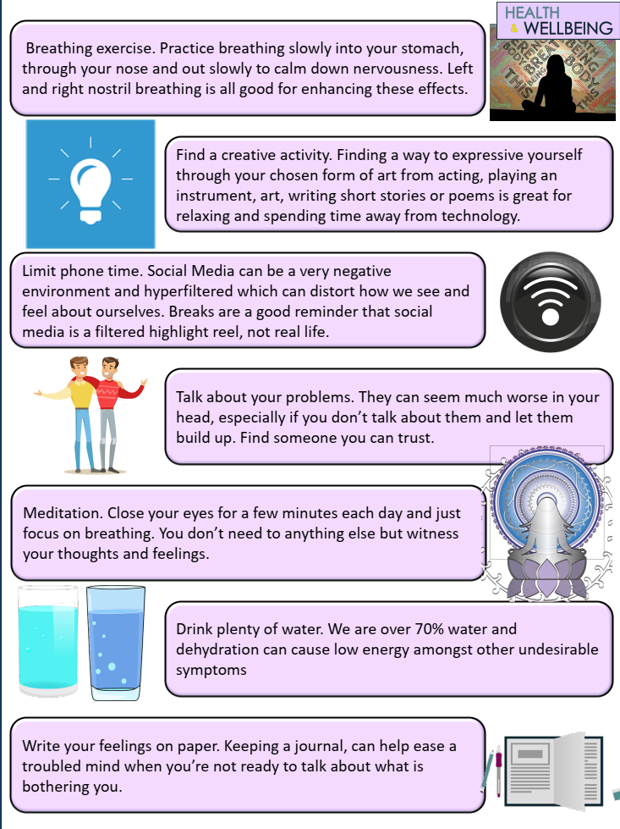

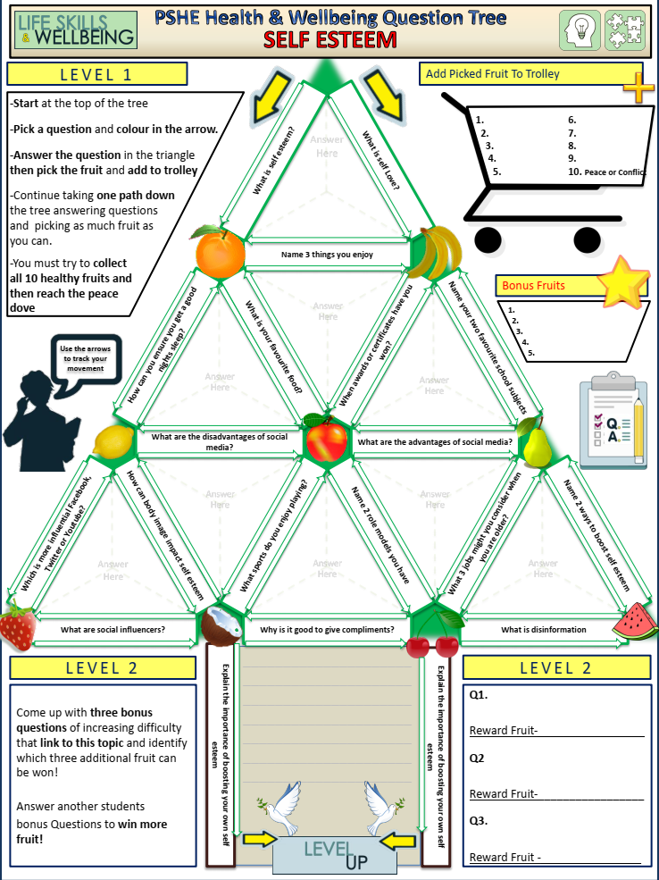

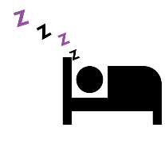
- The importance of Sleep
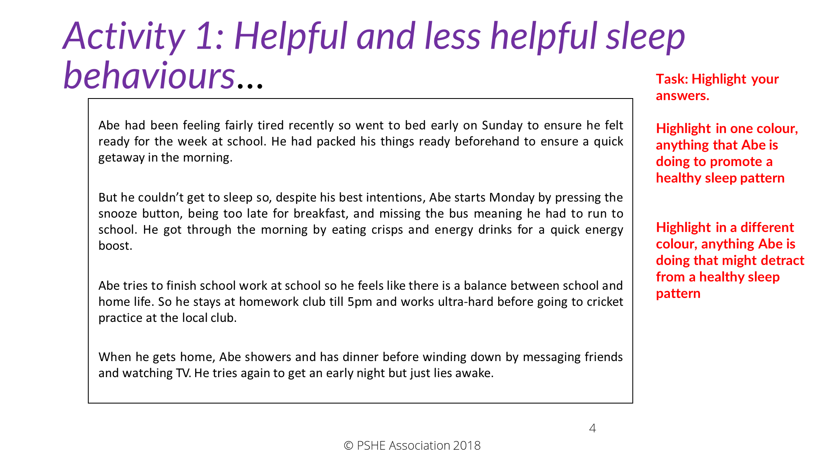

Read the following Key points:
- young people of your age need approximately 9 hours’ sleep per night
- this is similar to that required during childhood but, importantly, around 13/14 years old there is a natural shift to a later sleep pattern, i.e. around 11pm to sleep and 7-8am to rise
- this natural cycle can easily be impacted by social and academic commitments which in turn disrupt the natural sleep pattern and can make a young person more tired
Read ‘Activity 2: Consequences of poor sleep habits’ (on the next slide). As you read each scenario, think about the following questions:
- What might the consequences of poor sleep be for the character?
- What could the character do next?
- How could the character change or improve their sleep patterns?
Then, read through the answer sheet (on the following slide).
Now, for each character, summarise into a single bullet point one thing they could do in future.
Check your suggestions against the possible answers on the next slide…

Layla has slept through her morning alarm so her dad starts telling Layla off for being late. She shouts back as she runs out of the door.
Abdi’s family business is in making furniture so he often helps out in their woodwork shop after school. Recently, he’s not been getting enough sleep but doesn’t want to let his parents down so he carries on working in the shop.
Su went out with her girlfriend the night before a basketball final as she wanted to take her mind off her nerves. They stayed out longer than expected and she’s feeling pretty exhausted ahead of today’s fixture.
Tal was up really late studying for an exam later in the week so a friend offers him an energy drink from their ‘stash’. Tal wouldn’t normally drink this kind of thing as he knows they aren’t that great for your health but he’s too tired to argue.
Alima is late for her Saturday job at a café so she decides to take her moped. However, she’s slept badly and is not really feeling that alert.
Connor didn’t sleep well last night so when a teacher asks him a question, Connor realises he’s been daydreaming and can’t answer. He feels like a fool in front of the class so spends the rest of the lesson chatting and being generally disruptive.

Possible answers
Attainment in sports is very much affected by lack of sleep. Reaction time and the capacity for strategic thinking are affected so players don’t look as ‘on the ball’ — they are more likely to miss shots or passes and positioning may be poor. Due to the impact of the emotion-filter discussed above being reduced, there is an increased risk of frustration resulting in unsporting conduct. Research also shows that, not only is stamina reduced but there is an increased risk of sports-related injuries.

Su can make minimal impact on her performance for this game but can plan better next time. Su may be tempted to use a standard energy drink or caffeine pills to give her a boost. But these have a range of side-effects which may affect her performance, and they are likely to lose effectiveness just as she needs the energy most. Sports drinks which are well adapted to cardio workouts may be useful at keeping her hydrated, in the same way that they would do when she is not tired, but studies have been inconclusive
— some have shown they make no difference, others a slight increase in performance, others suggest the side effects affect performance. In any respect, they are unlikely to mask the lack of sleep.
Su went out with her girlfriend the night before a basketball final as she wanted to take her mind off her nerves. They stayed out longer than expected and she’s feeling pretty exhausted ahead of today’s fixture.
Working with machines and power-tools whilst tired is very risky – in fact a recent study found that being awake for 17 to 19 hours can impair ability more than being over the drink-driving limit. Researchers found that reaction times in a series of tests were up to 50 per cent slower in people deprived of sleep compared with the same people being given increasing doses of alcohol. This doesn’t mean it’s okay to drink then operate machinery, simply that lack of sleep can be dangerous when using tools and machinery. It is important that Abdi discusses this with his parents so that he and his family are not subject to unnecessary risk when using the tools and machinery in the woodwork shop.
Abdi’s family business is in making furniture so he often helps out in their woodwork shop after school. Recently, he’s not been getting enough sleep but doesn’t want to let his parents down so he carries on working in the shop.
The pre-fontal cortex normally allows us a chance to think about our reactions before we do something. But if we are tired, this ‘brake’ on our emotional reactions no-longer functions so we can end up lashing out or acting without thinking. It would help for Layla and her dad to talk about a better morning routine to avoid similar occurrences.
Layla has slept through her morning alarm so her dad starts telling Layla off for being late. She shouts back as she runs out of the door.

Lack of sleep has been shown to affect concentration, memory, information processing and reasoning. Connor’s emotional reaction to the situation can be accounted for by the poor emotional filter explained above. Connor should take steps to stop this happening again and should catch up on the work missed. He should also take responsibility for his behaviour rather than distracting others to mask his embarrassment.
Connor didn’t sleep well last night so when a teacher asks him a question, Connor realises he’s been day- dreaming and can’t answer. He feels like a fool in front of the class so spends the rest of the lesson chatting and being generally disruptive.
Research shows that driving on less than five hours sleep results in a one in ten chance of staying awake on a lengthy journey. Both lack of sleep and alcohol slow reaction time, affect the ability to process information and impair memory. In one study, driving while sleepy and driving while drunk were both found to potentially double your risk for a car accident. It’s therefore really important that Alima does not drive if she does not feel alert enough to do so. Incidentally, studies suggest that we are generally quite poor at estimating how tired we really are, particularly young drivers.
Alima is late for her Saturday job at a café so she decides to take her moped. However, she’s slept badly and is not really feeling that alert.
Energy drinks are notoriously unhelpful around exam season as they can give a temporary feeling of alertness but this is lost quite quickly and the person drinking them is likely to find themselves less able to concentrate than if they hadn’t had one at all. Caffeine boosts like this can also affect a person’s ability to sleep well by disrupting the circadian rhythm (sleep cycle). Sleep during exam season is incredibly important. Research has shown that better outcomes are often linked to more sleep not less. So cramming for exams can be counterproductive. It is best to stick to a normal sleep pattern and allocate revision accordingly.
Tal was up really late studying for an exam later in the week so a friend offers him an energy drink from their ‘stash’. Tal wouldn’t normally drink this kind of thing as he knows they aren’t that great for your health but he’s too tired to argue.

TASK: Create a mind map of ideas of how someone could promote good quality sleep and avoid issues with sleep.
E.g. avoid caffeine close to bedtime, create a bedtime routine…

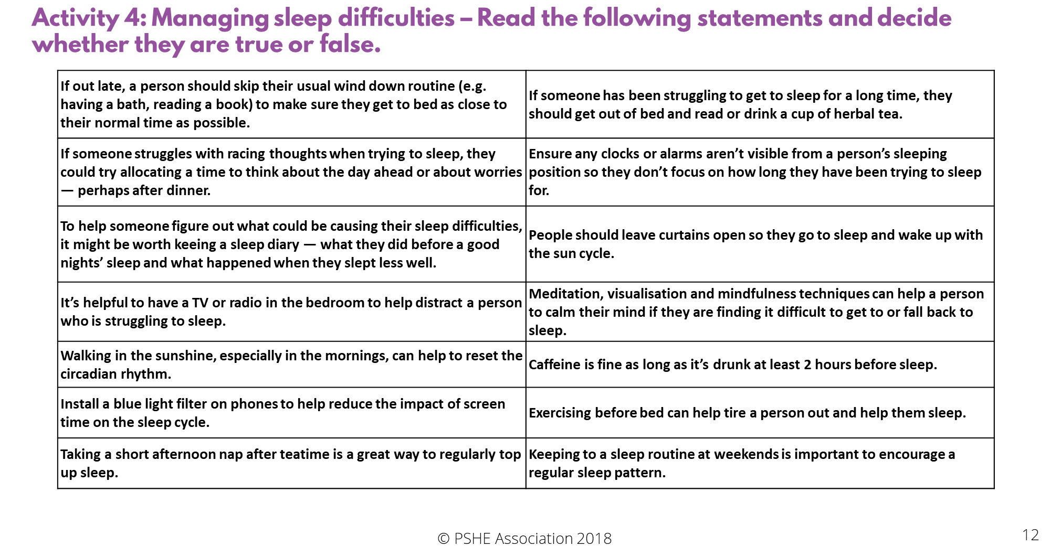

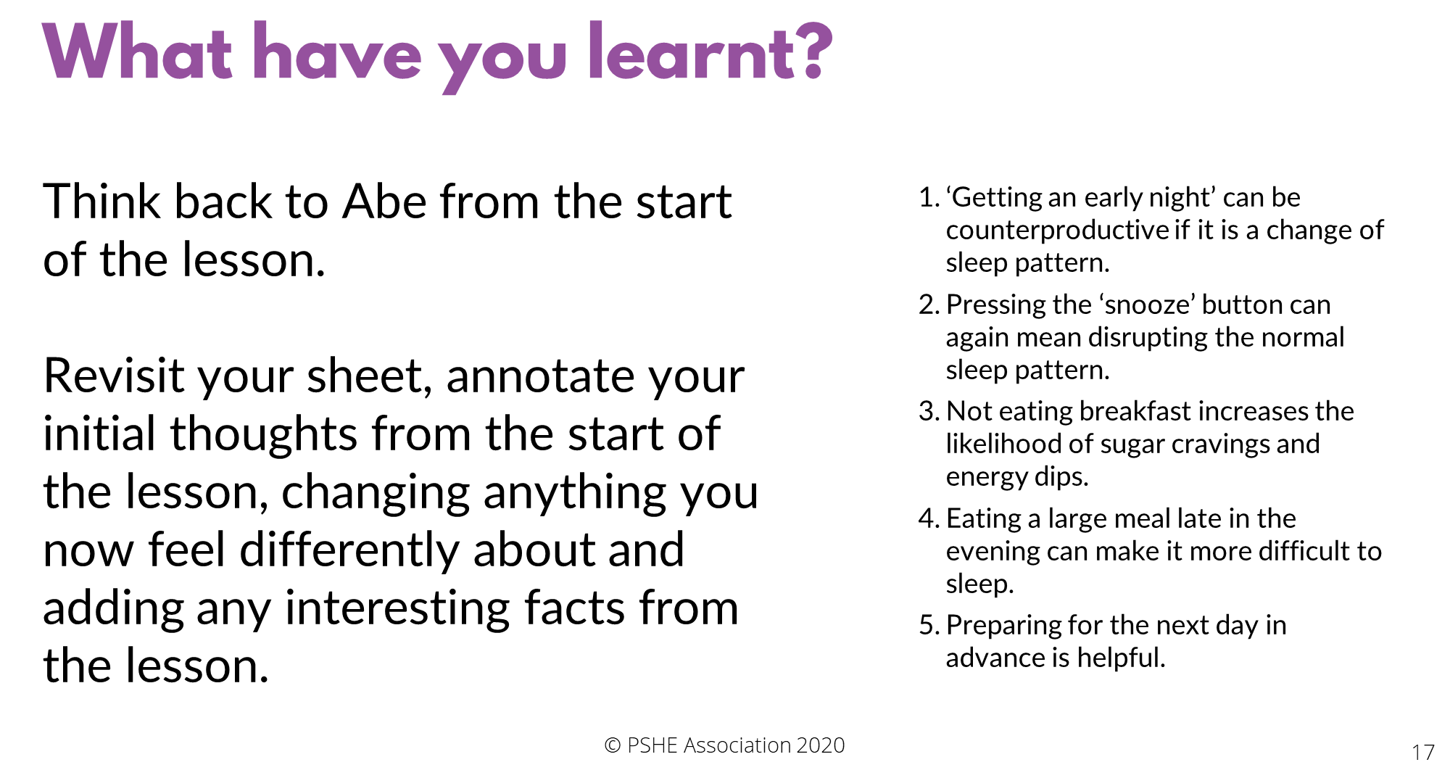
5 Sharing information safely online
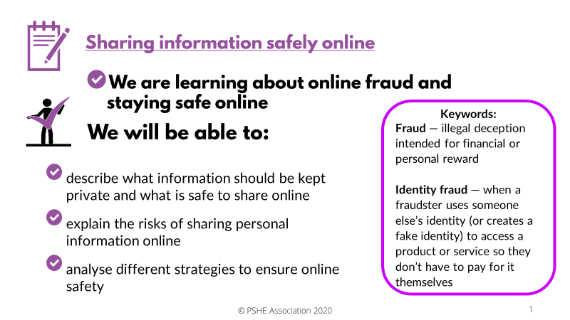

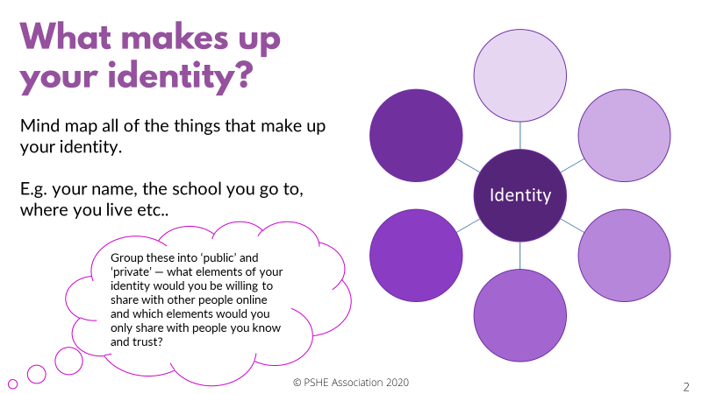

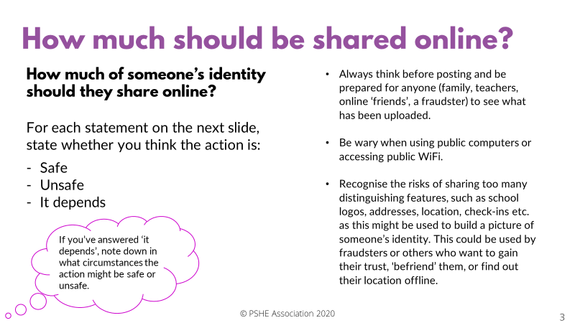
For each statement decide whether it is safe, unsafe, or it depends?
Action | Safe, unsafe, or it depends?
Posting a photo wearing school uniform
Checking privacy settings on social media after accepting a new update
Doing online banking on public Wi-Fi at a café
Always checking in at favourite locations
Having passwords of 10 or more characters that include numbers, letters and capitals
Using date of birth as a pin number for a bank card
Saving bank card details on a public computer in a library
Having address, email and phone number on a profile
page
Renewing antivirus software when it runs out
Entering bank card details to buy something from Amazon
Having open settings so anyone can send a friend request or view your profile
Setting a profile so only friends, or friends of friends can follow or like posts
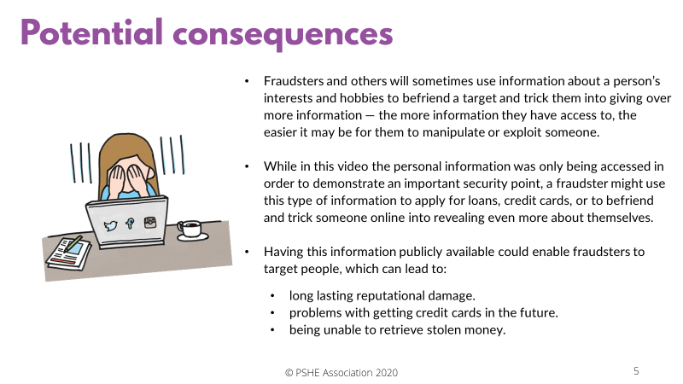

Put the bullet points in order by putting the online safety tip you think is most important at number 1, down to the least important safety tip.
- Have secure passwords (e.g. three random words with letters, numbers, capitals)
- Make sure photos don’t include sensitive or private information
- Don’t overshare information on social media
- Password and pin protect all devices
- Update firewalls and antivirus software
- Don’t access personal information if using public Wi-Fi (e.g. in a café or on a train)
- Always check before passing on anyone else’s information, even to a friend
- Regularly check privacy settings, especially after updates
- If unsure about online safety, visit an online source of support (e.g. thinkuknow.co.uk)

Using what you now know about the consequences of sharing personal information online, and the different strategies that could be used to stay safe, write a short piece of advice to the three characters below: Afterwards read the next slide to reveal the answers: Does your advice include some of these key points?

AALIYAH
Aaliyah has been contacted on social media by someone she doesn’t know. They have sent her a message telling her a little bit about themselves and have asked her questions about herself in return. They seem to just want to be friends.
What would your advice to Aaliyah be?

AUSTIN
Austin has been sent an email, congratulating him on winning a competition. He can’t remember entering this particular one, but all he has to do to claim his prize is enter a few simple details. He’s excited to have won something!
What would your advice to Austin be?

Personal reflection
Using what you have learnt today, write down three things that you will aim to do in future to increase your safety online.

