Year 7

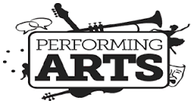

Name |  | Class
Starting Point |  | Target Grade
Teacher:

What is Performing Arts?
Performing Arts include the following disciplines:
Theatre
Music
Dance
Object Manipulation

The Performing Arts in education provides students with the opportunity to engage the mind, the body and emotions into a collaborative expression of what it means to be human. Through study and performance, students explore and present essential themes and ideas.
Performance is more than just self-expression and self-communication; it allows us to escape into the refuge of our fantasy, and leave behind the stress of the modern day world.
The Arts have a major importance in modern society because it defines us as individuals and make us better people.
Culture is the lifeblood of a vibrant society, expressed in the way we tell stories, celebrate, remember the past, entertain ourselves, and imagine the future. Our creative expression helps define who we are, and helps us see the world through the eyes of others.
Culture provides important social and economic benefits. With improved learning and health, increased tolerance, and opportunities to come together with others, culture enhances our quality of life and increases overall well-being for both individuals and communities.

LITERACY SKILLS
Spelling and understanding Subject Specific Vocabulary
Reading and understanding stimulus material
Researching and understanding stimulus context
Responding appropriately to others, politely and with good manners
Evaluating the impact of self and peers throughout the process

CORE SKILLS
Listening
Self-Control
Cooperation
Concentration
Coordination

PERFORMANCE SKILLS
Voice
Movement
Gesture
Facial Expression

EXPLORATIVE SKILLS
Tableaux/Still Image/Freeze Frame
Narration/Thought Tracking
Marking the Moment
Hot Seating
Forum Theatre

Explaining your peers’ practical work:
What did they do?
Why did they make these choices?
What was the effect on the audience?
What were the strengths?
What could be improved?

Explaining your practical work:
What did you do?
Why did you make these choices?
What was the effect on the audience?
What were the strengths?
What could be improved?

YEAR 7 TOPICS & TECHNIQUES

AUTUMN

Art Form | STIMULUS FORM | CONTEXT | TECHNIQUE
Drama | William Kidd  ‘Pirates’ | Historic | Image / still-image  Role-play  Mime  Body-prop  Montage  Thought-tracking  Flashback
Dance | Around the world | Culture and Diversity | Unison  Canon  Repetition  Motif development  Contrast  Stimulus  Solo, duet, group  ADSR  (Action, Dynamics, Relationships and Space)

DRAMA
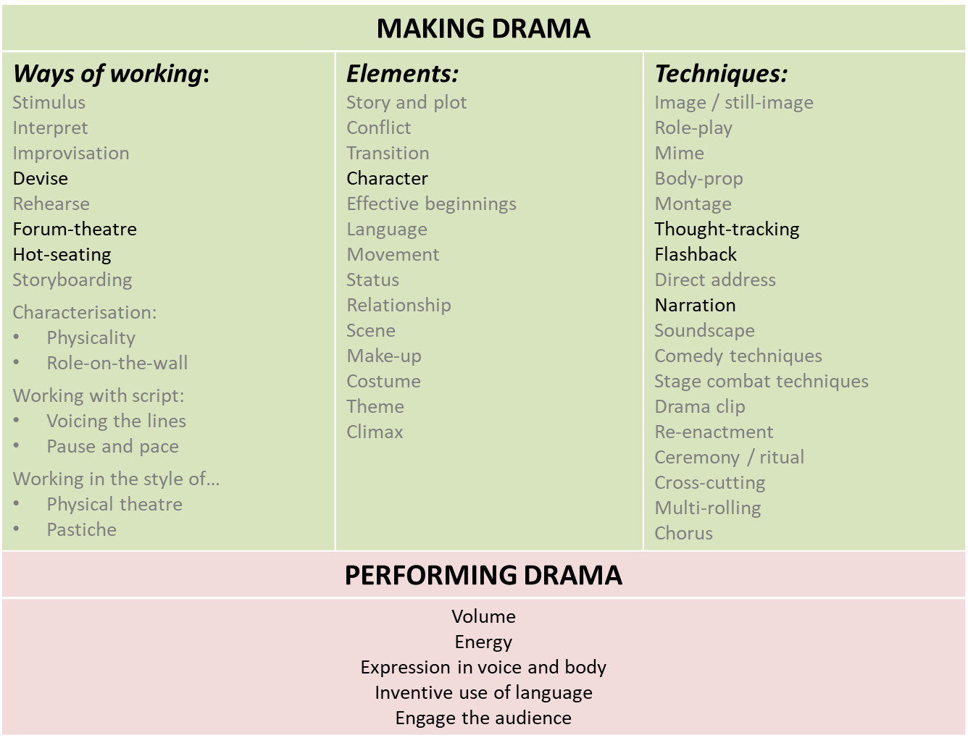
In this drama unit as pirates we are to develop understanding of a range of drama techniques, and to apply them thoughtfully to create dramatic meaning, communicate character and narrative.
REVISIT and RE-ENFORCE
MAKING DRAMA:
  - Ways of working: interpret, stimulus, improvisation and rehearsal
  - Elements: story, conflict and transition
  - Techniques: still-image, role-play, mime, body-prop
INTRODUCE / ELABORATE
MAKING DRAMA:
  - Forum theatre, hot-seating and devising as ways of working
  - Element of character
  - Techniques: narration, flashback, thought-tracking
PERFORMING:
Volume, energy, expression, inventive language, engage audience

Year 7 Performing Arts Literacy
Home Learning Spellings
Autumn 1
- ROLE PLAY

- THOUGHT TRACKING

3. MIME

- STILL IMAGE

- WILLIAM KIDD

Is when you step into the shoes of a different character.
is when a character steps out of a scene to address the audience about how they're feeling

Is a frozen picture which communicates meaning. It's sometimes called a freeze frame or tableau
is acting without speaking or sound.

was a Scottish sailor who was tried and executed for piracy

Home Learning Research
Homework 2 | William Kidd
TASK | You are to write a letter to the government explaining what skills you have that make you suitable for a privateer job.  What is a privateer?  Who are you writing it to?  What skills do you need?  What makes you perfect for the job?
WHAT I LEARNED FROM OTHERS . . .

WHAT I WOULD LIKE TO KNOW MORE ABOUT . . .

Homework 3
- Flashback

- Narration

- Transition

- Duologue

- William Moore (RESEARCH)

a technique whereby one or more performers speak directly to the audience to tell a story
Is a way of presenting events that happened prior to the current action taking place.
The movement from one scene to another.
Is a frozen picture which communicates meaning. It's sometimes called a freeze frame or tableau

The gunner on a British pirate ship

Home Learning Research
Homework 4 | William Kidd
TASK | Write a diary entry as William Kidd about the events on board the ship today.  Think about how you feel ?  What Happened ?  Are you happy that Moore is dead ?  Are you happy or not that you wll now be an illegal pirate ?
WHAT I LEARNED FROM OTHERS . . .

WHAT I WOULD LIKE TO KNOW MORE ABOUT . . .

Year 7 Performing Arts Literacy
Home Learning Spellings
Home work 5
1.Thought Tunnel

2. Forum theatre

3. Character profile

4.Montage

5. presentational theatre

an interactive form of theatre that presents a theatrical debate.
A character from the drama walks slowly between two rows of students. As the character passes each student, they call out what they guess the character is thinking

a description of a fictional character's life.
is a series of short scenes or images.

is a genre of theatre that confronts the audience by acknowledging them through language, movements and signs that shows that the actors are aware of the audience’s presence

PUPIL | Autumn 1 Assessment William Kidd
TASK | APPLYING SKILLS FOR ASSESSMENT  The Trial of William Kidd
GRADES | Beginner |  |  | 1 . |  | 2. |  | 3.
 | Foundation |  |  | 1. |  | 2. |  | 3.
 | Developing  . |  |  | 1. |  | 2. |  | 3.
What I have done

What I could do better

TEACHER | Autumn 1 Assessment William Kidd
TASK | APPLYING SKILLS FOR ASSESSMENT  The Trial of William Kidd
GRADES | Beginner |  |  | 1 . |  | 2. |  | 3.
 | Foundation |  |  | 1. |  | 2. |  | 3.
 | Developing  . |  |  | 1. |  | 2. |  | 3.
What you did well | 1.  2.  3.
Targets for Drama 2 | 1.  2.  3.
YEAR 7 EVALUATION

LITERACY SKILLS
Spelling |  | B | D |  | S |  | E
Reading Stimulus |  | B | D |  | S |  | E
Researching Context |  | B | D |  | S |  | E
Responding Appropriately |  | B | D |  | S |  | E
Evaluating self/peers |  | B | D |  | S |  | E
CORE SKILLS
Listening |  | B | D |  | S |  | E
Self-Control |  | B | D |  | S |  | E
Cooperation |  | B | D |  | S |  | E
Concentration |  | B | D |  | S |  | E
Coordination |  | B | D |  | S |  | E
EXPLORATIVE SKILLS
Tableaux |  | B | D |  | S |  | E
Narration/Thought T |  | B | D |  | S |  | E
Improvisation |  | B | D |  | S |  | E
Role Play |  | B | D |  | S |  | E
Forum Theatre |  | B | D |  | S |  | E
PERFORMANCE SKILLS
Voice |  | B | D |  | S |  | E
Movement |  | B | D |  | S |  | E
Gesture |  | B | D |  | S |  | E
Facial Expression |  | B | D |  | S |  | E
Mime |  | B | D |  | S |  | E
OVER ALL GRADE

DANCE

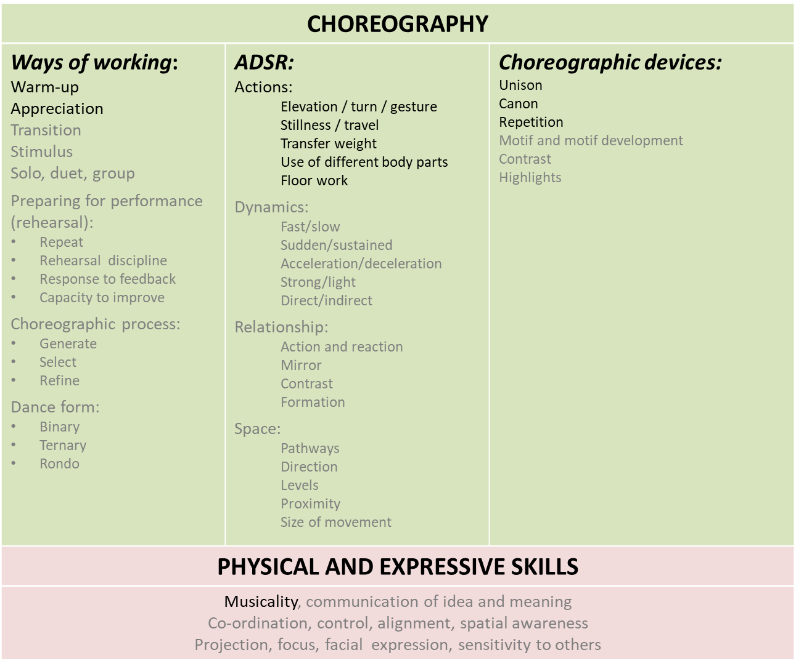
Through dancing around the world our aim is to learn to appreciate the cultural importance and diversity of dance styles around the world

CHOREOGRAPHY:
- Introduction to some ways of working in Dance: warm up, appreciation
- To know what ADSR stands for, and to know and use the dance actions
- Use basic choreographic devices in dance work: unison, canon
PHYSICAL and EXPRESSIVE SKILLS
Develop an awareness of musicality

Homework 1
- Elevation

- Turn

- Gesture

- Stillness

- travel

- Transfer weight
- Floor work
- different body parts
the body’s propulsion into the air away from the floor.
The rotation of the body

Is the absence of motion.
A series of movements performed on the floor
a movement that you make with a part of your body.

The use of different body parts to form a dance phrase
movement so that their weight is moved from one supporting foot (or supporting limb/body part) to another one fully or partially
The movement from one area to another

Home Learning Research
Homework 2 | Dance around the world
TASK | You are to create a fact file about street dance. You must have a section ‘’about my dance’’ where you talk about and evaluate your dance.  What is street dance?  When does it date back to ?  What skills do you need?  Can you find any famous street dancers?
WHAT I LEARNED FROM OTHERS . . .

WHAT I WOULD LIKE TO KNOW MORE ABOUT . . .

Home Learning Research
Homework 3 | Dance around the world
TASK | You are to create a fact file about Bollywood/Bhangra. You must have a section ‘’about my dance’’ where you talk about and evaluate your dance.  What is Bollywood/Bhangra?  When does it date back to ?  What skills do you need?  Can you find any famous Bollywood/Bhangra dancers?
WHAT I LEARNED FROM OTHERS . . .

WHAT I WOULD LIKE TO KNOW MORE ABOUT . . .

Home Learning Research
Homework 4 | Dance around the world
TASK | You are to create a fact file about Capoeira You must have a section ‘’about my dance’’ where you talk about and evaluate your dance.  What is Capoeira dance?  When does it date back to ?  What skills do you need?  Can you find any famouCapoeira dancers?
WHAT I LEARNED FROM OTHERS . . .

WHAT I WOULD LIKE TO KNOW MORE ABOUT . . .

Home Learning Research
Homework 5 | Dance around the world
TASK | You are to create a fact file about salsa dance. You must have a section ‘’about my dance’’ where you talk about and evaluate your dance.  What is salsa dance?  When does it date back to ?  What skills do you need?  Can you find any famous salsa dancers?
WHAT I LEARNED FROM OTHERS . . .

WHAT I WOULD LIKE TO KNOW MORE ABOUT . . .

Home Learning Spellings
Homework 6
- Street Dance
- Salsa
- Bollywood / Bhangra
- Capoeira
- Elevation
- Turn
- Gesture
- Stillness
- travel
- Transfer weight
- Floor work
- different body parts

PUPIL | Autumn 2 Assessment Dance Around the World
TASK | APPLYING SKILLS FOR ASSESSMENT  Choreography and Performance
GRADES | Beginner |  |  | 1 . |  | 2. |  | 3.
 | Foundation |  |  | 1. |  | 2. |  | 3.
 | Developing  . |  |  | 1. |  | 2. |  | 3.
What I have done

What I could do better

TEACHER | Autumn 2 Assessment Dance Around the World
TASK | APPLYING SKILLS FOR ASSESSMENT  Choreography and Performance
GRADES | Beginner |  |  | 1 . |  | 2. |  | 3.
 | Foundation |  |  | 1. |  | 2. |  | 3.
 | Developing  . |  |  | 1. |  | 2. |  | 3.
What you did well | 1.  2.  3.
Targets for Dance 2 | 1.  2.  3.
LITERACY SKILLS
Spelling |  | B | D |  | S |  | E
Reading Stimulus |  | B | D |  | S |  | E
Researching Context |  | B | D |  | S |  | E
Responding Appropriately |  | B | D |  | S |  | E
Evaluating self/peers |  | B | D |  | S |  | E
CORE SKILLS
Listening |  | B | D |  | S |  | E
Self-Control |  | B | D |  | S |  | E
Cooperation |  | B | D |  | S |  | E
Concentration |  | B | D |  | S |  | E
Coordination |  | B | D |  | S |  | E
EXPLORATIVE SKILLS
Tableaux |  | B | D |  | S |  | E
Narration/Thought T |  | B | D |  | S |  | E
Improvisation |  | B | D |  | S |  | E
Role Play |  | B | D |  | S |  | E
Forum Theatre |  | B | D |  | S |  | E
PERFORMANCE SKILLS
Voice |  | B | D |  | S |  | E
Movement |  | B | D |  | S |  | E
Gesture |  | B | D |  | S |  | E
Facial Expression |  | B | D |  | S |  | E
Mime |  | B | D |  | S |  | E
OVERALL GRADE

