BTEC Tech Award in Health and Social Care
Component 3
Health and Well-being
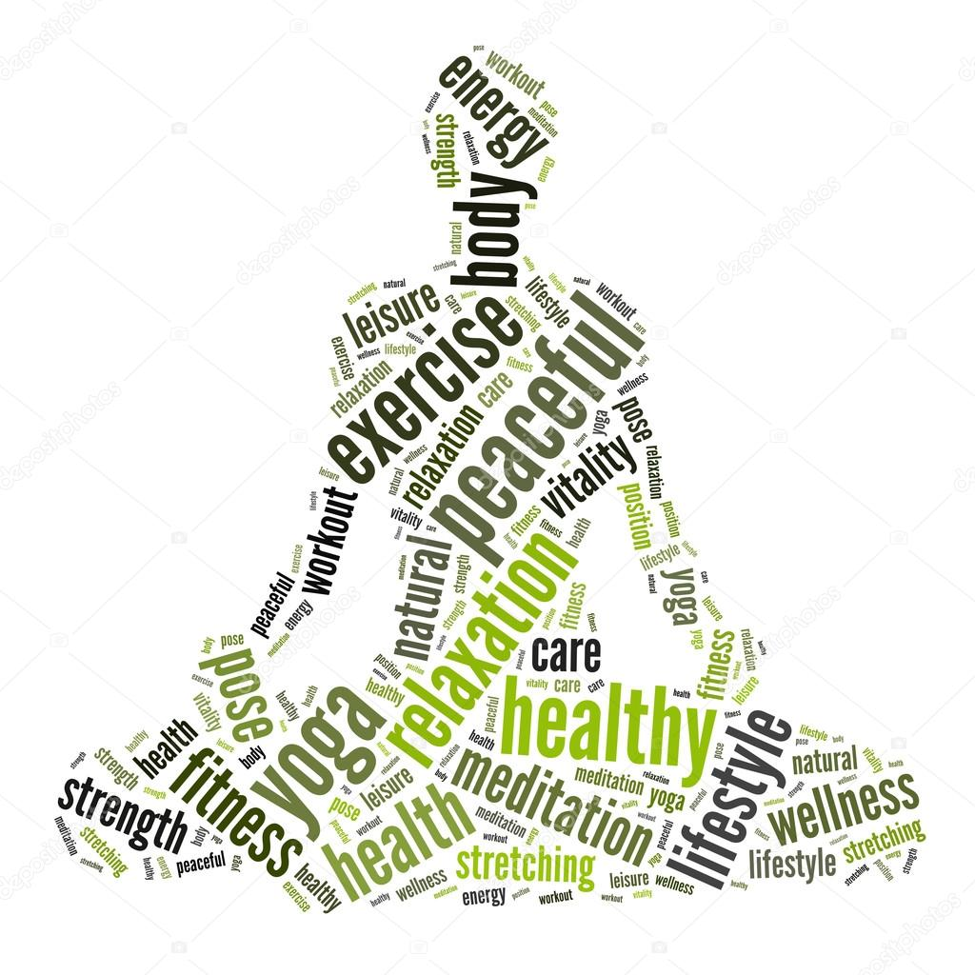

Name: ……………………………………
Part 1
Assessment criteria
Introduction
What does being healthy actually mean? It can mean different things to different people: you might think ‘healthy’ is not having to visit the doctor but an older person might consider it being mobile and able to get out and about, being happy and having friends.
In this component, you look at the factors that can have a positive or negative influence on a person’s health and wellbeing.

You will learn to interpret physiological and lifestyle indicators, and what they mean for someone’s state of health.

You will learn how to use this information to design an appropriate plan for improving someone’s health and wellbeing, including short- and long-term targets.

Additionally, you will explore the difficulties an individual may face when trying to make these changes.

You will develop skills in analysing information and communicating for a specific purpose, which will support your progression to Level 2 or 3 vocational or academic qualifications.

Summary of assessment
This external component builds on knowledge, understanding and skills acquired and developed in Components 1 and 2.

You will be given a case study and will assess an individual’s health and wellbeing, drawing on their understanding of life events from Component 1. They will design a health and wellbeing improvement plan that draws on their knowledge of services and care values from Component 2.

A task worth 60 marks will be completed under supervised conditions. The supervised assessment period is a maximum of three hours.

Assessment objectives

AO1 Demonstrate knowledge and understanding of factors that affect health and wellbeing
AO2 Interpret health indicators
AO3 Design a person-centred health and wellbeing improvement plan
AO4 Demonstrate knowledge and understanding of how to overcome obstacles relating to health and
wellbeing improvement plans

Health and Social Care Knowledge Organiser: Component 3 Health and Wellbeing
LAA Factors that affect health and wellbeing | LAB Interpreting health indicators | LAC Person centred health and wellbeing improvement plans
A1 Factors affecting health and wellbeing  - Definition of health and wellbeing  - A combination of physical health and social and emotional wellbeing, and not just the absence of disease or illness  - Physical and lifestyle factors that can have positive or negative effects on health and wellbeing:  - Genetic inheritance, including inherited conditions and predisposition to other conditions  - Ill health (acute and chronic)  - Diet (balance, quality and amount)  - Amount of exercise  - Substance user, including alcohol, nicotine, illegal drugs and misuse of prescribed drugs  - Personal hygiene  - Social, emotional and cultural factors that can have positive or negative effects on health and wellbeing:  - Social interactions, e.g. supportive/unsupportive relationships, social intergration/ isolation  - Stress, e.g. work-related  - Willingness to seek help or access services, e.g. influenced by culture, gender, education  - Economic factors that have a positive or negative effect on health and well-being  - Financial resources  - Environmental factors that can have a positive or negative effect on health and well-being:  - Environmental conditions, e.g. levels of pollution, noise  - Housing, e.g. conditions, location  - The impact of life events relating to relationship changes and changes in life circumstances | B1 Physiological indicators  - Physiological indicators that are used to measure health:  - Pulse (resting and recovery rate after exercise)  - Blood  - Peak flow  - Body mass index (BMI)  - Using published guidance to interpret data relating to these physiological indicators  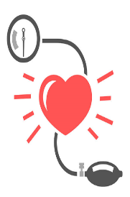  - The potential significance of abnormal readings: risks to physical health | C1 Health and wellbeing improvement plans  - The importance of a person-centred approach that takes into account an individual’s needs, wishes and circumstances  - Information to be included in plan:  - Recommended actions to improve health and wellbeing  - Short term (less than 6 months) and long term targets  - Appropriate sources of support (Formal and/ or informal)
 | B2 Lifestyle indicators  - Interpretation of lifestyle data, specifically risks to physical health associated with:  - Smoking  - Alcohol consumption  - Inactive lifestyles  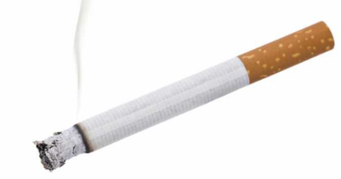 | C2 Obstacles to implementing plans  - Potential obstacles  - Emotional/ psychological – lack of motivation, low self-esteem, acceptance of current state  - Time constraints – work and family commitments  - Availability of resources – financial, physical, e.g. equipment  - Unachievable targets – unachievable for the individual or unrealistic timescale  - Lack of support, e.g. from family and friends  - Other factors specific to individual – ability/ disability, addiction  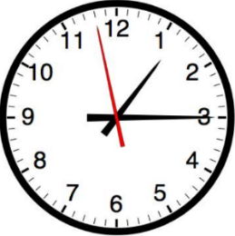  - Barriers to accessing identified services
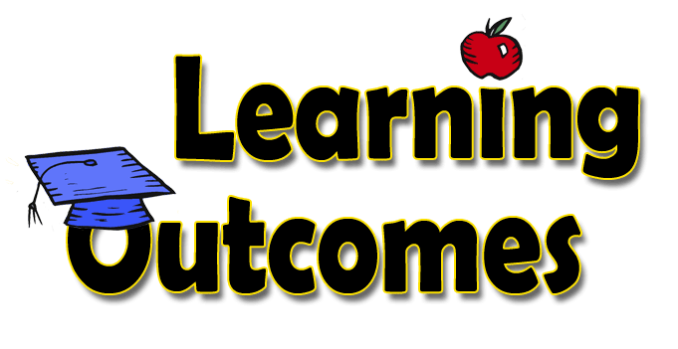
Learning outcomes:
- To be able to explain the difference between ‘health’ and ‘wellbeing’ and identify a range of factors which may influence them.
Write down what you think the following words mean:
health
well-being

Outline of component 3:

What is health and wellbeing?
- Health and well-being can be described as the absence of physical illness, disease and mental distress. This is a negative definition of health and well-being.
- Health and well-being can be described as the achievement and maintenance of physical fitness and mental stability.
- This is a positive definition of health and well-being. Health and well-being as being the result of a combination of physical, social, intellectual and emotional factors. This is a holistic definition of well-being.
- The ideas about health and well-being changes over time and vary between different cultures and life stages.
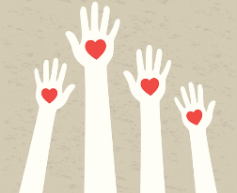
Task: Identify physical aspects of health, social and emotional aspects of well-being in the space below:

Task 2: Factors influencing health and wellbeing
List all the factors which could have a positive and negative impact on a person’s health and wellbeing. In the middle of the Venn diagram, write down the factors which could be both (positive and negative).

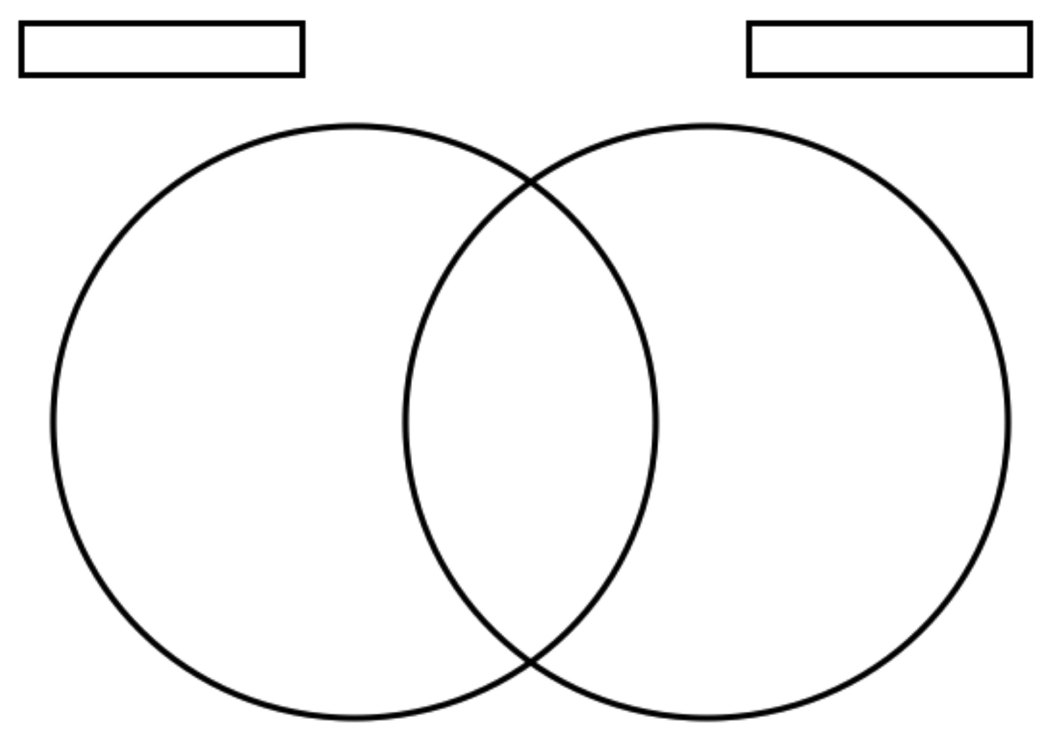
Positive
Negative
Task 2: Factors influencing health and wellbeing
Positive | Negative
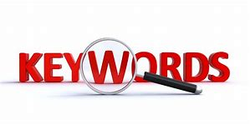
Key words:
Health, wellbeing, factors, physical, intellectual, emotional, social.

Health | The general condition of the body or mind
Well-being | Condition of existence – a state characterised by health, happiness and prosperity
Factors | Elements contributing to overall well-being

Positive definition:
A positive definition looks at how physically fit and mentally stable a person is. You have a positive attitude towards health and wellbeing if:
- you realise there is something you can do to improve your health and wellbeing and do it.
Negative definition:
A negative definition looks at the absence of physical illness, diseases and mental distress. You have a negative attitude towards your health and wellbeing if you:
- Base your attitude on not having anything wrong with you
- Continue as you are – including keeping bad habits such as smoking and eating junk food
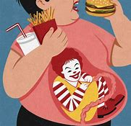
- Assume that because you currently feel fine you will stay healthy in the future.
Which one are you? …………………………………………………………………………………………….

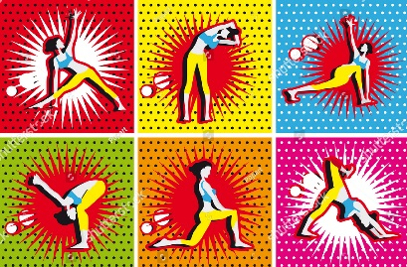
A holistic definition of well-being.
A holistic definition of well-being is a combination of physical health and social and emotional well-being. It is not just the absence of disease or illness. It looks at all aspects of a person’s health and well-being. You have a holistic attitude towards health and well-being if you look after:

- Physical health – by meeting the needs we have to keep our bodies working as well as they can, such as food, water, shelter, warmth, clothing, rest, exercise and good personal hygiene.
- Social aspects of well-being – by meeting the needs we have to help us develop and enjoy good relationships with others, including mixing with others in appropriate environments and having access to leisure facilities/activities.
- Emotional aspects of well-being – by meeting the needs we have that make us feel happy and relaxed, such as being loved, respected and secure; we need to be able to feel, express and recognise different emotions so we can cope with whatever situations arise in life.
In addition, we should consider our mental and intellectual health, by meeting the needs have to develop and keep our brains working as well as possible; these include mental stimulation to keep us motivated and interested.

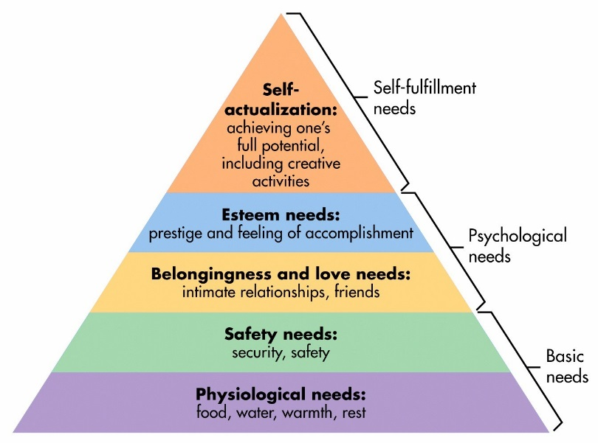
Activity:

Create an information sheet on the factors that can have a negative impact on your health and well-being. Include an information sheet for each of the PIES. Make sure you include information on how and why the factor can have a negative impact.
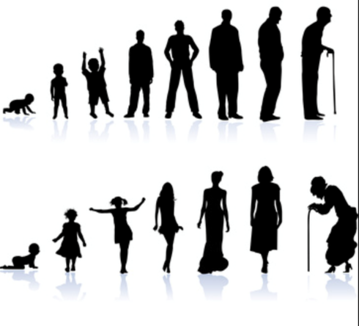
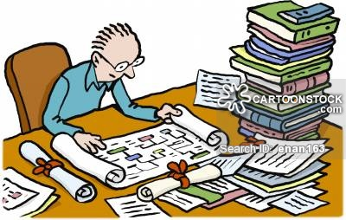
Life stages and our needs
Our basic needs do not change as we pass through the various life stages. However, different people will need different kinds of support from health and social care services depending on their particular situation or life stage. People also have different views on their needs. For example, and adult might enjoying having time alone to relax, a child left on its own might find it frightening.
Research:
- What does the word predisposition mean?
- Find examples to explain.
Learning outcomes:
- To be able to explain what ‘genetic inheritance’ is and how this may affect an individual’s life in relation to their PIES development.
Key words:

Health | The general condition of the body or mind
Well-being | Condition of existence – a state characterised by health, happiness and prosperity
factors | Elements contributing to overall well-being
genetic inheritance | The genes a person inherits from their parents.
predisposition | a liability or tendency to suffer from a particular condition, hold a particular attitude, or act in a particular way
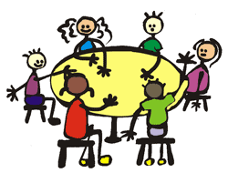
In pairs/groups of three, discuss with the person next to your answers to the homework.
Watch the following clip to help extend your understanding of predisposition. Add to your homework notes on the previous page!

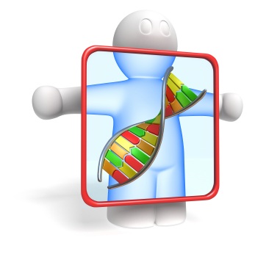
Genetic inheritance
Physical and lifestyle factors have positive and/or negative effects on health and well-being. One example of such a factor is genetic inheritance.
Some conditions or diseases are inherited, which means they are passed down from one generation to another. One example is haemophilia, which only effects males. This would affect the PIES needs in males. A male with this disease would need to make sure he does not cut himself, as his blood would not clot. As a result, he would have to think carefully about:
- What type of work to apply for (physical)
- Which type of leisure activities to avoid (social)
This could affect him emotionally and intellectually, because he may be worried and distracted by his condition.
Inherited disorders are caused by faulty genes, which are mostly (but not always) recessive alleles. For example, cystic fibrosis is an inherited disorder that affects the cell membranes, causing the production of thick and sticky mucus. It is caused by a recessive allele, which means that it must be inherited from both parents.

Add page 17 of REVISION BOOK HERE

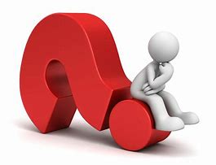
Quick questions:
- People are genetically predisposed to the following:
- Pet preferences
- Flexibility
- Biological and behavioural issues
- Approachability

- To be genetically predisposed to an illness means to be _____ to that illness.
A) Susceptible
B) Attractive
C) Immune
D) Fearful

If Brandon is genetically predisposed to diabetes, he:
- Will definitely get diabetes
- Will never get diabetes
- Will only get diabetes if his siblings do as well
- May get diabetes

Starter Activity: Inherited conditions
Cystic fibrosis is an inherited condition in which the lungs and digestive system can become clogged with thick, sticky mucus.
It can cause problems with breathing and digestion from a young age. Over many years, the lungs become increasingly damaged and may eventually stop working properly.
Most cases of cystic fibrosis in the UK are now identified through screening tests carried out soon after birth. It's estimated that 1 in every 2,500 babies born in the UK has cystic fibrosis.
A number of treatments are available to help reduce the problems caused by the condition, but unfortunately average life expectancy is reduced for people who have it.
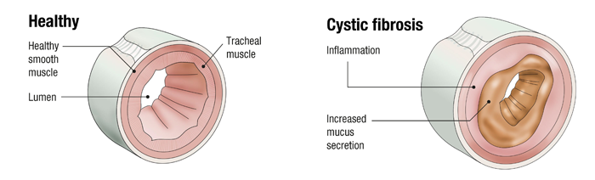
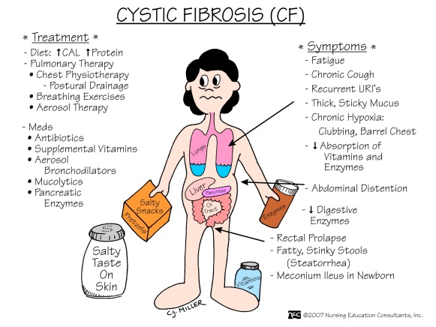
Some of the main symptoms of cystic fibrosis can include:
- recurring chest infections
- difficulty putting on weight
- frequent, wet-sounding coughs
- diarrhoea
- occasional wheezing and shortness of breath

People with the condition can also develop a number of related conditions, including diabetes, thin, weakened bones (osteoporosis) and liver problems.

Watch the video clip and make some notes:
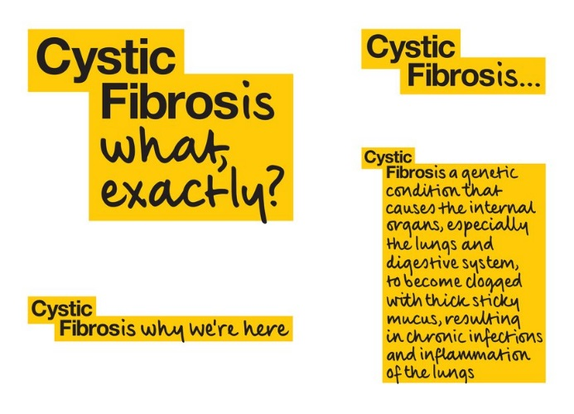

Questions to consider:
What might it be like to inherit a condition such as cystic fibrosis?

What impact does cystic fibrosis have on everyday life?

How might cystic fibrosis affect health and well-being:
Physical | Intellectual | Emotional | Social

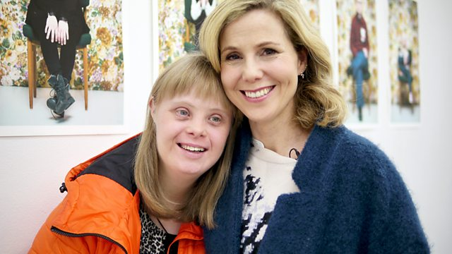
Down's syndrome, also known as Down syndrome or trisomy 21, is a genetic condition that typically causes some level of learning disability and certain physical characteristics.
People with Down's syndrome are more likely to have certain health problems, including:
- heart disorders, such as congenital heart disease
- hearing and vision problems
- thyroid problems, such as an underactive thyroid gland (hypothyroidism)
- recurrent infections, such as pneumonia
Questions to consider:
What might it be like to inherit a condition such as Down’s syndrome?

How this would affect their PIES needs.
Physical | Intellectual | Emotional | Social

What is a predisposition?
It is a tendency to a particular condition usually based on the combined effects of genetic and environmental factors. If you have a predisposition to think or act a certain way, you can anticipate your reaction before it happens.
A genetic predisposition means you are likely to inherit a trait from your parents. Someone might have a genetic predisposition to diabetes or to another illness. This means they are more susceptible to getting the predisposition.
Find examples to explain
- Breast cancer
- Diabetes
- Bad teeth
- Baldness
- Behaviour (drug/alcohol addictions)
- Personality types (aggressive)

Research real-life examples of predispositions outlining the positive and negative effects on their health and well-being.
An example could be:
- A woman chooses to have a mastectomy because they have a predisposition to breast cancer.
- A someone who has a predisposition to heart disease adjusting their diet and exercise routine could improve their life chances.

Predisposition to other conditions:
Predisposition means that someone is more likely to suffer from a particular condition due to:
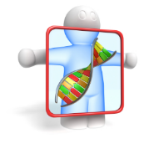
- genetic factors
- environmental factors
- a combination of both

Research Huntington’s disease and explain how it affects health and well-being.

add page 19 of revision book here

Pick a plenary:

Using the title ‘What if …?’ you must choose a style of creative writing to reflect on how a predisposition would affect your PIES.
Choose one of the following predispositions to write about (must be different to the one you chose for Task 1):
- Breast cancer
- Diabetes
- Bad teeth
- Baldness
- Behaviour (drug/alcohol addictions)
- Personality types (aggressive)
This must be written in a paragraph format and in first person (as if you had the condition yourself)

To be able to explain the differences in ill-health e.g. chronic and acute ill health and how these affect the individual.

Key words:
Health, wellbeing, ill-health, chronic, acute, illness, physical, intellectual, social, emotional.
Health | The general condition of the body or mind
Well-being | Condition of existence – a state characterised by health, happiness and prosperity
ill-health | Poor physical or mental condition
chronic | Illness comes on gradually, is long term (more than 3 months) and generally can be treated but not cured
acute | Illness comes on quickly , is short term and can be cured
illness | a disease or period of sickness affecting the body or mind

Starter Activity: Acute VS Chronic
“An illness is a disease or period of sickness affecting the body or mind.”

However, there are different types of illnesses which are known as either ‘acute’ or ‘chronic’.
These are linked to the length/ability to overcome the illness.
In pairs, discuss the definitions for these and what you think they might mean.
Try and give some examples of acute and chronic illnesses.

Task 1: Chronic and Acute Illnesses
Watch the following clip (add notes to your notes from the starter activity):
http://study.com/academy/lesson/chronic-vs-acute-disease-in-older-adults.html

Acute illness | Chronic illness

A disease that lasts only a short time is called a(n) __________ illness.
- Serious
- Heart
- None are correct
- Acute
- Chronic
___________ illnesses cannot be cured.
- None are correct
- Serious
- Heart
- Acute
- Chronic
A disease that lasts a long time and does not go away is called a(n) _________ illness.
- Heart
- Chronic
- Acute
- Serious
- None are correct

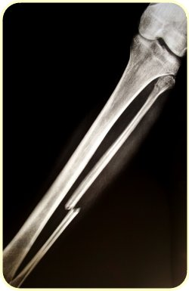

Some illnesses of conditions are acute but may develop because of a chronic condition. For example, a person may have osteoporosis (a chronic condition that weakens bones) making their bones fragile and more likely to break. Broken bones are an acute condition. Similarly, a person with chronic heart disease (caused by partially blocked coronary arteries) will suffer from angina (chest pains), which can be controlled by medication. If arteries become completely blocked it will cause a heart attack, an acute condition.

Task 2: Effects of Acute/Chronic illnesses
Research and complete the following:
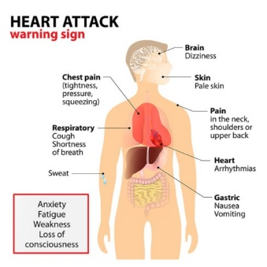
One (1) Acute Condition
- What is an acute condition?
- Explain your chosen example in detail
- Outline the long-term and short-term effects on a person’s PIES.
Create a powerpoint slide or poster of your findings.
One (1) Chronic Condition
- What is a chronic condition?
- Explain your chosen example in detail
- Outline the long-term and short-term effects on a person’s PIES.
Create a powerpoint slide or poster of your findings.
Use the table we recently completed for help!
Extension: Complete another example for both an acute and chronic condition.
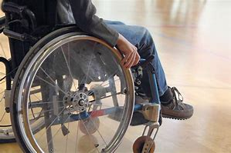
Create a powerpoint slide or poster of your findings.
Activity:
Andrew is 45 years old. He has Huntingdon’s disease, a degenerative disorder of the central nervous system. It causes jerky and uncontrollable movement of the limbs. It will eventually affect his motor skills and speech and lead to a loss of physical movement.
- Which of Andrew’s needs is currently being met by the job he does in an office?
- How could his working conditions, such as the layout of his office, be adapted so he can go on working for longer?
Plenary: Debate the following
A long term condition which is controlled by medication (e.g. asthma) has more impact on the health and wellbeing of the individual as opposed to a heart attack.
Do you agree or disagree? In pairs, you have 2 minutes to think of reasons why you agree/disagree.
Use examples to support!
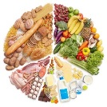
Diet – Food Log: In preparation for next lesson, create a one day food diary logging everything you have eaten and drank in one day.
Meals | Snacks | Drinks

Once you have done this, consider the following questions:
- Is it healthy?
- Is your diet balanced and varied?
- Which aspects are healthy?
- Which aspects are unhealthy?

The importance of healthy eating

- To be able to explain the importance of healthy eating and how it affects health and well-being.

Key words:
Carbohydrates, protein, fats, potatoes, bread, rice, pasta. starchy carbohydrates. Fruit, vegetables dairy, oils and spreads, beans, pulses, fish, eggs, meat, proteins

Carbohydrates | Carbohydrates are the sugars, starches and fibers found in fruits, grains, vegetables and milk products. Though often maligned in trendy diets, carbohydrates - one of the basic food groups - are important to a healthy life.
Protein | Protein is needed in the body for growth and repair

Write down 10 things that you know about a healthy diet:
1
2
3
4
5
6
7
8
9
10
In 2016 the ‘eatwell’ plate became the ‘eatwell’ guide.
Take a close look at the images. What has changed? Why do you think the changes have been made?
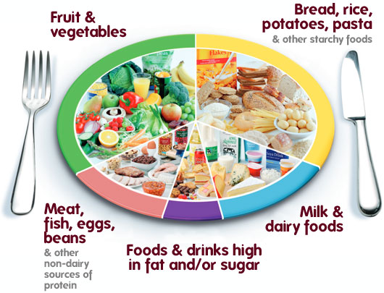
Eatwell plate

Annotate the picture below:

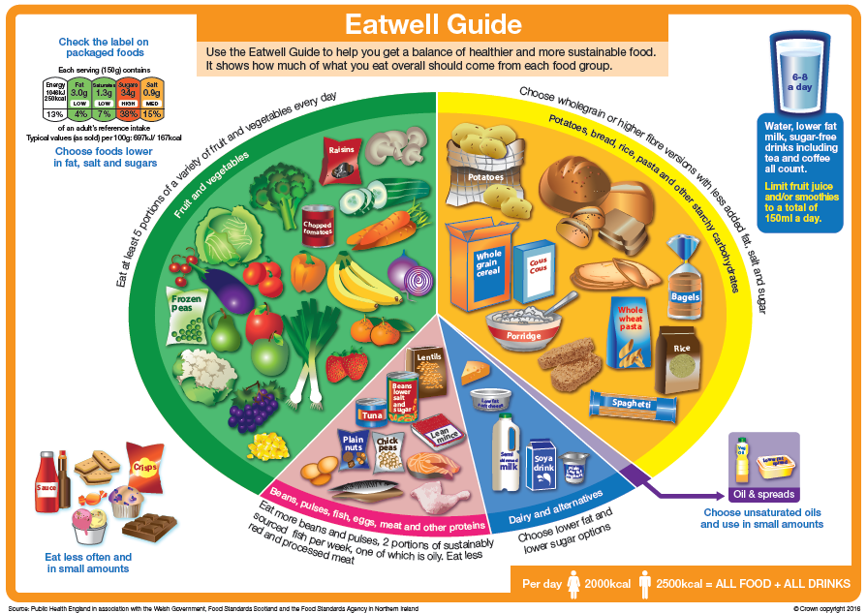

Insert page diet and nutrition from revision book here

Introduction:
Public Health England (PHE) regularly reviews dietary recommendations as part of its role in promoting public health. In light of new evidence about our diet and health, particularly revised recommendations on sugars and fibre, a review of The ‘eatwell’ plate was undertaken. As a result of the review, a new healthy eating guide for the UK has been developed – the Eatwell Guide.
Key messaging:
The Eatwell Guide shows the proportions in which different groups of foods are needed in order to have a well-balanced and healthy diet.
- The proportions shown are representative of food eaten over a day or more, not necessarily at each meal time.
- Choose a variety of different foods from each food group to help get the wide range of nutrients the body needs to stay healthy.
- The Eatwell Guide applies to most people regardless of weight, dietary restrictions/preferences or ethnic origin.
- It doesn’t apply to children under two years because they have different nutritional needs. Children aged two to five years should gradually move to eating the same foods as the rest of their family, in the proportions shown on the Eatwell Guide.
- Anyone with special dietary requirements or medical needs might want to check with a registered dietitian on how to adapt the Eatwell Guide to meet their individual needs.
- The Eatwell Guide divides foods into groups, depending on their nutritional role and shows the proportions of each of the groups needed for a healthy, varied diet.
A balanced diet is one that contains nutrients in the right proportions to our bodies and minds healthy.
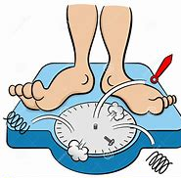
Diet is often lifestyle choice. Choosing to eat too much or too little might make us less able to take all the opportunities that life offers.
A person who is overweight may:
- Be more prone to illness and conditions
- Have their life expectancy reduced
- Be less able to exercise efficiently
- Miss out on learning experiences
- Miss out on some sporting activities, such as skiing
- Be less successful in job interviews
- Feel embarrassed and self-conscious about their appearance in social situations.
An overweight or underweight person could try to control their weight through a balanced, healthy diet of good quality food. The essential parts of a healthy, balance diet are:
- Fats (saturated and unsaturated)
- Carbohydrates (sugars and starches)
- Minerals
- Vitamins
- Proteins
You also need to consume the right amount of food and fluids each day.
The ‘Eatwell guide’ says we should try to:
- Eat at least 5 portions of fruit or vegetables a day
- Base meals on starchy foods like potatoes, bread, rice, pasta (preferably wholegrain or wholemeal varieties) to give more fibre; this should make up about 1/3 of what we eat each day.
- Have some dairy each day, but lower fat varieties
- Eat some beans, oily fish, eggs, meat and other proteins, which also contain vitamins and minerals
- Eat small amounts of oils and spreads, most of it unsaturated
- Reduce out intake of food and drinks high in saturated fat, salt and sugar
The food we eat affects the way we feel and look. It is very important for our health and well-being:
If we eat more than we need, the body will store it as fat and this, for example leads to:
- Obesity
- Heart disease
- High blood pressure
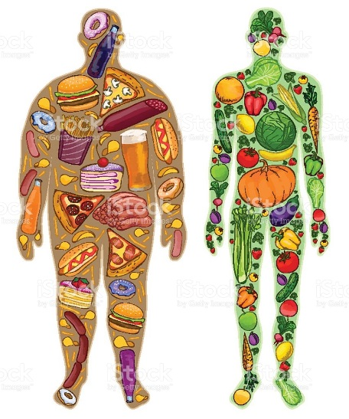
- Strokes
- Tooth decay
- Cancer
If we eat less than we need, the body does not get enough nutrients to grow and develop properly and this, for example leads to:
- Eating disorders (such as anorexia nervosa)
- Stunted bone growth
- Heart failure
- Depression
- Tiredness
- Cancer
- Rickets
Some of the above can even lead to death!
ACTIVITY:
Use the information on the following pages, the internet, and your knowledge to create a concept map to show how the balance, quality and amount of food and drink you the diet affects a person’s health and wellbeing.
Make sure you include positive and negative effects.
This is going to form part of a classroom display!
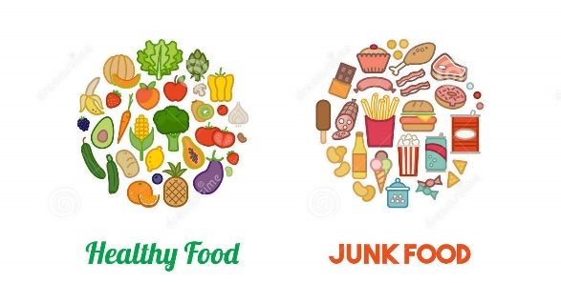

Balanced diet
A balanced diet is made up of ……………………………………, ……………………………………, ……………………………………, ……………………………………, ……………………………………, ………………………………………………………………………, ……………………………………, and……………………………………, are known as ………………………………… because they are required in the body in large amounts.
………………………………… and……………………………………, are known as …………………………………… as they are needed in small amounts yet are essential.
A balanced diet means eating the right foods in the right quantities.
This enables your body to work efficiently, helps you feel happy and you’ll be less prone to nutrition related diseases i.e. diabetes and heart disease.
If we don’t eat a variety of foods in the correct proportions, we will not get all the …………………………………… and …………………………………… we need to make up a balanced diet.
Word Bank:
carbohydrates, | water | minerals | Macronutrients
Fats Fibre | proteins, | Vitamins | micronutrients
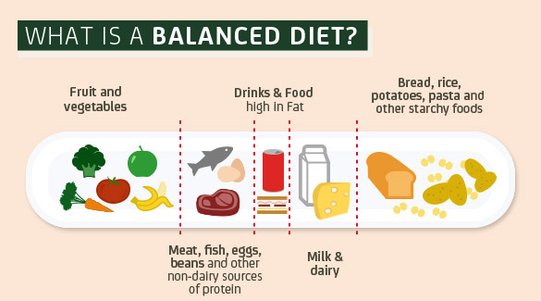

Carbohydrates
Carbohydrates provide the main source of energy in a diet. They are sugars, starches and fibre. They include grains, pulses, fruit and vegetables and should make up about 50-60% of a diet.
Starches are found in wholemeal cereals, such as oats, wheat, barley, rye and rice. This group also includes potatoes, root vegetables, pulses and beans. Some starches are refined and are present in foods such as pizza, which are often high in fat so should be limited in the diet.
When carbohydrates are eaten they break down into glucose, which is what we need to provide energy for the body. The glucose is absorbed into the bloodstream and a hormone called insulin released by the pancreas to control the absorption of glucose into the cells.
Glucose is a simple sugar which is found in fruit, plants and the blood of animals. Glucose syrups are used in the manufacture of cakes, sweets and jams. These are digested more quickly than starches, so they can be absorbed more easily, but they cause dips and spikes in blood glucose levels, so energy levels are much less stable.
Polysaccharides or fibre cannot be digested by the body but play an important role in adding bulk to faeces and helping to prevent constipation. A daily intake of 25g of fibre is recommended.
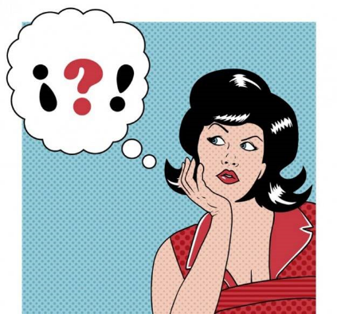
Do it yourself…
Task: Now let’s test your memory
Complete the task sheet on carbohydrates
Carbohydrates provide the main source of ____________ in the diet. These are sugars, _____________ and fibre. They include grains, pulses, __________________ and vegetables, and should make up about 50-60% of the diet.
Fruit Starches Energy
Glucose is a simple sugar, which is found in fruit, plants and the blood of animals. Glucose syrups are used in the manufacture of ___________, sweets and jams. These are digested more ____________ than starches, so they can be ________________ more easily, but they cause dips and spikes in blood glucose levels, so energy levels are much less stable.
Quickly Absorbed Cakes
Starches are found in wholemeal cereals, such as __________, wheat, barley, rye and rice. This group also includes ________________, root vegetables, pulses and beans. Some starches are refined and are present in foods such as ___________, which are often high in ____________ so should be limited in the diet.
Potatoes Fat Pizza Oats
When carbohydrates are eaten they break down into _______________, which is what we need to provide energy for the body. The glucose is absorbed into the ___________________ and a hormone called insulin released by the _________________ to control the absorption of glucose into the cells.
Bloodstream Pancreas Glucose
_____________________________ or fibre cannot be digested by the body but play an important role in adding bulk to faeces and helping to prevent ___________________. A daily intake of ____________ of fibre is recommended.
Polysaccharides 25g Constipation

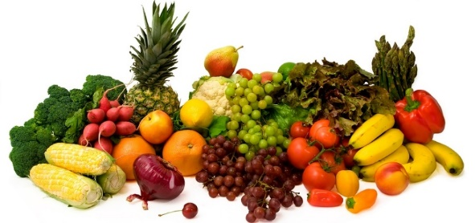
Fruit and Vegetables
The main nutrients in fruit and vegetables are vitamin C, carotenes, folates, and some carbohydrate. They also provide fibre in the diet. Fresh, frozen and tinned fruit and vegetables, dried fruit and fruit juice are all included in this group. Beans and pulses can also be eaten.
The advice is to eat lots – at least five portions a day. Beans, pulses and fruits juice count as one portion however much you eat and drink in one day. You should eat a wide variety of fruit and vegetables of as many different colours and types as possible.
Try to avoid adding too much fat or rich sauce to vegetables (E.g. butter on potatoes), and sugar or syrupy dressings to fruit (e.g. chocolate sauce on banana).
Protein
Protein is needed in the body for growth and repair. Proteins are made up of chains of amino acids and nine of them are essential for every metabolic process. Among their most important tasks are the transport and storage of all nutrients (i.e. water, fat, carbohydrates, proteins, minerals and vitamins).
Proteins can be divided into animal and vegetable sources.
Animal proteins include meat, fish, cheese and eggs.
Plant proteins include nuts, beans, peas, soya and tofu. They are high in fibre, vitamins and minerals, and low in fat.
Texturised vegetable proteins (TVP) and mycoprotein are developed from plant proteins and are used by vegetarians and vegans.
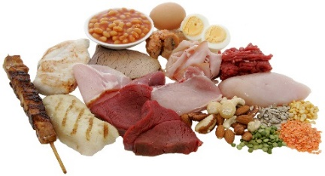
Meat, Fish and Alternatives
This group is used in the body for growth and repair. It includes meat, poultry, fish, eggs, nuts, beans etc. Meat includes bacon and salami and meat products such as sausages, beef burgers and pate. They are all quite high fat choices.
Beans and pulses are in this group and they are a good source of protein for vegetarians. Fish includes frozen and tinned fish, such as sardines and tuna, fish fingers and fishcakes. You should aim to eat at least one portion of oily fish, such as sardines or salmon each week. The main nutrients are iron, protein, B vitamins, zinc and magnesium.
The recommendation is to eat moderate amounts and choose lower-fat versions, such as meat with the fat cut off, poultry without the skin and fish without batter. Cook these foods without added fat. Beans and pulses are good alternatives to meat as they are naturally very low in fat.

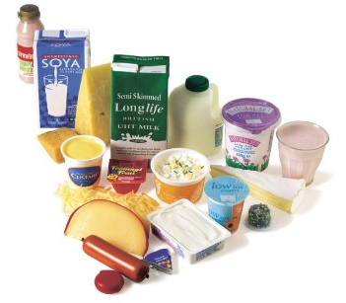
Milk and dairy foods
This food group includes milk, cheese, yoghurt and fromage frais but not butter and cream. The main nutrients are calcium, protein, vitamins A, B₁₂ and D. They are needed in the body to build strong bones and maintain healthy skin and eyes.
The recommendation is to eat or drink moderate amounts, and choose lower-fat versions when you can. Lower-fat versions mean semi-skimmed milk, low-fat yoghurts or fromage frais, and lower fat cheeses. Check the amount of fat by looking at the information on the labels. Compare similar products and choose the lowest; for example, 8 percent of fromage frais may be labelled ‘low fat’, but it is not actually the lowest available.
Fats
The main sources of fat come from animal and dairy products. These are called saturated fats and are solid at room temperature, for example butter and fat on meat and can cause heart disease by blocking blood vessels.
Plant fats are usually liquid at room temperature, for example olive oil and sunflower oil. They are known as unsaturated fats. They are less likely to contribute to heart disease, because they do not have the same affect of blocking the blood vessels.
Essential fatty acids are very important for the prevention of heart disease. They are the Omega 3 and Omega 6.
Omega 3 is found in oily fish, seeds, soya and leafy green veg.
Omega 6 is found in sunflower, grape seed and corn oil as well as cereals, eggs and poultry.
Food/ drink high in fat/ sugar
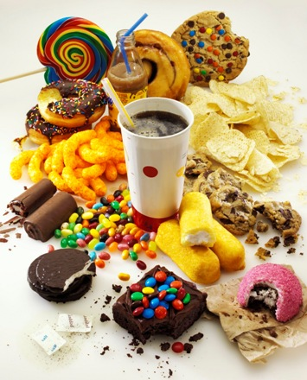
Foods containing fat include margarine, butter, other spreading fats and low-fat spreads, cooking oils, oil-based salad dressings, mayonnaise, cream, chocolate, crisps, biscuits, pastries, cakes, puddings, ice cream, rich sauces and gravies. Foods containing sugar include soft drinks, sweets, jam and sugar, as well as foods such as cakes, puddings, biscuits, pastries and ice cream.
The main nutrients are fats including some essential fatty acids, and fat is needed in the body to transport vitamins A, D, E and K, which are fat-soluble vitamins. Some products also contain salt or sugar. Sugar is described by some people as ‘empty calories’ because it contains calories, but few, if any, nutrients.
You should eat foods containing fat sparingly and look for low-fat alternatives. Foods and drinks containing sugar should not be consumed too often as they can contribute to tooth decay. All foods and drinks containing should be consumed mainly at mealtimes to reduce the risk of tooth decay.

Bread, other cereals and potatoes
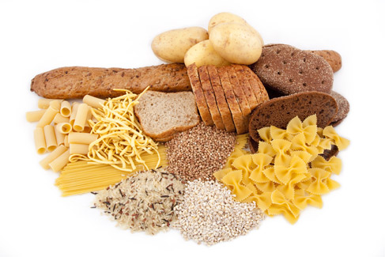
This group is mainly made up of ______________-rich food and provides much of the ______________ needed in the diet. Other nutrients in them are calcium and iron, B vitamins and f__________.
C___________ are foods such as breakfast cereals, pasta, rice, oats, noodles, maize, millet and cornmeal. This group also includes yams and plantains. B___________ and pulses can be eaten as part of this group.
You should eat ___ ______ of foods in this group, and try to eat w_____________, wholegrain, brown or high-fibre versions where possible. Avoid having them fried too often and adding too much fat (e.g. thickly spread butter, margarine or low-fat spread on bread), or adding rich sauces to pasta.

Macronutrients - are energy-providing chemical substances consumed by in large quantities.
Micronutrients - any substance, such as a vitamin or trace element, essential for healthy growth and development.

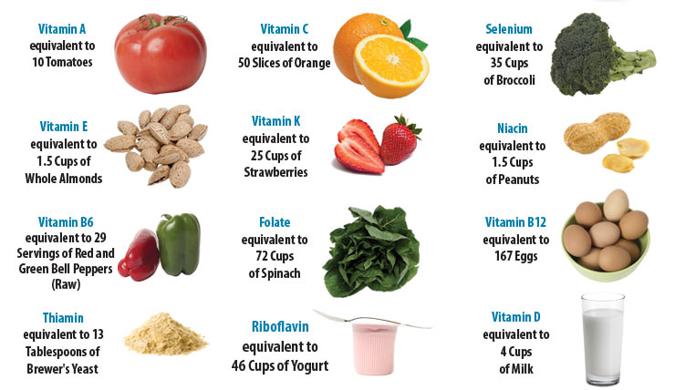

Activity:
The Soloman family is a nuclear family. Mrs Solomon works full time as a secretary, and Mr Soloman works manually on a building site.
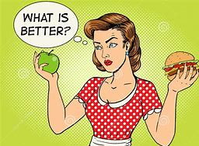
Sally (aged 6) and Jason (aged 12) are both in full time education.
Mrs Soloman makes them all a packed lunch. The packed lunch comprises of:
- 2 ham sandwiches on white bread with butter
- A packet of salt and vinegar crisps
- A chocolate bar
- A can of fizzy coca cola
Evaluate the suitability of this lunch for the family in relation to the eatwell guide.
Create a packed lunch that is more appropriate for the family.
You may decide to create different lunches for each member that takes into account their age, gender and amount of physical activity.
Justify your decisions.

Nutrient needs:
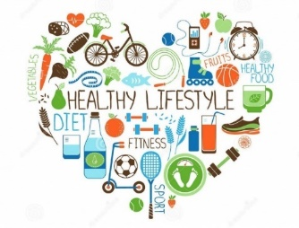
The energy needs of adults go down as they age. For example, people in their 50s need about 17% less energy in their diet than people in their 30s.
Men and women require the greatest amount of energy around 18years of age, however it also depends on their day to day lifestyles.
Women need more iron than men to make up for the amount of iron they lose in their menstrual period. Iron deficiency is the most common nutrient deficiency in women. Insufficient iron can lead to anaemia. Common symptoms of anaemia include tiredness and breathlessness. Iron is especially important during pregnancy.
Men require more protein than women however it is not because they are building more muscle or because they are stronger - it is simply because men tend to be taller and heavier than women. A bigger man equals a larger need for protein. Two men who are of the same exact weight may have slightly different protein needs however if one of them is a total couch potato or computer nerd whose only exercise is thumbing the scroll button on the mouse or clicking a remote, but the difference will be just that - slight.
To explain the importance of exercise in maintaining a healthy lifestyle.

Bell Activity: What is the effect of this lifestyle? Annotate with your thoughts:

Starter:
We need to exercise to ensure we maintain our health and well-being. Exercise is a lifestyle factor that can bring many benefits.
In small groups consider what are the benefits of exercise?
Are there just physical benefits?
Create a mindmap or list of your thoughts. (Remember to consider all aspects of PIES)

Think about an older person that you know.
How mobile are they?
What exercise do they have?
How does their mobility affect them?

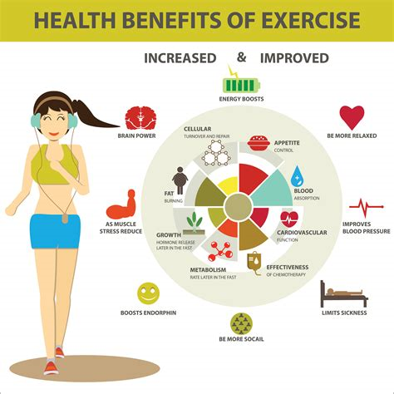
Benefits of exercise:
We need to exercise to ensure we maintain our health and well-being. Exercise is a lifestyle factor that can bring many benefits.
Exercise improves our strength, stamina, and suppleness, as well as our muscle and body tone. It helps us to:
- Concentrate
- Relieve stress
- Relax and feel good
- Gain personal satisfaction
- Socialise with others (for example, in a gym or at a running club)
Getting enough exercise is essential and can help prevent heart disease and stroke – 2 of the UKs top 5 killers. Doing at least 2.5 hours of moderate physical activity a week in 30-minute sessions, improves health. Any type of exercise – for example, using the stairs instead of a lift – helps you heart to be healthier. Moderate exercise causes your heart to beat faster. Increases your breathing rate and makes you sweat. It can also lower your blood pressure and cholesterol level.
Do we all need the same amount of exercise?
Justify your answer:
Task 1:
Individually research how much exercise the Government recommends you should do. Feedback to the person next to you!
Write your findings here:
What do you think stops young people from exercising?

Why are so many young people unfit or overweight?

Taking exercise:
There are different ways of taking exercise.
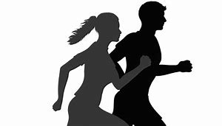
- Going for walks or jogging is free and you do not able to commit to set times
- Joining a gym or taking a class such as boxercise will cost money. However, some might say that paying for exercise makes your more likely to commit to exercise
- Swimming or cycling are excellent holistic aerobic exercise activities
- Joining a team (for example, football or netball) may provide a social side in addition to the exercise.
Some people are happier to take their exercise alone. For others, it is an opportunity to socialise and meet new people or make new friends. Remember, whatever exercise you take part in, your brain will release hormones called endorphins, which provide a feeling of well-being.
Even those with limited mobility can take exercise. For example, residents in car homes are frequently offered gentle standing or armchair exercises. Armchair activities can help people with conditions such as osteoporosis, arthritis and high blood pressure to exercise without putting any strain on their knees or hips.
Activity:
What do you think stops young people from exercising?

Why are so many young people unfit or overweight?

Watch the film clip to see the long term effects of a poor diet and no exercise. Make your notes below:

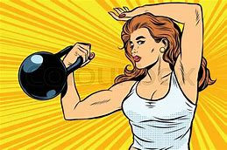
Not taking exercise:
Lack of exercise can lead to conditions like;
Stiffening of the joints
- Poor stamina, strength and suppleness
- Obesity
- Stroke
- Coronary heart disease
- Poorly developed heart and skeletal muscles
- Sluggish blood flood
- Osteoporosis
Anyone of these conditions means that health and well-being will suffer!

Now let’s see the positive effects of exercise and how it affects all areas of development…
Create 2 mindmaps with the benefits you can think of:

Health Benefits of Physical Activity

Psychological Benefits of Physical Activity

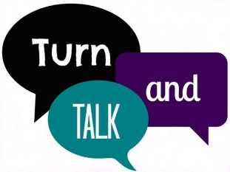
Task 2:
- In groups of 3 you will now be allocated one of the five different life stages from Component 1 (combining infants and early childhood)
- You need to discuss the negative and positive effects on health and well-being of getting enough exercise for that life stage.
Make some notes below:

Task 3:
Create a leaflet/poster or other promotional material to promote the positive/negative effects on health and well-being or exercise (for the health stage you have). Ensure that you promote the positive aspects of getting enough exercise and warn of any risks.
Try and make it fun and informative!
Can you think of activities that involve exercise in everyday life instead of going to the gym?

Plenary:
Give me 5!
5 benefits of exercise
4 different types of exercise
3 tips for people who struggle to exercise
2 things you are going to do to improve the amount you exercise
1 thing you learnt this lesson that you didn’t know before

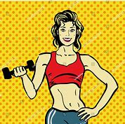
Homework:
- Keep a diary of how much exercise you do over the next week
- Are you getting the recommended amount of exercise? If not suggest how you could improve the amount you have and how you can make it enjoyable
Day: | Exercise …

Add revision book pages in here

