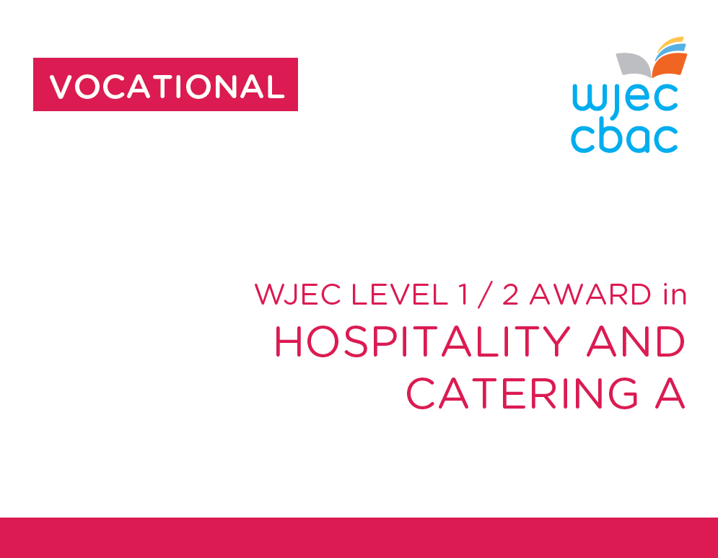

**Unit 1**

**The Hospitality and Catering industry**

Exam June

90 mins

40% overall grade



**LO1**

**Understand the environment in which hospitality and catering providers operate**

|  |  |
| --- | --- |
|  |  |
|  |  |
|  |  |
|  |  |
|  |  |
|  |  |
|  |  |
|  |  |
|  |  |
|  |  |
|  |  |
|  |  |
|  |  |
|  |  |
|  |  |
|  |  |
|  |  |
|  |  |
|  |  |
|  |  |
|  |  |
|  |  |
|  |  |
|  |  |
|  |  |
|  |  |
|  |  |
|  |  |
|  |  |
|  |  |
|  |  |
|  |  |
|  |  |
|  |  |
|  |  |
|  |  |
|  |  |
|  |  |
|  |  |
|  |  |
|  |  |
|  |  |
|  |  |
|  |  |
|  |  |
|  |  |
|  |  |
|  |  |
|  |  |
|  |  |
|  |  |
|  |  |
|  |  |
|  |  |
|  |  |
|  |  |
|  |  |
|  |  |
|  |  |
|  |  |
|  |  |
|  |  |
|  |  |
|  |  |

|  |  |  |
| --- | --- | --- |
| **The learner can:** | **Assessment Criteria** | **Content unit 1** |
| **LO1**  **Understand the environment in which hospitality and catering providers operate** | AC1.1  Describe the structure of the hospitality and catering industry | **Hospitality and catering industry**   * Types of provider * Types of service * Commercial/non commercial establishment * Services provided * Suppliers * Where hospitality is provided at non-catering venues * Standards and ratings * Job roles within the industry |
| AC1.2  Analyse job requirements within the hospitality and Catering industry | **Requirements**   * Supply and demand * Jobs for specific needs * Rates of pay * Qualifications and experience, training * Personal attributes |
| AC1.3  Describe working conditions of different job roles across the hospitality and catering industry | **Working conditions**   * Different types of contract * Working hours * Rates of pay * Holiday entitlement, remuneration |
| AC1.4  Explain factors affecting the success of hospitality and catering providers | **Factors**   * Costs,profit,Economy * Environment * Emerging cooking techniques,technology * Customer demographics/lifestyle and expectations * Customer service * Competition * Trends,media, political factors |