Activity sheet 1.2: Areas of growth and development
Learning aim A: Understand human growth and development across life stages and the factors that affect it
Learning aim A1: Human growth and development across life stages
Discuss what is happening in the four photographs below. Complete the sentences to show you understand the links to the relevant area of development and life stage.

Anna has been bullied at secondary school.
Photo 1 shows that Anna is feeling __________________________ . The area of development affected is _________________________ . The individual is in the ____________________________ life stage.

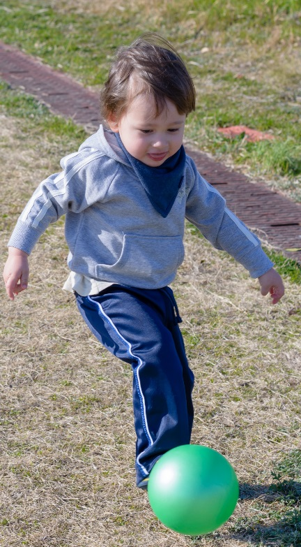
Tom has just started nursery. He loves to play outside.
Photo 2 shows that Tom is using ______________________ skills . The area of development being shown is ____________________ . The individual is in the ____________________________ life stage.

Tina enjoys meeting up with friends after work.
Photo 3 shows Tina _____________________________________ . The area of development being shown is ____________________ . The individual is in the ____________________________ life stage.

Sam enjoys completing puzzles in his newspaper
Photo 4 shows Sam using ____________________________ skills. The area of development being shown is ____________________ . The individual is in the ____________________________ life stage.

