## MC900331616[1]MCj00961070000[1]WATCH THE TIME

Read the information on the first page

Try to complete the activities on the second page

**BEAT** and **PULSE** mean the same thing in music. Keeping a steady beat is most important when people are moving to the music. Otherwise, they would get out of step! Two types of music where keeping a steady beat is very important are:

A **MARCH** – Left Right, Left Right – a march usually contains 2 beats in a bar with a strong emphasis on the first beat.

A **WALTZ** – Oom-cha-cha, Oom-cha-cha – a waltz usually contains 3 beats in a bar with a strong emphasis on the first bear.

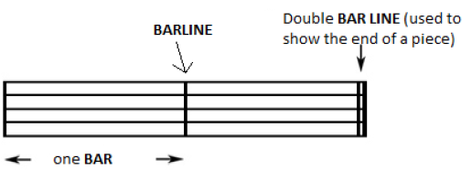4 beats in a bar is also common – **1** 2 3 4, **1** 2 3 4 – especially in pop songs. Here, the first beat of the bar has a strong emphasis and the third beat of the bar also has an emphasis, although not as strong as the first.

A **BAR** is a small section of music which contains a specified number of beats. A **BARLINE** shows where the end of the bar is and a **DOUBLE BAR LINE** shows the end of a piece of music or a section within a piece of music.

N0H9_NmhlVh02qNZMrz-2lMPC4jQOmd48U0mu53FIpP5qkIQGPA2IP918Q99NTJQTnC4ygv2PxY5imhAOT3TXAuKBlM6tMjn-gt0QG4Wvy8I-zDccePyAwEhLDdJAyzaY8854yY48qLiyEihawThe first beat of the bar is always the strongest. This helps to keep the music steady. The most common type of pulse/beat is a **CROTCHET PULSE**.

fircCJqDSK90_kiwxnOyp9UCBrAkOsABtTnX9eyzeDEGOCKLmKd6aCxeKs1qY_M3rg2Wgl2vW4l-EF41R-27TdpDHJs1smu8hdSsPhUe7GZlQZhHaTOXc6mDAWq9Gi3AEk2_X_3dUVv7WvmRVQHere is a one-beat note: a **CROTCHET**

Here is a two-beat note: a **MINIM**

vp-LLewGfKuuWMiQ1j0X1WUnnJSCKn02l9yhyxRQmQ4w1WjiUbm5Pauv0_KUaTM2CYARScO0tumWRoglMqgWcuOnjJA5wBg3wctVq41U0rJ-sYXNcC5vQuwCHQYtyfiDFRPk6lW8RNs7pl-SBgbZds4RNMU3XTVzgTKPkUoptHzP58FxiiDBY_zUp7ZAyBGyhQJV0w2i9pf34ysaOOZ_S_ozbI76bDXRGwIctaBlAT6QCTHPAYfmZCgintR2tMefVznwOZOiwkM-01_mAGKBpMAlis3XvtxCzttAHere is a four-beat note: a **SEMIBREVE**

Here is a half-beat note: a **QUAVER**

Here are two half-beat notes: a **PAIR OF QUAVERS**. These two quavers take the same time as one crotchet (½ + ½ = 1).

**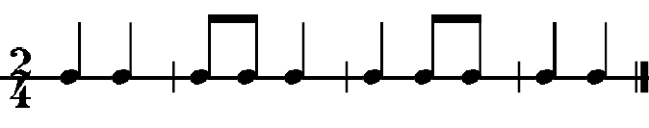**Here is an example of a **MARCH** rhythm with 2 beats in a bar – the numbers in front of each pattern tell us how many beats there are in each bar 2/4 = two crotchets beats in each bar – this is called the **TIME SIGNATURE.**

**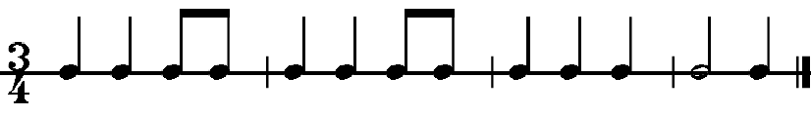**Here is an example of a **WALTZ** rhythm with 3 beats in a bar – the numbers in front of each pattern tell us how many beats there are in each bar 3/4 = two crotchets beats in each bar – this is called the **TIME SIGNATURE.**

## MC900331616[1]MCj00961070000[1]

1. Explain in your own words what “keeping a steady beat” means

2. Keeping a steady pulse/beat is very important in marches and waltzes. Give another example.

3. What is the difference between “pulse/beat” and “rhythm”?

4. Write these notes in the boxes below. Label each box with its correct name.

1 beat ½ beat 2 beats 4 beats 2 half-beats

Name

5. Look at the rhythm below. The time signature is 4/4. How many beats are there in each bar? . Now draw in the bar lines in the correct places so that each bar adds up to 4 beats. Put a double bar line at the end.

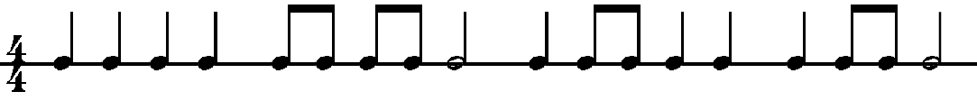

6. Now make up your own 4/4 rhythm and write it in the bars below.



7. Look at the rhythm below. The time signature is 3/4. How many beats are there in each bar? . Now draw in the bar lines in the correct places so that each bar adds up to 3 beats. Put a double bar line at the end

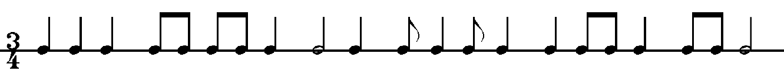

8. Now make up your own 3/4 rhythm and write it in the bars below.

