Treble Clef Staff Notation

Name Form

Activity 1 – Complete the names of the notes below, remembering that we only use the first seven letters of the alphabet when naming notes.
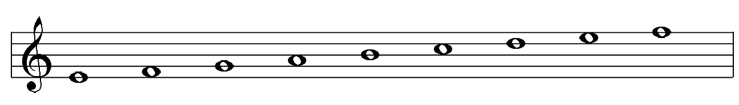

G

Activity 2 – Give the following note names:
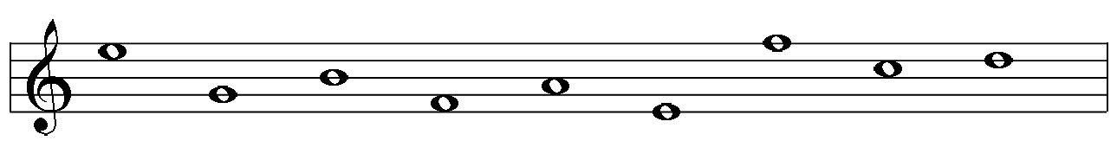

Activity 3 – Can you Remember?

- What does the word NOTATION mean?

- What note name or pitch does the TREBLE CLEF “fix” and how?

- What is the correct name for the five lines and spaces that notes are positioned on in STAFF NOTATION?

Activity 4 – Give the following note names:
