MC900216520[1]Staves, Clefs and Notes

Name Form

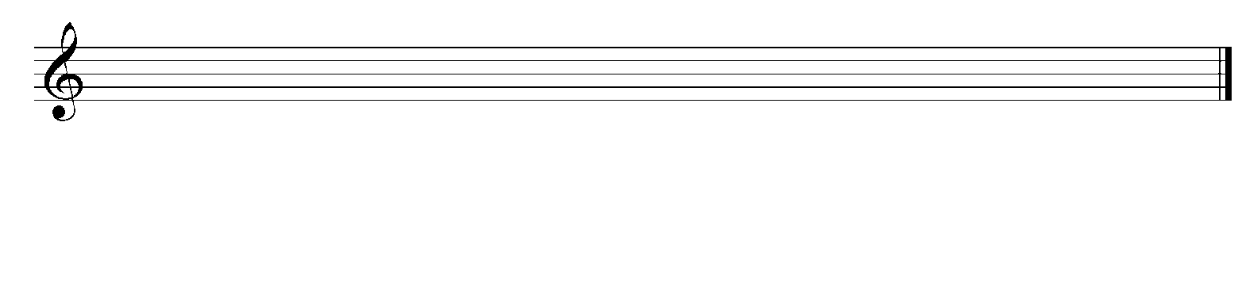So that we know which pitch to play, we use a **stave**. A stave is a set of five lines that looks like this:

The symbol at the beginning is called a treble clef.

1. Draw a treble clef on each stave below.

  

Each line and space on the stave shows a letter of the musical alphabet. First, we’ll have a look at the spaces. There is an easy way to remember which notes are in the spaces – just remember *‘face in the space’.*

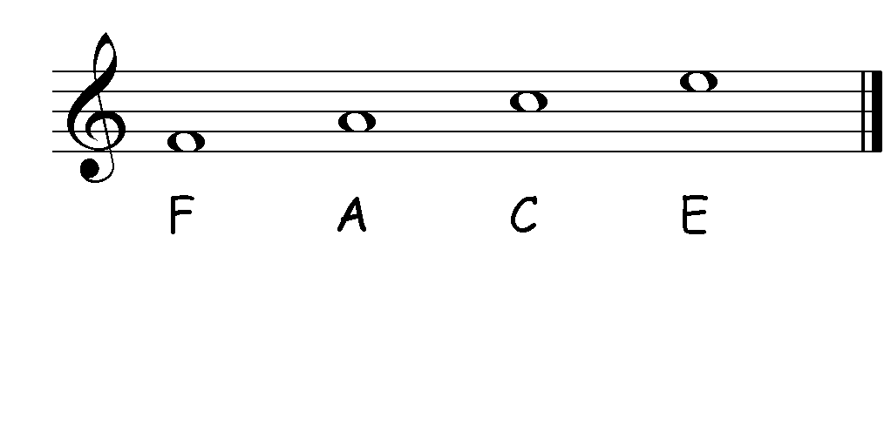

2. Write the names of the notes in the **SPACES** of the treble stave.

Next, we’ll have a look at the notes on the lines. To learn the note names on the lines going from the bottom (first) line to the top (fifth) line, we use rhymes:

To learn the lines, we use rhymes…

Every Good Boy Deserves Fruit

Elephants Go Backwards Down Fire-escapes

Every Green Bogey Deserves Flicking

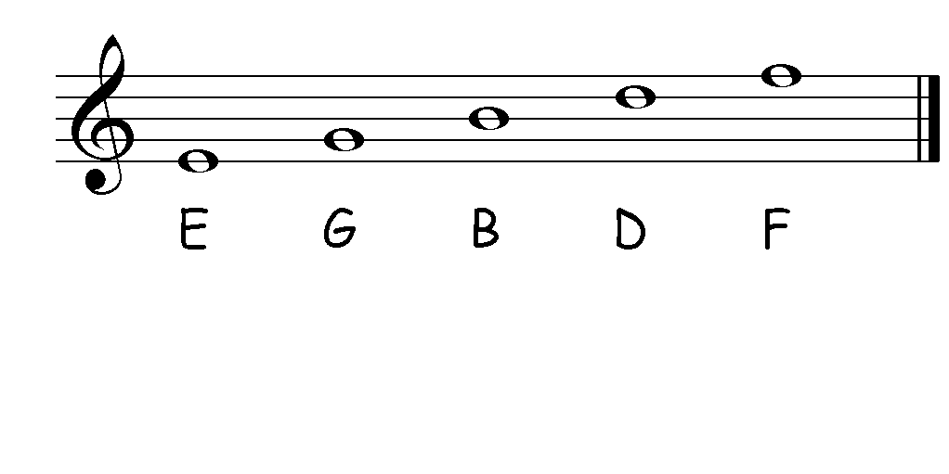

3. Make up your own rhyme to help you remember the notes on the lines.

E___________ G___________ B___________ D___________ F____________

2. Write the names of the notes on the **LINES** of the treble stave.

So, now you know the notes on the stave. You might notice some extra notes and lines on the stave below. If we need to write pitches that are higher or lower than the ones you have already learned, we add **ledger lines**.

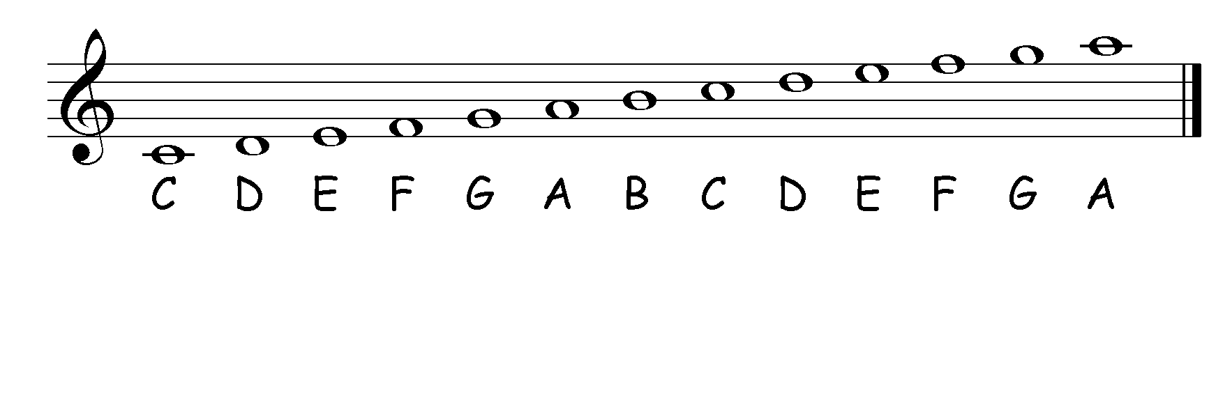

3*.* Write these notes on the correct line or space onto the stave.



F D B E G C A

4. Now, write each note in a different place on the stave from the place you chose in question 4.



F D E C

6. These notes are clues to words. Solve the clues and write the words below the notes.







7. Write the correct notes onto the stave to make these words.



F A C E A G E D A B F A B C A F E



E D G E B E E F F A D B A D G E

8. Work out the note names and copy the story out in full.



My took a



into town. He got out with his and went into a



. He ordered roast



and but the



waiter thought he said there was a dead



* 

in his

* MC900230295[1]

**Stretch and Challenge**

List as many words as you can which only use the note letters.

Make up a nonsense story using words from your list.

Write these words on a stave using their notes.

Give your story to a friend and get them to decode it.

* MC900112418[1]