St. Anne’s Academy
Home Learning Work Booklet: Computer Science
Main Topics: Game Design and Binary

Year 9
Mrs Graziano
2020-2021

Lesson 1 – Reviewing Games
Firstly, to understand what makes a great game we need to review some games that currently exist.
Please pick two games that have different purposes and review their strengths and weaknesses
Each Game must be for a different genre and age range, e.g. Sport, educational, first-person style.
Each review must include:
- The name of the Game
- What the style of the Game is?
- Does the Game have a theme?
- Is the Game easy to use / find things on?
- What are the two best things about the Game?
- What would you change about the Game if you were in charge?
- Challenge: Why would these changes make the Game better ? Would this help the Game meet its purpose?
Key words:
Game design, Layout, Colour scheme, Navigation, Target audience, purpose
Key words challenge – how many of these challenge words can you include in your review?
Help and support:
Here are some sentence starters to help you get started
The name of the Game I am reviewing is…
I like/don’t like the layout of the Game…
The best thing about this Game is…
I think this because…
I would change….

Game review 1:
____________________________________________________________________________________________________________________________________________________
______________________________________________________________________________________________________________________________________________________
______________________________________________________________________________________________________________________________________________________
______________________________________________________________________________________________________________________________________________________
______________________________________________________________________________________________________________________________________________________
______________________________________________________________________________________________________________________________________________________
______________________________________________________________________________________________________________________________________________________
______________________________________________________________________________________________________________________________________________________

Game review 2:
____________________________________________________________________________________________________________________________________________________
______________________________________________________________________________________________________________________________________________________
______________________________________________________________________________________________________________________________________________________
______________________________________________________________________________________________________________________________________________________
______________________________________________________________________________________________________________________________________________________
______________________________________________________________________________________________________________________________________________________
______________________________________________________________________________________________________________________________________________________
______________________________________________________________________________________________________________________________________________________

Lesson Two: Target Audience
Now we know what makes a good game, we need to understand how different Games appeal to different users. These people are called the target audience.
The target audience of a Game will affect the colours used, the images used, the style of the game and even the language used.
For example, you may notice a game designed for adults looks is very different to the game that is designed for children.
When we think about target audience we think about:
- Age
- Gender
- Location / Languages spoken
- Income (how much money someone has)
- Hobbies and interests.
Looking at the images of the Games below can you explain who you think the target audience is and why?
- Fortnite
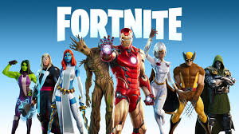

- Crash Bandicoot
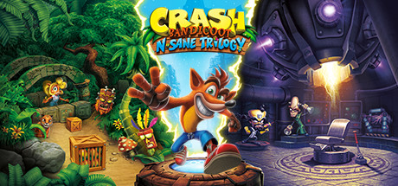

- FIFA
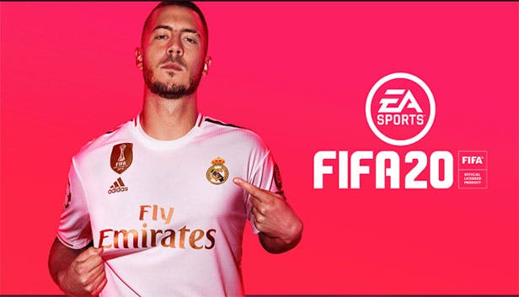

For each of these Games answer the following questions:
Who is the target audience?
Think about Age, Gender, Location, Income, Hobbies and interests.
Does the Game use colours that would appeal to this target audience?
Does the Game use images that would appeal to this target audience?
Does the Game use language that is appropriate for this target audience?
Key words:
Target audience, Age, Gender, Genre, appropriate
Key words challenge – how many of these challenge words can you include in your review?
Help and support:
Here are some sentence starters to help you get started
The age of the target audience of this Game would be…
The gender of the target audience of this Game would be…
I think the target audience would live in…
I think their hobbies and interest would be…
____________________________________________________________________________________________________________________________________________________
______________________________________________________________________________________________________________________________________________________
______________________________________________________________________________________________________________________________________________________
______________________________________________________________________________________________________________________________________________________
______________________________________________________________________________________________________________________________________________________
______________________________________________________________________________________________________________________________________________________
______________________________________________________________________________________________________________________________________________________
______________________________________________________________________________________________________________________________________________________
____________________________________________________________________________________________________________________________________________________
______________________________________________________________________________________________________________________________________________________
______________________________________________________________________________________________________________________________________________________
______________________________________________________________________________________________________________________________________________________
______________________________________________________________________________________________________________________________________________________
______________________________________________________________________________________________________________________________________________________
______________________________________________________________________________________________________________________________________________________
______________________________________________________________________________________________________________________________________________________
____________________________________________________________________________________________________________________________________________________
______________________________________________________________________________________________________________________________________________________
______________________________________________________________________________________________________________________________________________________

Lesson: Create a front cover for your game.
Now we know what makes a good game, and we know how games are targeted at specific people. It is now your turn to take those skills and apply it to your own brief.
Rockstar games have hired you to design a new game they’re planning to release next year. The theme of the game is space and building an alliance between aliens to save your world from certain doom. The target audience of a game will affect the colours used, the images used, the style of the game and even the language used.
For example, you may notice a game designed for adults looks is very different to the game that is designed for children.
When we think about target audience we think about:
- Age
- Gender
- Location / Languages spoken
- Income (how much money someone has)
- Hobbies and interests.
Keep the target audience in mind whilst you complete this task:
Task: Create a front cover for your game and place a picture of it below…

