|  |
| --- |
| **St. Anne’s Academy** |
| **Home Learning Work Booklet: Computer Science** |
| **Main Topics Covered: ESafety, the internet, Malware and Software Engineering**  **Year 7** |
| Mrs Graziano  2020-2021 |



**E-safety poster**

**Your task is to design a poster to for year 7 students to raise the awareness of e-safety**

Objective:

Make a poster for year 7 students - To know how to use the internet safely

Success Criteria:

* Produce a short e-safety poster on social networking to inform other pupils how to stay safe. This postershould be able to take into consideration purpose and audience. Make the poster professional presentable and through the sensible use of colour and images.

Here is an example to help you with your ideas and planning:

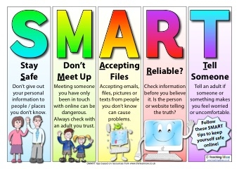

**Use this helpsheet to come up with key points for your e-safety poster.**

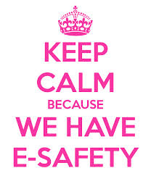**SOCIAL NETWORK RISKS**

* You never know who you’re talking to
* Bullying
* Phishing - may lead to identity theft
* People being annoying or rude
* Grooming (Stranger Danger)
* Unsuitable use of photos

**HOW TO STAY SAFE WHEN USING SOCIAL NETWORK SITES**

The **DO’s** of Social Networking

* Communicate only with people on your Contact List.
* Use a screen name that doesn't give away any sensitive information. .
* Check the terms, conditions and privacy statements of the chat site before  
   you begin chatting.
* Use a chat nickname that doesn't give away any sensitive information.

The **DON’T’s** of Social Networking

* Do not provide sensitive information (bank card number, passwords, address) about yourself in an IM conversation. Instant Messages are not encrypted, so they are easy targets for hackers.
* Do not agree to meet an unfamiliar person you came into contact with through private messages. You can never know who that person really is.
* Do not download or accept files from people you don't know.
* Do not send your screen name online. People might find it and use it to send you unsolicited Instant Messages.

**REMEMBER STAY SMART - STAY SAFE**

S - Safe  
 M - Meeting  
 A - Accepting  
 R - Reliable  
 T - Tell

**Plan your poster here below, think about the key points on the help sheets. Be creative. Think about the use of colours, text and images.**

**Web Browsers**

A Web Browser, the internet and a search engine are all very different things.

Firstly, label the image below naming each web browser.



Can you name this relatively new browser?



A web browser (commonly referred to as a browser) is a software application (app) for opening information on the World Wide Web. When a user requests a web page from a particular website, the web browser retrieves the necessary content from a web server and then displays the page on the user's device. Web browsers are now on all your devices that access the web such as your computer, smart phones, tablets and even TV’s. Even if each device has a different web browser they are all used to find websites on.

However, a search engine is slightly different…

See how many of the search engines you can think of below, using the example to help you:

* ________________________
* ________________________
* ________________________
* ________________________
* ________________________

Challenge: Can you tell me already how a search engine is different to a web browser? (Use the defintions at the bottom to help you if you need)

________________________________________________________________________________________________________________________________________________________________________________________________

The internet I soften mistaken as the same as the search engines or the web browsers however, it is different the internet is the actual connection of computers. Its this connection that allows computers to share information all over the world.

Draw up lines to connect the key terms with the definitions and then the images:



Searches through the internet to retrieve websites on the internet

The Internet



Software application for opening information on the world wide web

Global connection of computers

Search Engine

Web Browser

**Malware Worksheet**

**This next task is about internet dangers, also known as Malware.**

**Task: Complete the table. You can use the malware help sheet on the next page to help you.**

* **Column 1 - Add an image to illustrate (draw) the risk (Spyware Phishing or virus)**
* **Colum 2 - The problems associated with the issue; what problems are caused.**
* **Column 3 - Any possible solutions on how to stay safe.**

|  |  |  |
| --- | --- | --- |
| **The risk**  **Draw a picture here for each risk below:** | **What is it?**  **Explain in your own words what the internet danger is:** | **How can you protect yourself from it?**  **Explain ways to protect yourself and your computer from the internet danger in your own words:** |
| Virus |  |  |
| Spyware |  |  |
| Phishing |  |  |

******Malware Help sheet**

Malware is a term for internet dangers. A popular internet danger most people will be aware about is a virus. There are more than viruses out there that are harmful and dangerous for our computers and ourselves.

Virus **Definition:**A computer virus is a malicious (harmful) software program loaded onto a user’s computer without the user’s knowledge and performs malicious (harmful) actions.  
  
**Description:**The term 'computer virus' was first formally defined by Fred Cohen in 1983. Computer viruses never occur naturally. They are always induced by people. Once created and released, however, their diffusion is not directly under human control. After entering a computer, a virus attaches itself to another program in such a way that execution of the host program triggers the action of the virus simultaneously. It can self-replicate, inserting itself onto other programs or files, infecting them in the process.

Phishing Attack: What is a phishing attack

Phishing is a type of social engineering attack often used to steal user data, including login information and credit card numbers. It occurs when an attacker, hidden as a trusted being, targets a victim into opening an email, instant message, or text message. The receiver is then tricked into clicking a malicious (harmful) link, which can lead to the installation of malware (such as a virus), the freezing of the system as part of a [ransomware attack](https://www.imperva.com/learn/application-security/ransomware/) or the revealing of sensitive information.

An attack can have devastating results. For individuals, this includes unauthorized purchases, the stealing of funds, or identify theft.

Spyware: Spyware is software that installs itself onto devices and then steals personal information about the user​, such as;

Passwords, ​Email addresses and other important information. ​The hacker does this through a process called key logging meaning the hacker downloads a software which keeps a track of all the keys you press on your keypad. This way the hacker will find your passwords for your emailed, social media and maybe your banking information!

**Input/output**

An input device is a device or a part of your computer that puts information into your computer – for example a keyboard you type information into the computer using a keyboard.

An output device is a device that allows information to come out of the computer for example a screen/monitor you can see the information on the screen, so the information is being put out/ outputted from the computer.

For each image below: write INPUT if the hardware is an input device and OUTPUT if it’s an output device on the line after each number.

1.

_______________

2. _______________

3. _______________

4. _______________

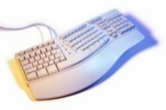5. _______________

6. _______________



7. _______________



8. _______________



9. _______________

10.  _______________

Input/Output/Neither Devices**.** Identify/name the following devices then write if Input or Output device.

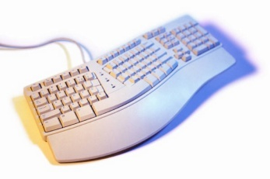

Name of device ___________________

Identify if Input/Output/Neither ____________

Name of device ____________________

Identify if Input/Output/Neither____________



Name of device ____________________

Identify if Input/Output/Neither____________

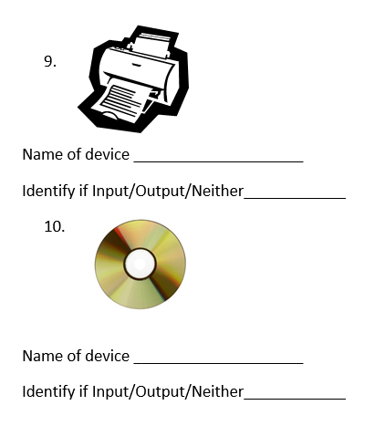

Name of device ____________________

Identify if Input/Output/Neither____________

MC900351911[1]

Name of device ____________________

Identify if

Input/Output/Neither____________

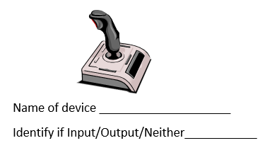

Name of device ____________________

Identify if Input/Output/Neither____________



Name of device ____________________

Identify if Input/Output/Neither____________

**Hardware and Software**

**Definitions of key terms for Hardware and Software:**

**Hardware:** physical parts or components of a computer that you can touch and handle

**Software:** the actual programs consist of instruction that allow to do useful job

**Internal hardware devices:** processor, motherboards, random access memory (RAM), read-only memory (ROM), video cards, sound cards and internal hard disk drives)

**External hardware devices:** monitors, keyboards, mice, keyboards, printers as input and output devices and external storage devices in general

**Applications Software:** word processing, spreadsheet, database management systems, control software, measuring software, applets and apps, photo-editing software, video-editing software, graphics manipulation software

**System Software:** compilers, linkers, device drivers, operating systems and utilities which help the system run smoothly

Use the definitions on the page above to help you fill in the hardware and software blanks below:

|  |  |  |
| --- | --- | --- |
| applications | pointer | output |
| physical | utilities | programs |
| input | hardware | Motherboard |
| system |  |  |

Computer ______________ is the name given to the ________________ parts of the computer that can be touched. This includes the monitor so the user can see the ________________ , a keyboard so the user can type in their ______________ and a computer mouse to control the ________________ on the screen. It also includes the parts of the computer that are inside the machine such as the ____________________.

Software is the name given to the _________________ that run the computer. These can include ______________ such as Word or Excel, the operating _________________________ and ______________ software to manage the system and make sure it is running smoothly.