The Orchestra

History

The orchestra is made up of four instrument families. These families are:

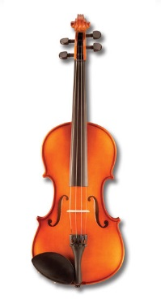

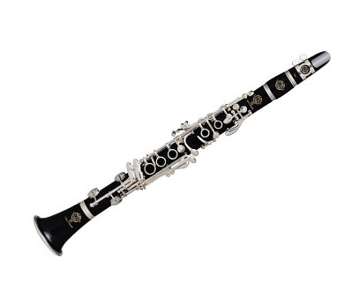STRINGS,

WOODWIND,

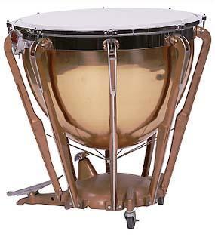

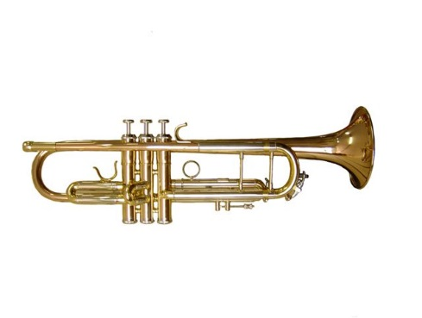

BRASS, PERCUSSION.

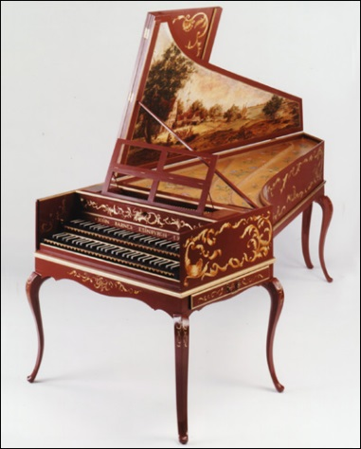However, this was not always the case. When the composer Bach was alive (1685-1750), the orchestra mainly consisted of strings, with occasional use of recorder, flute, oboe, trumpet or timpani (kettle drums). In this period of history, the orchestra had no conductor, but was led by a harpsichord player. (Harpsichords are similar to pianos, and were used before pianos were invented.)

[Listen to an orchestra from this time](https://www.youtube.com/watch?v=4Z4yn6-dY_8) - Bach

In the late 1700s, the orchestra began to expand, as composers started writing pieces of music to include a wind section (flutes and oboes) and a brass section (trumpets and horns). Timpani were used more frequently (percussion section).

[Listen to an orchestra from this time](https://www.youtube.com/watch?v=JMrm9jEo_Pk) - Beethoven

Gradually, the wind section expanded to include clarinets and bassoons, and the brass section expanded to include trombones and tubas.

1. Write underneath each of the pictures the name of the instrument.

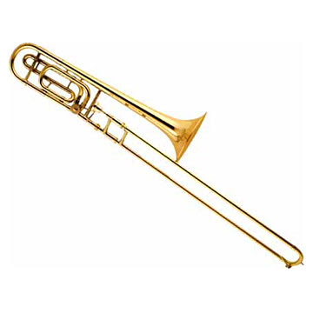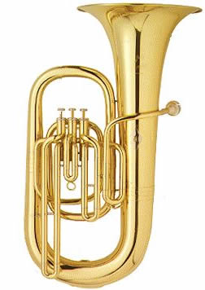

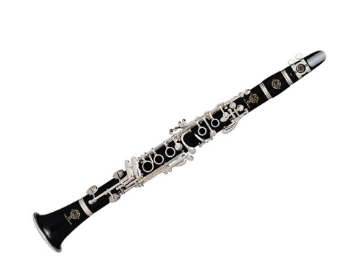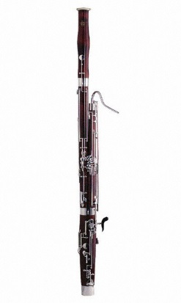

________________ ____________ _________ __________________

Percussion was used more and more, throughout the 1800s. In the twentieth century, many composers were writing for large percussion sections involving not just timpani, but cymbals, different types of drums, tuned percussion (e.g. xylophone) and hand-held percussion (e.g. triangle, tambourine). Sometimes orchestras use a harp or a piano as well.

Orchestras are led by conductors. A conductor is responsible for leading rehearsals, as well as leading the orchestra on concert nights. He can tell the orchestra what he wants them to do through waving a baton.

1. **What are the four instrument families of the orchestra?**

**______________________________________________________________**

1. **What was the orchestra like in Bach’s time?**

**_____________________________________________________________________________________________________________________________________________________________________________________________________________________________________________________________________________________________________________________________________________________________________**

1. **What instrument did the leader of the orchestra play in this period of history? __________________________________________________**
2. **Which were the first instruments to be introduced into the wind section?**
3. **Which were the first instruments to be introduced into the brass section?**

**________________________________________________________________**

1. **Name five different percussion instruments.**

**___________________________________________________________________**

# [http://t1.gstatic.com/images?q=tbn:ZLHJCSqs-oN8lM:http://www.courtneyandwalker.co.uk/acatalog/cello_pa602_front_sm.jpg](http://www.google.co.uk/imgres?imgurl=http://www.courtneyandwalker.co.uk/acatalog/cello_pa602_front_sm.jpg&imgrefurl=http://www.courtneyandwalker.co.uk/acatalog/cellos.html&usg=__yhcGMruxLCRwQqbu-7_9QcvND7w=&h=559&w=300&sz=59&hl=en&start=1&itbs=1&tbnid=ZLHJCSqs-oN8lM:&tbnh=133&tbnw=71&prev=/images%3Fq%3Dcello%26hl%3Den%26gbv%3D2%26tbs%3Disch:1)Strings

Stringed instruments are usually played with a bow (this is called arco), but can also be plucked with fingers (this is called pizzicato). There are four stringed instruments: violin (high pitch), viola (medium pitch), cello (low pitch) and double bass (very low pitch). Each instrument has four strings. The violins are split into two groups: 1st violins and 2nd violins.

1. **Describe the two different ways of playing stringed instruments.**

**_______________________________________________________________**

1. **How many strings does each stringed instrument have?_____________**

## Woodwind

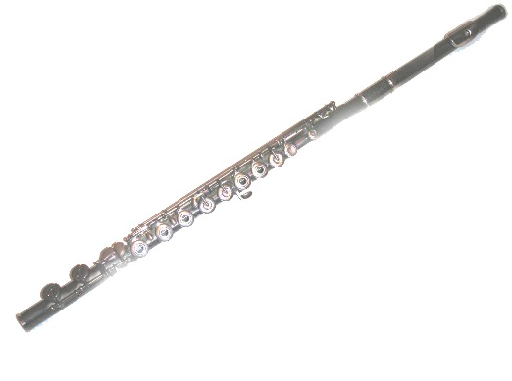Woodwind instruments are blown. There are four woodwind instruments: flute (high pitch), oboe (fairly high pitch), clarinet (medium pitch) and bassoon (low pitch). Sometimes a piccolo is used. This is a smaller version of a flute and is even higher in pitch. Often each woodwind instrument group is split into two groups, to create more harmony, e.g. 1st and 2nd flutes, 1st and 2nd oboes etc.

1. **Name the four woodwind instruments.**

**__________________________________________________________**

1. **What is the smaller version of the flute and how is it different?**

**____________________________________________________________**

## http://totalmusicltd.com/images/French_Horn.jpgBrass

Brass instruments are also blown, like woodwind instruments, but they have a louder, harsher tone, as they are made of brass. There are four brass instruments: French horn (can play high and low), trumpet (high pitch), trombone (medium pitch) and tuba (low pitch). Each brass instrument has valves, which are pressed to create different notes.

1. **Name the four brass instruments._______________________________**
2. **What does a brass player press to create different notes?_________________________________________________________**

## http://www.musicwithease.com/marimba.gifPercussion

Percussion includes any instrument that you strike, shake or scrape. Timpani (sometimes called kettle drums) are the most widely used percussion instrument. They are large drums that sit on the floor and are played with beaters. Other untuned percussion (instruments which cannot play a melody) include cymbals, snare drum, bass drum, bongos, triangle, maracca, tambourine and castanets. Tuned percussion (instruments which can play a melody) include xylophone, marimba, glockenspiel, vibraphone, tubular bells and sometimes piano and harp.

1. **What are timpani also known as?_______________________________**
2. **Name three untuned percussion instruments, and three tuned.**

**_______________________________________________________________**